Required Project 24.1 (Part 2): Analyzing Live Streaming Data Using ThingsBoard
Robby MacNaughton
- Provide a screenshot to show that you created the alarm field inside your Realtime database and initialized it to zero.
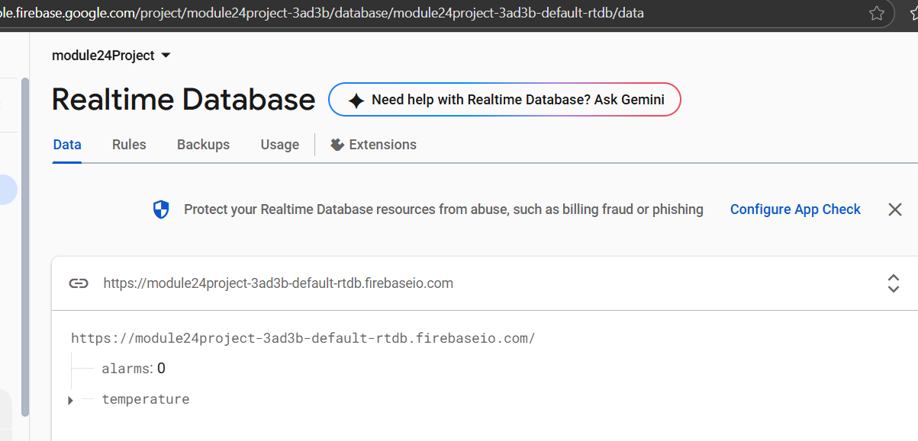
- Provide a screenshot to show that you created the CreateAndClearAlarms rule chain with all of the necessary components.
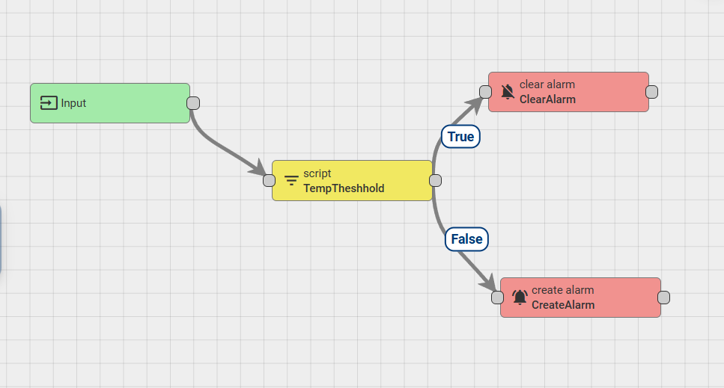
- Provide a screenshot to show that you created the TempToFirebase rule chain with all of the necessary components.
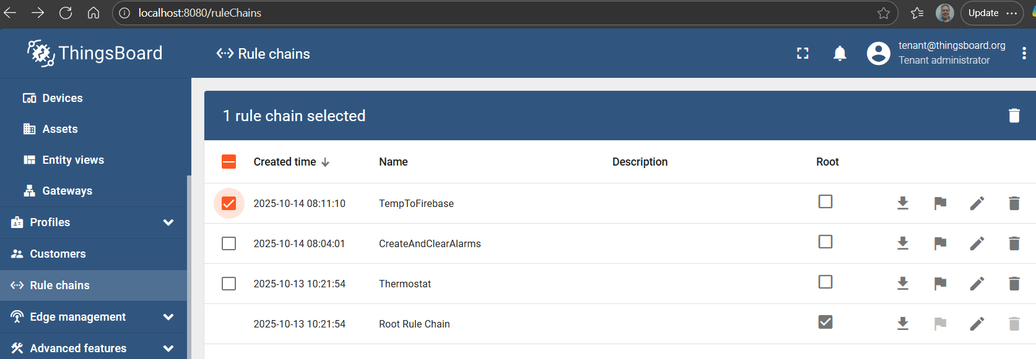
- Provide two screenshots. The first screenshot should show that you added the TempToFirebase node to your Rule Engine correctly. The second screenshot should show that you connected the Input and TempToFirebase node
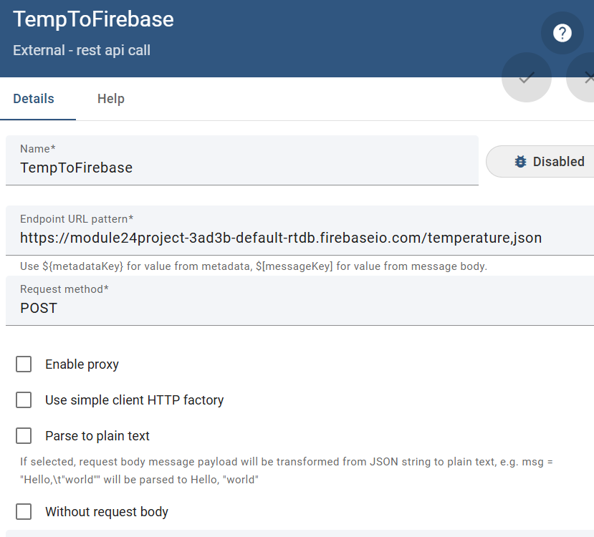
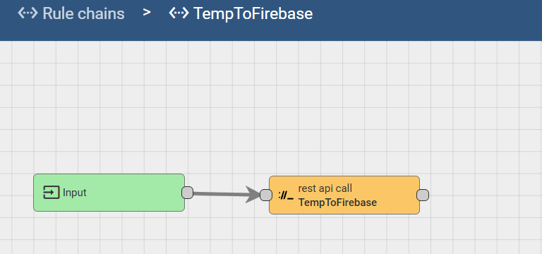

- Provide a screenshot to show that you created the AlarmToFirebase rule chain with all of the necessary components.
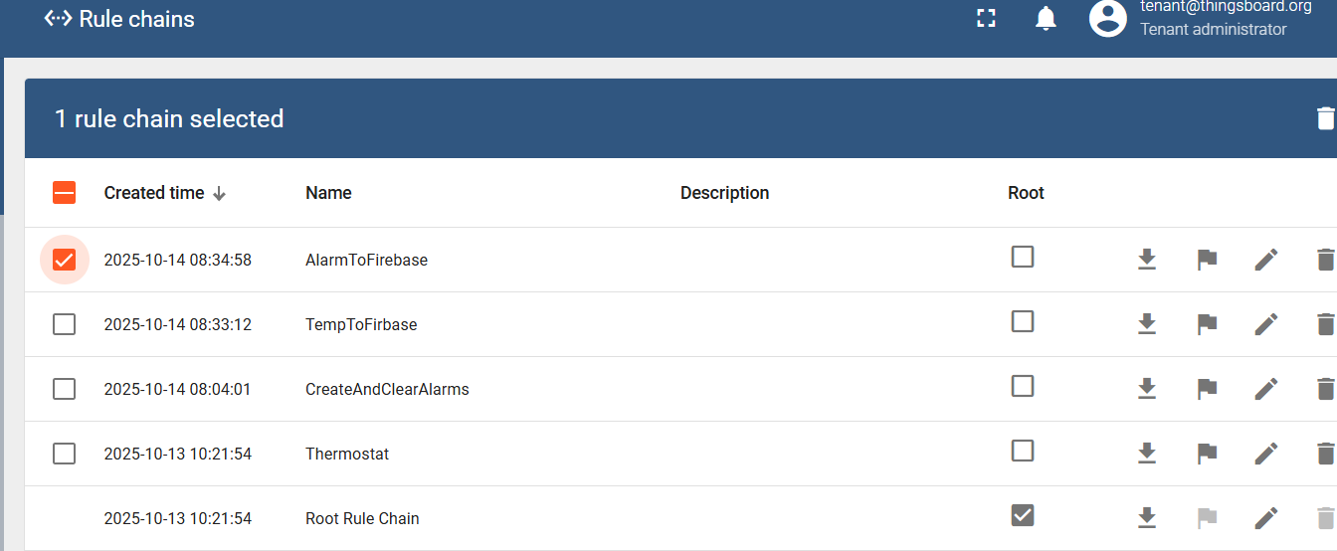

- Provide two screenshots. The first screenshot should show that you added the AlarmToFirebase node to your Rule Engine correctly. The second screenshot should show that you connected the Input and AlarmToFirebase nodes.
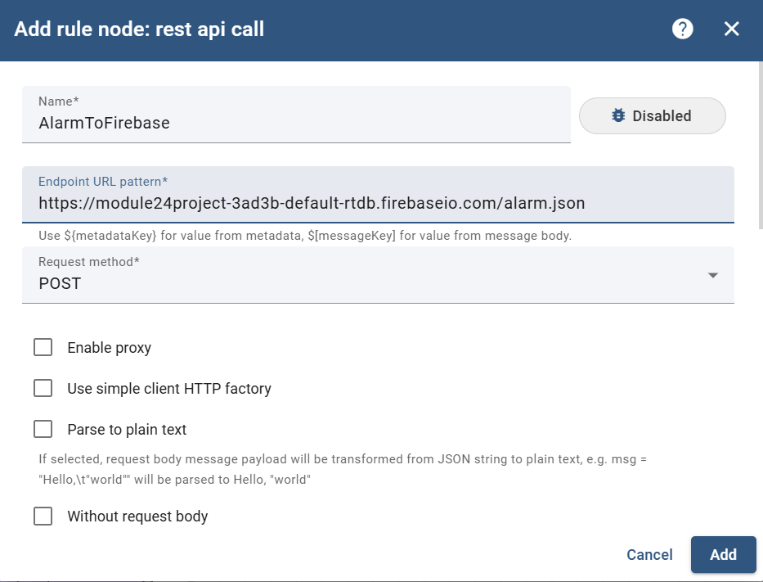
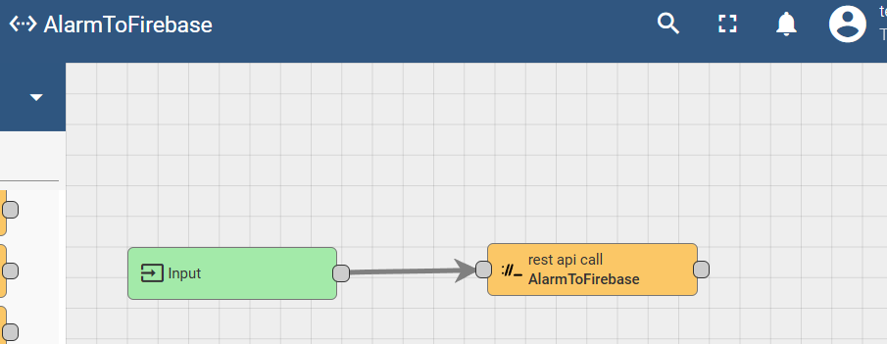
- Provide a screenshot to show that you added the AlarmToFirebase node to your Rule Engine correctly.
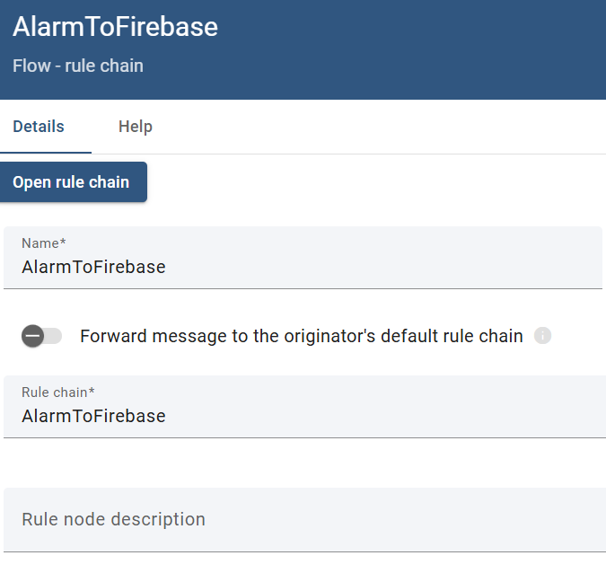
- Provide a screenshot to show that you connected the CreateAlarm and AlarmToFirebase nodes with a Created link label.
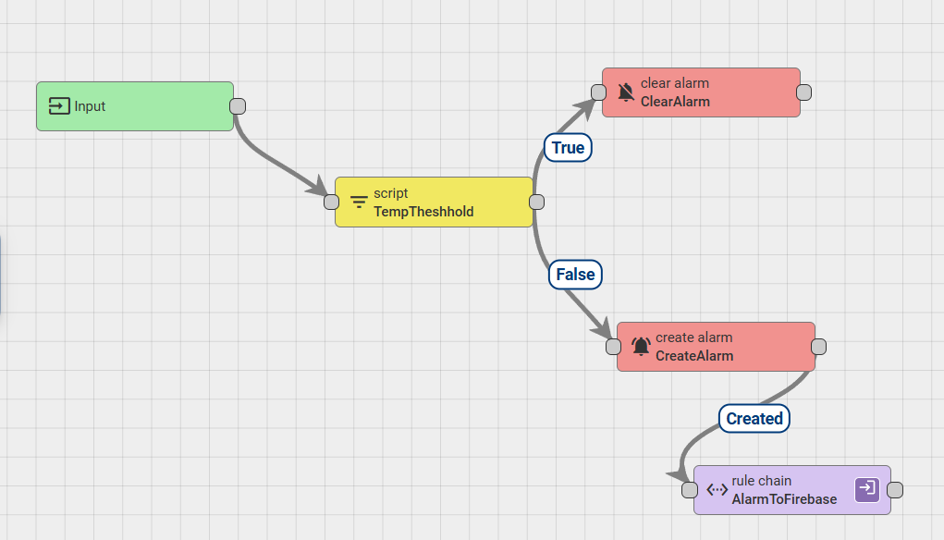
- Provide a screenshot to show that you added the TempToFirebase node to your Rule Engine correctly.
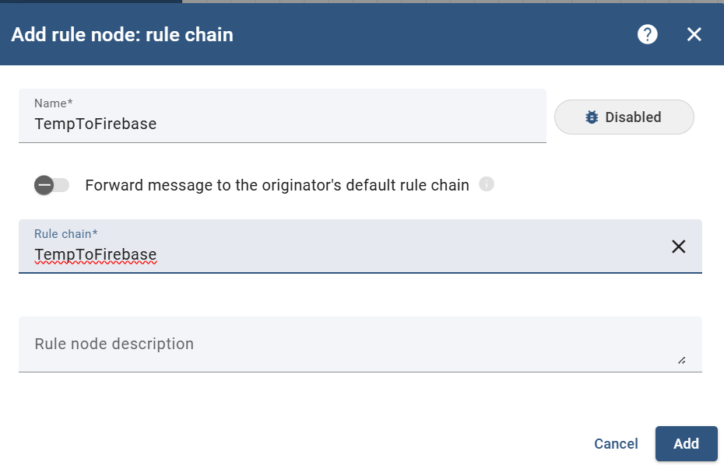
- Provide a screenshot to show that you connected the MaxTemp and AlarmToFirebase nodes with a True link label. There’s no MaxTemp used TempThreshold instead
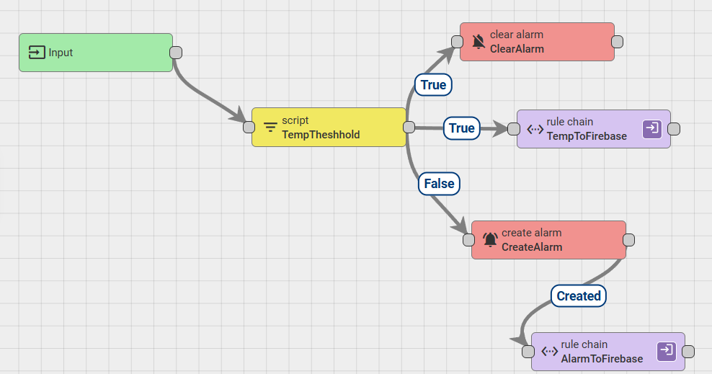
- Provide a screenshot to show that you added the CreateAndClearAlarm node to your Rule Engine correctly.
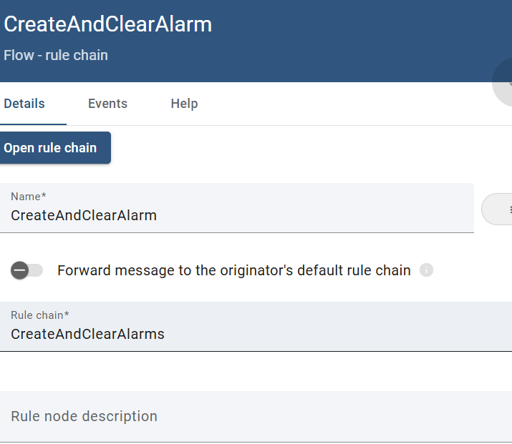
- Provide a screenshot to show that you connected the SaveTimeseries and CreateAndClearAlarm nodes with a Success link label.
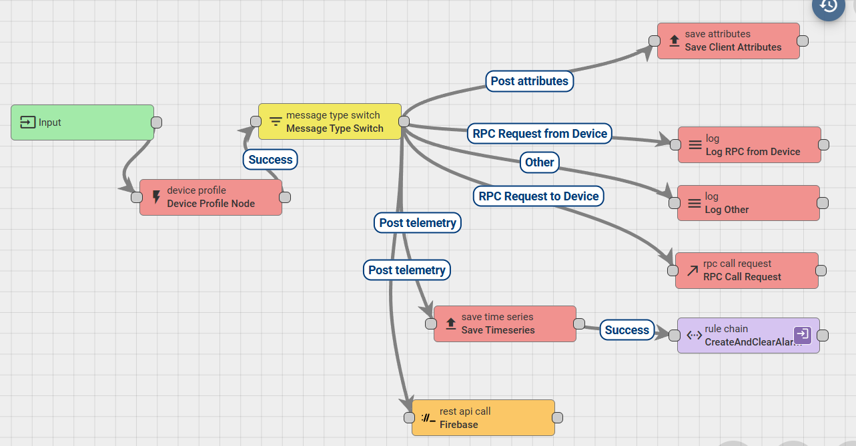
- Provide two screenshots. The first screenshot should show that the alarm field is being populated with the live streaming data from the CreateAndClearAlarm rule chain. The second screenshot should show that the temperature field is being populated with temperature and humidity data.
