PROCESS FOR RETRIEVING, WINNOWING AND EXPORTING PROJECT DATA

- Access the data from the YBRSS site.
  - Navigate to https://www.cdc.gov/yrbs/data/index.html
  - Select 2023
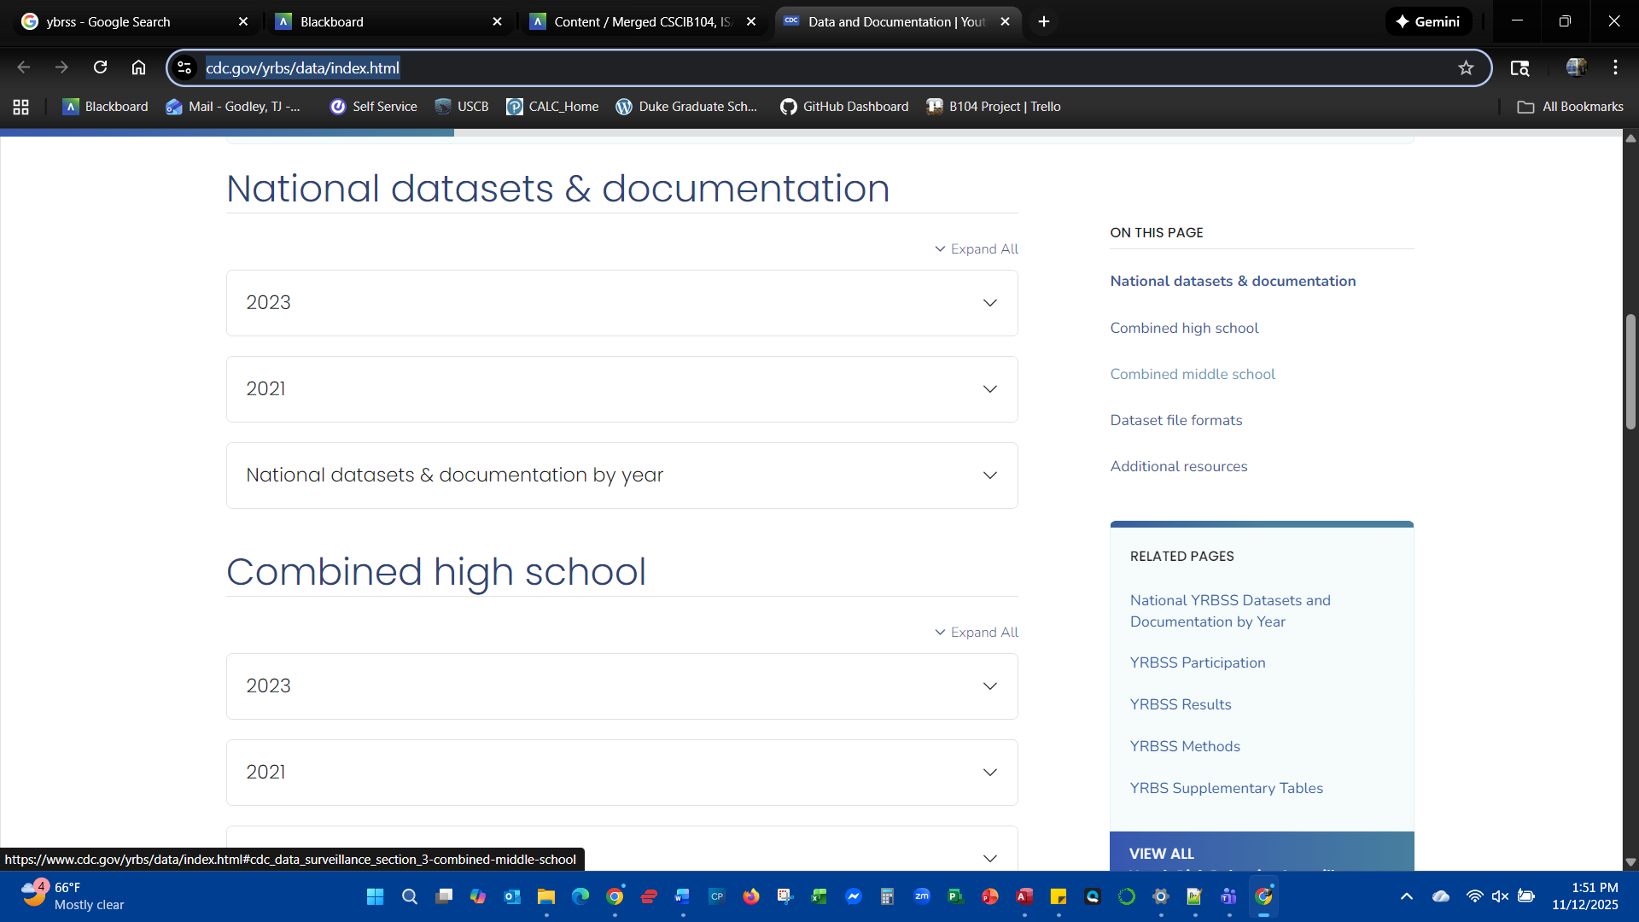
- Retrieve data in Access format.
  - Select Access zip
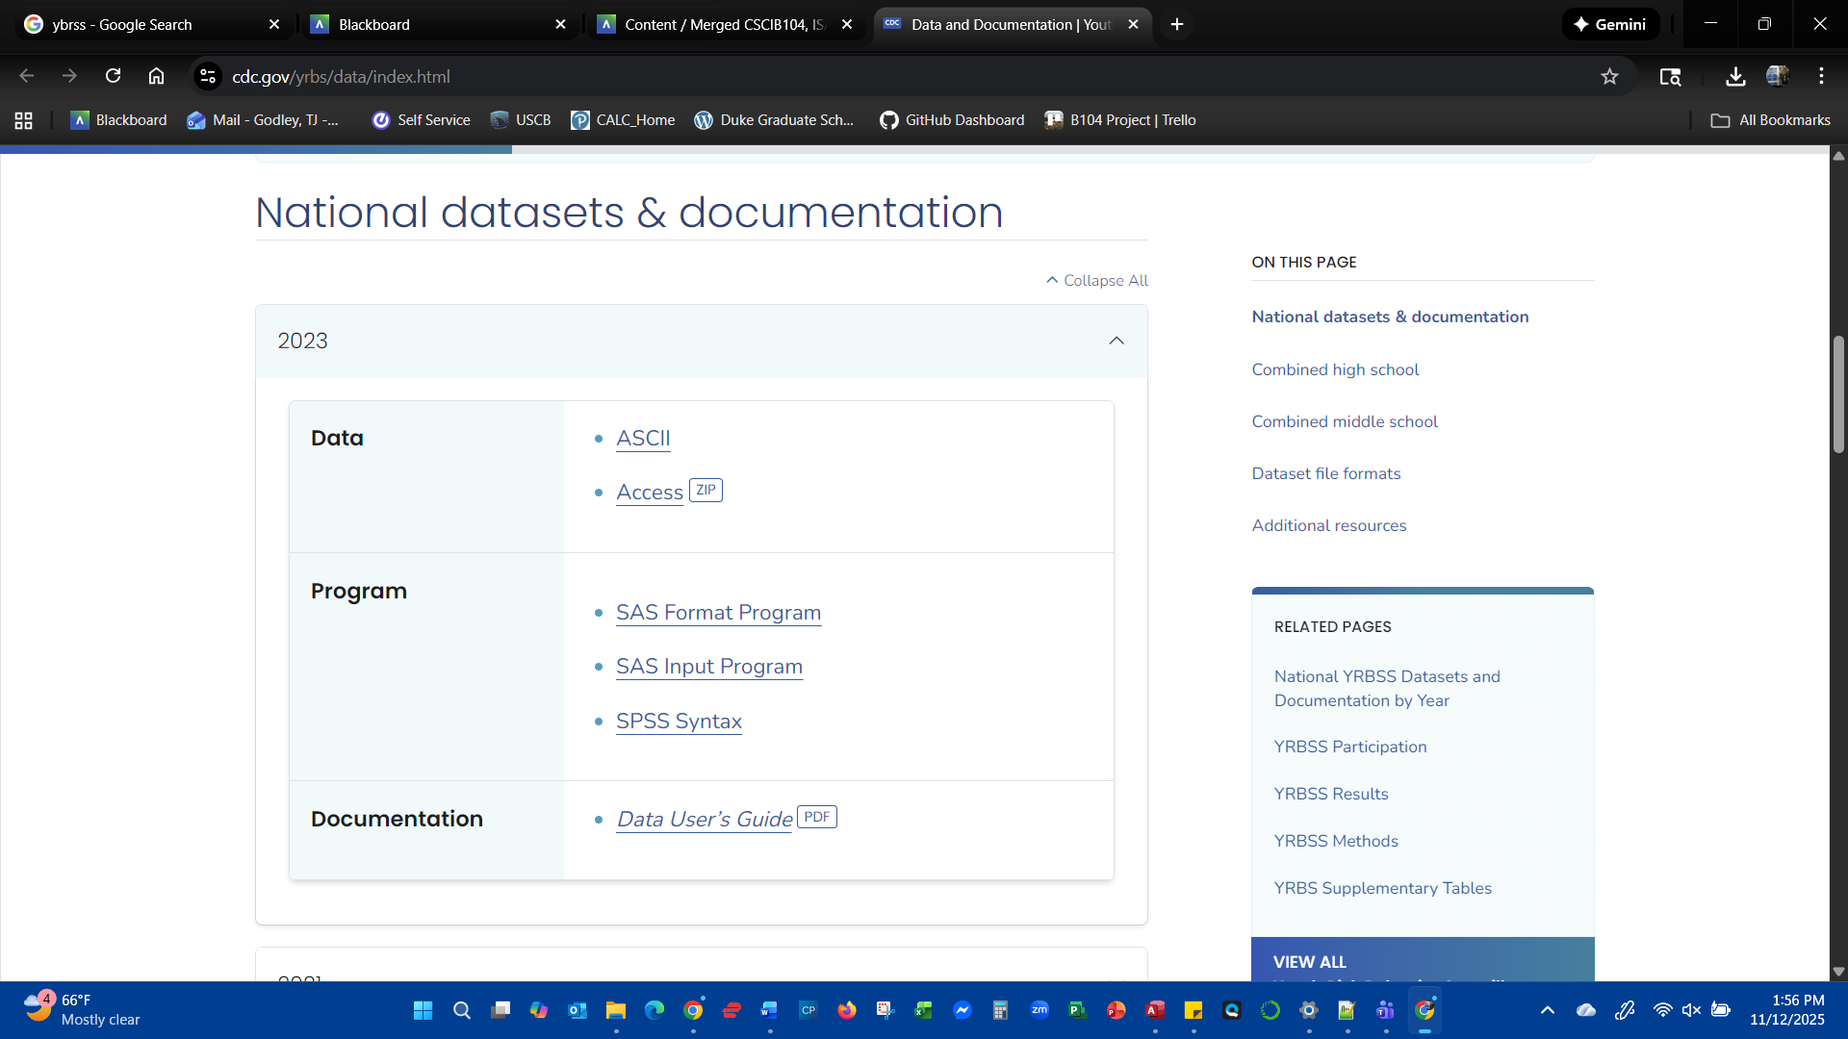
  - Zip file saves in your desired location (downloads folder)
- Unzip the Access file
  - Right click the saved file<select “Extract all”
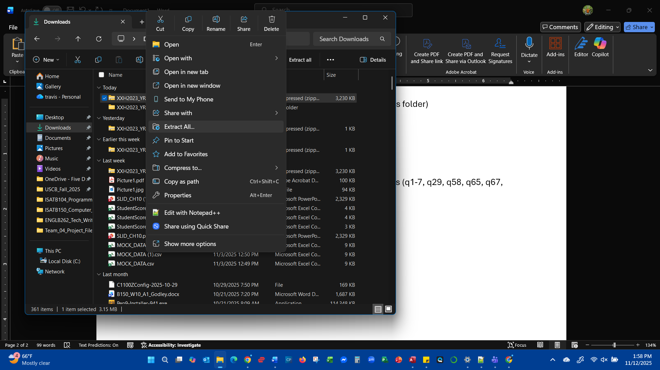
  - Window appears asking for location to save
  - Select a location to save (project folder)
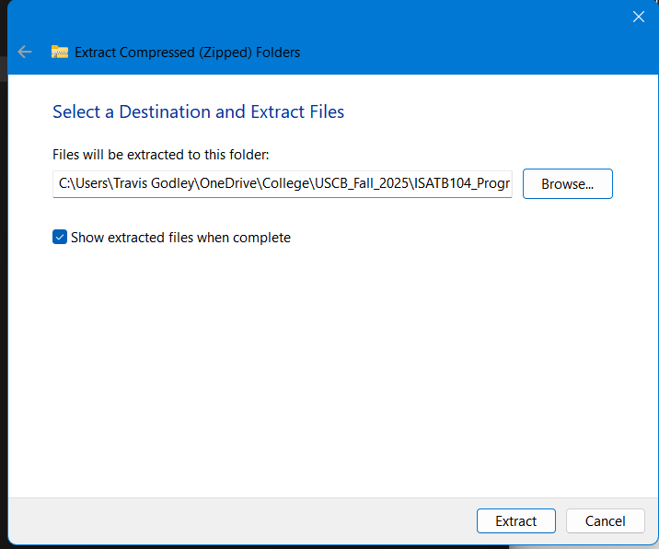
  - Files are extracted to desired location
- View data table in Access
  - Double click the saved *.mdb file to open in Access
  - Data opens in Access<Two tables of data are visible
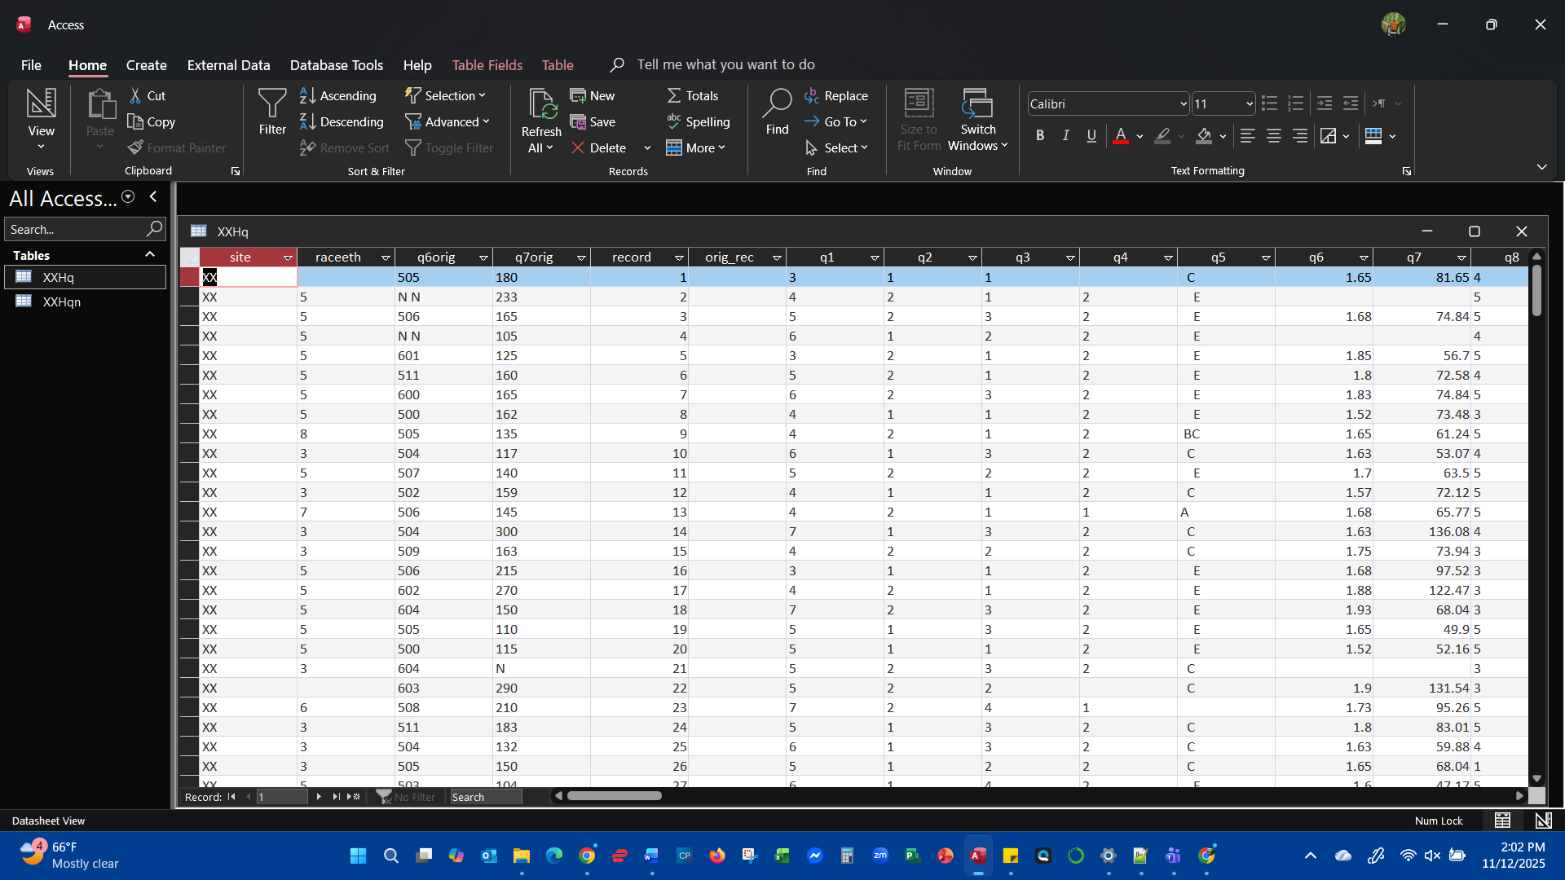

- Create SQL Query to winnow data to selected questions (q1-7, q29, q58, q65, q67, weight, stratum, PSU)
  - Select the Create tab<select SQL Query
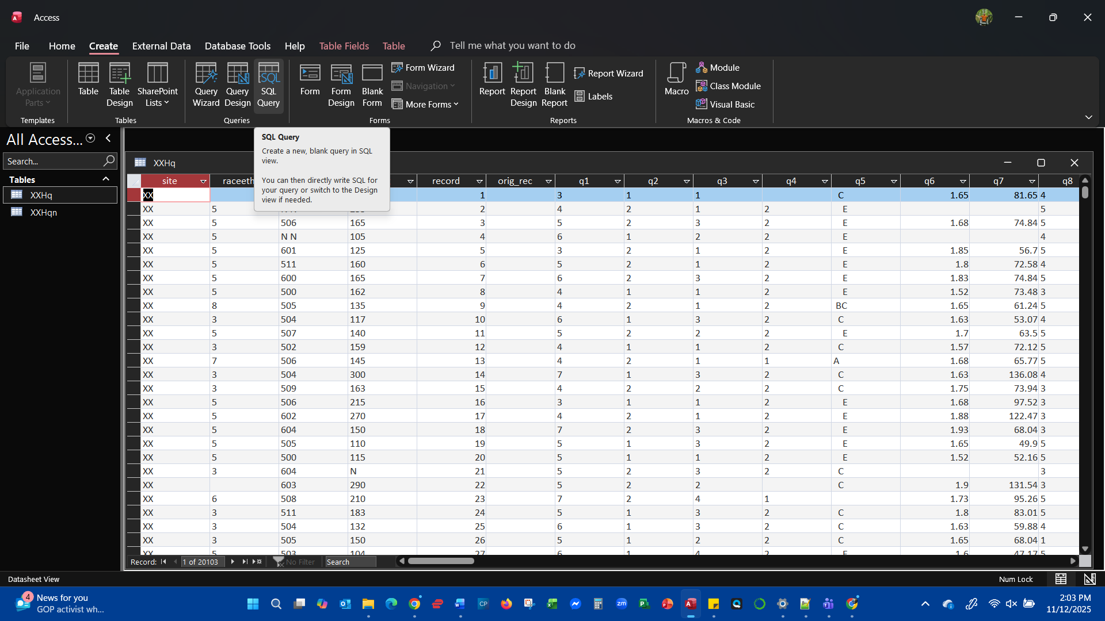
  - Window opens to the SQL query editor
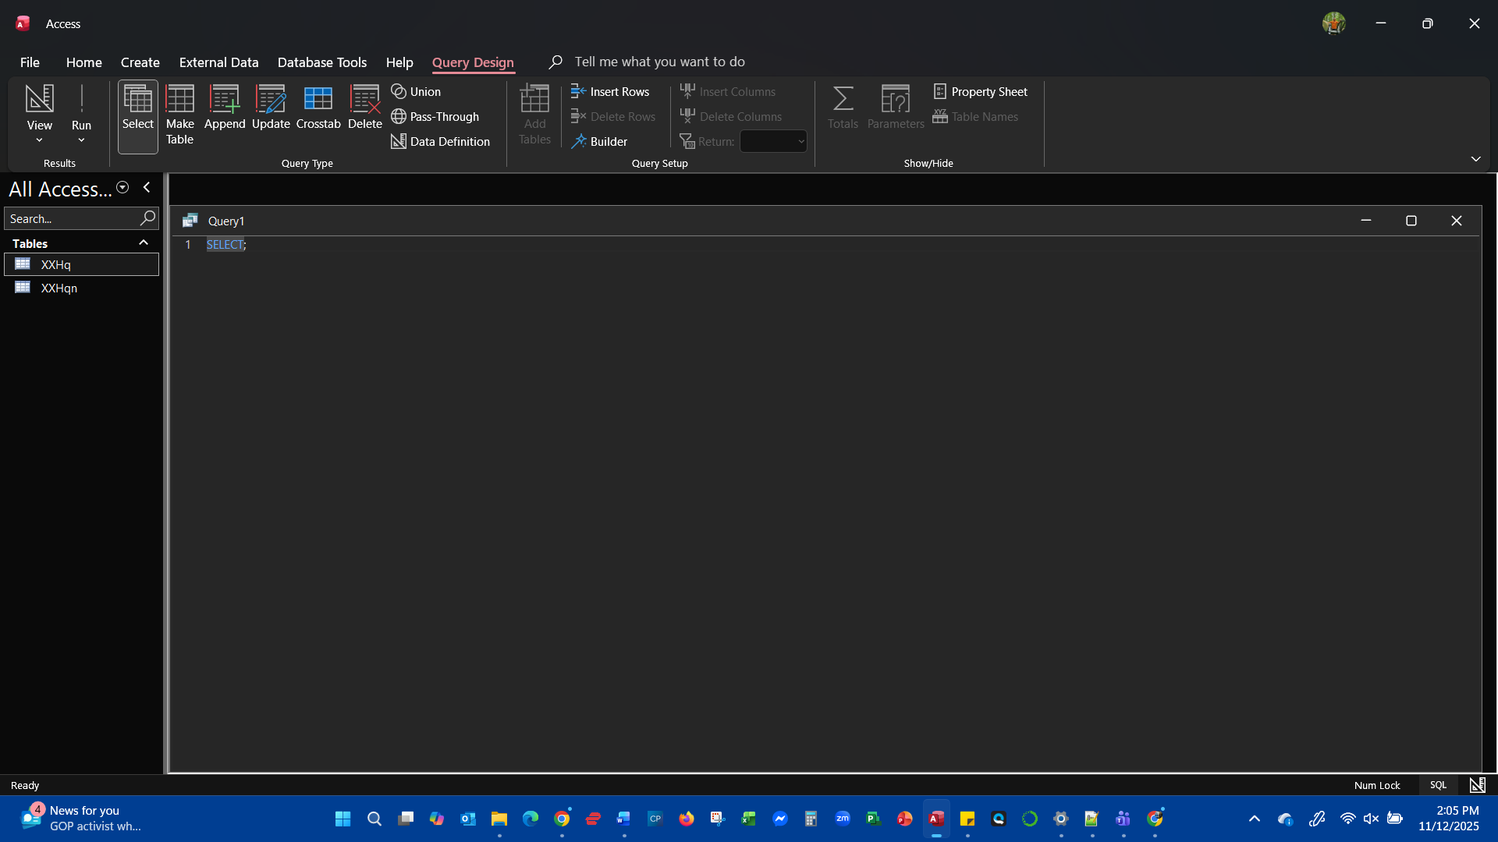
  - Enter SQL code to select only the desired columns.
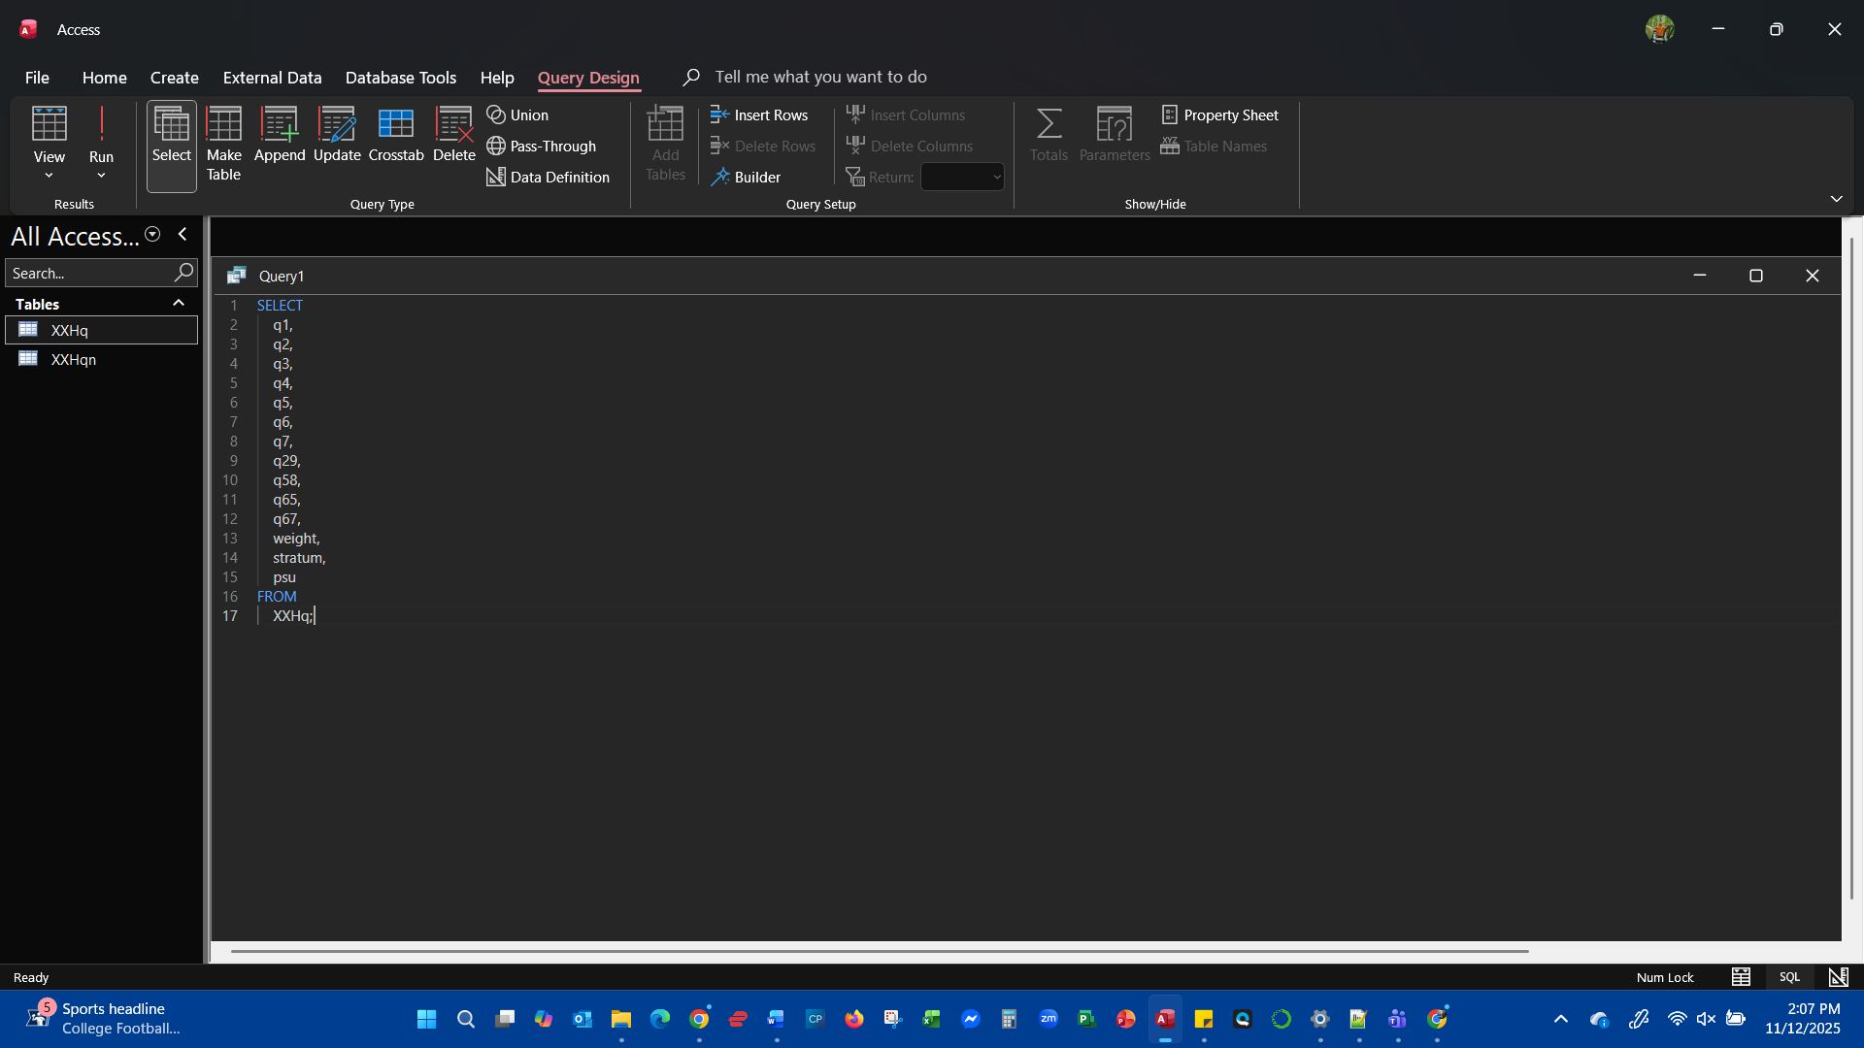
  - Click on the RUN command on the toolbar
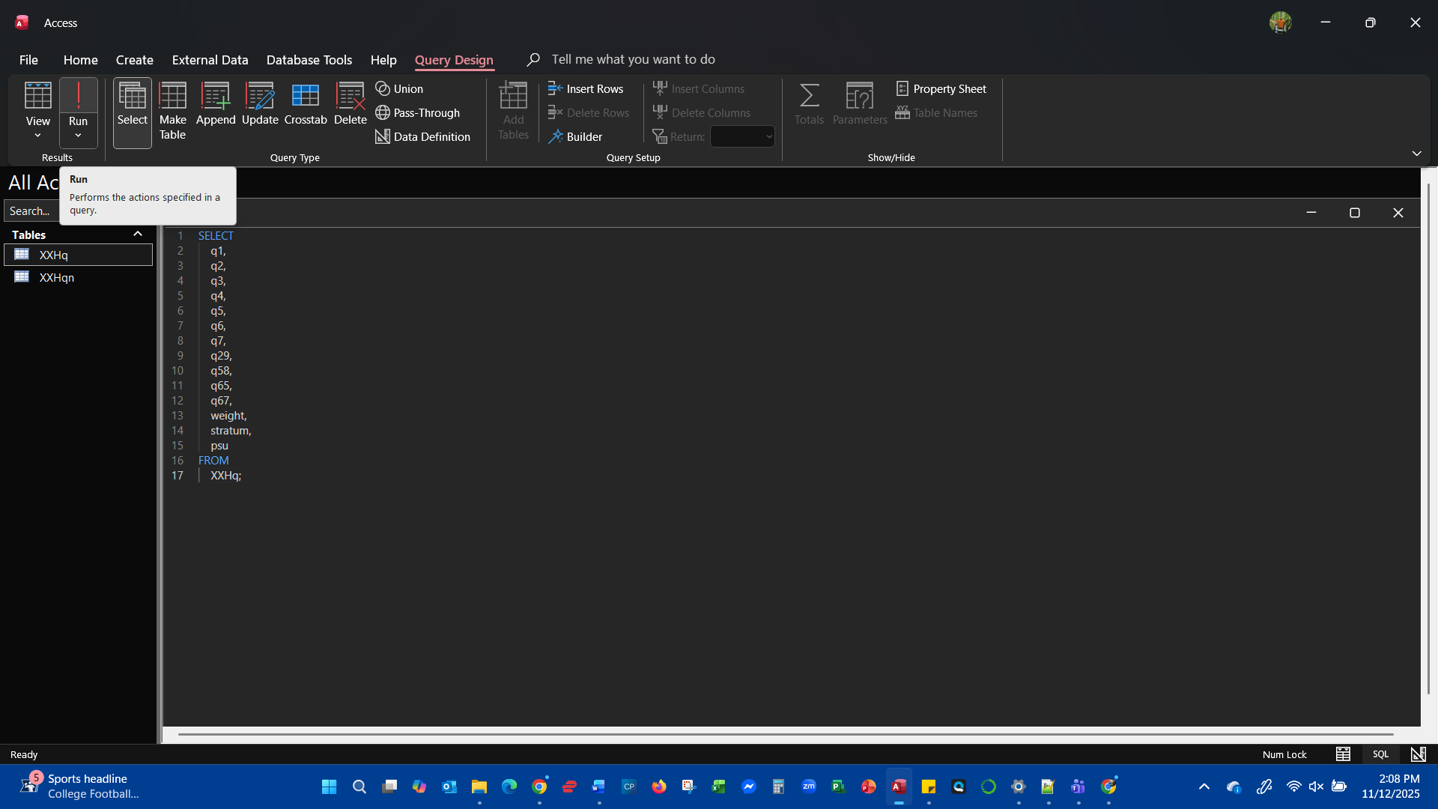
  - Query executes showing your results.
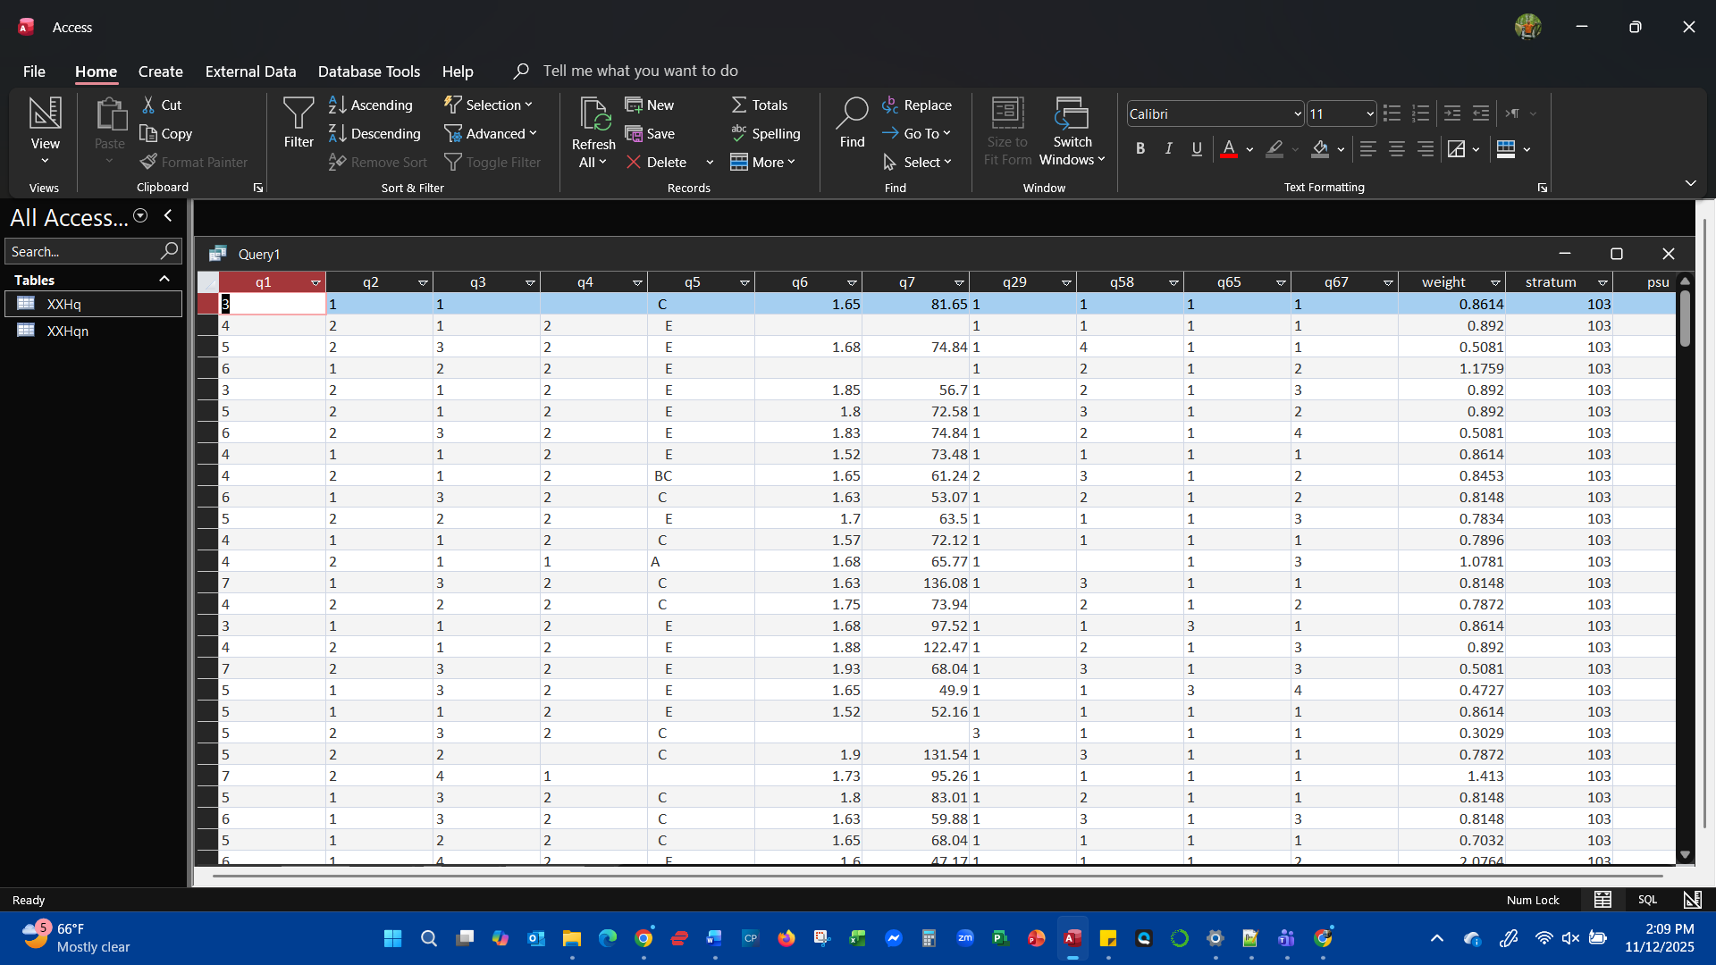

- Save query
  - Select File<Save
  - Name your query (B104_Project_Questions)
  - 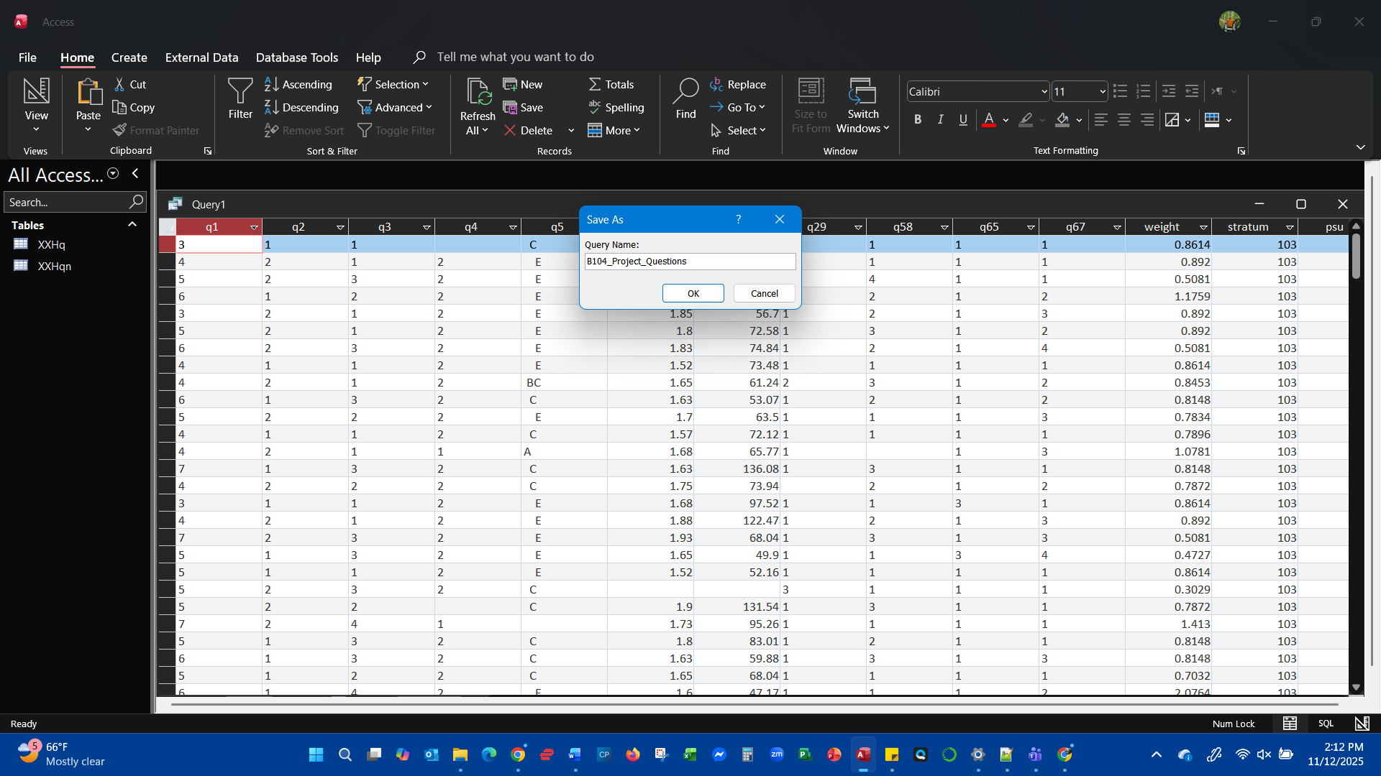
- Export results from query to Excel
  - Right click the created query<select Export<Excel
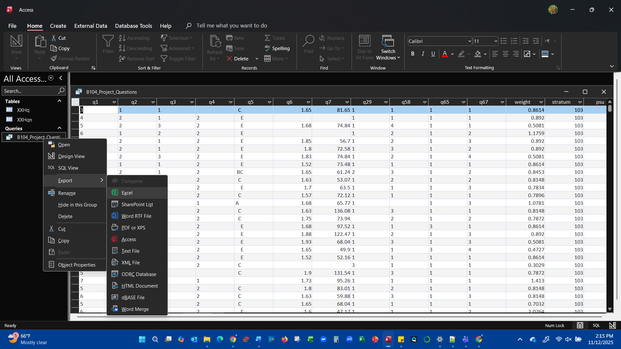
  - Window appears asking where to save
  - Navigate to desire location (Project files)
  - Name the file (B104_Project_Questions)
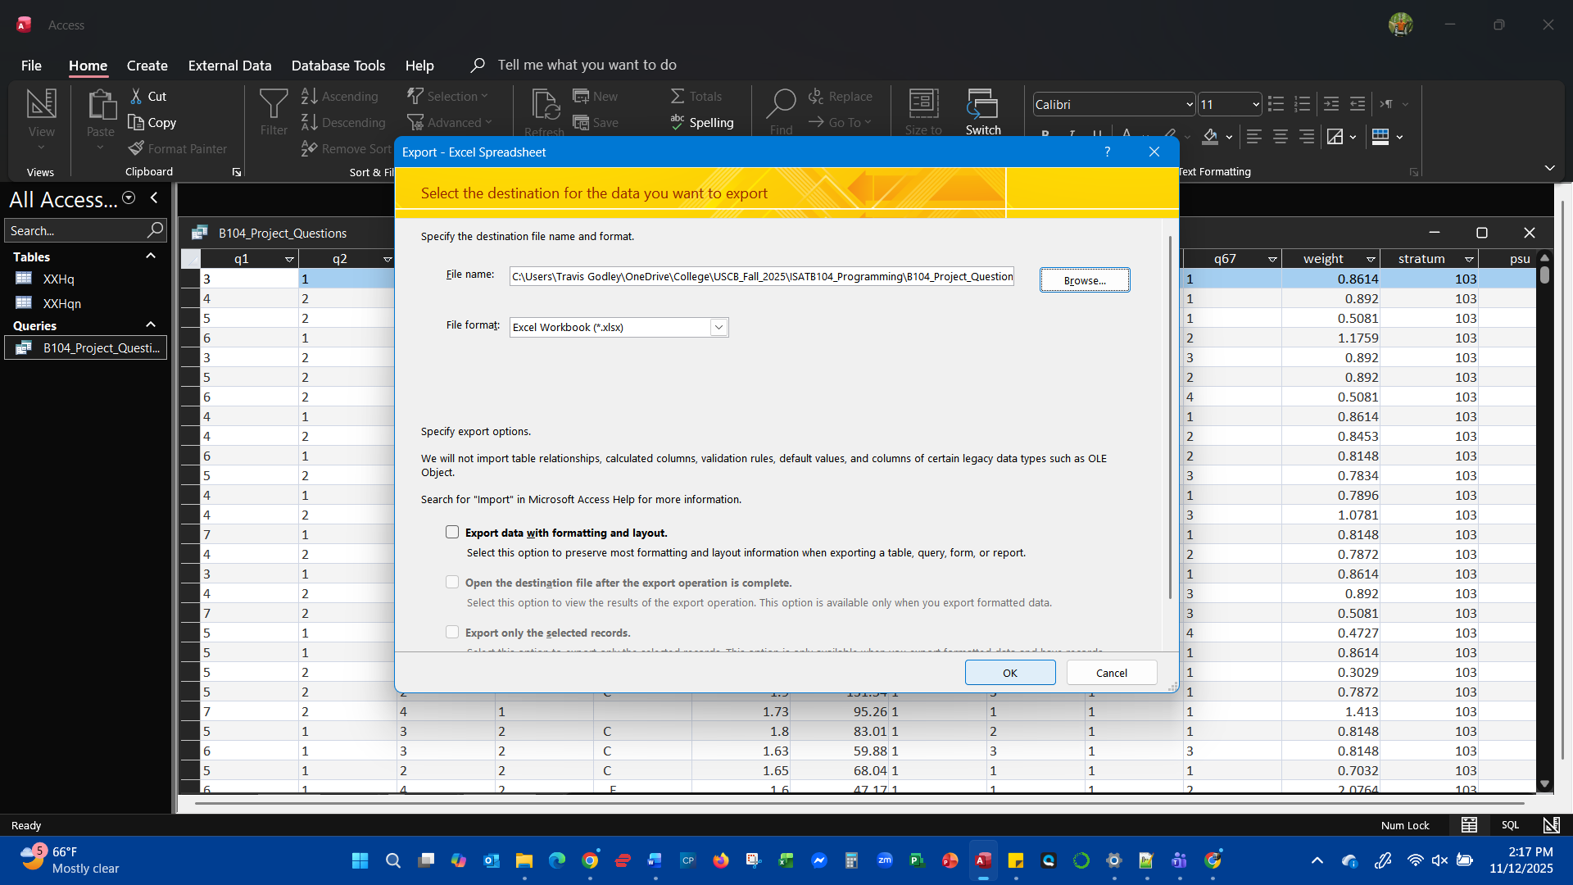
  - Select<OK
- Save data from Excel as CSV
  - Open the save Excel file
  - Review data for accuracy
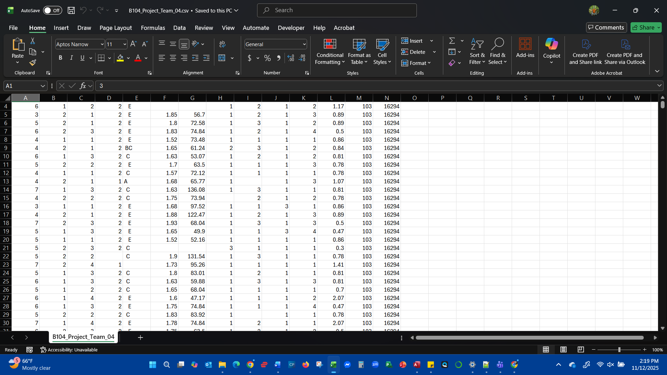
  - Select File<Save as<Name your file<select save
