 | CSCI/ISAT B104  Computer Programming Techniques, Practices, and Tools  Fall 2025  Project Documentation  Team XX

Contents
Project Contributions by Team Member 2
Collaboration Tools 3
YRBS Questions Explored 4
YRBS Demographic Information Explored 5
YRBS Data Winnowing & Retrieval 6
Research Question and/or Hypothesis 7
Bibliography 8
Acknowledgements 8

Project Contributions by Team Member

Members and their Contact Information
Member | Email | Text
Travis Godley | tjgodley@email.uscb.edu | (843) 441-3360
Dylan Folscroft | dylanrf@emailuscb.edu | (978)-799-6586

Overall
Relative Contribution of each member over the course of the entire project

Member | Contribution | Total Hours
Travis Godley | 0 % | 0.0
Dylan Folscroft | 0 % | 0.0

YRBS Question Identification & Documentation
Member | Contribution | Hours | Components
Travis Godley | 0 % | 0.0
Dylan Folscroft | 0 % | 0.0

YRBS Data Winnowing & Retrieval
Member | Contribution | Hours | Components
Travis Godley | 0 % | 0.0
Dylan Folscroft | 0 % | 0.0

Data Analysis (via Python)
Member | Contribution | Hours | Components
Travis Godley | 0 % | 0.0
Dylan Folscroft | 0 % | 0.0

Data Visualization (via Python)
Member | Contribution | Hours | Components
Travis Godley | 0 % | 0.0
Dylan Folscroft | 0 % | 0.0

GUI Creation (via Python)
Member | Contribution | Hours | Components
Travis Godley | 0 % | 0.0
Dylan Folscroft | 0 % | 0.0

Python Script Creation
Member | Contribution | Hours | Components
Travis Godley | 0 % | 0.0
Dylan Folscroft | 0 % | 0.0

Presentation Preparation & Practice
Member | Contribution | Hours | Components
Travis Godley | 0 % | 0.0
Dylan Folscroft | 0 % | 0.0

Project Documentation & Administration
Member | Contribution | Hours | Components
Travis Godley | 0 % | 0.0
Dylan Folscroft | 0 % | 0.0

Collaboration Tools
- Trello
- GitHub

YRBS Questions Explored
Questions & responses explored over the course of the project.

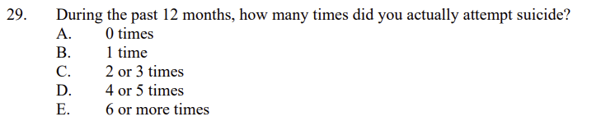
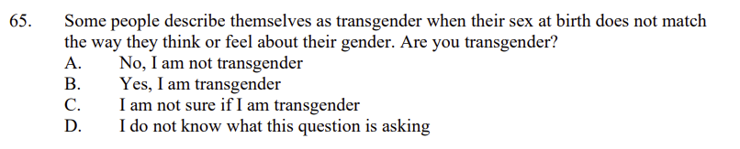
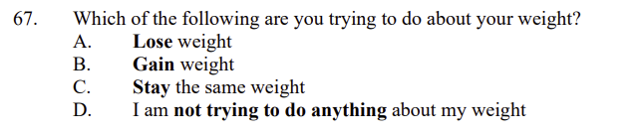
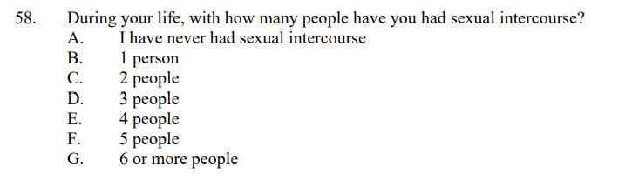

YRBS Demographic Information Explored
Demographic questions & responses explored over the course of the project

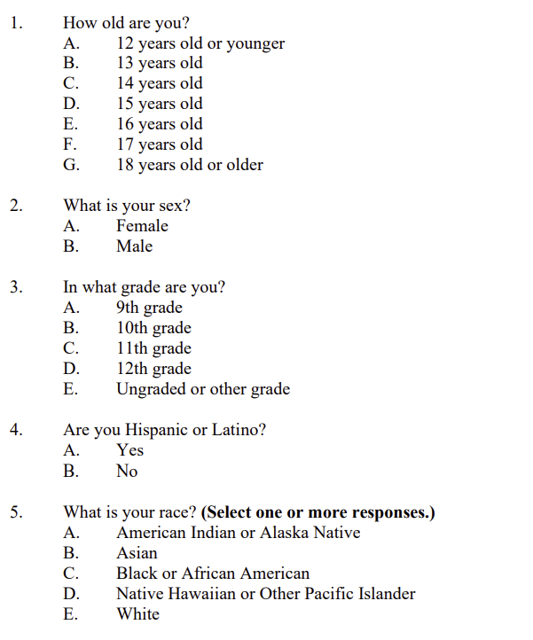
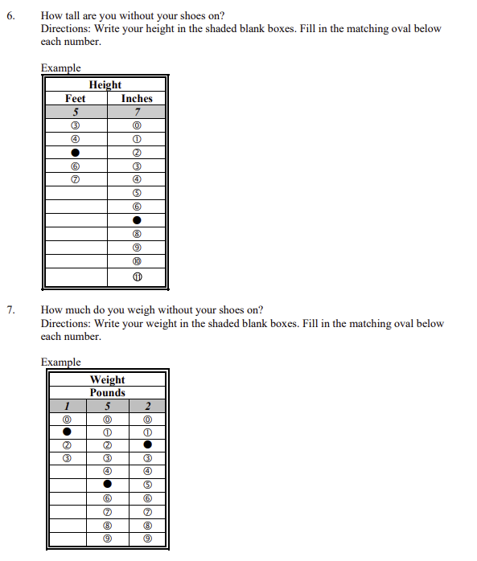

YRBS Data Winnowing & Retrieval
How we winnowed & retrieved the data explored over the course of the project.

Write down a step-by-step guide explaining how you winnowed & retrieved the data from the YRBS site.

Place screenshots of the SQL code and other relevant details here

Research Question and/or Hypothesis
The specific research questions we sought to answer.

Write down your research question here.

Bibliography
Resources which we used over the course of the project.

Citations for:

Python Library Documentation
Python Tutorials
Best Practices
Poster Templates
Stack Overflow questions/answers
Etc.

Follow APA format

Acknowledgements

Specific peers who helped you debug
Upper class students, parents, siblings, friends, etc. who provided feedback and guidance
Etc.

