Language: NL DE EN FR ⬇ PDF

System Audit
Cross-border jurisdictional vacuum in social security
Document C — The visual architecture
Author: Eric Messa
Last updated: 1 October 2026, 13:02
Note on translation: This document is a translation of the Dutch source version. As a result, it may contain minor translation errors or linguistic irregularities. In case of doubt, the Dutch text serves as the reference.

Table of Contents
Table of Contents 2
Introduction and reading guide 7
What this document is 7
The difference compared with the other documents 7
Fixed grammar 7
The Two Worlds 7
The membrane 8
The three channels 8
The colours 8
The structure of this document 8
How to read it 9
What the reader can expect 9
The position of Document C within the whole 9
I. Human beings 11
The presentation 11
Part I-A — The structure 11
Part I-B — The key players 13
Part I-C — The relationships 22
The cascade 26
Frame 1 — The trigger 26
Frame 2 — What keeps flowing 26
Frame 3 — What’s leaking out 26
Frame 4 — What doesn’t get in 27
Frame 5 — The result 27
II. Belgium 29
The pots and the tie-in sales 29
Part II-A — The jars 29
Part II-B — Tying 33
Part II-C — The four catch-22s 34
What this chapter sets out 36
Determination and decision 37
The five votes 37
Two decision-makers, one mechanism 37
The common pattern 38
The Parentia Staircase 39
Level 1 — The KSZ blockade 39
Level 2 — The bypass is accepted 39
Level 3 — Refusal on income grounds 39
The pattern is repeating itself 40
The Belgian tax route 41
Part A — What works 41
Part B — The bypass for the increased tax-free allowance 42
Part C — The double confirmation 43
Part D — AGODI: the moving target and the final conclusion 44
Part E — What this chapter sets out 45
The reopening 47
What the letter says 47
What the website says 47
What this achieves 47
The CM and the flow of funds 49
Part A — The three funding streams 49
Part B — Social Security contributions and their allocation 49
Part C — Why assistive devices are covered but benefits are not 50
Part D — The CDZ as a supervisory authority 50
Part E — The Labour Audit Office: who monitors the monitor? 51
Part F — The Medical Council: disciplinary proceedings against the medical adviser 51
Part G — What this chapter sets out 52
III. The Netherlands 54
The UWV and the appeals process 54
Part A — Six rounds at the UWV 54
Part B — NEO and the C4 form 54
Part C — The refusal to synchronise foreign data 55
Part D — The pattern: procedural rejection 56
Part E — A summary of the grounds for rejection 56
Part F — The two objections in detail 56
Part G — What this chapter sets out 57
CZ — the two faces of the gatekeeper 59
Story 1 — The insurance policy and the healthcare allowance 59
Story 1a — The chain of the blockade: CZ, CAK, ZIN 60
Story 2 — Patient transport 61
Part C — The parallel: CZ and CM 62
Part D — What this achieves 62
The Hulst-trap municipality 64
Part A — The local authority as the first point of contact that doesn’t help 64
Part B — The pending appeal 65
Part C — The mathematical models that fail to reflect reality 65
Part D — The mobility antics 66
Part E — The limits of transport under the Wmo 67
Part F — The pattern repeats itself 67
What the local authority should have been 67
Tax and Customs Administration and benefits 69
Part A — The three allowances 69
Part B — The mechanics behind it 69
Part C — Medical expenses that were reduced to zero 70
Part D — Citizens’ responsibilities 71
Part E — What this achieves 71
IV. Back and forth 73
The manual U1 problem 73
The two directions 73
Direction 1 — Belgium to the Netherlands 73
Route 2 — From the Netherlands to Belgium 74
The pattern 74
ESSPASS in 2030 — what won’t change 75
What ESSPASS does and does not solve 76
Why this serves as a bridge to the Dutch section 76
SVB and Parentia — a working example 78
Part A — The split 78
Part B — Why this works 78
Part C — The recalculation that threatens success 79
Part D — What this chapter illustrates 79
The body without a rear guard 81
Part A — The legal impossibility 81
Part B — The practical implications 81
Part C — The law that protects and paralyses the family 82
Part D — The paradox 83
What this chapter sets out 83
The central pot 85
Part A — The account as a reserve 85
Part B — The three private gates 85
Part C — The bank as the de facto creditor of the welfare state 86
What this chapter sets out 86
V. Europe 88
The European layer 88
Part A — The European and international level 88
Part B — The circular reference 88
Part C — The two openings 89
Part D — The infringement proceedings that never materialise 90
Part E — The European paradox 91
What this chapter sets out 91
VI. Those who are watching 93
The control and mediation layer 93
Part A — The four mediators 93
Part B — The difference between the two ombudsmen 93
Part C — The circular reference between the two SOLVIT centres 94
Part D — The ELA: the road that won’t open 94
Part E — The pattern 95
The courts 97
Part A — The two legal remedies 97
Part B — The pro bono threshold 97
Part C — The irony of the reference year 98
Part D — What this means 99
Politics 100
Part A — The separation of powers 100
Part B — What politics can and cannot do 100
Part C — Belgian parliamentary practice 101
Part D — Parliamentary practice in the Netherlands 101
Part E — A summary of the differences 102
Part F — The power of framing 103
Part G — What this document does 103
The nobility 105
Part A — Formal power: what the King can and cannot do 105
Part B — The right to petition 105
Part C — In practice: how petitions are dealt with 106
Part D — The paradox of the informal channel 106
Part E — Practical aspects of this case 106
Part F — What this chapter sets out 107
The allies and the watchdog 108
Part A — ACV: the trade union that helps and takes action 108
Part B — UNIA: the watchdog that isn’t allowed to bite 109
Part C — The academic observation layer 109
Part D — What this chapter sets out 111
VII. Conclusion 113
Conclusion — the complete pyramid 113
The pyramid 113
What this case has shown 113
The bridge to Document D 114
The entire network 115
What the family sees 115
What this diagram does 115
What isn’t in it 116

Introduction and reading guide
Document C is the visual document for the System Audit project. It shows at a glance what is set out in various parts of the other documents: the structure of the network, the flow of information between organisations, and the mechanisms that cause failures.

What this document is
Document C is not a repetition of the other documents in terms of presentation. It offers a distinct perspective that exists solely in diagrams. Whilst Document A tells the story, Document B organises the facts, and Document D draws the conclusions, Document C reveals the underlying architecture that underpins all those facts.
The document is structured as a series of chapters. Each chapter consists of a separate diagram accompanied by a short text. There is no continuous narrative, nor are there any lengthy analyses. Each diagram illustrates a single mechanism, a single pattern, or a single connection which can be found in the other documents, but never at a single glance.

The difference compared with the other documents
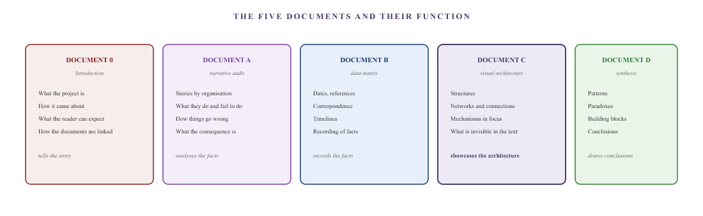
Figure 0.1 — The five documents. Each document has its own function. Document 0 is the introduction and reading guide, Document A is the narrative audit, Document B is the data matrix, Document C is the visual architecture, and Document D is the synthesis. Document C illustrates the architecture that underlies everything.

Fixed grammar
Every chapter of Document C uses the same visual language. Once you are familiar with that language, you can read any diagram. Here is the vocabulary.

The Two Worlds
Belgium and the Netherlands are portrayed as two distinct worlds: rigid, closed systems that do not adapt their rules to accommodate a citizen who lives in both countries at the same time. Both worlds are composed of four concentric layers: implementation, oversight, politics and symbolism.

The membrane
The family lives between two worlds. The family is not a sphere but a membrane: a flexible, transparent form that stretches and contracts according to the demands of the day. At the weekend, it is entirely in the Netherlands; on weekdays, it spans both worlds.

The three channels
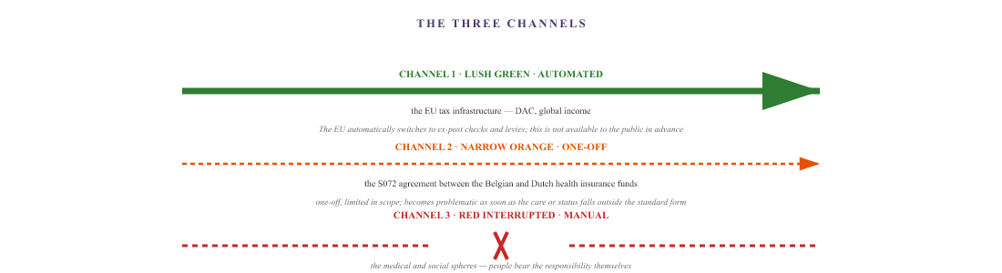
Figure 0.2 — The three channels. The nature of a channel determines whether data flows through, is held up or is completely blocked. Channel 1 is used for ex post checks and levies; it is not used to provide citizens with information in advance.

The colours
In the diagrams, connections are colour-coded according to what is happening:
- Green — the traffic is flowing. Automatically, without delay, without human intervention.
- Orange — it’s a bit of a struggle. There’s a channel, but it’s narrow, a one-off or delayed.
- Red — it is blocked. There is no channel, or the channel is closed.

The structure of this document
Document C follows the human sequence. It begins with humanity, then moves on to Belgium (because the author is Belgian), then to the Netherlands, then back and forth between the two countries, then to Europe, then to those looking at Europe, and finally to the world, which is supposed to see the whole picture.
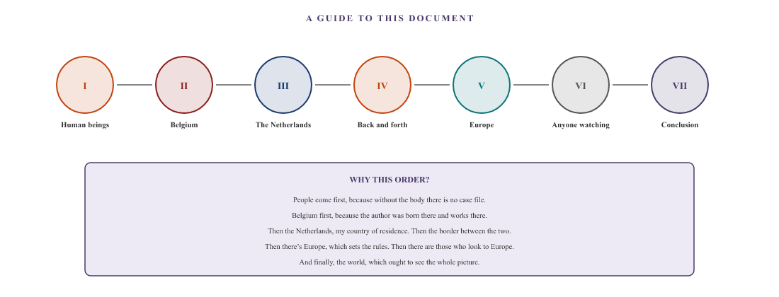
Figure 0.3 — The path through this document. Seven sections, in the order of human reality: from the body, through the two countries, to Europe, to the observer, and finally to the conclusion.

How to read it
Document C is not intended to be read from start to finish in one go. Each chapter stands on its own. Readers can choose their own path.
For those who wish to understand the whole picture: start with Block I (Man), followed by the other blocks in order. In this way, the picture builds up step by step: from man, through the two countries, to Europe, to the observer, and finally to the conclusion.
If you are specifically interested in a particular topic, select the relevant chapter. Tied sales, the cascade, the UWV, CZ, the local authority, the Tax and Customs Administration, the European level — each has its own chapter.
If you want to see the full network, read Section I (Humanity) first, then the conclusion. Taken together, these two sections provide an overview of the structure at a glance.

What the reader can expect
- Each diagram has its own title and a brief explanation below the figure.
- Organisations are displayed as blocks or as numbered dots on a ring. Names are public and are listed.
- Individuals are referred to by their role or their symbol. Never by their name.
- Amounts, dates and reference numbers are taken from Document B. Where an amount or date is uncertain, this is explicitly stated.
- Where the diagram shows a pattern that is explained in more detail in Document D, a reference to the relevant chapter in D is provided.

The position of Document C within the whole
Document C is situated between Document B and Document D. Whilst B sets out the facts and D draws the conclusions, C reveals the architecture that makes the failure possible. If you want the facts: B. If you want the conclusions: D. If you want to understand why the facts lead to these conclusions: C.
What this document illustrates is the essence of the power vacuum at a glance: one body, two worlds, three channels. And a citizen who has to hold their own in the gap between the two worlds.
This is Document C — The visual architecture. All organisations referred to in this document are legal entities. Natural persons are referred to by their role or their symbol. The facts are based on Document B. The conclusions are set out in Document D. This document does not constitute legal advice.

I. Human beings

The presentation
Two rigid worlds. One membrane that stretches and contracts. Three channels, each with its own character. And within each world, four institutional rings that citizens must navigate in order to get anything done. This chapter sets out the playing field: who is where, how the layers are structured, and which actors operate within each layer.

Part I-A — The structure

The Two Worlds
In this dossier, Belgium and the Netherlands are referred to as two worlds: the World of Belgium and the World of the Netherlands. Each world constitutes a self-contained, sovereign legal and administrative system. For a citizen who spends their entire life within a single world, the internal links generally fit together seamlessly.
However, both worlds are rigid. They lack flexibility. They do not adapt their administrative boundaries when a citizen exercises their right to free movement. Each system assesses applications solely on the basis of national definitions, national medical criteria and territorial conditions — the ‘country of residence’ principle versus the ‘country of employment’ principle. The two systems physically adjoin one another at the national border and rub shoulders, but do not merge at all at the operational level.

The membrane
Between these two rigid worlds lies the membrane: the family. Unlike the two national systems, the family has no fixed geometric shape. It is a transparent, irregular form that must stretch and contract to accommodate the incompatibility between the two systems. Whilst the institutions remain rigid, citizens are required to be completely flexible.
The diaphragm moves in a cyclical motion with two positions:
- Weekday status (solid outline): the family straddles both worlds. They live in the Netherlands but cross the border every day for school, medical treatment and ongoing procedures on the Belgian side.
- Weekend status (dotted outline): the membrane retreats within the Dutch sphere. Its physical presence is then entirely within the Netherlands, whilst its legal and financial dependence on Belgium continues unabated.
Inside the membrane there are three people, represented by symbols:
- The father (♂) — a Belgian of Franco-Italian origin, born in Belgium, living in the Netherlands. His employment and medical history are in Belgium; his place of residence and part of his healthcare and benefits arrangements are in the Netherlands.
- The mother (♀) — Belgian, living in the Netherlands. She works in Belgium and acts as the day-to-day logistical and administrative hub between their home in the Netherlands and the Belgian authorities.
- The son (young boy) — lives in the Netherlands and attends school in Flanders. Every day, he crosses the border between the Netherlands, where he lives, and the Flemish education and child benefit systems.

The four institutional layers
Each world is structured from the outside in, consisting of four concentric rings. Anyone who becomes stuck in the outermost layer and seeks protection further up moves from the outside in through these four layers:
- Implementation — the service points with which members of the public come into direct contact: health insurance funds, healthcare insurers, hospitals, tax authorities, benefits agencies, local authorities and utility companies. This is where decisions are made and payments are processed or blocked.
- Supervision — the supervisory authorities and ombudsman services. They monitor the system, but do not take binding action at the operational level in individual cross-border cases.
- Politics — national parliaments, parliamentary committees and political parties. They have the formal power to amend the law, but leave individual systemic blockages unaddressed.
- Symbolism — the highest representative body of the state: the Royal Palace in Belgium, the Royal House in the Netherlands. This body has no executive or legislative powers and refers petitions back to the political or executive level.

The three channels between the worlds
Although the two worlds do not merge, there are three structural axes of connection between Belgium and the Netherlands. They reveal a fundamental asymmetry between what the state knows about its citizens and what the state provides for them.
- Channel 1 — thick green, automated. The EU’s tax and administrative data infrastructure: the Directive on Administrative Cooperation and the global exchange of income data. Tax data flows automatically between the Belgian FPS Finance and the Dutch Tax and Customs Administration. When it comes to auditing and taxation, the government knows everything.
- Channel 2 — narrow orange, one-off. The agreement between the Belgian health insurance fund and the Dutch health insurer (S072) and the CAK. A narrow, one-off administrative channel that covers standard reimbursements and immediately runs into difficulties as soon as care or status falls outside the scope of the standard form.
- Channel 3 — red, interrupted, manual. The medical and social sphere. There is no automated channel between Belgian and Dutch hospitals, GPs, medical examiners and social services. The line is broken and marked with a ✕: families must physically carry files, medical imaging and certificates from one country to the other themselves.

The EU’s outer layer
Surrounding both these national spheres lies the EU’s outer layer. This layer comprises three clusters: official European and treaty-based institutions, cross-border mediation bodies, and the societal resonance layer (academia, strategic litigation, the media and UN human rights). The dotted line illustrates the fundamental problem with European social law: the EU proclaims the free movement of persons and coordinates this on paper (Regulation 883/2004), but has no dedicated enforcement body capable of breaking through a deadlocked national chain.
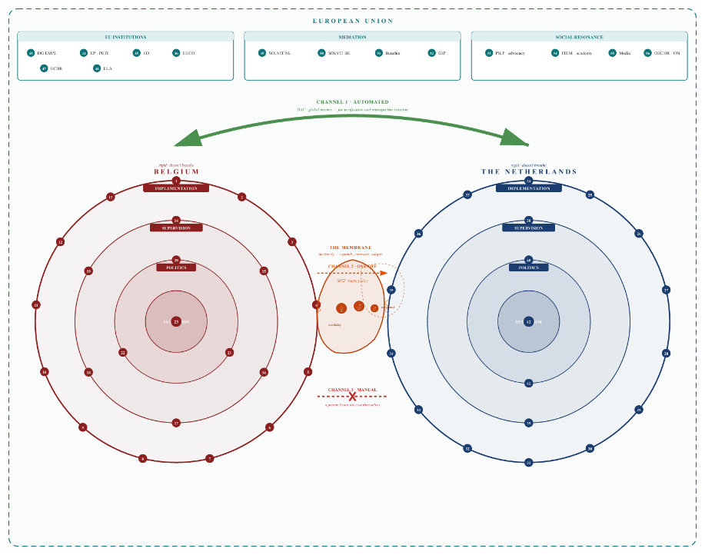
Figure I.1 — The game board. Two rigid worlds (Belgium, the Netherlands), each with four concentric layers (Implementation, Oversight, Politics, Symbolism). All actors are numbered — the legend below this figure gives the name and role for each number. In the centre, the membrane bridges the gap in two positions (extended on weekdays, retracted at weekends). The three channels illustrate the structural tension: thick green (automated), narrow orange (one-off), red dotted (manual).

Part I-B — The key players
For readers unfamiliar with Belgium and the Netherlands: listed below are all the organisations featured on the game board, organised by world and by layer. First, their public or private-law function, then their specific role in this case.
WORLD BELGIUM

Implementation
1 Christian Health Insurance Fund (CM)
Belgium’s largest health insurance fund; a private-law association with a statutory public mandate to administer compulsory sickness and disability insurance and to pay out income replacement benefits.
Role in this case: Primary gatekeeper for sickness benefits, medical expenses and the S072 agreement form. Blocks or delays the processing of claims as soon as the insured person resides in the Netherlands.
2 Vitaz
: A general secondary care hospital in the Waasland region, close to the Dutch-Belgian border.
Role in this case: The first medical point of contact in the case. Provides acute care but does not produce administrative documentation. Clinical data remains locked within its own system.
3 Ghent University Hospital (UZ Gent)
An academic tertiary care hospital specialising in highly specialised and complex diagnostics and treatment.
Role in this case: Academic coordination. It does, however, provide the administrative translation that primary care providers refuse to provide, and publishes via the eHealth network.
4 Ophthalmologists in Sint-Niklaas
: A specialist private ophthalmology practice in Sint-Niklaas.
Role in this case: Carries out invasive treatments but records the forced discontinuation as patient refusal. No link to any eHealth platform.
5 Ter Vierschaar
GP Practice : Primary care GP practice on the Belgian side.
Role in this project: Overall medical coordinator, involved from the outset. Handles the translation into the administrative systems of both countries. Operates via Vitalink and SumEHR.
6 Independent Experts BE
: Self-employed medical experts who assess medical injuries and degrees of disability on commission.
Role in this case: Complete silence. Not a single expert contacted has responded to requests for an independent assessment.
7 Vertico Business Solutions
: a Belgian private-sector employer.
Role in this case: correctly implements the statutory continued payment of wages. Submits employment certificates on time. The friction only begins when the case is handed over to the public authorities.
8 FPS Social Security — DG for People with Disabilities (DG HAN)
The Belgian federal ministry responsible for medically assessing the severity of a disability and issuing official certificates of recognition.
Role in this case: Formally recognises the medical limitations, but makes recognition conditional upon residence within Belgium. It even refuses to grant purely medical recognition for tax purposes if the citizen resides in the Netherlands.
9 FPS Finance
: The Belgian national tax administration.
Role in this case: Automatically exchanges income data with the Netherlands via the EU Green Channel, but decides independently on tax exemptions and requires a certificate from DG HAN, which this body does not provide in this case. It then raises the threshold (9 points) above the level granted by DG HAN (8 points).
10 NEO
The Belgian federal body that regulates unemployment insurance and issues European career certificates (PD U1).
Role in this case: Refuses to integrate foreign employment records into its own system. For teaching careers, it requires a C4 form which does not legally exist under that status.
11 Parentia
: An accredited Belgian paying agency for family allowances and the Flemish Growth Package.
Role in this case: Retrieves income data via the Crossroads Bank (KSZ) and is therefore entirely dependent on the information provided by the health insurance fund (CM). If the CM fails to record sickness status, the social allowance is suspended.
12 Agency for Educational Services (AGODI)
An executive agency of the Flemish Ministry of Education responsible for the payroll administration of teaching staff.
Role in this case: Withholds income tax at source for the mother, but refuses to make retroactive tax adjustments on the basis of a federal disability certificate. Hides behind the school secretariat and the federal tax authorities.
13 General Christian Trade Union (ACV)
Belgium’s largest trade union, which also acts as a paying agency and provider of social assistance.
Role in this case: Fully acknowledges the systemic error but refuses to take legal action against the CM if the patient does not hold a membership number. Solidarity stops at the individual membership threshold.

Supervision
14 NIHDI
The central federal body that administers and funds compulsory health and disability insurance.
Role in this case: Confirms in writing that medical recognition is separate from the right to financial benefits, but refuses to intervene in individual cases to overturn decisions made by the health insurance fund.
15 Health Insurance Funds Supervisory Authority (CDZ)
Federal supervisory authority for health insurance funds.
Role in this case: Declares that it has no jurisdiction over individual cases. Classifies a structural breach of EU law as an individual medical dispute and closes the case.
16 Federal Ombudsman
: Independent complaints handler for the Belgian federal government.
Role in this case: Achieved a procedural breakthrough at DG HAN, but capitulated in the face of the CM’s administrative defence. Closed the case definitively without resolving the underlying impasse.
17 Ghent
Labour Prosecutor’s Office : The specialised public prosecution service attached to the labour courts, with jurisdiction over social security legislation.
Role in this case: Declares that it has no jurisdiction to supervise health insurance funds. Classifies the administrative deadlock as a civil dispute and refers the matter to the Labour Court.
18 UNIA (Interfederal Centre for Equal Opportunities)
An independent body that combats discrimination.
Role in this case: Declares itself to have no jurisdiction because place of residence is not a protected ground under anti-discrimination legislation. Exclusion resulting directly from a law or decree falls outside its remit.
19 Medical
Council: A professional body governed by public law that oversees medical ethics and exercises disciplinary authority.
Role in this case: It handles complaints concerning medical examiners and expert doctors within a closed disciplinary procedure. The patient is not a party to the proceedings, and the mandate is limited to the doctor’s individual conduct.

Politics
20 Chamber of Representatives — Committee on Social Affairs, Employment and Pensions
The standing parliamentary committee responsible for drafting federal social security legislation and scrutinising the relevant ministers.
Role in this matter: Receives a documented report of a system failure, but does not initiate any parliamentary action. No question, no interpellation, no hearing.
21 Chamber of Representatives — Committee on Petitions
The parliamentary committee responsible for dealing with the constitutional right to petition.
Role in this case: Declares the petition admissible and forwards it to the relevant specialist committee and the minister. This concludes the committee’s involvement. A procedural formality without any substantive action.
22 Belgian Political Parties
: The parties that constitute the legislative and executive branches.
Role in this matter: Nine parties were contacted. Five did not respond. The other four referred the matter to their research departments or stated that they were not competent to respond. None of the parties invoked any parliamentary procedure.

Symbolism
23 Royal Palace of Belgium
The King’s Office, which handles petitions from citizens.
Role in this process: Symbolic final stop. Confirms receipt and forwards the petition to the relevant minister — thereby returning the citizen to the operational level. The Palace’s email server is technically inaccessible.
WORLD NETHERLANDS

Implementation
24 CZ (Centrale Zorgverzekeraar)
A major Dutch health insurer that provides compulsory basic cover and administers the treaty policy on the Dutch side.
Role in this case: Reimburses medical bills, but refuses to cover patient transport on the basis of a perimetry requirement which is not routinely measured in Belgium. Fails to register the treaty policy in the RIV register.
25 ZorgSaam
: Regional healthcare provider in Zeeuws-Vlaanderen.
Role in this case: Provides complex wound care at home for several months and documents 126 clinical entries. This report is not automatically visible to the UWV, CZ or the Belgian social security authorities. External Belgian documents are passively archived under a multimedia tab.
26 CAK (Central Administration Office)
An independent administrative body that manages the national insurance register (RIV) and implements the provisions of the agreement.
Role in this case: Refuses to register the treaty policy on procedural grounds: the system only recognises the ‘standard’ cross-border worker (working in the Netherlands, living abroad), not the reverse situation (living in the Netherlands, working in Belgium). The computer does not recognise this field.
27 Dutch Healthcare Institute (ZIN) — an independent administrative
body under the Ministry of Health, Welfare and Sport.
Role in this matter: Manages and supervises the RIV register at system level, but refuses to grant access to individual personal data. Refers enquiries back to CZ and the CAK.
28 Pallion GP Practice
: Primary care GP practice in Hulst.
Role in this case: Refuses to register the patient for information purposes. Dutch law prohibits dual registration across borders. The patient does not have a local GP in his country of residence who is familiar with his Belgian medical records.
29 Independent Experts NL
Public and private medical examiners and medical assessors.
Role in this case: The GGD refuses to deal with private individuals. GPs refuse to see non-patients. Commercial agencies charge exorbitant fees for a remote medical examination. The system requires a Dutch initial medical assessment but does not provide an accessible way of obtaining one.
30 Employee Insurance Agency (UWV)
An independent administrative body that administers employee insurance schemes (WIA, WW, Sickness Benefits Act) and carries out socio-medical assessments.
Role in this case: Does not apply the Vester judgement. Uses an incorrect reference date (11 May instead of 11 April 2025) and refuses to assess the substance of the medical situation. Issues a flawed PD U1 form in which 21 years of Belgian employment history are omitted.
31 Social Insurance Bank (SVB) with the Office for Belgian Affairs (BBZ)
The administrator of the Dutch statutory social insurance schemes, with a specialised helpdesk for cross-border workers.
Role in this case: Awards child benefit to the father because the mother works in Belgium, thereby activating the child-related budget. The BBZ mediates between NIHDI and UWV, but cannot enforce any decisions. The mediation process is terminated without result.
32 Tax and Customs Administration (including the Benefits Service)
The Dutch national tax authority responsible for levying income tax and social security contributions, and for paying out income-related benefits.
Role in this case: The online tax return portal has been designed for households with Dutch taxable income. A cross-border worker’s household with foreign income results in a zero balance. The healthcare allowance remains at zero due to the RIV block; housing benefit and the child-related budget are granted in part.
33 ING Netherlands
: Main commercial bank.
Role in this case: Offers a repayment plan for the accumulated overdraft and credit card debt (approx. €6,709 in total), subject to strict banking restrictions. The bank effectively becomes a creditor of the failing welfare state.
34 Vattenfall
Commercial energy supplier.
Role in this case: Requires a medical certificate from an independent Dutch doctor to confirm ‘medically vulnerable consumer’ status. This requirement is impracticable for a cross-border worker. After several months, the supplier admits that the requirement was unjustified and refers the matter to the network operator.
35 Stedin
: Regional network operator for gas and electricity in Zeeland.
Role in this case: Responsible for the physical supply and disconnection guarantee. There is no automatic data transfer between Vattenfall and Stedin: the patient must rebuild the entire medical case file from scratch with this new private provider.
36 Municipality of Hulst (including the Hulst voor Elkaar Foundation)
– a Dutch border municipality and its implementing body for the social sector (Social Support Act, Youth Act, Participation Act).
Role in this case: Emails and GDPR access requests are systematically met with DNS errors. Requests for assistance are deleted unread after months. The municipality refuses to recognise the European disabled parking card and demands a new local assessment.
37 Travelling through Zeeland
Regional transport centre for Wmo transport.
Role in this case: Refuses journeys to Belgian government agencies (e.g. FPS medical examinations), but accepts journeys to academic hospitals across the border. The system distinguishes based on destination, not distance. The direct debit schedule does not take into account the pay cycle of cross-border workers.

Supervision
38 The National Ombudsman (NL)
An independent high-level state body that scrutinises the actions of Dutch public authorities.
Role in this case: Registers the complaint, reports capacity issues and refuses to intervene actively whilst objection or appeal proceedings are ongoing. Closes the case definitively and registers it as a passive signal.
39 Dutch Healthcare Institute (ZIN) — supervision
Carries out systemic supervision of the lawful implementation of the Health Insurance Act.
Role in this case: The body that manages the RIV register states that it has no access to individual personal data and refuses to inspect the register. The tripartite dialogue between CZ, CAK and ZIN remains at a standstill.

Politics
40 House of Representatives — Standing Committee on Social
Affairs and Employment The parliamentary committee responsible for overseeing the Dutch social security system.
Role in this matter: Formally records the urgent letter and sets the matter aside pending a committee debate. Explicitly rules out individual consideration.
41 Dutch Political Parties
The parties representing the people in the Dutch parliament.
Role in this case: Governing parties refer the matter to the National Ombudsman. Opposition parties forward the case to policy advisers. None of the parties invokes a parliamentary procedure.

Symbolism
42 The Royal House
The constitutional office of the Dutch Head of State.
Role in this case: The Cabinet confirms that it is unable to intervene and offers to forward the petition to the relevant minister. The national escalation procedure has been exhausted without a substantive solution being found.
EU OUTER LAYER

Settings
43 European Commission — DG EMPL
The EU’s executive body responsible for ensuring the application of EU law.
Role in this case: Registers the complaint, consolidates multiple complaints, but has no enforcement powers in individual cases. Can only initiate infringement proceedings — a process that can take years.
44 European Parliament — Committee on Petitions (PETI)
The committee responsible for dealing with petitions from EU citizens.
Role in this case: Declares a petition admissible, publishes a summary, and opens the petition for co-signatories. However, it cannot overturn national implementing decisions.
45 European Ombudsman
: Independent ombudsman for EU institutions.
Role in this case: Declares a complaint about SOLVIT inadmissible: SOLVIT is a national service, not an EU institution. SOLVIT’s failure falls into a jurisdictional vacuum.
46 European Council (EUCO)
The EU’s highest political body, comprising the Heads of State or Government.
Role in this matter: Sets the long-term strategic direction, but has no mechanism for engaging with individual citizens. It is too removed from day-to-day implementation to play a role.
47 European Court of Human Rights (ECHR)
– the Council of Europe’s international court of justice.
Role in this case: Declared the application inadmissible on the grounds that domestic remedies had not been fully exhausted. Reduces the transnational issue to a dispute against the Belgian State alone.
48 European Labour Authority (ELA)
Specialised EU agency for fair labour mobility and the coordination of social security.
Role in this matter: Acts as a mediator solely at the request of national governments themselves, not at the request of individual citizens. The specialised emergency exit remains closed to those who need it most.

Mediation
49 SOLVIT Netherlands
The Dutch national centre of the European informal problem-solving network.
Role in this case: Closes both cases, concluding that the national reference periods have been applied correctly. Refuses to review the Vester judgement. Refuses to refer the matter to the ELA.
50 SOLVIT Belgium
The Belgian national SOLVIT centre.
Role in this case: Declares that it lacks the authority to carry out a substantive analysis and refers the matter back to SOLVIT Netherlands. Also refuses to refer the matter to the ELA. Circular referral between two national SOLVIT centres.
51 Benelux Union
: An intergovernmental cooperation body comprising Belgium, the Netherlands and Luxembourg.
Role in this matter: Acknowledges the issue following a careful review, but does not deal with individual cases and has no authority to amend EU legislation.
52 GrensInfoPunt (GIP)
– Euregional information service for cross-border workers.
Role in this case: Provides accurate theoretical information, but has no executive powers. Refuses to report a documented system error as a barrier to cross-border movement, citing neutrality.

Social impact
53 Strategic Advocacy (PILP et al.)
Human rights organisations and legal aid initiatives.
Role in this case: Receive the case, recognise its value, and use it to fuel future proceedings. Do not offer an immediate remedy for the individual case.
54 Academic Observation Layer (ITEM et al.)
Scientific knowledge institutes for cross-border cooperation.
Role in this dossier: Publishing on an ongoing basis about cross-border failures, but failing to respond to an active case for months on end. When the dossier crosses the academic threshold in the autumn of 2026, the institute will commence a substantive review.
55 Media and Public Intellectuals
Investigative journalism and public opinion-makers.
Role in this issue: The issue is brought to their attention. The impact is fleeting: an article generates short-lived pressure but does not change the underlying structure. Algorithms do not read newspapers.
56 OHCHR / United Nations
The UN’s human rights body, including the CRPD Committee.
Role in this matter: Sets out the international human rights standards to which Belgium and the Netherlands have committed themselves. Has no supervisory powers to correct a failing national implementing body.

Part I-C — The relationships
The actors on the game board are not isolated units. They are bound by fixed relationships of authority and data that define the space within which the family must operate. The crux of the power vacuum is that these relationships are structured in such a way that no single actor bears ultimate responsibility for the whole.
Ratio | Formal authority | Actual practice | Impact on the family
Regulatory body ↔ implementing  body BE NIHDI, CDZ → CM  NL ZIN → CZ | Regulatory authorities oversee the operators and may issue guidelines. | No mandatory mandate to intervene in individual cases. The case worker decides independently at the counter. | Complaints to the regulator do not resolve a specific obstacle.
Federal ministries ↔ federal ministries  BE FPS SZ → FPS Finance  NL SVB → Benefits | Ancillary services with their own statutory mandates. | Each department makes its own decisions within its own legal framework. Certificates issued by one department are not binding on another. | Medical recognition does not automatically lead to tax protection.
Data  flow: CM → KSZ → Parentia / SVB | Statutory data exchange via the Cross-Sectoral Data Bank and the European EESSI network. | Parentia and the SVB are entirely dependent on the source code provided by CM. If CM fails to deliver, the entire chain comes to a standstill. | Family allowances and social benefits are being frozen without the recipient being able to do anything about it.
EU infrastructure  Channel 1 FPS Finance ↔ Tax and Customs Administration NL | Linked via EU directives (DAC) and the bilateral tax treaty. | Fully automated exchange of information on worldwide income. Maximum transparency for tax collection and recovery. | The EU knows all about income, but offers no safety net should it be lost.
Verdrag  Canal Canal 2 CM ↔ CZ / CAK | Linked via form S072 (Regulation 883/2004). | A narrow, one-off channel. It becomes problematic as soon as the care or status falls outside the standard form. | Ongoing friction over authorisations, parcel limits and personal contributions.
Medical sector  Channel 3 Vitaz · UZ Gent ↔ ZorgSaam · Pallion | No cross-border connection. | National EHR systems are hermetically sealed at the national border. | The family carries the files themselves. The patient becomes the sole link between two systems.
Politics ↔ implementation  : Belgian Chamber of Representatives & Dutch House of Representatives | Parliaments are the highest legislative bodies and exercise oversight over the government. | Politicians do not intervene in individual implementation cases. | Structural flaws in the law persist in its implementation.
EU ↔ Member States  EU outer layer | EU law takes precedence over national law (Regulation 883/2004). | The EU lacks its own enforcement body. SOLVIT is non-binding. ELA refuses to assist citizens. | A circular reference between Brussels and the national capitals.
Symbolism  of the Royal Palace of Belgium and the Dutch Royal Family | Constitutional head of state, with no executive powers. | Ceremonial postbox. Petitions are forwarded to the minister. | The end stop returns letters to their starting position in Layer 1.
All organisations mentioned in this chapter are legal entities; their names are public and are listed in Document B. Natural persons are referred to solely by their role or by a symbol (♂, ♀, small ♂). This is both a methodological choice and a requirement under the General Data Protection Regulation. The author of this report is the patient in question; he is permitted to publish his own medical and administrative data.

The cascade
Block II will shortly show the pots, the mechanism and the decision. This chapter shows what happens when the mechanism and the decision converge on a single family, in a single timeline, with one visible consequence: an empty bank account.

Frame 1 — The trigger
11 April 2025 · Week 1
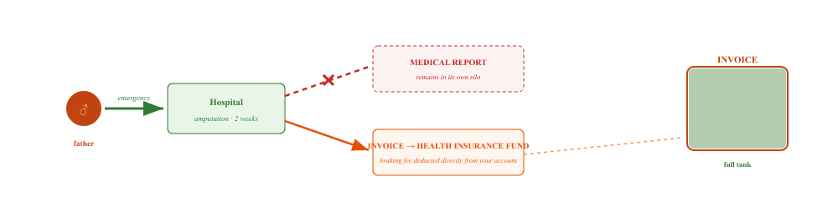
The body is admitted. The medical report and the invoice are separated: the report remains at the hospital, whilst the invoice is sent to the health insurance fund. The patient’s contribution is deducted directly from their bank account.

Frame 2 — What keeps flowing
ongoing · from day 1
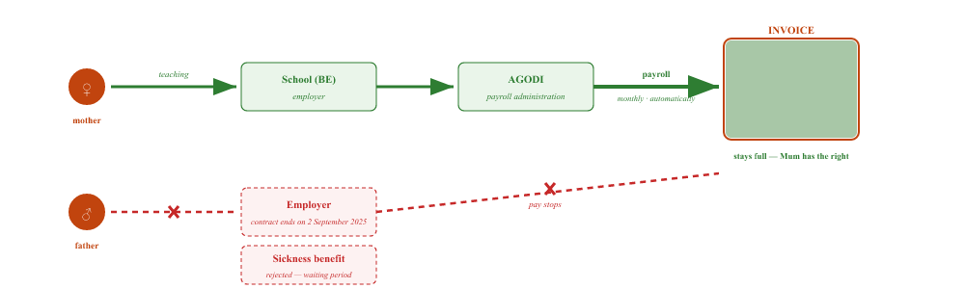
One line continues to flow uninterrupted: the mother. Everything the father contributes comes to a halt.

Frame 3 — What’s leaking out
April 2025 · ongoing
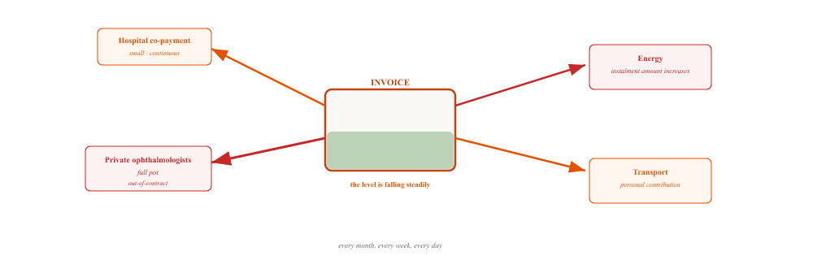
Whilst the mother’s wages come in, they leak out at the other end. Small and predictable, or large and sudden. The reserve is running dry.

Frame 4 — What doesn’t get in
May 2025 — September 2026 · blocked
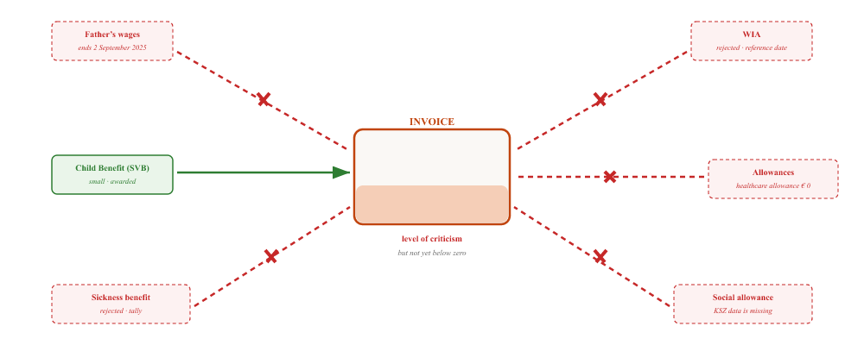
Five channels would need to be in place to offset the loss of income. Four are blocked. One small channel — child benefit — keeps the family just above the poverty line.

Frame 5 — The result
autumn 2026 · eighteen months later
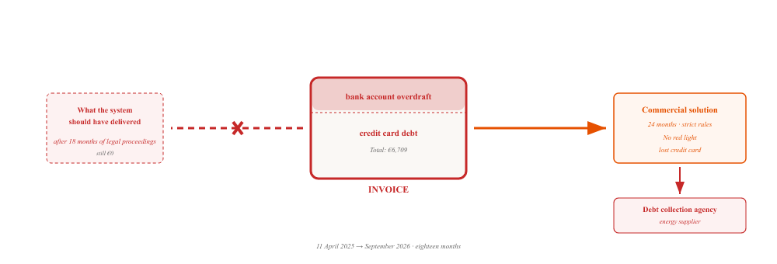
Eighteen months later, the account is in the red. The commercial bank has offered a solution involving penalties. The debt collection agency has been called in. And the system that was supposed to have dealt with this is still not delivering any results.

The cascade is not a chain of errors. It is a single mechanism that responds in five different ways to a single event. Each link has its own rule, its own point of contact, its own logic. No link can see the next one. And the bank account is the only place where all the links converge — as a result, not as a cause.
The facts are based on Document B. Amounts can be found in the relevant entries for each organisation. Natural persons are identified by symbols (♂, ♀); organisations by their public name.

II. Belgium

The pots and the tie-in sales
A family that loses its income due to illness can apply for a range of benefits in Belgium and the Netherlands. These are spread across two countries, two tax systems, two social security systems and two benefit schemes. This chapter first sets out what funds are available. It then explains why most of these funds remain untapped — not due to a single cause, but because of a mechanism that is common to both countries.

Part II-A — The jars
In theory, the family is entitled to, or may claim, the following benefits. The status for each fund is based on Document B.

Belgian jars
Pot | Administrator | Condition | Status
Sickness benefit (incapacity for work, first year) | CM | Declared unfit for work + waiting period completed | Blocked — 180-day waiting period not applied under the European aggregation rule
Disability benefit (after 1 year of incapacity for work) | CM | Automatic transition after 365 days of incapacity for work | Blocked — fictitious end date prevents transfer
IVT (income replacement allowance) | FPS Social Security / DG HAN | Recognised disability + reduced earning capacity + residence in Belgium | Blocked — residence requirement, no Belgian domicile
Increased tax-free allowance | FPS Finance | Recognition of a severe disability (9 points) | Blocked via DG HAN, activated via a tax bypass (see Chapter II — The Belgian tax route)
Child Benefit / Growth Package | Parentia | Dependent child + country-of-employment principle (mother works in Belgium) | In work — main payer registered in the mother’s name, supplemented by the SVB
Social allowance (as part of the Groeipakket) | Parentia | Household income below the threshold + 6 consecutive months | Blocked — Parentia assesses on the basis of theoretical earning capacity, not actual income
MAF (maximum invoice amount) | CM | Co-payment above the ceiling — increased ceiling upon recognition of a disability | Partially — standard MAF active, enhanced MAF blocked due to disability refusal
Tax relief on medical expenses | FPS Finance | Proof of medical expenses via the annual tax return | Partially — tax-deductible, but with limited impact as long as other income remains low
Assistance with medical aids | CM (under the NIHDI agreement) | Medical requirements and approval by the consulting doctor | Works — orthopaedic shoes approved, diabetes convention in progress
Diabetic Foot Clinic, UZ Gent | CM (convention) | Agreement with a teaching hospital | Valid — approved from 19 June 2026 to 27 May 2027
European parking permit | FPS Social Security | Recognition of disability | Granted — 3 August 2026, indefinite duration
Public transport discount card | FPS Social Security | Recognition of a disability + specific mobility barrier | Rejected — 21 August 2026, medical criteria not met
Certificate of Fitness to Drive | FPS Mobility / ophthalmologist | Visual acuity above the statutory threshold | Rejected — visual acuity below the threshold, permanent

Dutch jars
Jar | Administrator | Condition | Status
WIA benefit (incapacity for work) | UWV | 104-week qualifying period + insurance cover on the reference date | Blocked — incorrect reference date, Vester judgement not applied
Social assistance benefit (Participation Act) | Municipality of Hulst | Insufficient income + assets below the threshold | Blocked — request for help deleted after 73 days without being read
Special assistance | Municipality of Hulst | Special expenses + income below the threshold | Blocked — no substantive assessment
Healthcare allowance | Benefits Department | Insured in the Netherlands + income below the threshold | Blocked — The RIV register does not contain any treaty policies
Housing benefit | Benefits Department | Rent above the threshold + income below the threshold | Partially — granted, amount revised on the basis of incomplete income details
Child-based budget | Benefits Department | Child + income below the threshold | Partially — granted following SVB linkage
Child benefit | SVB | Dependent child + country of residence principle | Granted — small amount, active since 20 April 2026

Cross-border claims
Claim | Basis | Condition | Status
Aggregation of insurance periods | Regulation 883/2004, Article 6 | Periods of insurance in several EU Member States | Not applied — CM and UWV apply national reference periods
Pro-rata calculation | Regulation 883/2004, Article 52 | Entitlement to benefits under the aggregation rule | Not applied — condition: recognition of entitlement to benefits
Application of the Vester judgement | ECJ C-134/18 | Income gap arising from successive insurance policies in two Member States | Not applied — UWV refuses, CM refuses

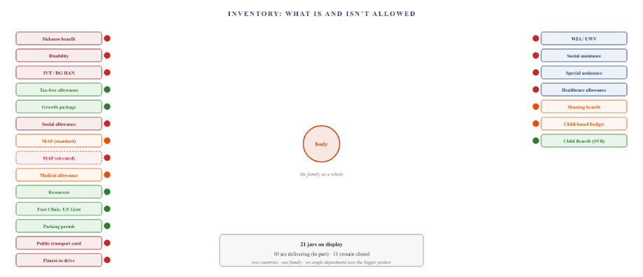
Figure II.1 — The inventory. Surrounding the family are the benefits to which they are entitled or might be entitled. Green = active. Orange = partially active or via a roundabout route. Red = blocked or not claimed. On the left are the Belgian funds, on the right the Dutch ones. The green funds are small or indirect. The large income funds are all red.

Part II-B — Tying
The schemes are not independent of one another. In both countries, there is a link between them: a medical assessment leads to two possible outcomes — a benefit payment and a tax relief — but the tax relief is only granted once the entitlement to the benefit has been recognised. Legally, they are two separate processes. Administratively, they are linked.

How tie-in sales work
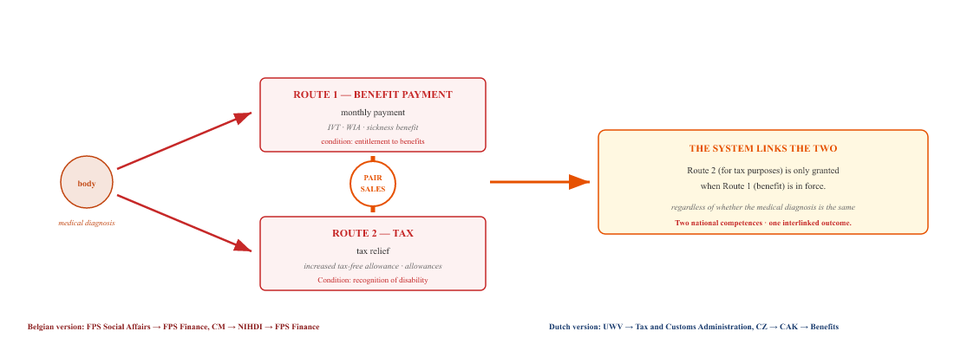
Figure II.2 — Tied sales. One medical assessment, two routes. The tax route is not assessed independently, but is linked to the benefit route. Applied in both countries, with their own administrative variations.

Why this is fatal for a cross-border worker
A national citizen has a single system. If they encounter problems with tied sales, they can take legal action through a single point of contact. A cross-border worker has two national systems which do not recognise them as a single person.
In your country of residence (the Netherlands): you live here, so we are not authorised to pay the benefit, as you were working in Belgium. In your country of employment (Belgium): you work here, but you live in the Netherlands, so we do not have to grant the tax benefits. Each system applies its own tie-in, and no system resolves this by decoupling it from the medical assessment.
The EESSI network and Regulation 883/2004 provide for the aggregation of periods (Article 6) and pro rata calculation (Article 52). However, they do not provide for the decoupling of the medical assessment from the conditions for entitlement to benefits. Such decoupling falls within national competence, and neither state applies it to cross-border workers.

Part II-C — The four catch-22s
In practice, tying leads to a series of circular arguments. Below are the four most common ones.

Catch-22 No. 1 — The waiting time that doesn’t count
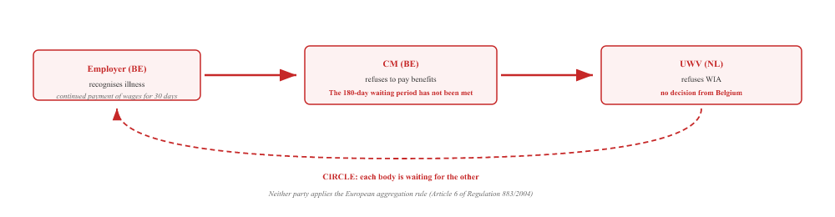
CM has refused because the national waiting period has not been met. The UWV is awaiting a decision from the Belgian authorities before applying the Vester judgement. The citizen is caught between two authorities, each of which imposes its own condition that the other authority has made impossible to fulfil.

Catch-22 No. 2 — The 8 versus 9 points
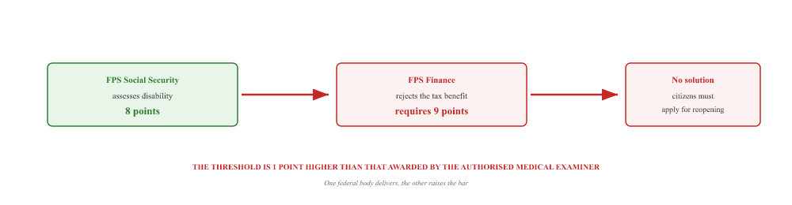
One federal body grants formal recognition of a disability. Another federal body imposes a stricter threshold for tax purposes. The citizen must reopen the case with the first body in order to score one more point — for a physical condition that has already been established by five independent healthcare professionals.

Catch-22 No. 3 — Data that doesn’t flow
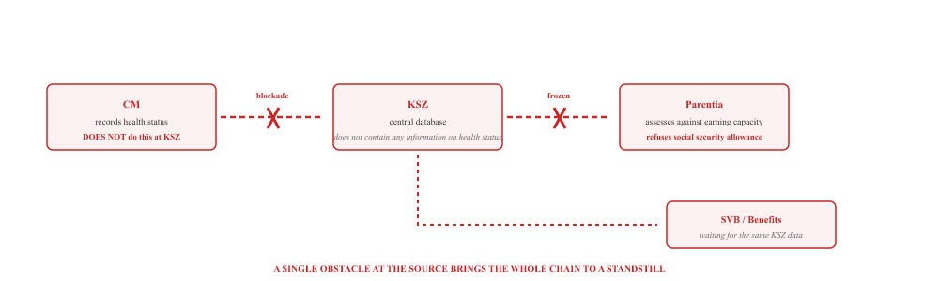
The CM does not record sickness status in the Cross-Sectoral Social Security Database. Parentia, the SVB and the Dutch Benefits Agency all access data via this same database or a derivative thereof. A single block on data from one agency halts six other benefit payments.

Catch-22 No. 4 — The MAF that neither rises nor falls
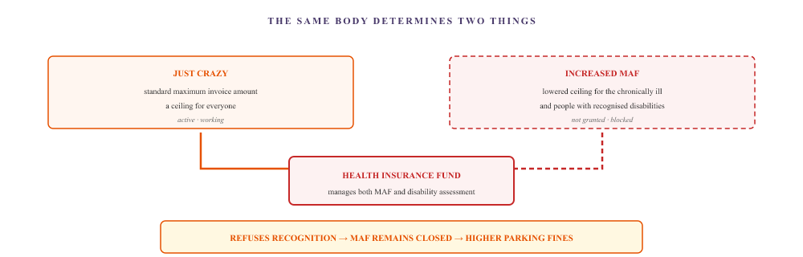
The health insurance fund administers both the maximum invoice (MAF) and the recognition of disability. Anyone recognised as disabled is subject to a lower excess threshold — lower co-payments, higher reimbursements. Because the same health insurance fund refuses to grant this recognition, the family remains subject to the standard threshold. The patient therefore pays more co-payments than a person with a disability in the same physical condition. The same body has established the medical reality through the approval of medical aids, but refuses to use that reality to increase the financial safety net.

What this chapter sets out
The family is entitled to a wide range of benefits. In theory, the combined network of the two welfare states covers almost every aspect of their medical and financial situation. In practice, however, more than half of the funds remain inaccessible. Not because the eligibility criteria are impossible to meet, but because the pathways to accessing them are structured in such a way that they block one another.
The linking of the benefits route and the tax route is the most common mechanism. The catch-22s are the result of this: circular arguments between two national systems that do not communicate with one another, and between federal authorities within the same system that do not recognise each other’s thresholds.
The following chapter focuses on the actors that perpetuate these catch-22s — not as individuals, but as roles within a system.
All organisations in this chapter are legal entities. Natural persons are referred to solely by their role or by a symbol (♂, ♀). This is both a methodological choice and a requirement under the General Data Protection Regulation. The ‘pots’ inventory is based on Document B, which records the actual applications, statuses and refusals for each organisation.

Determination and decision
Five healthcare professionals examined the body. Two medical officers made the decision. This chapter shows that both bodies — the Belgian health insurance fund and the Belgian Federal Public Service — apply the same mechanism, each with its own variation.

The five votes
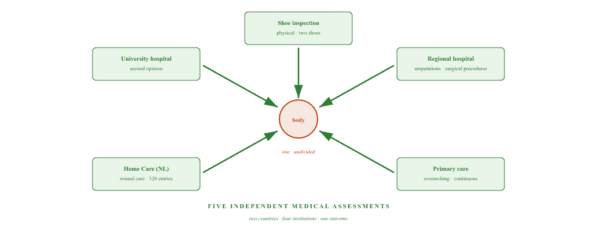
Five healthcare professionals, working in two countries, examined the body. All five identified the same permanent disability.

Two decision-makers, one mechanism
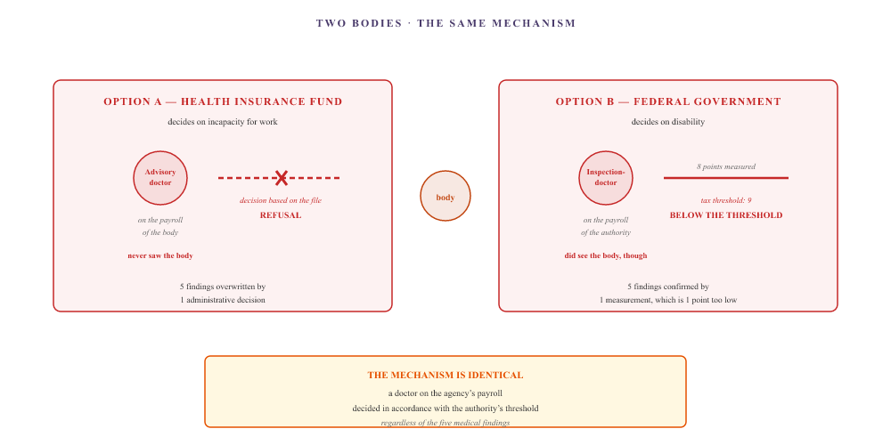
Figure III.1 — Two variants, one mechanism. The health insurance fund (variant A) allows its own doctor to make the decision without examining the patient. The federal public service (variant B) allows its own doctor to make the decision on the basis of a measurement that falls one point below the tax threshold. In both cases, the administrative threshold takes precedence over the medical assessment.

The common pattern
In both cases, the doctor making the decision is on the agency’s payroll. In both cases, an administrative threshold is applied which does not exist in clinical practice. In both cases, five independent medical assessments carry less weight than a single administrative decision.
That is not the personal fault of any individual doctor. It is the system: the doctor carrying out the assessment is not a better doctor, has not undergone more training, nor does he possess deeper knowledge. He is the gatekeeper of an administrative hurdle. The gate is closed, not because the body isn’t unwell — that has been proven five times over — but because the algorithm behind the gate says: the benefit isn’t being paid, so the recognition isn’t granted, so the tax route isn’t available.
All organisations mentioned in this chapter are legal entities. Natural persons are referred to solely by their position. The facts are based on Document B.

The Parentia Staircase
An organisation that accepts the medical reality, but then stumbles over its own revenue model. Three levels, one outcome. And the pattern repeats itself at another organisation.

Level 1 — The KSZ blockade
September 2025 — April 2026
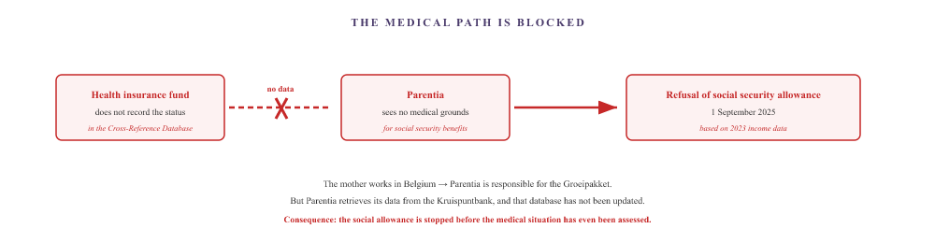

Level 2 — The bypass is accepted
April — September 2026
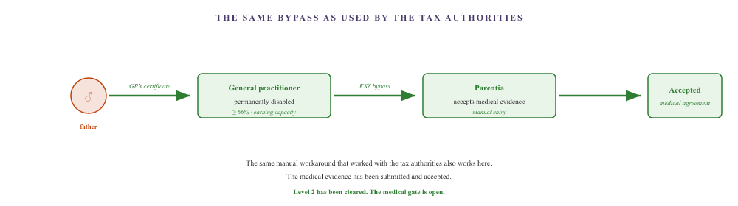

Level 3 — Refusal on income grounds
September 2026
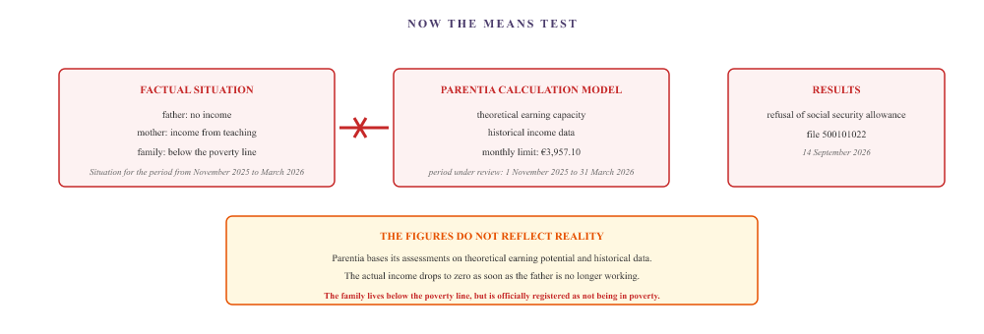
The medical route has been cleared. The evidence has been accepted. It then transpires that the income model does not reflect the actual situation. The figures add up, but the family falls outside the criteria.

The pattern is repeating itself
Municipality of Hulst · 2026
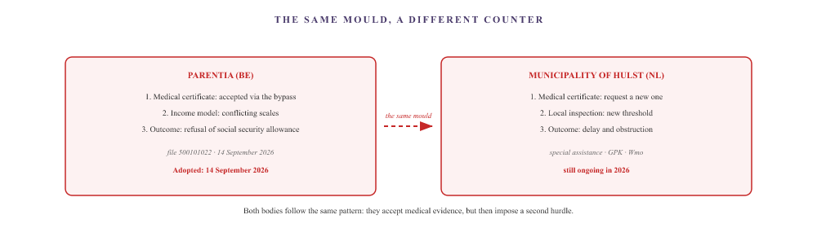
What happened at Parentia is happening again at the local authority. Each organisation has its own medical portal and its own second hurdle. Citizens have to go through the same process all over again.

The Parentia process consists of three stages. First, the medical route is blocked by a data issue at another agency. The citizen is then forced to use a workaround — the same manual evidence that also worked with the tax authorities. Once the medical evidence has been accepted, it turns out that the income model fails to reflect the actual situation. And when the citizen approaches the next agency, the cycle starts all over again.
Facts based on Document B. Natural persons are identified by symbols; organisations by their public names.

The Belgian tax route
So far, this case study has mainly highlighted what goes wrong. This chapter shows the opposite: the Belgian tax route works, and provides the family with a substantial annual benefit. Four tax deductions and allowances, one of which was achieved via a workaround. This workaround has now been confirmed twice — once by the submission of the tax return itself, and once by an independent written confirmation from the tax authorities that the chosen approach is legally sound.

Part A — What works
Tax benefit | Basis | Status in this case
Increased tax-free allowance (disability code) | Sections 131 and 135 of the WIB 92 · permanent disability of ≥66% · earning capacity less than one-third | Activated via a bypass, confirmed twice. Benefit: €2,669.97 on the joint tax return for 2026.
Marriage ratio | Section 87 of the WIB 92 · allocation of part of the earned income to the partner with the lower income | Applied automatically when filing a joint tax return. Reduces the tax burden on family income.
Childcare tax relief | Art. 14535 WIB 92 · costs for the care of children under the age of 14 | The holiday childcare certificate has been added manually to the 2026 tax return.
Tax relief on medical expenses | Sections 140–145 of the WIB 92 · medical expenses exceeding a certain percentage of income | Partially tax-deductible. Limited impact as long as income remains low.

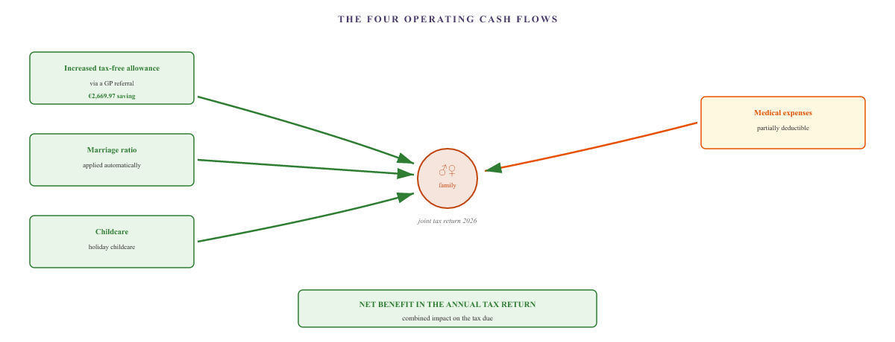
Figure VI.1 — The four tax relief streams. Three green streams: increased tax-free allowance, marriage allowance and childcare allowance. One orange stream: medical expenses (threshold). Together, they determine the tax relief shown on the annual Belgian tax return.

Part B — The bypass for the increased tax-free allowance

The problem
Three roadblocks on the main road:
- The sickness benefit has been refused, so incapacity for work has not been recognised.
- The Cross-Reference Database is not being updated, so other organisations cannot see the sickness status.
- The Federal Disability Service awards 8 points. The tax threshold is 9.

The solution
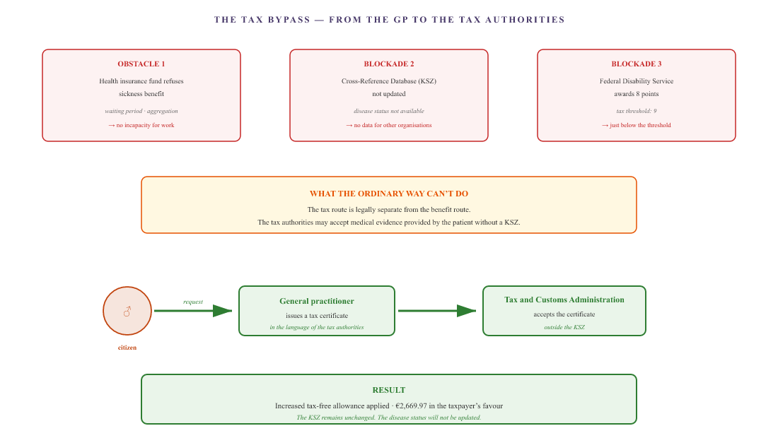
Figure VI.2 — The tax bypass. Three obstacles on the standard route. The tax authorities are legally separate from the benefits system and are permitted to accept their own medical evidence. A single document from the GP, drawn up in the language of the tax authorities, triggers the increased tax-free allowance without the need to amend the central database.

Part C — The double confirmation
The bypass is based on a single assumption: that the tax authorities will accept a medical certificate from the GP without the involvement of the FPS Social Security. This assumption has been confirmed in this case in two independent ways.

Initial confirmation — the submission itself
On 25 September 2026, the final Non-Resident Tax Return (tax year 2026, income year 2025) was submitted by the ACV’s tax department. The return includes:
- The disability code for the dependent partner, based on the medical certificate provided by the GP.
- 1 dependent child.
- 2 receipts for childcare costs, added manually.
- Confirmation of €0.00 in Dutch income or benefits.
The result: €2,669.97 in the family’s favour. The tax return was submitted on 25 September 2026 with a calculated balance; we are awaiting final processing and the tax assessment notice from the FPS Finance.

Second confirmation — the independent assessment
In parallel with the submission, an independent researcher specialising in cross-border employment — employed at an academic institution and not involved in the case — made an anonymous enquiry to the FPS Finance. The question was whether the voluntary inclusion of medical certificates with the tax return is a valid means of demonstrating tax disability status under Belgian law.
The FPS Finance, Non-Resident Tax Management and Services Team (PG15 Ledeberg), has confirmed this in writing. In two successive replies, the tax authorities state that:
- If there is no replacement income in excess of €13,460, a tax discrepancy arises.
- It is advisable to include the medical certificates with the tax return of your own accord.
- The tax authorities may conclude from this that, under Belgian law, the person concerned must be regarded as disabled for tax purposes.
The result is that not only does the bypass work in practice, but the tax authorities themselves confirm that the chosen approach is legally sound. It is no longer a matter of guesswork or favour. It is formal confirmation that the approach the family has found is the right one.
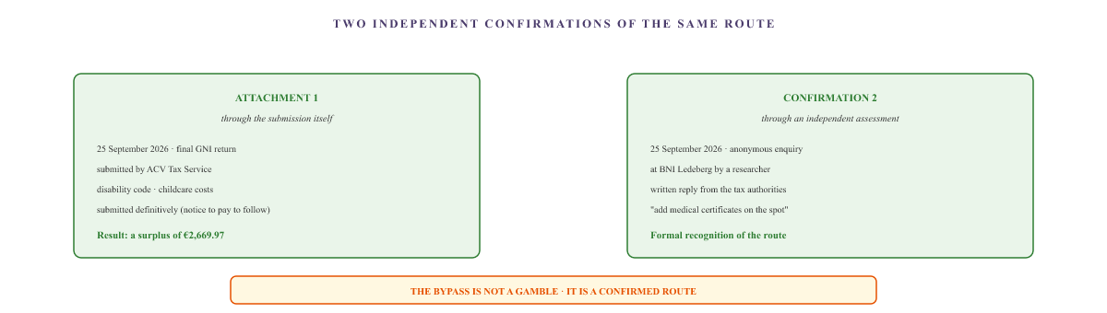
Figure VI.3 — The double confirmation. The same bypass route has been confirmed twice: once in practice (the final tax return submitted, showing the calculated benefit), and once in theory (the tax authorities’ written confirmation to an independent investigator).

Part D — AGODI: the moving target and the final conclusion
The Agency for Educational Services (AGODI) is the Flemish agency responsible for the payroll administration of teaching staff. In this case, AGODI acts as the mother’s employer. When the federal tax benefits are activated, AGODI must reflect them in the payroll records. And that is where things initially go wrong.

The first refusal — 25 March 2026
AGODI rejects the retroactive amendment to the payroll tax regarding the teachers’ exemption under the double taxation agreement. The reason: the tax statements for previous years have already been issued.

The Medical Interpretation — 24 August 2026
AGODI refuses to make the adjustment on the basis of the federal certificate awarding 8 points. The payroll department has taken it upon itself to carry out a medical and tax assessment: the certificate is said to be valid only for a parking permit, and 9 points are normally required for a reduction in payroll tax.

The Full Turn — 8 September 2026
Once the conclusive medical certificate (permanent disability ≥66 per cent, earning capacity reduced to one third) has been submitted, AGODI takes over completely. The authority suddenly states that it does not need to receive any supporting documents, that the school must send only an electronic adjustment, and that the tax authorities will ultimately settle the account.

Final completion — 25 September 2026
On 23 September 2026, the school secretariat recorded the official notification ‘change in tax status of disabled partner’ in the Informat staff system (notification number 4, [partner’s registration number]). This electronic notification records, with retroactive effect from 1 January 2026, that the dependent partner has no earned income and is formally registered as disabled. The administrative process has thus been fully completed.
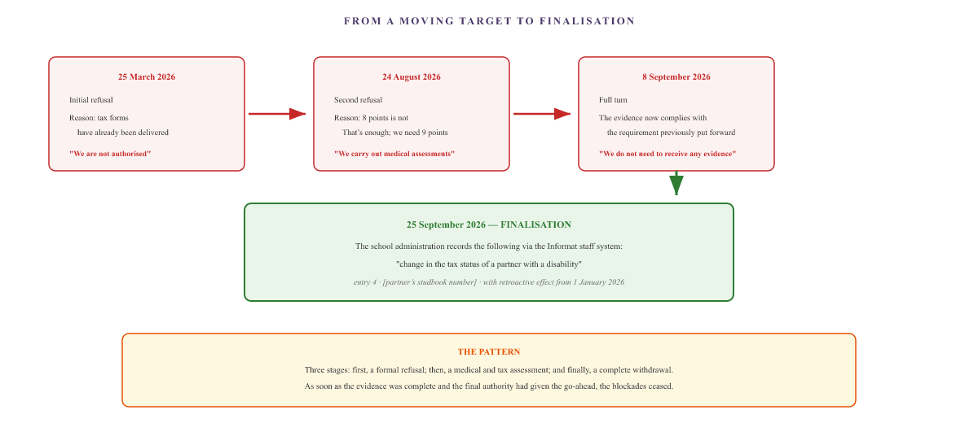
Figure VI.4 — From a moving target to final completion. Three rounds of rejection, followed by the final registration of the electronic signal. What initially seemed impossible has now been administratively finalised.

Part E — What this chapter sets out
The Belgian tax route works — perfectly. Four tax deductions, one bypass, a joint tax return offering a substantial benefit. The workaround has been confirmed twice: once in practice, and once by the tax authorities themselves. And the final authority in the chain (AGODI) ultimately issued the electronic signal that registered the tax status with retroactive effect.
What this chapter shows is that, within the very same system that structurally excludes cross-border workers in other areas, there are indeed avenues that do work. The tax route is one such example. It does not depend on health insurance registration, nor on the disability services, nor on European coordination. It runs directly from the GP to the tax authorities.
And just as importantly: the route has been confirmed by the tax authorities themselves and verified by an independent investigator. The outcome is not the result of any favour. It is the result of the correct application of the law by a member of the public who has found a way to circumvent the blocked channels.
For anyone in the same situation: ask your GP to issue a certificate that meets the tax authorities’ requirements (Articles 131 and 135 of the Income Tax Code). The Federal Disability Service is not required for the tax route. Registration with a health insurance fund is not required. The certificate is submitted directly with the tax return.
A tax adviser (in Belgium, via a trade union or an accountant) can attach this certificate to the tax return. The disability code is entered on the tax return and the increased tax-free allowance is applied automatically.
Don’t forget to check the other deductions as well: the marriage allowance and childcare allowance. These are not always applied automatically.
The amounts are based on the 2026 tax return and may vary from case to case. The relevant statutory provisions are Articles 87, 131, 135, 140–145 and 14535 of the Income Tax Code 1992. All organisations mentioned in this chapter are legal entities. Natural persons are referred to by their position or their symbol. This chapter does not constitute tax advice.

The reopening
Anyone who receives a decision from the Federal Disability Service and disagrees with it will find in the letter that they can take the matter to the employment tribunal. What the letter does not mention is that there are four other options – cheaper and quicker – which the individual can pursue themselves.

What the letter says
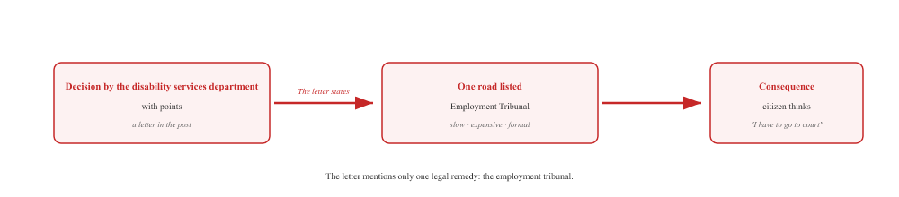

What the website says
The Federal Disability Service’s website lists four options that members of the public can pursue themselves — without a solicitor and without going to court. These are known as ‘re-examinations’. Applications can be made in writing via the contact form or by post.
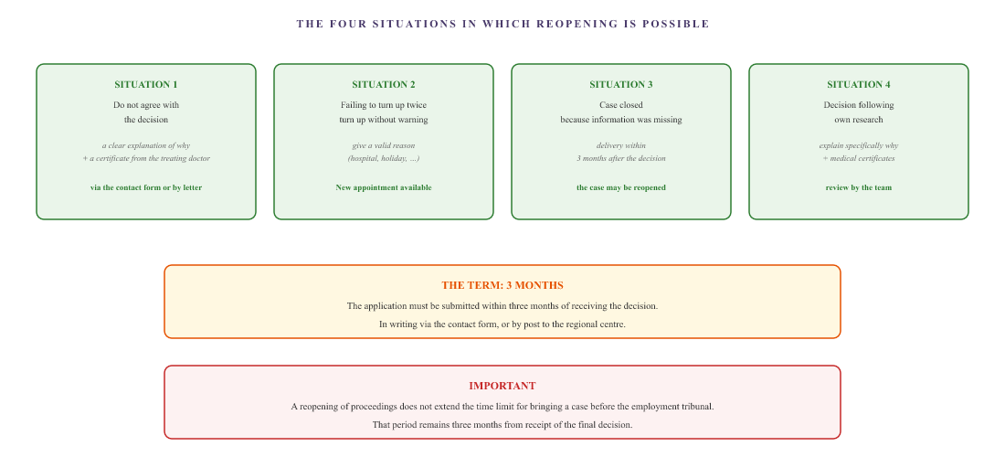
Figure VII.1 — The four routes to reopening the case. These are set out on the website of the Federal Disability Service, not in the letter. Applications for them can be made in writing, without a solicitor and without going to court.

What this achieves
A request for a review is not an appeal to the court. It is a request to the same body to reconsider the decision — with new arguments, new evidence, or an explanation of why the previous decision is incorrect. The attending doctor can assist with this: he or she can explain in writing why the disability service’s decision is incorrect.
Unlike a court case, reopening a case does not require a solicitor or court fees. It simply involves a letter or an online form. And the decision is again made by the same body, but this time taking into account the arguments put forward by the treating doctor.
For anyone in the same situation: have you received a decision from the Federal Disability Service with which you disagree? Visit the website handicap.belgium.be under ‘Request a review’. Four scenarios are described. Choose the one that applies to you, submit your application in writing within three months, and ask your GP for a supporting letter. This is not a court case — it is a request for a review.
Please note: the statutory time limit for taking your case to the employment tribunal remains three months. If in doubt, seek legal advice before this time limit expires.
The information in this chapter is based on the official page ‘Applying for a reopening’ of the FPS Social Security (DG People with Disabilities), last updated on 15 September 2025. The legal basis and the procedure can be found at handicap.belgium.be. This chapter does not constitute legal advice; if in doubt, consult a specialist service or a solicitor.

The CM and the flow of funds
The health insurance fund is not a bank with a single account. It is an organisation with three separate streams of funding: compulsory health insurance, the CM package of services and benefits, and optional insurance schemes. The first stream comes from the government via the RSZ. The second from membership fees. The third from separate premiums. And each of these streams feeds a different department. This chapter explains where the money comes from, why one branch works and another does not, and who can ultimately intervene when the CM refuses.

Part A — The three funding streams
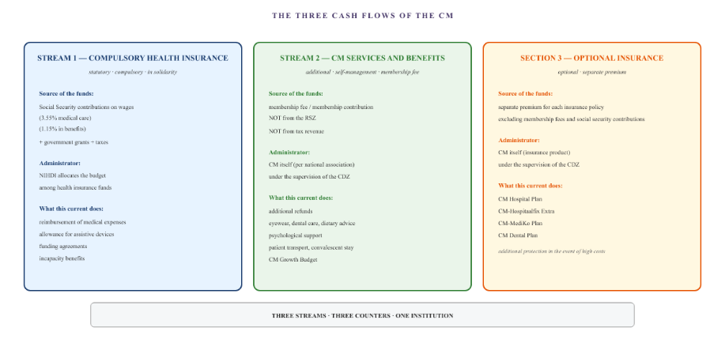
Figure XIV.1 — The three funding streams. Compulsory health insurance is funded by social security contributions and taxes, administered by the NIHDI, and delivered by the health insurance funds. CM services and benefits are funded by membership fees. Voluntary insurance schemes are funded by separate premiums. Each of the three funding streams feeds a different service.

Part B — Social Security contributions and their allocation
Compulsory health insurance is not paid directly by the CM. The employer deducts a portion of the wages and pays it to the National Social Security Office (RSZ). The RSZ distributes the money amongst the various social security branches. There are two separate branches for health insurance:
- Medical care — reimbursement for medical services, medicines, medical aids and private healthcare agreements. Employee contribution rate: approximately 3.55 per cent of gross pay.
- Benefits — sickness and disability benefits in the event of incapacity for work. Employee contribution rate: approximately 1.15 per cent of gross pay.
The NIHDI receives the total budget and allocates it amongst the health insurance funds. Each health insurance fund receives a budget based on the number of members and their profile. The health insurance fund uses this budget to pay for services provided to its members. The health insurance fund receives a separate reimbursement to cover administrative costs.
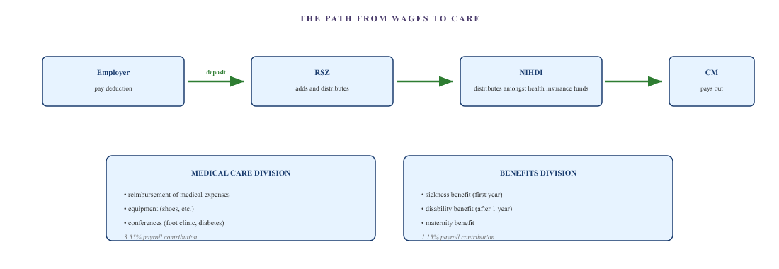
Figure XIV.2 — The path from wages to healthcare. The employer deducts the RSZ contribution from wages. The RSZ pays the funds to the NIHDI. The NIHDI distributes the funds amongst the health insurance funds. The health insurance fund makes payments from two categories: medical care and benefits.

Part C — Why assistive devices are covered but benefits are not
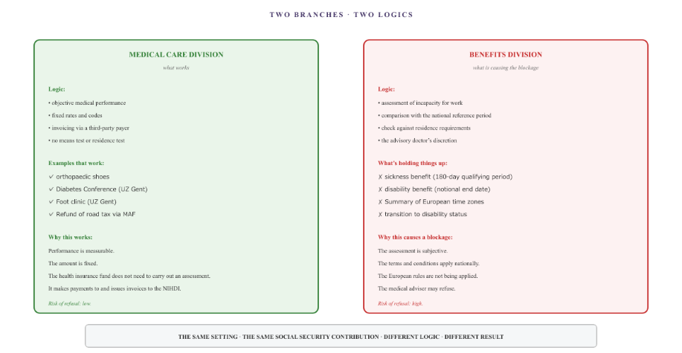
Figure XIV.3 — Two branches, two sets of criteria. The healthcare branch operates on the basis of objective, measurable performance. The benefits branch operates on the basis of subjective assessments and national criteria. The same institution, the same National Social Security Fund (RSZ) contribution, but a fundamentally different logic — and therefore a fundamentally different outcome.

Part D — The CDZ as a supervisory authority
The Health Insurance Funds Supervisory Authority (CDZ) oversees the CM as a whole — including compulsory insurance, supplementary services and optional insurance schemes. The CDZ audits the accounts, monitors compliance with financial rules and ensures the correct application of statutory provisions. It may issue recommendations to the Minister and approve amendments to the articles of association.
What the CDZ does not do: settle individual disputes. The CDZ is an administrative supervisory body, not a dispute resolution body. It can investigate the structural functioning of the health insurance fund, but cannot review a decision in an individual case. It is not an appeals body.

Part E — The Labour Audit Office: who monitors the monitor?
When an implementing body systematically disregards the law, there is a judicial body in Belgium which, in theory, can intervene: the Labour Audit Office, the public prosecutor’s office attached to the labour courts. It is responsible for enforcing social security legislation and can take action when an organisation fails to comply with the law.
On 10 September 2026, a formal report was submitted to the Ghent Labour Inspectorate in this case. The report concerned systemic procedural errors at the CM, a breach of the European Coordination Regulation, and a failure to comply with NIHDI guidelines. The full timeline and the medical certificate for tax purposes were attached as supporting documents.
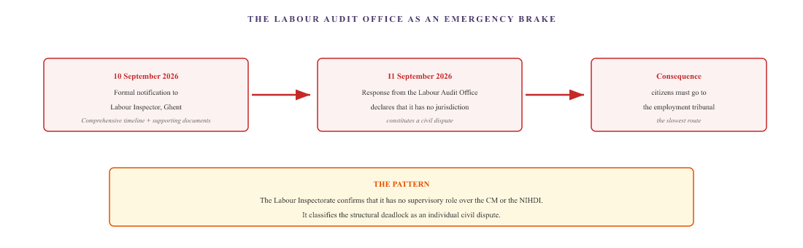
Figure XIV.4 — The Labour Audit Office. The report reaches the Labour Audit Office on 10 September 2026. The response comes one day later: the body declares that it has no jurisdiction and classifies the structural deadlock as a civil dispute. The citizen is referred to the employment tribunal, the slowest route.
What the Labour Inspectorate is doing here is the same as what the CDZ does: passing the buck on the issue of responsibility. The body that is supposed to intervene in the event of a breach of social legislation classifies the dispute as a private matter. And the public is left with one less body to turn to.

Part F — The Medical Council: disciplinary proceedings against the medical adviser
The Medical Council is the statutory body responsible for upholding medical ethics and exercising disciplinary authority over individual doctors. It can investigate complaints and impose disciplinary sanctions — ranging from a warning to striking off the register of doctors — but has no authority over administrative decisions made by institutions or over algorithmic processes within a health insurance fund.
In this case, a complaint was lodged with the Provincial Council of Antwerp on 19 September 2026 regarding the conduct of the CM’s medical adviser. The complaint concerns the issuing of conflicting decisions bearing a visually identical signature, without traceable access to the current medical file. The question is whether this practice is ethically compatible with the independent practice of medicine.
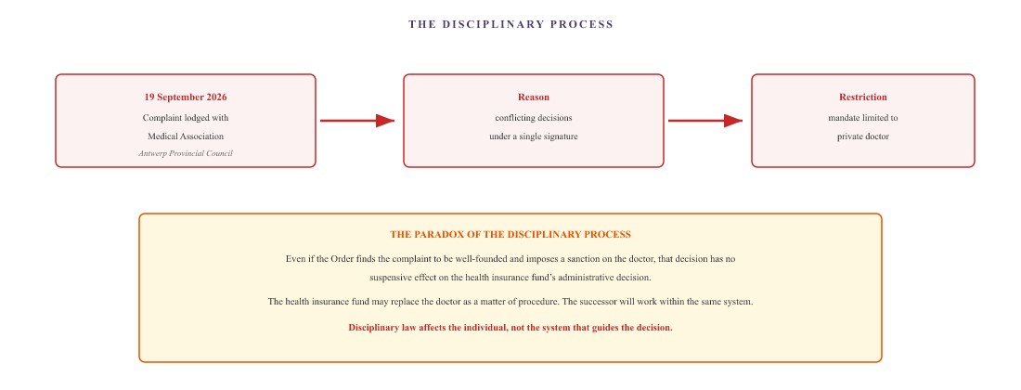
Figure XIV.5 — The Medical Council. Disciplinary proceedings may affect the individual doctor, but not the framework that produces the decision. Even a well-founded complaint does not alter the outcome for the patient, as the health insurance fund replaces the doctor and the algorithm remains unchanged.

Part G — What this chapter sets out
The question of why medical aids are covered but benefits are not has a structural explanation. The CM carries out two legally distinct tasks within the compulsory health insurance scheme. One task is based on measurable outcomes and fixed rates. The other is based on subjective assessments and national criteria.
There are therefore two different systems within the same organisation. When it comes to medical care, the CM does not need to assess an individual — it simply pays the bill. For benefits, however, it must assess whether someone is unfit for work, and that assessment is subject to conditions laid down by law. For a cross-border worker, these conditions are problematic, as they are based on national reference periods and residence requirements.
And when the CM refuses, the two supervisory bodies — the CDZ and the Labour Inspectorate — do not consider themselves competent to deal with individual cases. The Medical Council can only take action against the individual doctor, not the system that drives the decision. This conclusion is not an accusation of bad faith. It is simply an observation that the system does not assign responsibility for the whole to any single body. Each body carries out its own part. And no single body bears responsibility for the whole.
All organisations in this chapter are legal entities. Natural persons are identified by their role or their symbol (♂, ♀). The information on funding is based on official communications from the CM, the NIHDI and the CDZ. The procedural information concerning the Labour Inspectorate and the Medical Council is based on Document B and public sources. This chapter does not constitute legal or financial advice.

III. The Netherlands

The UWV and the appeals process
The UWV assesses whether a person is unfit for work and whether they are entitled to benefits. What follows is not a single refusal. It is a series of refusals. Each refusal has its own reason, its own procedure and its own outcome. None of the refusals is examined in substance. And NEO, the Belgian equivalent, in turn employs the same tactic in the opposite direction.

Part A — Six rounds at the UWV
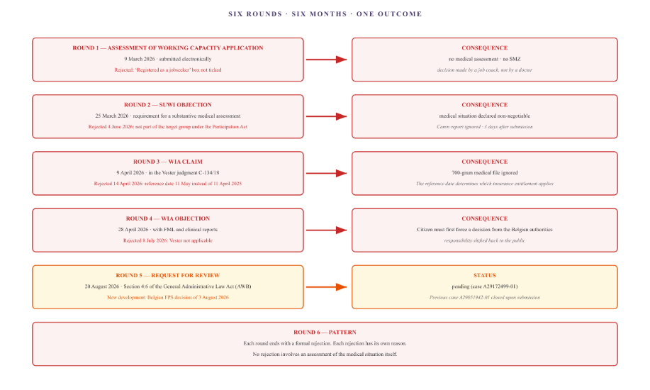
Figure IX.1 — The six rounds. Five applications, two objections, one review. Each round ends with a formal rejection. At no point throughout the entire process is the medical situation assessed in substance, despite five independent medical assessments and hundreds of pages of evidence.

Part B — NEO and the C4 form
The UWV is not the only body that blocks the issuance of a career certificate. On the Belgian side, the National Employment Office (NEO) employs a similar tactic, but in relation to teaching careers.

The problem with a career in teaching
The partner works as a permanent teacher in the Flemish education system. To apply for the European Career Certificate (PD U1), the NEO must complete a form documenting their entire teaching career. However, the NEO is blocking the application by requiring a C4 form.
What is the C4 form? It is a termination document used in the private sector. It is used when an employee in the private sector leaves their job. For permanent staff in the education sector, this form does not exist in legal terms. There is no termination, no private employer, no C4.
NEO is therefore applying the logic of the private sector to a career that falls entirely outside that framework. The agency is forcing a public-sector career into a private-sector mould.
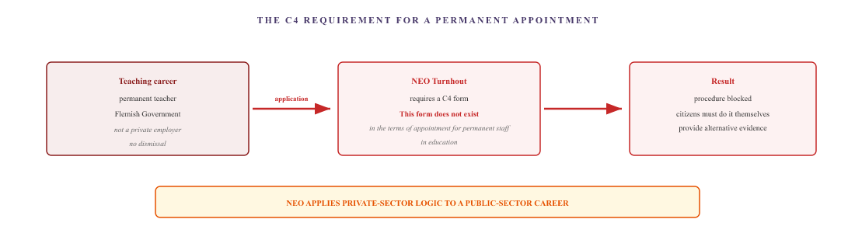
NEO requires a C4 form for a career path for which there is no legal basis for a C4. The application is blocked. The citizen must provide alternative evidence themselves via the Agency for Educational Services (AGODI), which issues the official Calculation of Financial Seniority.

Manual submission
The patient resolves the issue by submitting the AGODI certificate in person. The Agency for Educational Services issues an official document setting out the patient’s full educational history. This document is sent to NEO, after which the second PD U1 certificate is issued.
This results in a third layer of manual intervention. The patient acts not only as a data hub between two countries, but also as a data hub between two agencies within the same country: between the federal NEO and the Flemish AGODI. These two levels of government, which have access to the same career history, do not automatically exchange this data.

Part C — The refusal to synchronise foreign data
Following the issue of the second PD U1 certificate, the patient submits a formal request to synchronise their Dutch employment records with the Belgian MyCareer system. NEO refuses.
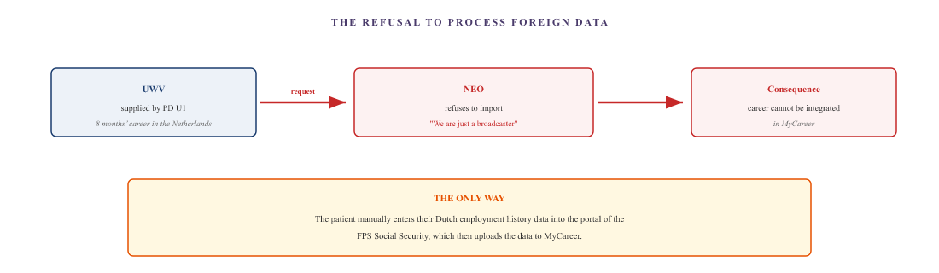
The UWV provides the data, but the NEO refuses to process it. The patient bypasses the NEO via another federal agency. Two government agencies within the same country cannot exchange data with one another without the citizen acting as a data hub.

Part D — The pattern: procedural rejection
What the UWV consistently does is not to refuse. It is to reject on procedural grounds. That is a fundamental difference.
In the event of a refusal on the merits, the UWV would have to state that the medical condition is not severe enough. This would mean that a doctor had examined the patient, confirmed the amputations, tested their visual acuity, and, on that basis, concluded that the person was not entitled to benefits.
In the event of a procedural rejection, the UWV states: the application does not meet the formal requirements. No tick. Incorrect reference date. No basis for insurance. No Belgian decision. No C4 form.
A procedural dismissal has three advantages for the authority:
- No medical assessment is required. The assessment will be skipped or postponed.
- It is not a decision open to dispute. Formal arguments are difficult to challenge in court.
- Automatic referral to the member of the public. The member of the public must first force a different decision before the authority takes any action.
The UWV and the NEO follow the same pattern here, but in the opposite direction. The UWV refuses to take note of the Belgian decision. The NEO refuses to take note of the Dutch decision. Both bodies are waiting for the other, and neither is taking responsibility.

Part E — A summary of the grounds for rejection
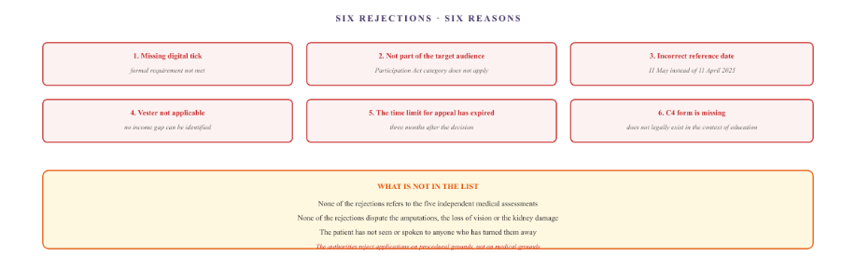
Figure IX.4 — Six rejections, six reasons. All the reasons are procedural. None of the reasons are medical. The medical situation is not assessed in substance at any stage of the process.

Part F — The two objections in detail

Objection 1 — The Caren amendment
4 June 2026
On 1 June 2026, the patient submits three additional supporting documents for the first appeal: the Caren report from the Dutch home care service (126 clinical entries confirming the period of hospitalisation from 11 April to 9 May 2025), an ophthalmological report from the teaching hospital, and an endocrinological report.
Three days later, the UWV declared the appeal unfounded. This was six weeks before the deadline of 15 July 2026, as announced by the UWV itself. The Caren report — the Dutch evidence confirming the reference date — was not examined in substance.

Objection 2 — The Vester refusal
8 July 2026
The second objection concerns the WIA rejection of 14 April 2026. The patient cites the Vester judgement: in the case of successive insurance schemes in two Member States, a Member State may not apply the qualifying period in such a way as to create an income gap. The UWV explicitly rejects this, arguing that the loss of income cannot be determined without a formal decision from Belgium.
As Belgium is also refusing, the UWV closes the case with the message that the citizen must first secure a decision from the Belgian authorities. The responsibility for breaking the deadlock is shifted back onto the citizen.

Part G — What this chapter sets out
The UWV and NEO follow the same pattern, but in the opposite direction. Both agencies reject claims on procedural grounds. Both agencies refuse to take the other’s information into account. Both agencies pass the responsibility back to the public.
The member of the public is caught between two bodies, each of which imposes its own condition that the other body has made impossible to fulfil. And throughout the entire process, the medical situation is not assessed in substance even once.
For anyone in the same situation: if your application is rejected by the UWV or NEO, it is important to check whether the rejection is on the merits or on procedural grounds. A procedural rejection can often be challenged by meeting the formal requirement — but if that requirement is impossible to meet in practice (such as a C4 form that does not exist), a request for review under Article 4:6 of the General Administrative Law Act (NL) or a formal appeal (BE) may be the correct course of action.
For career documentation: request an official Calculation of Financial Seniority from AGODI as alternative evidence for the NEO. For Dutch data: manually enter the PD U1 via the MyCareer portal of the FPS Social Security.
All organisations mentioned in this chapter are legal entities. Natural persons are referred to by their role or their symbol (♂, ♀). The facts are based on Document B. This chapter does not constitute legal advice.

CZ — the two faces of the gatekeeper
CZ administers the treaty-based insurance policy for a resident of the Netherlands who is employed in Belgium. CZ reimburses the cost of healthcare, but refuses to register the person for the healthcare allowance. CZ also refuses to provide patient transport, citing a requirement that does not exist in the country of treatment. In both cases, the organisation’s protocol takes precedence over medical reality. And in both cases, the authorities that should be ensuring the process runs smoothly are failing to do so.

Story 1 — The insurance policy and the healthcare allowance

What is a contract policy?
A treaty policy is a European instrument. The employee lives in the Netherlands and works in Belgium. Under the European coordination rules, the country of employment is responsible for social security. The employee pays their social security contributions in Belgium, to the Belgian health insurance fund.
However, he is also entitled to healthcare in his country of residence. That is what the treaty policy is for: CZ acts as the Dutch administrator of the policy, reimburses the Dutch healthcare costs, and settles them with Belgium.
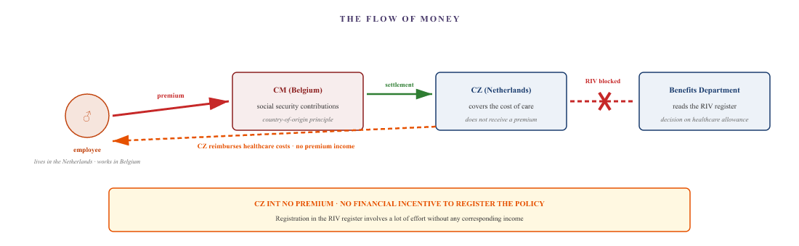
The premium goes to the country of employment (Belgium, via CM). CZ reimburses Dutch healthcare costs but does not receive a premium. Registration in the RIV register involves a lot of work for CZ without any corresponding income.

CZ’s reasoning
- The treaty policy is not Dutch health insurance within the meaning of the Health Care Allowance Act.
- The premium for the treaty policy is paid in the country of employment (Belgium), not in the Netherlands.
- Anyone who is insured for medical care in Belgium is not considered an insured person within the meaning of the Dutch Healthcare Allowance Act.
- There is therefore no entitlement to healthcare allowance.
The result is that, in the Netherlands, the holder of a treaty policy is insured for healthcare, but not for the benefit. The Benefits Service refers exclusively to the RIV register. If it isn’t in there, it doesn’t exist.

Story 1a — The chain of the blockade: CZ, CAK, ZIN
CZ’s refusal to register the treaty policy is not the only issue. The RIV register — the Reference Database for Insured Persons under the Health Insurance Act — is managed by the Central Administration Office (CAK). And the Dutch Healthcare Institute (ZIN) oversees its implementation. In this case, all three bodies involved are refusing to resolve the problem.
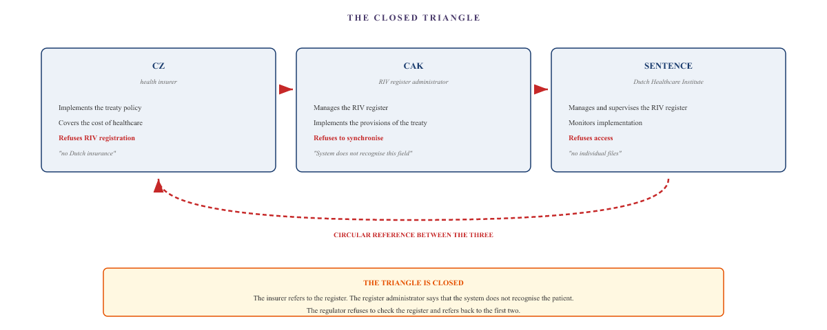
Figure X.2 — The closed triangle. CZ refuses to register the data. The CAK manages the register but refuses to synchronise it. The ZIN supervises the process but refuses to grant access to individual files. Each body points the finger at the other. The citizen is trapped in a vicious circle that nobody is breaking.

The CAK’s reasoning
The CAK manages the Health Insurance Act Insured Persons Reference Database (RIV) and administers the contractual schemes. If, in April 2026, the patient formally demands that the active and paid-up treaty policy be entered into the register, the CAK will expose a fundamental architectural flaw in its own systems.
The authority refuses to register the policy on procedural grounds. The CAK states that it only registers ‘ordinary’ cross-border workers: those who work in the Netherlands and live abroad. For the reverse situation — living in the Netherlands and working abroad — there is simply no category programmed into the system.
The system does not recognise the form field. And rather than adding the field, the CAK closes the file.

ZIN’s reasoning
The Dutch Healthcare Institute (Zorginstituut Nederland) manages and supervises the RIV register. When, in April 2026, the patient asks the Institute to investigate and rectify the exclusion from the register, the Institute states that it has no access to individual personal data. It refuses to check the register and refers the matter back to CZ and the CAK.
The body that manages the register cannot access the register. That is the essence of the closed triangle: each body has a limited scope of authority, and no single body has the full scope.

Story 2 — Patient transport
Due to amputations and loss of vision, the patient is no longer able to drive independently. His healthcare providers are in Belgium. He lives in the Netherlands. He requires adapted transport for these journeys — seated patient transport. In the Netherlands, this is a benefit provided through the health insurer. For a policy under a treaty, this is CZ.

What CZ is demanding
On 18 March 2026, the patient submits an application for authorisation for seated patient transport to the Belgian hospital. On 25 March, CZ sends a request for further information: a perimetry test — an examination of the field of vision — is required.
What is perimetry? An ophthalmological examination in which the full perimeter of the visual field is measured. It is a standard examination in Dutch ophthalmology. It is not a standard examination in the Belgian protocol for this specific condition — diabetic retinopathy with macular oedema. The Belgian hospital does not carry out this test on this patient, as it is not included in the treatment protocol.
The result is that the patient cannot provide the evidence, as the test is not available in the country where he is being treated.
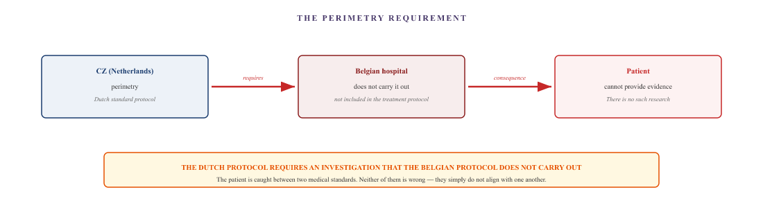
CZ is requesting a test that is not routinely carried out in the country where the patient is receiving treatment. The patient is unable to provide the evidence, not because he is unwilling to do so, but because the test is not included in his clinician’s treatment protocol.

The procedural dance
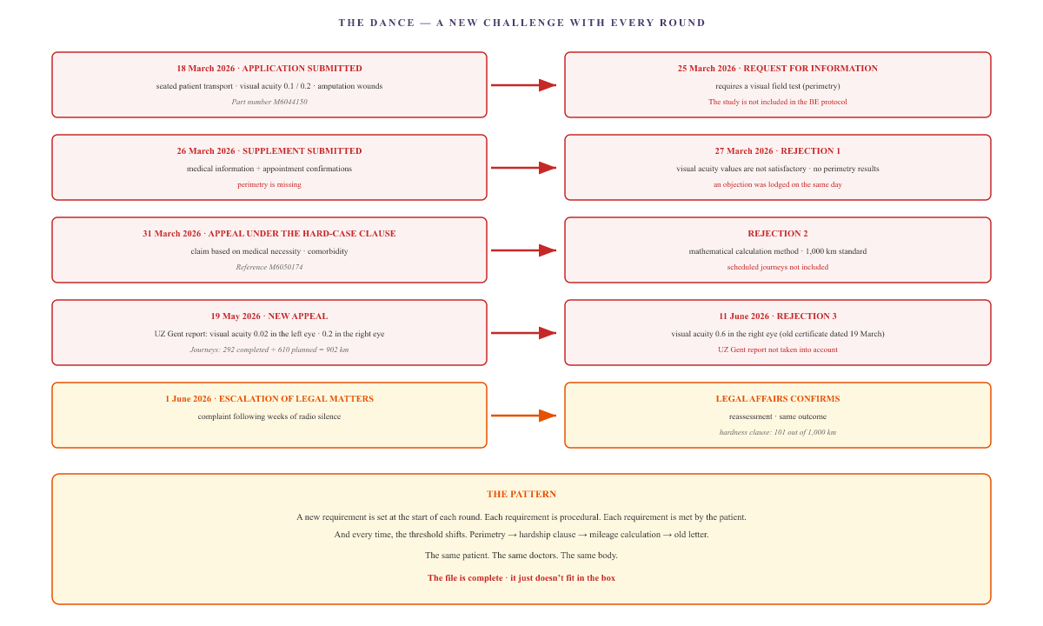
Figure X.4 — The dance. Five rounds, three rejections, one escalation. A new procedural requirement each time. Granted each time. And each time, the threshold shifts. The patient provides the evidence, but the protocol does not accept it.

Part C — The parallel: CZ and CM
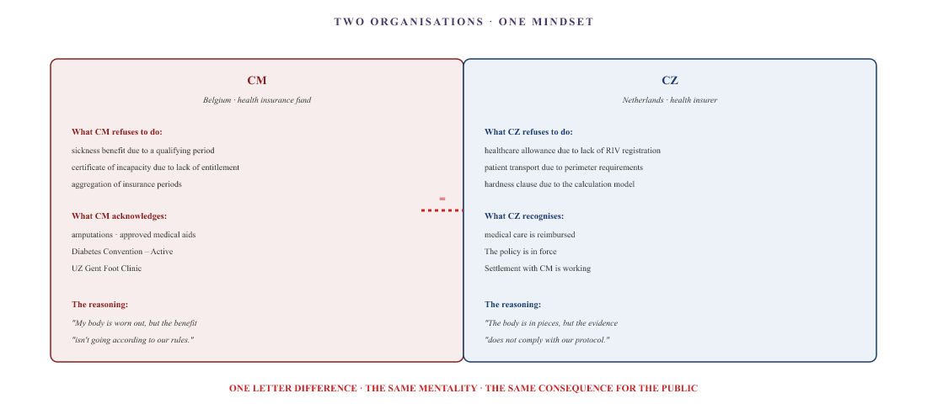
Figure X.5 — The parallel. CM and CZ apply the same logic: medical evidence is accepted where it fits within their own protocol, and rejected where the protocol imposes a procedural requirement that the patient cannot meet. The protocol is the truth, not the body.

Part D — What this achieves
In both cases, the patient has provided the maximum evidence he is able to provide. In the first case: a valid insurance policy, paid premiums, and an administering body in Belgium. In the second case: a complete medical file detailing amputations, visual acuity measurements, and an academic report from a university hospital.
In both cases, CZ rejects the claim on procedural grounds. The treaty policy is not a Dutch insurance policy. The scope is not specified. The mileage calculation is incorrect. The old letter carries more weight than the new report.
The crux of the matter is not that CZ is making mistakes. The crux of the matter is that the CZ protocol takes precedence over medical reality. And because the law allows CZ the leeway to follow the protocol, there is no breach. Just an outcome that the family cannot bear. And the CZ-CAK-ZIN triangle closes in on the family without a single loophole.
For anyone in the same situation: in the case of rejections by CZ on protocol grounds, there are four courses of action:
- Lodge a formal objection with CZ itself, emphasising the impossibility of providing the requested evidence (incompatibility with the protocol). Include a statement from the treating doctor confirming that the requested test is not included in the treatment protocol.
- Escalate the matter to the Office for Belgian Affairs (BBZ) at the SVB. The BBZ can exert pressure, but has no binding authority.
- For the healthcare allowance: lodge a formal objection with the Allowances Service based on the CZ claim summaries showing that you have paid the Dutch excess.
- Request for access under Article 15 of the GDPR from CZ, CAK and ZIN, focusing on the EESSI log files and the RIV registration attempts. This makes the communication measurable and may still force a manual correction.
All organisations mentioned in this chapter are legal entities. Natural persons are referred to by their title or the symbol (♂). The facts are based on Document B. This chapter does not constitute legal advice.

The Hulst-trap municipality
In the Netherlands, the local authority is the first point of contact for anyone facing financial hardship. For a cross-border worker in Zeeuws-Vlaanderen, the municipality of Hulst would be the logical place to apply for social assistance, special social assistance or social support. In practice, however, things are different. The local authority receives the cry for help, but does not provide any money. It offers equipment and assistance. And it uses calculation models that fail to reflect the actual situation. A formal appeal is now under consideration — but the decision on it has been postponed yet again.

Part A — The local authority as the first point of contact that doesn’t help

What the local authority could have done
Under the Dutch social security system, the local authority has three tools at its disposal to address income hardship:
- Social assistance (Participation Act) — a monthly benefit for those with little or no income.
- Special assistance — a one-off payment to cover unforeseen essential expenses.
- Wmo support — social support, including domestic help and transport.
These three schemes are designed to provide support when income is lost or insufficient. For a cross-border worker facing a medical emergency and a complete loss of income, that is precisely the situation for which they were created.

What the local authority did
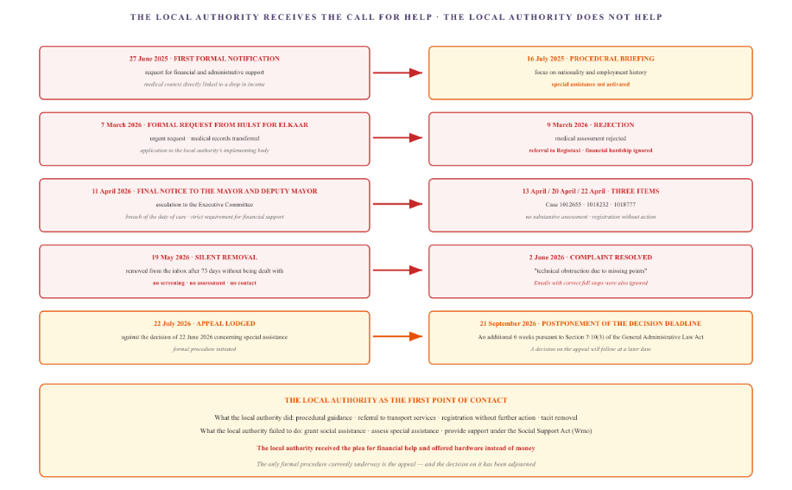
Figure XI.1 — The first helpline that doesn’t help. The local authority received six formal reports, spread over eleven months. Each time, the response is either a procedural one or no response at all. Applications for social assistance and special assistance are not assessed. The only formal procedure currently underway is the appeal lodged on 22 July 2026 — and the decision on that has been adjourned.

Part B — The pending appeal
The only formal procedure remaining is the appeal lodged on 22 July 2026 against the decision of 22 June 2026 concerning special assistance. This is the first point at which the local authority is required to formally assess the application. The local authority responded by extending the decision-making period.
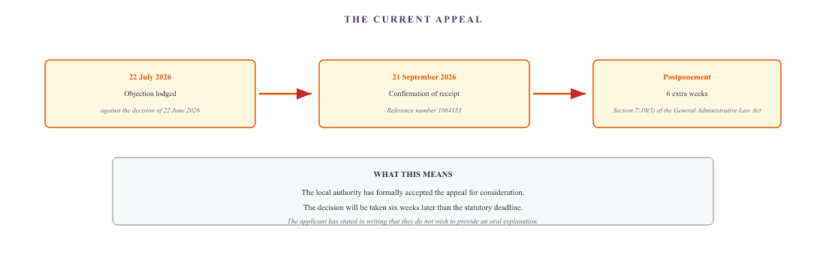
Figure XI.2 — The pending appeal. The appeal against the decision on special assistance was lodged on 22 July 2026. The local authority confirmed receipt on 21 September 2026 and extended the decision-making period by six weeks. The applicant did not request an oral hearing, as the grounds had already been sufficiently set out.

Part C — The mathematical models that fail to reflect reality
The reason why the local authority, like Parentia, does not allocate any funds is down to the calculation model. Social security benefits and special social security benefits are means-tested against an income threshold. In principle, that makes sense. But the model does not take the actual situation into account.
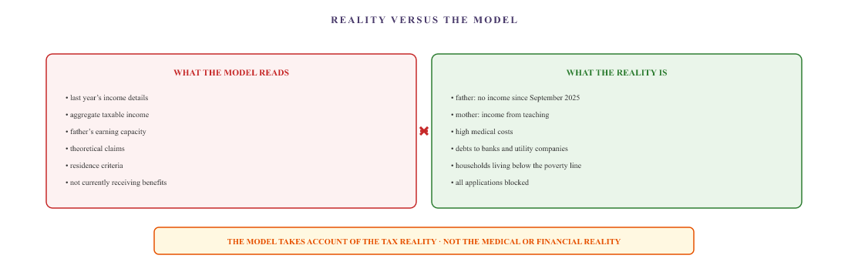
The calculation model uses historical tax data. It does not take into account that actual income has fallen to zero, that medical costs have risen, and that the household is living below the poverty line. It is exactly the same pattern as with Parentia.

Part D — The mobility antics
The local authority does offer something: mobility. There are two schemes: the disabled parking permit (GPK) and the Wmo pass for adapted transport. Both work — to some extent. And both come with their own personal contribution.

The disabled parking permit
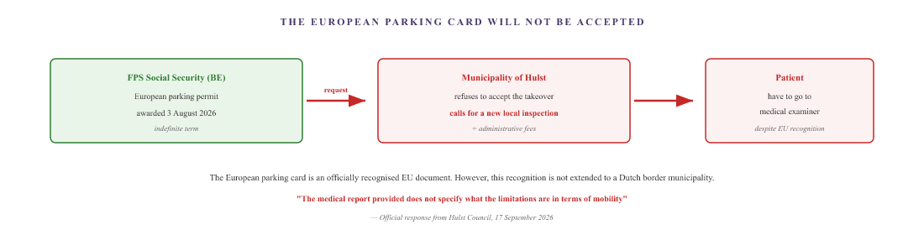
The patient holds a European parking card issued by the Belgian federal government. The municipality of Hulst refuses to accept it and is demanding a new local assessment, with the associated administrative fees. What is striking is that the patient was required to resubmit the medical file on 17 September 2026, even though it had already been submitted on 7 March 2026 and 20 August 2026.

The Wmo card and the personal contribution
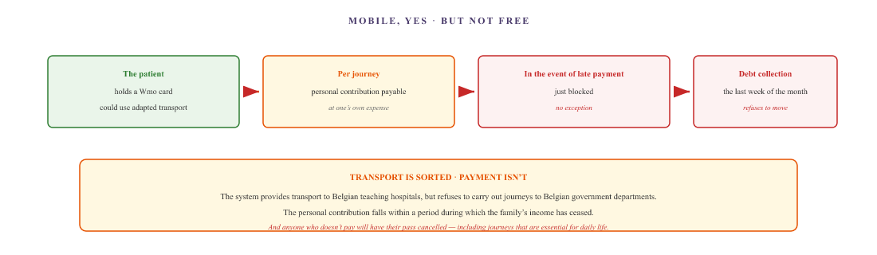
The Wmo card enables patients to get about. However, the personal contribution falls due during a period when they have no income. And anyone who fails to pay on time loses their card.

Part E — The limits of transport under the Wmo
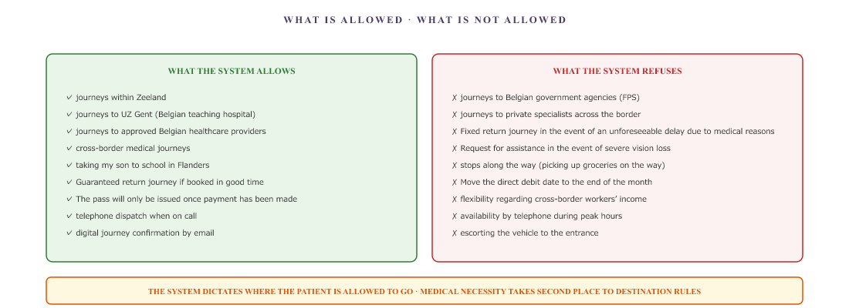
The system allows journeys to academic hospitals across the border, but refuses journeys to Belgian government agencies at exactly the same distance. Requests for assistance in cases of vision loss are also not recorded.

Part F — The pattern repeats itself
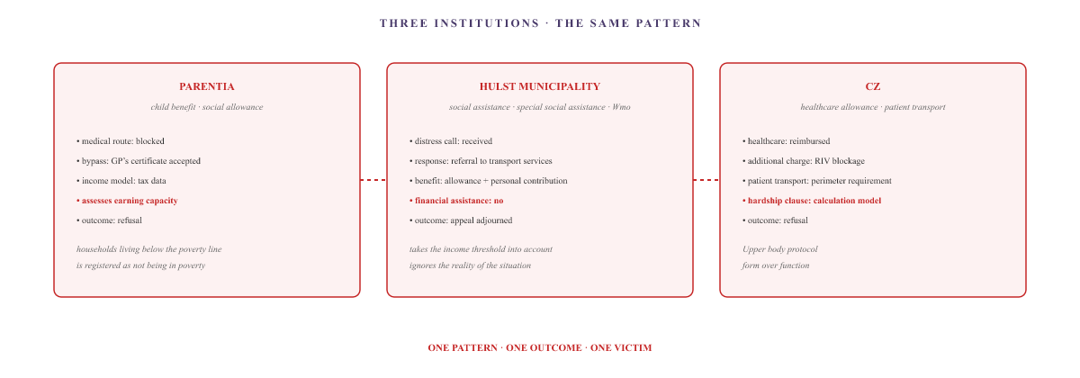
Figure XI.5 — Three bodies, one pattern. Parentia, the municipality of Hulst and CZ all apply the same mechanism: medical reality is recognised where it fits within the protocol, and rejected where the protocol imposes a procedural requirement that the citizen cannot fulfil.

What the local authority should have been
In theory, the local authority is the first point of contact. It knows its residents, is familiar with the local situation and has the tools to intervene quickly. In this case, however, the local authority failed to do so. It received the distress call six times and issued six procedural responses. Not once was the financial situation assessed in any substantive way.
And the crux of the matter is this: in theory, the benefits should be enough. The Belgian sickness benefit, the Dutch WIA, the top-ups, the family allowance — together, they should be enough to keep a household afloat. The problem isn’t that the money isn’t there. The problem is that nobody is plugging the gap that has arisen between the various schemes. Medical costs are the trigger, but the administrative deadlock is the cause of the impoverishment.
The only formal procedure currently underway is the notice of objection dated 22 July 2026. The deadline for a decision on this has been extended by six weeks. The applicant has not requested an oral hearing, as the grounds have already been sufficiently set out. The decision will follow at a later date. Until then, the financial situation remains unchanged.
For anyone in the same situation: the local authority is legally obliged to assess claims for social assistance and special assistance. A rejection on procedural grounds or because of an income model that does not reflect the actual situation can be challenged. Four steps:
- Submit a formal application for special assistance, detailing the specific emergency (medical costs, debts, blocked benefits).
- If the local authority does not respond within the statutory time limit (8 weeks), lodge an appeal on the grounds of a delayed decision.
- Request a face-to-face meeting with a debt counselling officer or a social welfare adviser.
- If the local authority continues to refuse: lodge a formal objection with the mayor and aldermen and, if necessary, lodge an appeal with the administrative court. Be aware that the local authority is legally permitted to extend the decision-making period by six weeks (Section 7:10(3) of the General Administrative Law Act) — which is what has happened here.
Regarding the Wmo pass and the GPK: a European parking card is a recognised EU document. The local authority cannot simply refuse to accept it. A formal objection on the grounds of mutual recognition may help.
All organisations mentioned in this chapter are legal entities. Natural persons are referred to by their title or the symbol (♂). The facts are based on Document B. This chapter does not constitute legal advice.

Tax and Customs Administration and benefits
The Benefits Service pays out three means-tested benefits: healthcare allowance, housing benefit and child-related budget. In this family, one person is on full benefits, one is on partial benefits, and one is in work. And the tax return itself presents the taxpayer with a task they cannot carry out: entering a ‘worldwide income’ that they do not know, whilst being held personally responsible for its accuracy.

Part A — The three allowances
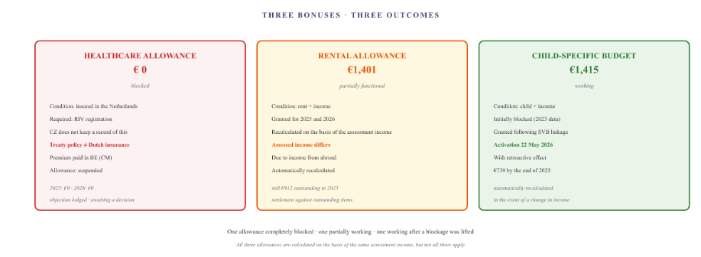
Figure XIII.1 — Three allowances. The healthcare allowance remains at zero because CZ does not register the treaty policy as Dutch insurance. The rent allowance is partially effective, but the assessed income differs due to the foreign income. The child-related budget only came into effect after the SVB link was established — and was paid out retrospectively.

Part B — The mechanics behind it
What the results of the benefit assessments do not show is what the citizen has to do to achieve those results. And what goes wrong when they do not do so, or are unable to do so.

The global income that the citizen must enter
When filing an income tax return, the Dutch Tax and Customs Administration asks for your worldwide income: all income that you have earned anywhere in the world. For a cross-border worker, this means: your Belgian salary, your Belgian benefits, your Belgian allowances – everything.
However, citizens do not receive this information automatically. The Belgian tax authorities do not send it to the Dutch tax authorities. The DAC (Directive on Administrative Cooperation) infrastructure is designed for the automatic exchange of income data — but the exchange is not in real time and is not always complete. Citizens must enter the amounts themselves, based on their own payslips, benefit statements and their estimate of their Belgian income.
The Tax and Customs Administration explicitly places the responsibility on the taxpayer. Whatever the taxpayer enters is assumed to be true. If it is incorrect, a correction will follow later. And in the event of a correction, any overpayment may be reclaimed.

Gross national income versus global income
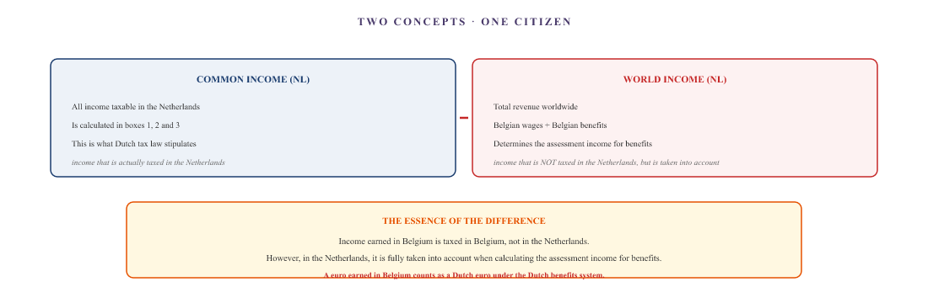
Figure XIII.2 — World income versus joint income. Belgian income is taxed in Belgium under the tax treaty and is exempt in the Netherlands. However, for the purposes of the allowances, it counts in full as global income. A euro in Belgium is not the same as a euro in the Netherlands — different purchasing power, different social security provisions, different cost structures. The allowance model does not take this difference into account.

Part C — Medical expenses that were reduced to zero
The patient then tries to claim the medical expenses as a personal allowance. In the Netherlands, medical expenses above a certain threshold are deductible from income. This reduces the assessed income — and that, in turn, reduces the basis for calculating the benefits.
The strategy makes sense: deducting medical expenses reduces the assessed income, and increases the benefits. It is an indirect way of compensating the family for the costs that the system does not cover.
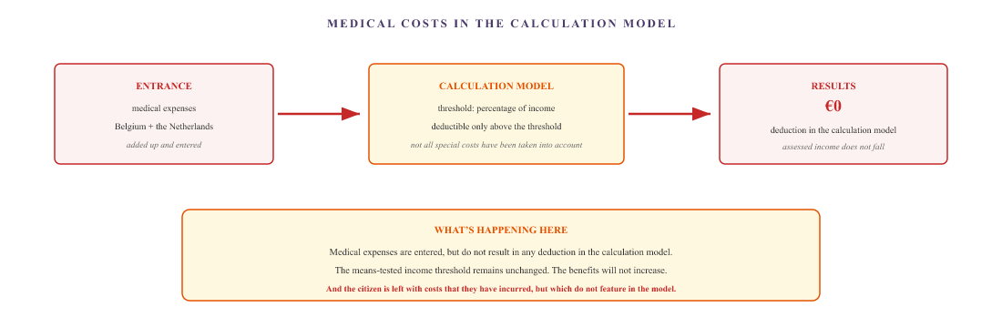
Figure XIII.3 — Medical expenses. The patient enters the medical expenses. The calculation model applies the deduction threshold. The result is zero. The assessment income does not fall, the benefits remain the same, and the actual costs continue to weigh on the family.

Part D — Citizens’ responsibilities
The Tax and Customs Administration consistently states that the responsibility for the accuracy of the tax return lies with the taxpayer. The taxpayer must:
- Enter his worldwide income, including any foreign components that are not automatically provided to him.
- To justify the accuracy of figures he has estimated himself.
- Dealing with the consequences of mistakes, including the recovery of benefits.
- Check for yourself whether the automatic exchange of data between Belgium and the Netherlands has worked.
- Retrieve the DAC log files yourself to check what data has been exchanged.
And if the automatic exchange of information has not worked — if Belgium has not sent the data, or if the Netherlands has not processed it — that is no reason to delay filing the tax return. The taxpayer must sort it out themselves.
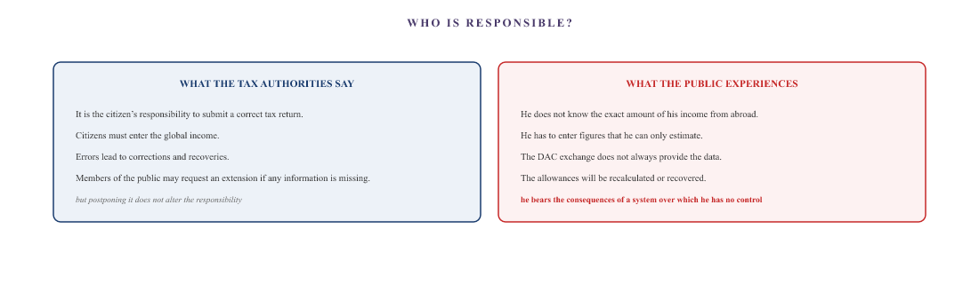
The Tax and Customs Administration places the responsibility for accuracy on the taxpayer. However, taxpayers cannot always obtain the correct information, as the automatic exchange of data between Belgium and the Netherlands is not comprehensive. The system shifts the risk of an administrative error onto those least able to cope with it.

Part E — What this achieves
Three allowances, three outcomes. One completely blocked, one partially blocked, one working. And the tax return itself asks the taxpayer to enter an income that they cannot calculate, placing the responsibility for its accuracy on them, with the consequences of a recalculation that automatically follows as soon as the Tax and Customs Administration has the actual figures.
What becomes apparent here is a pattern that recurs throughout the case file. The system has the tools, the laws and the intentions to support citizens. But the system does not interpret reality in the same way as citizens experience it. The benefits are calculated on the basis of an assessed income that treats a Belgian euro as equivalent to a Dutch euro. Medical expenses are entered but do not result in any deduction. And the citizen is personally responsible for the accuracy of an income figure of which they are unaware.
For anyone in the same situation: when it comes to cross-border income and benefits, there are three important points to bear in mind:
- Ask the Belgian tax authorities for a statement of your annual income and include this in your Dutch tax return. Keep all the documents.
- Request an extension if the information is not yet complete — this extends the deadline, but not your liability.
- If the benefits are recalculated or reclaimed: submit an appeal based on the actual figures, with supporting evidence. Base your appeal on the fact that the assessed income has not been correctly determined.
Specifically regarding the healthcare allowance: the block is with CZ (RIV registration), not with the Benefits Service. A manual correction via the CZ claims and proof of payment of the excess is the way to lift the block.
All organisations in this chapter are legal entities. Natural persons are identified by their role or their symbol (♂, ♀). The facts are based on Document B. This chapter does not constitute tax or legal advice. For the exact amounts and conditions, please consult the tax authorities or a tax adviser.

IV. Back and forth

The manual U1 problem
The PD U1 is the European certificate of a person’s employment history. A cross-border worker needs it in both directions: to have their Belgian years recognised in the Netherlands, and to have their Dutch years recognised in Belgium. In both directions, the transfer is carried out manually. And the ESSPASS will not resolve this by 2030, as the individual remains the link in the chain.

The two directions
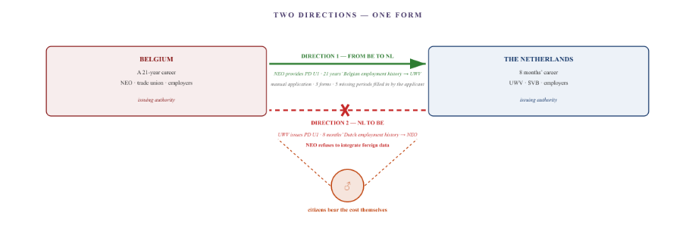
Figure VIII.1 — Two directions. Direction 1 works: the NEO supplies the PD U1 for the Belgian employment history to the UWV. Direction 2 is blocked: the UWV supplies the PD U1 for the Dutch employment history, but the NEO refuses to integrate foreign employment history data into its system. In both directions, the citizen must personally take the document from one authority to the other.

Direction 1 — Belgium to the Netherlands
The individual has worked in Belgium for 21 years. In order to claim Dutch benefits, that period of employment in Belgium must be verifiable within the Dutch system. To this end, NEO provides the PD U1 form to the UWV.
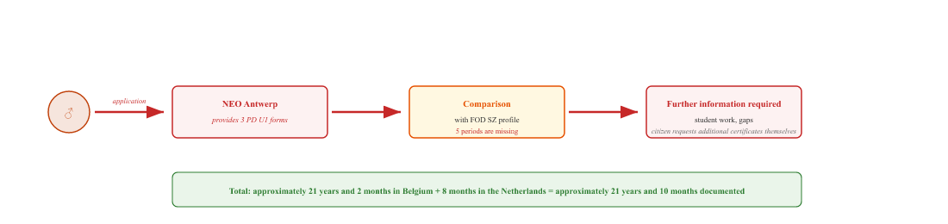
NEO provides three PD U1 forms. Upon comparison, it appears that five periods are missing — student work from 1999, gaps in 2001–2002, and transition periods. The citizen applies for the additional certificates themselves. The file is only complete once the information has been added manually. The system works, but only because the citizen detects and fills in the gaps themselves.

Route 2 — From the Netherlands to Belgium
The individual also worked in the Netherlands for eight months. In order to claim Belgian entitlements, this period of employment in the Netherlands must be verifiable within the Belgian system. The UWV issues the PD U1 form for this purpose. However, NEO refuses to integrate foreign employment records into its system.
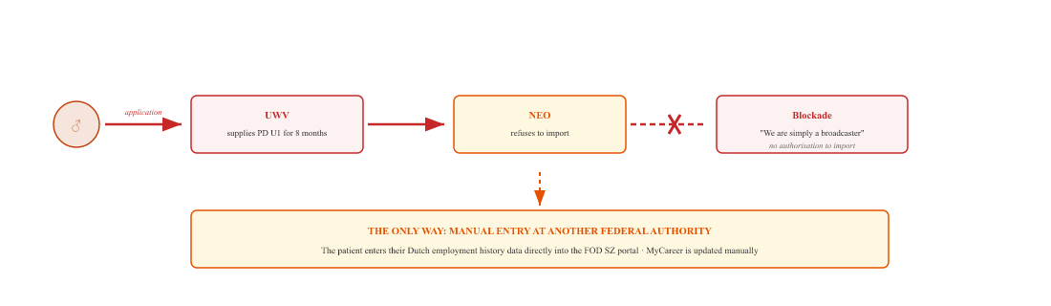
The UWV provides a PD U1 for the eight Dutch months. NEO refuses to integrate this data into its system: the agency regards itself as a sender, not a recipient. The only solution is for the citizen to manually enter the Dutch career data into the portal of another Belgian federal agency (FPS Social Security), which then transfers the data to MyCareer.

The pattern
Aspect | Direction 1 — BE → NL | Direction 2 — NL → BE
Publishing body | NEO (Antwerp) | UWV
Receiving body | UWV | NEO
Length of career | 21 years and 2 months | 8 months
Application | Manually, by email or via a form | Manually, using a form
Delivery | Works, with gaps | It works, but the recipient refuses
Transfer | Citizens must submit their applications to the UWV themselves | Citizen administers injection to FOD SZ
Blockade | 5 periods are missing; the citizen must fill them in themselves | NEO refuses to accept data from abroad
Bypass | Requesting additional certificates from employers | Manual entry via the FOD SZ portal
In both directions, the citizen is the only party who submits the document, either physically or digitally. NEO and the UWV do send documents to each other, but do not receive them from one another. There is no automatic system-to-system link. In direction 1, the citizen fills in the gaps themselves. In direction 2, they bypass the uncooperative NEO via another federal agency.

ESSPASS in 2030 — what won’t change
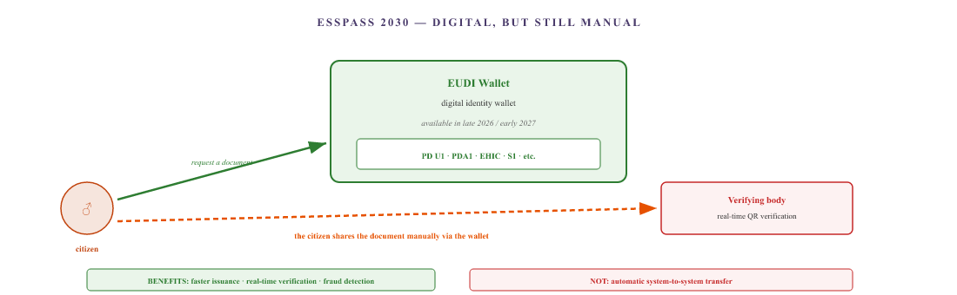
Figure VIII.2 — ESSPASS in 2030. The wallet digitises the document. Verification becomes faster. But the citizen’s process remains the same: they apply for the document and share it with the verifying authority. Member States do not automatically link their systems together. In 2030, NEO will still refuse to integrate foreign employment data, and citizens will still have to use the same workaround.

What ESSPASS does and does not solve
Aspect | Now (2026) | ESSPASS (2030)
Carrier | Paper | EUDI Wallet
Application | Manual, 75% no online application | Manually via the wallet
Issue | Manually, taking days to weeks | Automatically from the source, seconds
Transfer | In person, by post or by email | Manually via the wallet
Verification | Manually by a civil servant | Real-time QR scan
Fraud detection | Limited | Cryptographically strong
Coordination between Member States | None | None
ESSPASS eliminates paper-based delays. It does not eliminate the need for manual synchronisation. The citizen remains the party who requests and shares the document. What was a physical action in 2026 will become a digital action in 2030. The citizen’s role does not change.

Why this serves as a bridge to the Dutch section
In Belgium, the main administrative obstacles to this case have now been identified and, in part, overcome via the tax bypass. What remains in Belgium are implementation issues — the reopening of the case, the disciplinary complaint and the labour audit. No new structural obstacles are emerging.
The situation is different on the Dutch side. There, the WIA, the SVB, the Tax and Customs Administration, the municipality of Hulst, the CAK, the RIV registers and the entire Dutch administrative apparatus are still awaiting their own analysis. And that is precisely where a structural difference with Belgium lies, one that has not yet been highlighted.
The manual U1 issue is the final Belgian obstacle in this matter. At the same time, it is the gateway to the Dutch part — because direction 2 (the Netherlands to Belgium) is the first step that also affects the Dutch authorities. What is still touched upon in passing in this chapter will take centre stage in the following chapters: the WIA, the SVB, benefits, healthcare allowance and local authority implementation.
For anyone in the same situation: the PD U1 is a right, not a favour. You can request it from either organisation — from NEO for Belgian years of employment, and from the UWV for Dutch years of employment. If either of these bodies refuses to import foreign data, the only option is to go via the FPS Social Security (MyCareer portal). Ask your trade union or social services department about the correct procedure. ESSPASS in 2030 will simplify the application process, but will not remove the block at the receiving authority.
The information on the PD U1 is based on Document B and on the official procedures of NEO and the UWV. The ESSPASS information is based on public sources from the European Commission and the European Parliament concerning the ESSPASS Regulation, the EUDI Wallet and the phased implementation of the Labour Mobility Package. This chapter does not constitute legal advice.

SVB and Parentia — a working example
Not everything that happens between Belgium and the Netherlands amounts to a deadlock. This chapter highlights one case where European coordination actually works: child benefit for a child who lives in the Netherlands and attends school in Flanders. Two authorities, two countries, one child. They manage to find common ground. And then a recalculation takes place.

Part A — The split
For a child whose parents work in two different countries, the European Co-ordination scheme allocates child benefit. The rule is that one country pays the main contribution, and the other country tops up the difference to the level applicable in the country of residence. For this family, this means:
- Belgium is the main contributor, as the mother works in Belgium. Parentia pays out the Groeipakket.
- The Netherlands tops up the benefit to the Dutch level, as the child lives in the Netherlands. The SVB pays out the difference.
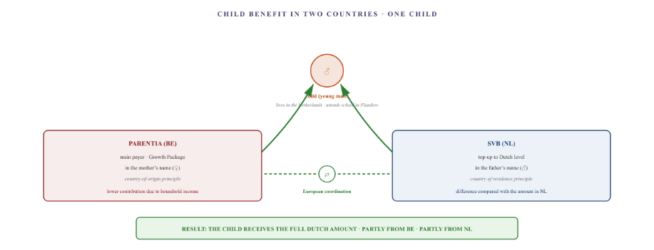
Figure XII.1 — The split. Parentia pays the Belgian contribution in the mother’s name (country-of-employment principle). The SVB tops this up to the Dutch level in the father’s name (country-of-residence principle). The child receives the full amount to which a Dutch child is entitled, divided between the two countries.

Part B — Why this works
What works here is precisely what goes wrong elsewhere in this case. Two national authorities, two different sets of laws, two languages, and one child. They manage to find common ground.
The European Coordination Regulation provides for a mechanism known as the ‘overlap of family benefits’. This mechanism determines which country pays the main contribution and which country pays the supplementary amount. Parentia and the SVB apply this mechanism. They exchange information on each other’s cases, recognise each other’s decisions, and settle the amounts.
The key: the supplementary benefit in the father’s name. The mother worked in Belgium, so the SVB could not award a supplement in her name — Belgium was already responsible for that. However, the father did not work outside the Netherlands and lived in the Netherlands. This made him the appropriate person to receive the difference. A straightforward application of the European rules.
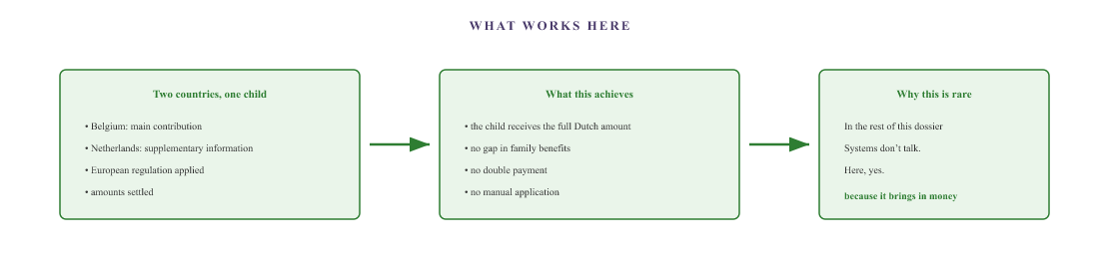
The European coordination of family benefits works here because both countries recognise each other’s systems and offset the amounts. Elsewhere in this dossier, things go wrong because no offsetting takes place — in the case of medical expenses, transport costs and allowances.

Part C — The recalculation that threatens success
Now comes the second part of the story. As soon as the father’s retroactive reclassification to ‘disabled dependant’ status takes effect, the family’s tax situation will change.
What will change: the mother will have more money left over after tax. Not because she earns more gross income, but because the family will be entitled to tax relief following the recognition of the father’s disability.
And that’s when the cascade effect begins.
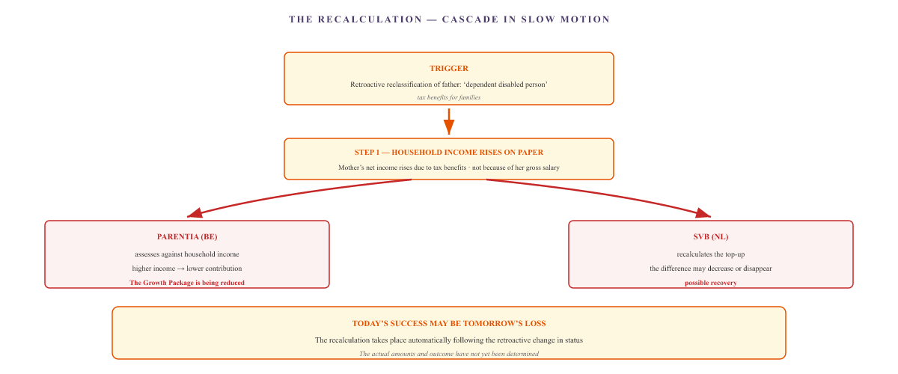
Figure XII.2 — The recalculation. The retroactive change in status to ‘dependent disabled person’ results in tax benefits for the family. On paper, the family’s income increases. Parentia reduces the contribution. The SVB recalculates the supplement. This may involve a recovery of benefits. What works today may be reversed tomorrow by an automatic recalculation.

Part D — What this chapter illustrates
This is the only chapter in Document C in which a mechanism works in its entirety. And that is precisely what makes it interesting, for three reasons:
Firstly, European coordination does indeed work for family benefits, because the regulation prescribes an explicit mechanism (overlap) and both countries adhere to it. Where that mechanism is lacking — such as in the case of medical conditions, healthcare allowances and patient transport — it does not work.
Secondly, the fact that the supplement is issued in the father’s name shows that the same administrative reality yields different results depending on who submits the application. If submitted in the mother’s name: no supplement. If submitted in the father’s name: a supplement is issued. One family, two outcomes, depending on the formal role.
Thirdly, the retroactive reclassification poses a new risk. As soon as the father’s status changes, the amounts are recalculated. What is currently a functioning system could result in a debt next year – not because of an error, but because of a recalculation.
These three points make this chapter the perfect counterpart to the Parentia case (Block II) and the Hulst Local Authority case (Block III). The same authorities, a different outcome. What this case study shows is that the system sometimes works — but it is never guaranteed. Success is the exception, not the rule.
For anyone in the same situation: the SVB is responsible for the child benefit supplement if you live in the Netherlands and do not work abroad. Do you have a working partner? In that case, you will not usually receive a supplement in your own name — ask the SVB about the correct allocation.
Please note regarding retroactive changes: as soon as either partner’s tax status changes, both Parentia and the SVB will recalculate the amounts. This may result in recovery claims. Keep all decision notices and check the recalculations annually.
The facts are based on Document B. The retrospective recalculation is a forecast based on the pattern of recalculations in the file; the final amounts and the outcome have not yet been determined. All organisations in this chapter are legal entities. Natural persons are identified by their position or their symbol (♂, ♀).

The body without a rear guard
A cross-border worker lives in the Netherlands and receives treatment in Belgium. His entire medical record is stored in Belgian data silos. What happens if something goes wrong in his country of residence? An emergency, a fall, an acute complication? Who, then, is the doctor who knows him? The answer is: no one. The law prohibits it.

Part A — The legal impossibility
In the Netherlands, a patient may only be registered with one GP practice. Anyone who registers with a new practice is automatically deregistered from their old one. This is a nationwide system designed to prevent duplicate registrations. For the average Dutch person, this makes sense. For a cross-border worker who has spent their entire medical history abroad, however, it is a problem.
The reason why dual registration is prohibited: the Dutch Health Insurance Act and the administrative regulations governing general practice prohibit dual registration across national borders. A GP may only register a patient if they actually bear primary and active medical responsibility for that patient. Registration without active treatment is not legally possible.
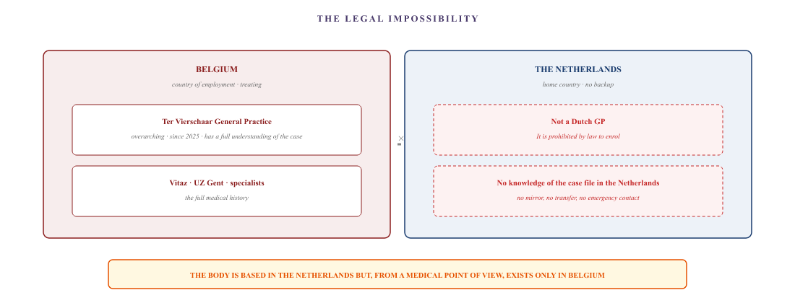
Figure XIX.1 — The legal impossibility. The patient’s complete medical records are held in Belgium. He cannot register with a GP in the Netherlands, as the law prohibits dual registration. He lives in a country where no doctor is familiar with his medical records.

Part B — The practical implications
What happens if a medical problem arises in the country of residence?
- A fall at home, an acute complication of diabetes, an infection at the amputation site — the GP on call is not familiar with the patient’s medical records.
- The clinician must make a decision based on limited information, without the patient’s amputation history, without their medication list, and without details of their specific wound care needs.
- The patient must explain the context themselves — in an emergency, they may not be able to do so.
- In the event of an emergency admission to a Dutch clinic: no medical records, no medication history, no wound care protocol.
The file explicitly sought to resolve this issue by registering the patient with a Dutch GP practice for purely informational purposes. No active treatment was provided; the aim was simply to ensure that the patient’s medical records were accessible on Dutch territory, so that an on-call doctor or an emergency doctor could see what the situation was.
That application was rejected. The practice acknowledged over the phone that, in an ideal world, this would be the right solution, but that the law does not permit it. Registration without an active treatment relationship is not legally possible. The letter confirmed the system block, leaving no room for reconsideration.
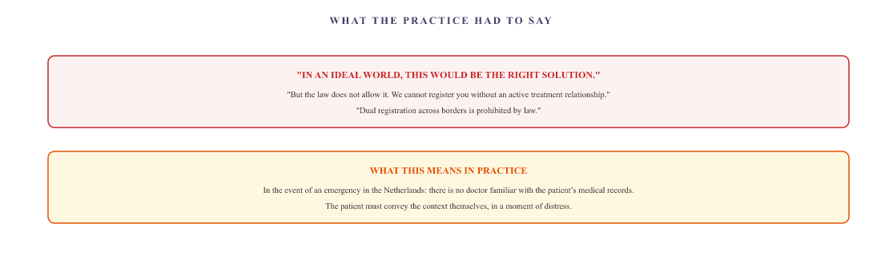
Figure XIX.2 — The practice’s response. The GP practice acknowledged that, in theory, an ‘informative’ registration would be the ideal solution, but that the law prohibits dual registration across borders. The practice cannot register a patient without an active treatment relationship.

Part C — The law that protects and paralyses the family
The rule that a patient may only be registered with one GP practice is intended to safeguard the quality and continuity of care. For ordinary citizens, this rule works. For cross-border workers who have spent their entire medical history in another country, however, this same rule creates a gap in their healthcare security.
The European Union recognises the right to free movement. It also recognises the right to medical care abroad. However, it does not provide a solution for patients whose medical records are held in one Member State whilst they are physically in another. The law safeguards continuity within a single country. It does not provide for continuity across borders.
What the family is left with is a pragmatic solution: the patient carries his own medical history with him, either in physical or digital form. If he has to see a Dutch doctor in an emergency, he must be able to explain the situation himself. If they are admitted to hospital in the Netherlands, they must provide the Belgian medical records themselves. They are not only the data hub for the administration, but also for their own immediate medical safety.

Part D — The paradox
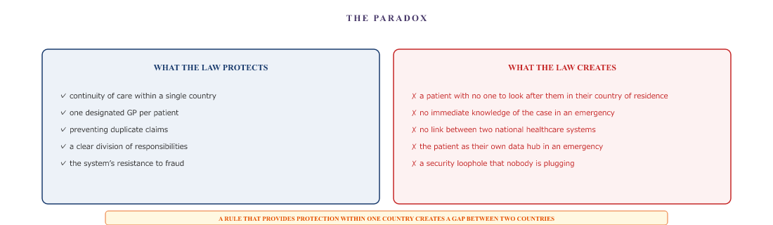
Figure XIX.3 — The paradox. The law safeguards continuity of care within a single country. It does not provide for continuity across borders. For the average citizen, the rule works. For a cross-border worker, that same rule creates a gap in protection.

What this chapter sets out
The patient lives in the Netherlands, but his entire medical history is in Belgium. Dutch law prohibits patients from being registered with two GPs. The patient is therefore unable to establish a medical base in the country where he lives. And in an emergency, there is no doctor who is familiar with his medical records.
The GP practice approached about this acknowledged that, in an ideal world, this would be the right solution. The law prohibits it. The European Union recognises freedom of movement and cross-border healthcare, but does not provide for continuity of care across borders. The family gets round this by having the patient carry their own medical records. Once again: not because the system requires it, but because there is no alternative.
For anyone in the same situation: three things to bear in mind:
- It is not legally possible to register with a Dutch GP practice for information purposes only. Ask your Belgian GP for an up-to-date medical passport in paper form (list of medications, diagnoses, treating practitioners).
- Carry this record with you at all times, even in emergencies. If necessary, keep an emergency card in your wallet containing your key medical details.
- Keep a digital copy of the most important reports on a USB stick or in a secure cloud, so that you can provide them immediately if you are admitted to hospital in the Netherlands.
Regarding long-term, structural solutions: this is one of the issues for which the European Union has not yet found a solution. Your feedback helps to build pressure to change this.
All organisations mentioned in this chapter are legal entities. Natural persons are referred to by their title or their symbol (♂). The facts are based on Document B. This chapter does not constitute legal or medical advice.

The central pot
All the previous chapters have described authorities that refuse to act, procedures that grind to a halt and systems that fail to recognise the reality of the situation. This chapter shows the result. When benefits fail to materialise, allowances remain at zero, medical costs continue to mount up and no one steps in to bridge the gap, there is only one player left: the private sector. The bank. The energy supplier. The network operator. And they do not operate according to protocols, but according to payment deadlines.

Part A — The account as a reserve
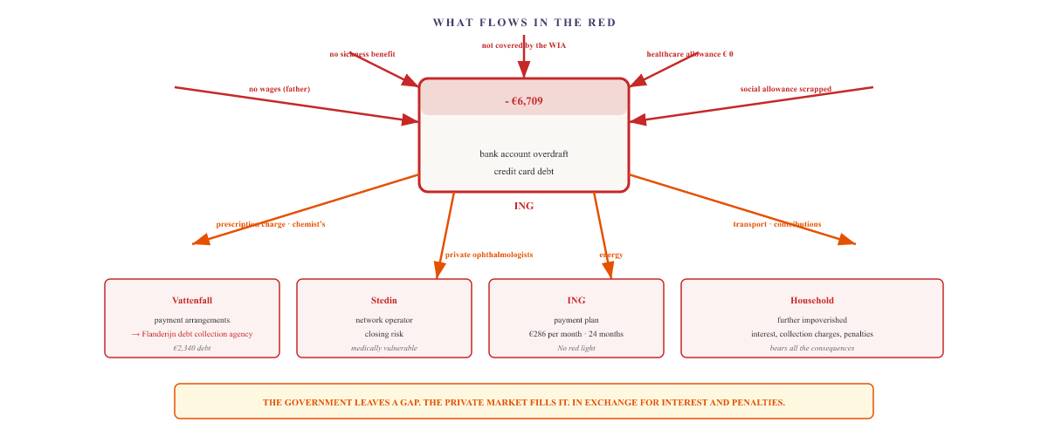
Figure XX.1 — The bank account as a reserve. Any shortfall in benefits and allowances, combined with outgoings on medical costs, creates a deficit in the bank account. That deficit is covered by commercial parties: the bank, the energy supplier, the debt collection agency. In return for interest, subject to penalties, and under strict conditions.

Part B — The three private gates

ING — the bank as a lifeline
When government payments stop and medical bills keep mounting up, the joint bank account goes into the red. The credit card reaches its limit. ING offers a payment plan: the entire debt is transferred to a separate account and repaid over twenty-four months.
The bank’s conditions: no overdrafts for three months. No credit card for twelve months. Monthly repayment of €286.55. Anyone who fails to comply with the conditions will lose their place on the scheme.
The bank is not acting in bad faith here. It is simply applying commercial logic. But the logic of the market is not the same as that of social justice. The public authorities that caused the shortfall bear no responsibility for the interest and penalties the family has to pay.

Vattenfall — the energy supplier
The energy supplier is seeing payment arrears mount up. Payment arrangements are agreed, broken and reinstated. The monthly instalments are increased to prevent a back payment. And when the patient invokes the ‘medically vulnerable consumer’ protection status, Vattenfall requires a statement from an independent Dutch doctor.
That requirement is impossible for a cross-border worker to meet. GPs refuse, the GGD refuses, and the private sector charges exorbitant fees for a remote medical examination. The family submits a Belgian medical certificate. Vattenfall refuses to recognise it. Only after months does the supplier admit that the requirement was unjustified and that the authority lies with the network operator.
Ultimately, the outstanding debt is referred to the debt collection agency Flanderijn. The total debt amounts to over €2,300.

Stedin — the network operator
Following the late referral from Vattenfall, the file is passed on to the network operator. Stedin is legally responsible for the physical supply. The patient must resubmit all medical evidence to a new private provider. There is no data transfer whatsoever, nor is there any recognition of documents previously submitted.
Stedin is the organisation that can guarantee the electricity supply, which is crucial for the refrigerated storage of insulin. However, the same applies here: the patient must rebuild the entire case from scratch, without the previous application to Vattenfall being recognised.

Part C — The bank as the de facto creditor of the welfare state
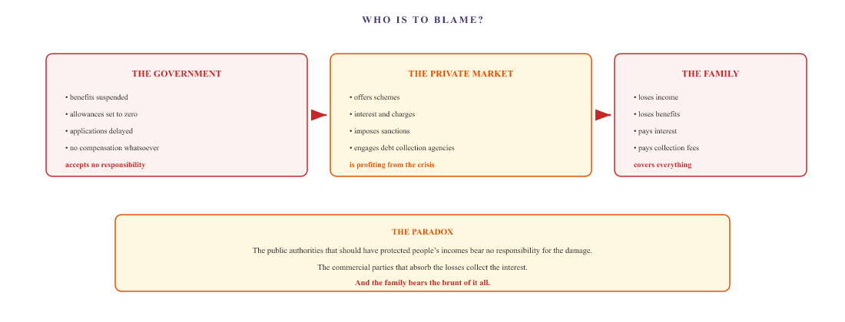
Figure XX.2 — Who bears the blame? The government causes the shortfall but accepts no responsibility. The private market fills the gap and collects the interest. The family bears the consequences: loss of income, loss of benefits, mounting interest, collection costs, and further impoverishment.

What this chapter sets out
The chain of failing public authorities ultimately leads to one central point: the bank account. What does not come in, and what does leak out, determines how far the family’s circumstances deteriorate. And what the family cannot cope with is absorbed by the commercial market — at interest, subject to penalties, and with collection charges.
Private sector organisations are not to blame here. They are simply applying commercial logic. What this chapter shows is that the government has shirked part of its responsibility. The gap it has left is being filled by the market. But the market does not fill gaps out of a sense of solidarity. The market fills gaps at a price.
And that price is paid by the family that already has no income. By the parents who already receive no benefits. By the patient whose amputations are not compensated by anyone. By the child who plays no part in this game but who bears the consequences.
For anyone in the same situation: the retail chain couldn’t care less about the cause of the debt. What helps:
- Gather evidence of every instance where the authorities failed to act, which led to the debt. Prove that the debt did not arise from your own choices, but from the failure of the authorities.
- Apply to your local authority for special assistance to cover the debts incurred. If the local authority refuses, lodge a formal appeal and refer to the chain of causality.
- Contact your local authority’s debt advice service (via the Debt Advice Centre). Ask for an amicable debt settlement that takes the cause of the debt into account.
- Engage a social counsellor or legal adviser (via your trade union or the Legal Advice Centre) to negotiate with commercial parties.
The private sector is not obliged to take the cause into account. However, an established causal chain may well alter the negotiating position.
All organisations mentioned in this chapter are legal entities. Natural persons are referred to by their position or their symbol (♂, ♀). The facts and figures are based on Document B. This chapter does not constitute legal or financial advice.

V. Europe

The European layer
When national avenues have been exhausted and national politicians fail to intervene, there is still one level left: Europe. In theory, Europe should provide the solution to a cross-border problem. In practice, however, it appears that most European bodies lack the mandate to break the deadlock in the national chain. But two exceptions have emerged in this case. Two opportunities that nobody had anticipated.

Part A — The European and international level
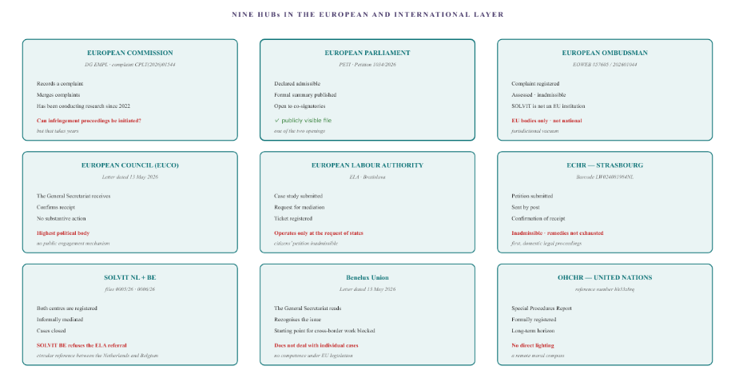
Figure XXII.1 — The European and international levels. Each with its own mandate, each with its own limitations. Two exceptions stand out: the European Parliament, where petition 1034/2026 has been made public and is open to co-signatories, and the Commission, which has been investigating several infringement complaints against Belgium and Flanders since 2022.

Part B — The circular reference
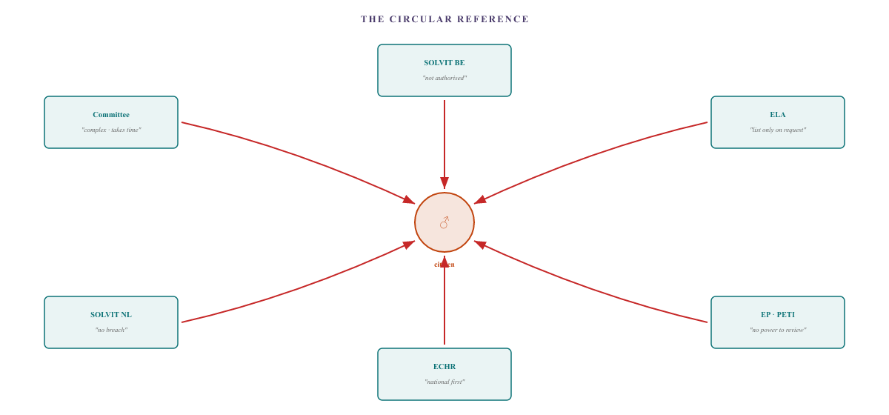
Figure XXII.2 — The circular reference. The European institutions refer to one another. The Commission is waiting for the Member States. The Member States are waiting for the Commission. SOLVIT is waiting for a clear infringement. The ELA is waiting for a request from the Member States. Parliament cannot review national decisions. The ECHR is waiting for national legal proceedings.

Part C — The two openings
In September 2026, two openings appeared in this seemingly closed circle that nobody had anticipated.

Petition 1 — PETI 1034/2026 open for co-signatories
The European Parliament has taken up petition 1034/2026. On 25 September 2026, the status was changed to ‘open to co-signatories’. This means that the petition has been given an official parliamentary summary and has been published on the European Parliament’s petitions portal.
The summary has been published under the policy areas of the Internal Market, Employment, Health, Social Affairs and Fundamental Rights, with Belgium and the Netherlands listed as the Member States concerned. The petition highlights the structural failure of both Member States to comply with the Vester judgment, their refusal to aggregate insurance periods, and the residence requirements. It calls on the European Commission to initiate infringement proceedings.
What this means is that the petition is no longer a private complaint sent to a PO box. It is a formal parliamentary dossier that any EU citizen can sign. This changes the political status of the dossier.

Point 2 — The Commission has been investigating this since 2022
On 25 September 2026, an official letter from the European Commission (DG EMPL) was added to the file. It reveals that the Commission has been investigating several infringement complaints against Belgium and Flanders since 2022 and 2023. These complaints relate to the Flemish job bonus, student finance and the Growth Package — all three of which fall under Regulation 492/2011 on the free movement of workers.
The Commission has not reached a final decision in all these years. That does not mean that the complaints have been rejected. It means that they are still under consideration. And that this family’s complaint forms part of a series of complaints that the Commission is already investigating.
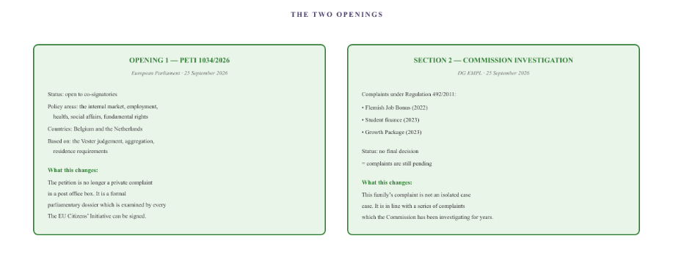
Figure XXII.3 — The two avenues. On the one hand, the petition in the European Parliament is public and open to co-signatories. On the other hand, it appears that the European Commission has been investigating several complaints against Belgium and Flanders since 2022 without reaching a decision. This family’s complaint is not an isolated case.

Part D — The infringement proceedings that never materialise
The European Commission has one binding instrument: the infringement procedure. Where a Member State systematically breaches EU law, the Commission may initiate proceedings which ultimately lead to a ruling by the Court of Justice and, in theory, to financial penalties for the Member State.
In practice, this is a political decision, not a legal formality. The Commission assesses whether it is politically expedient to initiate infringement proceedings. In this case, the complaint has been registered under CPLT(2026)01544 and merged with other complaints under Ares(2026)5891709. The Commission has not yet initiated infringement proceedings.
The reasons why this does not happen are structural:
- The Commission receives thousands of complaints every year. It cannot initiate proceedings in response to every complaint.
- The coordination of social security is formally a shared competence. Member States have a wide margin of discretion.
- On average, infringement proceedings take between four and six years before a ruling is handed down.
- A ruling establishes that a violation has taken place, but does not always lead to a resolution of the individual case.
What this means for the public: even if the Commission were to intervene, the proceedings would take years. And even if the Court were to rule that a violation had taken place, that would not immediately resolve the individual case.

Part E — The European paradox
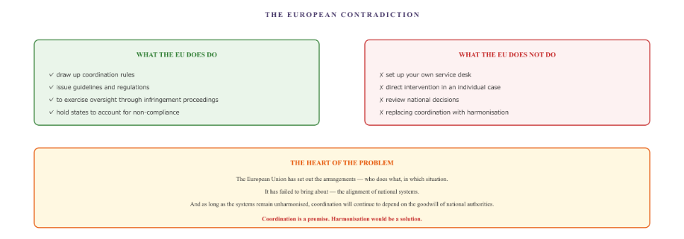
Figure XXII.4 — The European paradox. The EU coordinates social security, but does not harmonise it. As long as this remains the case, any solution will depend on national governments.

What this chapter sets out
The European level has created the framework within which cross-border social security should be organised. It has laid down the rules, established the liaison networks and set up the coordinating bodies. And it has entrusted itself with the task of monitoring compliance with the rules.
However, the European level has failed to ensure compliance with the architecture. Most bodies can only monitor, mediate and report — without any enforcement powers. And the path to the courts is a long one.
Two things stand out. The petition in the European Parliament has been made public and is open to co-signatories. This changes the political status of the case: it is no longer a private complaint. Furthermore, the European Commission has been investigating several infringement complaints against Belgium and Flanders since 2022. This family’s complaint is one of a series that is already underway.
What remains is a citizen who has knocked on every door in Europe and received the same message at every one: we have no jurisdiction over your individual case. But whilst some doors remained shut, two have been left ajar. For a case that went unheard for ten years, that is no small thing.
For anyone in the same situation: the European process is a long one, but there are opportunities.
- Submit a petition to the European Parliament (PETI). Once it has been declared admissible and made public, the petition will appear on the petitions portal. You can ask other citizens to co-sign it. This changes its political status.
- Register your complaint with the Commission (DG EMPL). Every complaint is registered. Multiple complaints on the same issue can be combined into a single case file.
- Be cautious when dealing with the ECHR. The Court declares complaints inadmissible until national legal remedies have been exhausted. Pursue national legal proceedings first.
- Do not use the ELA directly. The ELA only mediates at the request of Member States. It goes via SOLVIT, provided that body is willing to refer the case — which did not happen in this instance.
The European route is available. There are also two avenues open. It is up to the citizen to make use of them.
All organisations in this chapter are legal entities. The legal basis for the various procedures is set out in the Treaties of the European Union (Articles 258 and 259 TFEU for the infringement procedure), the Rules of Procedure of the European Parliament (PETI procedure) and the Statute of the Council of Europe (ECHR). The information on the complaints procedures is based on Document B. This chapter does not constitute legal advice.

VI. Those who are watching

The control and mediation layer
When an implementing body refuses, there is a level of authority that is expected to intervene: the ombudsmen, the mediation services, the European networks. In this case, that level was called upon. It listened, investigated, and concluded at every level that it could not intervene. In the end, it turns out that the most robust mediation route — the European Labour Authority — is not even accessible.

Part A — The four mediators
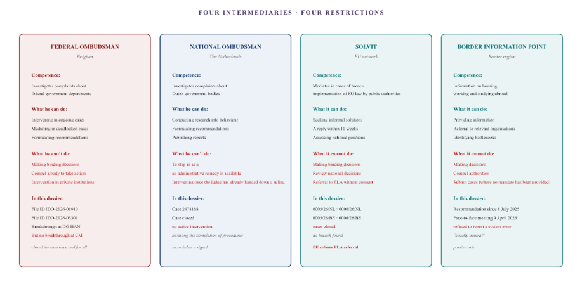
Figure XV.1 — Four mediators, four restrictions. The Federal Ombudsman may intervene in ongoing cases, but cannot compel action. The National Ombudsman cannot intervene whilst an administrative appeal is pending. SOLVIT cannot compel action and withdraws from ongoing proceedings. The GIP can only provide information and refuses to report a system error.

Part B — The difference between the two ombudsmen
The Belgian and Dutch ombudsmen appear similar, but their legal frameworks are fundamentally different.
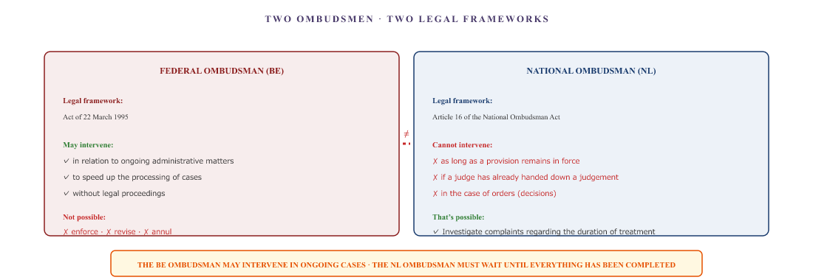
Figure XV.2 — The two ombudsmen. The Federal Ombudsman may intervene in ongoing administrative cases. The National Ombudsman is legally precluded from intervening whilst an administrative appeal is pending.

Part C — The circular reference between the two SOLVIT centres
Within the European framework, SOLVIT is the body responsible for mediating when national public authorities breach EU law. Two SOLVIT centres are involved in this case: SOLVIT Netherlands and SOLVIT Belgium. What follows is a pattern of mutual referral — until both centres withdraw.
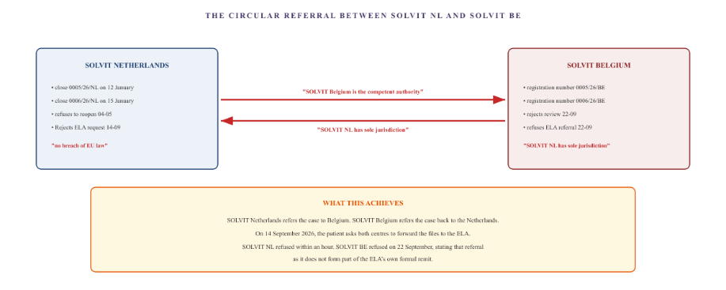
Figure XV.3 — The circular referral between SOLVIT NL and SOLVIT BE. Both centres refer cases to one another. And when the patient asks to be referred to the European Labour Authority, both refuse: SOLVIT NL because no infringement has been established, and SOLVIT BE because referral does not fall within its remit.

Part D — The ELA: the road that won’t open
If SOLVIT is unable to provide a solution, there remains one European body that was set up specifically to deal with cross-border disputes: the European Labour Authority (ELA). The ELA was established to promote fair labour mobility and to facilitate mediation between Member States in cross-border social security disputes.
In theory, the ELA should be the body that steps in when national governments cannot reach an agreement. In practice, however, the ELA appears to be inaccessible to individual citizens.
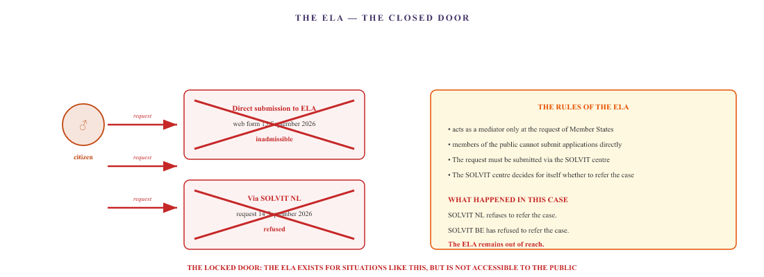
Figure XV.4 — The ELA as a closed door. The ELA only acts as a mediator at the request of Member States. Direct requests from citizens are declared inadmissible. And the referral points that are supposed to pass on these requests (SOLVIT NL and BE) refuse to do so. The body set up specifically for this sort of situation remains out of reach for those who need it most.

Part E — The pattern
What all mediators have in common is one fundamental characteristic: they can investigate, make recommendations and report, but they cannot compel. No mediator can oblige an implementing body to review a decision, award a benefit or process a registration.
There is a second characteristic to consider: each mediator has their own threshold for when they may intervene. The Federal Ombudsman may do so in ongoing cases. The National Ombudsman may not. SOLVIT may not do so in ongoing legal proceedings. The GIP may never do so. The ELA may only do so at the request of Member States. The ECHR may only do so after all domestic remedies have been exhausted.
And this dossier shows that the most robust mediation route — the European Labour Authority — is not only limited, but completely closed off. The ELA was designed for situations such as this, but is not accessible to individual citizens. And the only intermediaries that could grant access (SOLVIT NL and BE) refuse to do so.
The bottom line is that the mediation process acts as a series of filters. Every complaint is recorded, investigated and referred to another body which is also unable to take action. And when the final body is reached, it too turns out to have closed its doors.
For anyone in the same situation:
- The Federal Ombudsman (BE) is the only mediator who can intervene in ongoing cases without the need for legal proceedings first. Submit a complaint there if you get stuck dealing with a federal government department.
- The National Ombudsman (NL) can only take action once all administrative procedures have been completed. So do not start with the Ombudsman, but with the relevant authority itself and then take the matter to court.
- SOLVIT is useful for obtaining information and for documenting a systemic problem. In this case, however, both centres refused to refer the matter to the ELA. So do not expect a breakthrough through this channel.
- The ELA is not directly accessible to members of the public. Access is only possible via SOLVIT centres. And in this case, they have consistently refused to do so.
The mediation process complements the legal route; it is not a substitute for it. And sometimes even this complementary route is closed off.
All organisations mentioned in this chapter are legal entities. Natural persons are referred to by their job title. The facts are based on Document B. The legal frameworks are based on official communications from the relevant authorities. This chapter does not constitute legal advice.

The courts
When no other body intervenes, the courts are the last resort. In theory, this is where a decision can be enforced. In practice, however, access to the courts themselves proves to be a barrier — and that barrier is precisely the problem the courts were meant to resolve.

Part A — The two legal remedies
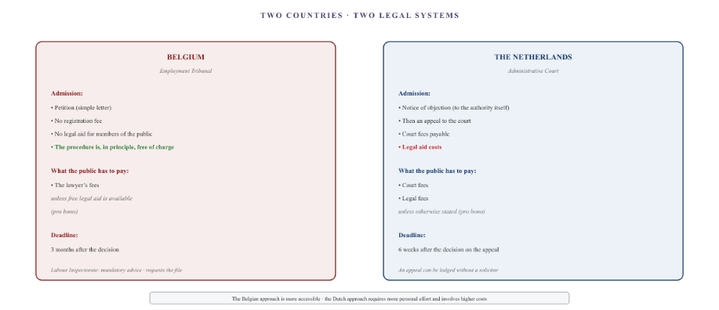
Figure XVI.1 — The two legal routes. In Belgium, the labour court can be accessed by means of a simple application, without any court registration fee or litigation costs for the citizen. The only costs are the lawyer’s fees. In the Netherlands, the process begins with a notice of objection lodged with the authority itself, followed by an appeal to the administrative court, which involves court fees and lawyers’ fees.

Part B — The pro bono threshold
Both countries have a system of subsidised legal aid: ‘pro deo’ in Belgium, and ‘toevoeging’ in the Netherlands. Anyone whose income falls below a certain threshold is assigned a solicitor, the costs of whom are (largely) borne by the state. However, the eligibility criteria pose a problem for a cross-border worker facing a medical emergency.
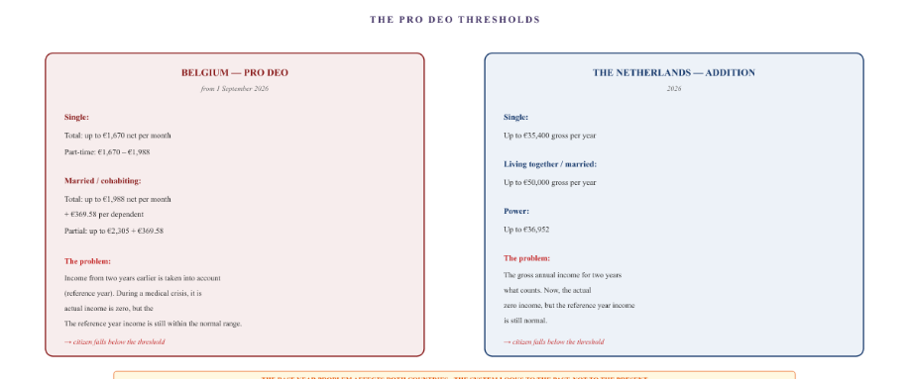
Figure XVI.2 — The pro bono thresholds. In Belgium, the assessment is based on the net monthly income from two years earlier (the reference year). In the Netherlands, the assessment is based on the gross annual income from two years earlier. In both countries, actual income has fallen to zero during the medical crisis, but the reference-year income is still based on the period before the crisis. On paper, the individual earns too much, whilst in reality they have nothing.

Part C — The irony of the reference year
The crux of the problem is the reference year. Both countries assess entitlement to subsidised legal aid on the basis of income from two years earlier. This is intended to prevent fraud: anyone who rapidly reduces their income in order to qualify is barred from the scheme. However, the system does not take into account a sudden, involuntary drop in income due to illness.
In the user’s file:
- Two years ago, their income was still normal — the father was working, and the medical crisis hadn’t started yet.
- At the moment, my actual income is zero: my sickness benefit has been suspended, my WIA claim has been rejected, and my benefits are at zero.
- Medical expenses have completely eroded our disposable income.
- However, the reference year income is still the old, standard income.
The result is that, on paper, the individual earns too much to qualify for legal aid, whilst in reality they have no money to pay for a solicitor. The threshold, which is intended to protect the most vulnerable, actually excludes those who have fallen on hard times due to a sudden crisis.
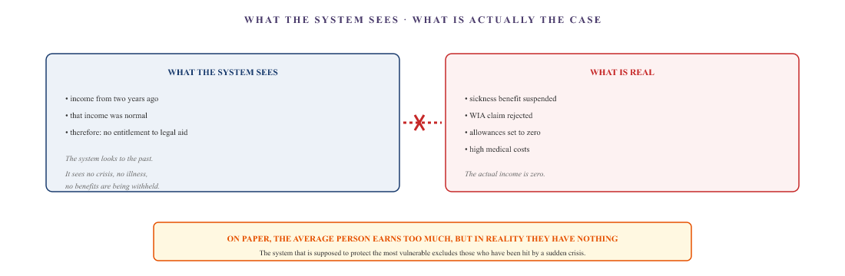
Figure XVI.3 — The irony of the reference year. The system assesses income from two years ago. In the context of a medical crisis, that income is no longer representative. On paper, the citizen earns too much to qualify for legal aid, whilst their actual income is zero. The threshold, which is intended to protect the most vulnerable, actually excludes precisely those who have fallen on hard times due to a sudden crisis.

Part D — What this means
In theory, legal action is the ultimate solution. A court can compel an authority to review a decision. In practice, however, access to the courts themselves proves to be a barrier. And that barrier is precisely the problem the court was supposed to resolve.
A citizen who cannot afford a solicitor cannot take legal action. A citizen who is not eligible for legal aid because their reference-year income is too high cannot take legal action. Citizens who have no income because their benefits have been suspended cannot take legal action. The system refers people to the courts, but the courts are out of reach for those who need access to them most.
In Belgium, the threshold is lower: the application form is straightforward and free of charge, and the only costs involved are the lawyer’s fees. But even those fees are unaffordable for many people. In the Netherlands, the barrier is higher: court fees, lawyers’ fees, and an even stricter assessment framework.
For anyone in the same situation: taking legal action is not impossible, but access is restricted by the reference year. Three things to bear in mind:
- Ask the Legal Aid Bureau (BE) or the Legal Aid Board (NL) for a reference year adjustment. In the Netherlands, this is possible if your income has fallen by at least 15 per cent compared with two years earlier. In Belgium, the Legal Aid Office may also take your current means into account.
- In Belgium, filing a petition with the labour court is free of charge. You can draw it up yourself, without a solicitor. A trade union or social organisation can help you.
- In the Netherlands, lodging an objection with the relevant authority is free of charge. If that does not help, the next step is the administrative court, but this involves costs. Apply for legal aid if your income in the current year is low — even if your income in the reference year was higher.
Legal action is a last resort. However, it is not equally accessible to everyone.
All organisations mentioned in this chapter are legal entities. The income thresholds for pro bono and legal aid are based on official communications from the relevant authorities (advocaat.be, the Legal Aid Board). This chapter does not constitute legal advice. If in doubt, consult a specialist service or a solicitor.

Politics
Politics has the power to change laws, allocate budgets and steer implementing bodies. In theory, it is the ultimate corrective power. In practice, however, it appears that politicians only exercise that power when the problem is presented as a collective systemic failure — not when it is raised as an individual complaint.

Part A — The separation of powers
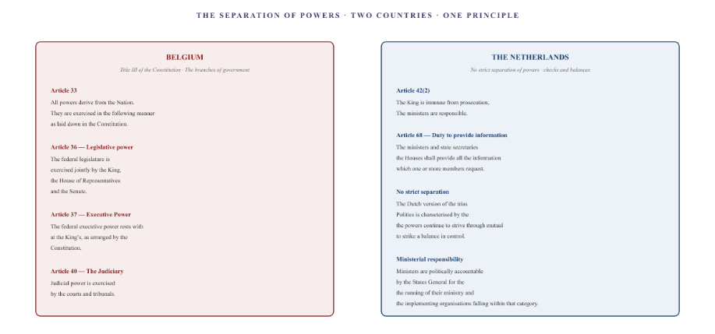
Figure XVII.1 — The separation of powers. Belgium has a classical trias politica, enshrined in Articles 33, 36, 37 and 40 of the Constitution. The Netherlands does not have a strict separation of powers, but rather a system of checks and balances, centred on ministerial responsibility (Article 42) and the duty to provide information (Article 68).

Part B — What politics can and cannot do
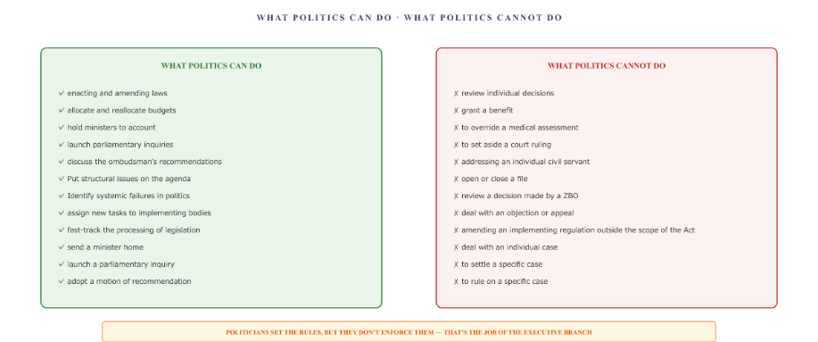
Figure XVII.2 — What politics can and cannot do. Politics can make and amend laws, but cannot review individual decisions. It can issue new instructions to an implementing body, but cannot open or close an individual case. The separation of powers prohibits interference in specific cases.

Part C — Belgian parliamentary practice
In Belgium, the Chamber of Representatives has a wide range of oversight tools at its disposal. The standing committees — including the Committee on Social Affairs, Employment and Pensions — draft legislation and scrutinise the government. Within these committees, Members of Parliament may ask written and oral questions, and raise interpellations which may lead to motions of recommendation or no confidence.
In addition, there is the Petitions Committee. Any citizen may submit a petition to it. The committee assesses whether the petition is admissible and then forwards it to the relevant committee or the relevant minister. That minister is required to provide a written response within six weeks. The committee may then decide to close the case, refer it elsewhere, or organise a hearing.
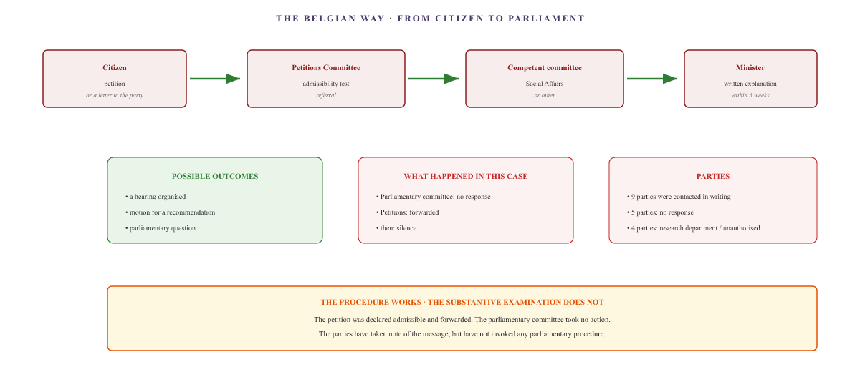
Figure XVII.3 — The Belgian way. A member of the public submits a petition. The Petitions Committee declares it admissible and forwards it to the relevant committee and the minister. The minister provides an explanation within six weeks. That is where the process ends. In this case: declared admissible, forwarded, no substantive response.

Part D — Parliamentary practice in the Netherlands
The House of Representatives has a similar range of instruments at its disposal. Members of Parliament may table written questions, ask oral questions, raise interpellations and table motions. The Standing Committee on Social Affairs and Employment (SZW) is responsible for scrutinising the Ministry of Social Affairs and Employment and the implementing bodies under its remit.
What sets the Netherlands apart is the parliamentary inquiry. This is the most powerful investigative tool: a committee that can hear witnesses under oath, request documents and publish a public report. The benefits scandal is the most recent example of how this instrument works — and how long it takes before it is deployed.
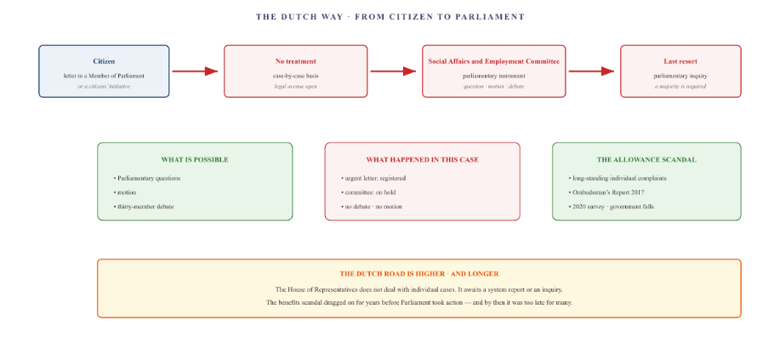
Figure XVII.4 — The Dutch approach. The House of Representatives does not deal with individual complaints. The Social Affairs and Employment Committee may shelve a case. The most powerful tool — the parliamentary inquiry — requires a majority and is only used in the event of major systemic crises. The benefits scandal illustrates just how long that takes.

Part E — A summary of the differences
Aspect | Belgium | The Netherlands
Individual complaint | Via the Petitions Committee · admissibility assessment · referral to the minister · written explanation within 6 weeks | Not under consideration · legal avenues must remain open or have been exhausted · a letter to an MP rarely leads to action
Parliamentary instrument | Written and oral questions · interpellations · motions for a recommendation · motion of no confidence · committee of inquiry | Written and oral questions · interpellations · motions · thirty-member debate · parliamentary inquiry
Strongest remedy | Parliamentary Committee of Inquiry · right of inquiry (Article 56 of the Constitution) | Parliamentary inquiry · witnesses under oath · legal basis (Parliamentary Inquiry Act 2008)
Case study in this dossier | The petition was declared admissible, forwarded, and then there was silence. Letters were sent to nine parties; five did not respond, and four referred the matter to their research department or stated they were not authorised to respond. | Urgent letter registered; set aside pending committee debate; no individual action taken. Parties were referred to the Ombudsman or the research department.
Lead time | Minister: 6 weeks for a written explanation · followed by a decision by the committee | No deadline for dealing with individual letters · survey: years

Part F — The power of framing
This is the key insight. The same facts can be presented in two different ways, and those two presentations elicit two completely different political responses.
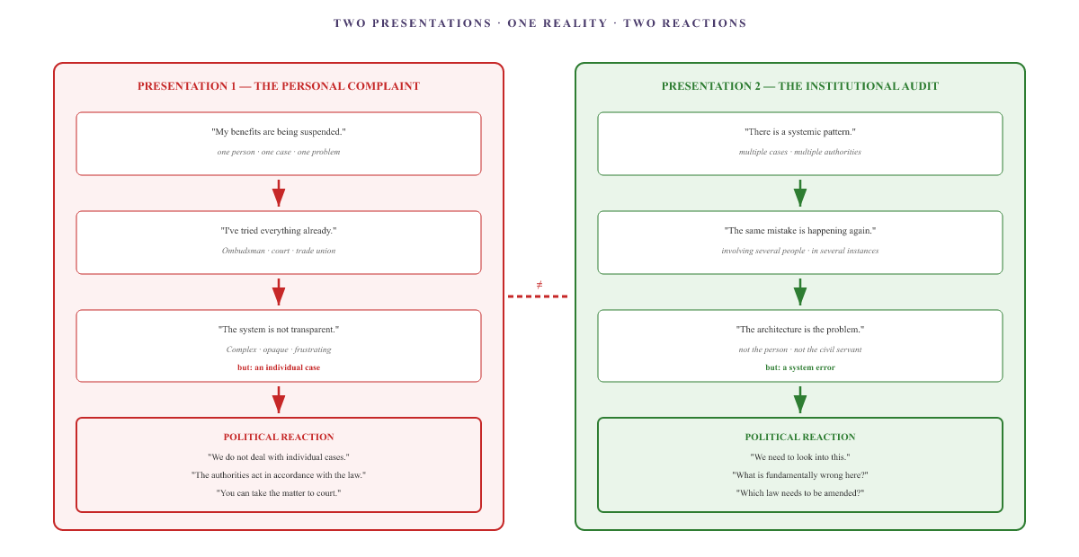
Figure XVII.5 — Two presentations, two responses. The same facts, presented differently. As a personal complaint: politicians declare themselves to have no jurisdiction. As an institutional audit: politicians have no choice but to address a systemic problem.

Part G — What this document does
This report is not a complaint. It is an audit. That is not a rhetorical choice — it is a strategic choice.
A complaint is treated as an individual problem. An audit is treated as a systemic problem. And only a systemic problem triggers the political mechanisms that can lead to real change.
The documents in this file are therefore organised in the form of an audit:
- Document B is not a list of complaints, but a data matrix: a factual record of dates, reference numbers and correspondence.
- Document C is not a picture book, but a visual architecture: a structural analysis of the institutional layers and the mechanisms that cause failure.
- Document D is not a summary, but a synthesis: the conclusions and the three building blocks for reform.
The difference is not merely superficial. It determines whether politicians can brush the matter aside — “we do not deal with individual cases” — or whether they must address it.
All organisations in this chapter are legal entities. Natural persons are identified by their position or their symbol (♂, ♀). The facts are based on Document B. The constitutional basis is Articles 33, 36, 37 and 40 of the Belgian Constitution, and Articles 42 and 68 of the Dutch Constitution. The parliamentary procedures are based on the rules of procedure of the Chamber of Representatives and the House of Representatives. The information on the benefits scandal is based on public reports by the National Ombudsman and the parliamentary committee of inquiry. This chapter does not constitute legal advice.

The nobility
In Belgium and the Netherlands, the King is the symbolic head of state. Formally, he has no independent power: his actions are only valid if co-signed by a responsible minister. Nevertheless, he receives thousands of petitions from citizens every year. These petitions are not legal proceedings. They are an informal channel — and precisely because they are informal, they can influence the political agenda in a way that formal complaints cannot.

Part A — Formal power: what the King can and cannot do
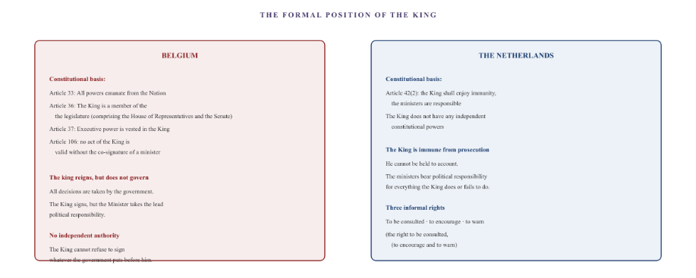
Figure XVIII.1 — The formal position of the King. In Belgium, the King is part of the legislature (Art. 36) and holds executive power (Art. 37), but no act is valid without the co-signature of a minister (Art. 106). In the Netherlands, the King is inviolable (Art. 42) and does not possess any independent constitutional powers. In both countries: the King reigns but does not govern.

Part B — The right to petition
In both countries, the right to submit a petition is enshrined in the constitution.
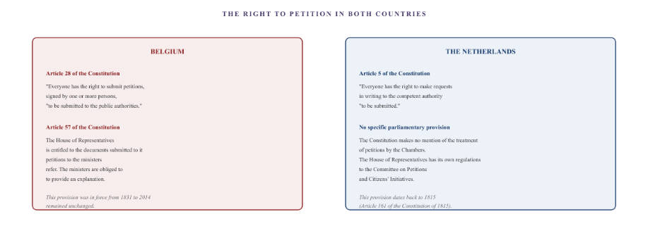
Figure XVIII.2 — The right to petition. In Belgium, the right to petition is enshrined in Article 28 of the Constitution, and Article 57 grants the Chamber of Representatives the power to refer petitions to ministers, who are obliged to provide an explanation. In the Netherlands, the right to petition is enshrined in Article 5 of the Constitution, without any specific parliamentary procedure. The House of Representatives has its own regulations governing the Committee on Petitions and Citizens’ Initiatives.

Part C — In practice: how petitions are dealt with
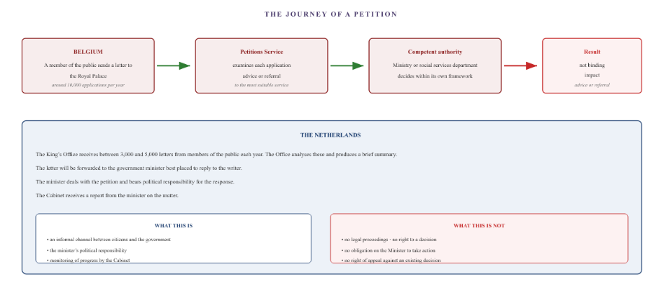
Figure XVIII.3 — The path of a petition. In Belgium, the Palace’s Petitions Service receives around ten thousand petitions each year. Each petition is examined and either given a response or referred to the most appropriate authority. In the Netherlands, the King’s Cabinet receives between three thousand and five thousand letters each year. The Cabinet analyses these and forwards them to the relevant minister. In both cases: there are no binding consequences.

Part D — The paradox of the informal channel
Formally speaking, the King has no power. The minister is responsible. Politics calls the shots. And yet: a petition to the King reaches a level that an ordinary complaint does not.
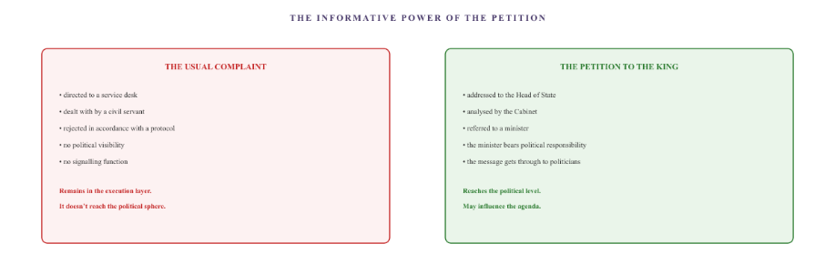
Figure XVIII.4 — The paradox of the informal channel. An ordinary complaint remains at the executive level. A petition to the King reaches the political level, because it is analysed by the Cabinet and must be answered by a minister. The King has no power, but his postbox does.

Part E — Practical aspects of this case
In this case, a petition has been submitted to the head of state in both countries.
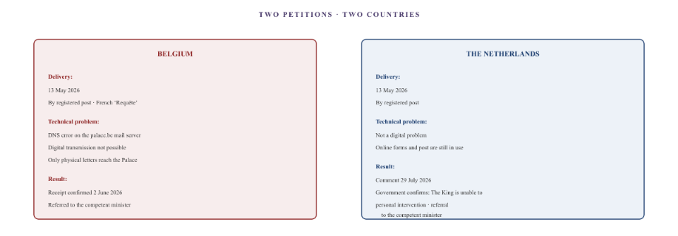
Figure XVIII.5 — The two petitions. In both countries, a petition was sent to the Head of State. In Belgium, the digital channel failed due to a DNS error on the Palace’s mail server; only the physical letter reached the Palace. In the Netherlands, the digital channel did work. In both cases, the petitions were forwarded to the relevant minister, without any substantive intervention by the King.

Part F — What this chapter sets out
The nobility — the King and his cabinet — have no executive power in Belgium and the Netherlands. The King reigns, but does not govern. He is immune from prosecution, but his acts are only valid if countersigned by a responsible minister.
Nevertheless, a petition to the King is a channel that does reach the political level. An ordinary complaint remains within the executive branch. A petition to the King is analysed by the Cabinet, answered by a minister, and — more importantly — the minister bears political responsibility for it. In this way, the message reaches a level where the executive branch cannot ignore it.
The paradox is that the King has no power, but his postbox does. It is an informal channel. No legal procedure. No right to a decision. But it is a channel that takes the message one level higher. And in a case where those in charge of implementation refuse to listen, that is no small matter.
All organisations in this chapter are legal entities. Natural persons are referred to by their title or symbol. The constitutional basis is Articles 28, 33, 36, 37, 57 and 106 of the Belgian Constitution, and Articles 5, 42 and 68 of the Dutch Constitution. The procedure for petitions is based on the official communications from the Royal Palace and the King’s Cabinet. This chapter does not constitute legal advice.

The allies and the watchdog
Alongside the government and the private sector, there are organisations that are supposed to support citizens: trade unions, equal opportunities centres, human rights organisations and academics. This report looks at four of them. One actually helps, with a tax service that makes a real difference. One claims it has no jurisdiction on the basis of a technical criterion. And the academic world only gets involved once the case has become irrefutable — and then things move quickly.

Part A — ACV: the trade union that helps and takes action
The General Christian Trade Union is Belgium’s largest trade union. As well as providing trade union representation, it offers legal assistance, tax advice and payment services for unemployment benefits. In this case, the trade union plays three roles.

What works: the tax office
The annual Belgian tax return is prepared via the ACV East Flanders tax department. The disability code is entered correctly. The childcare certificates are added manually. The result is a refund of €2,669.97, which was definitively submitted on 25 September 2026. This service is functioning correctly.

What doesn’t work: legal aid from the CM
If the CM refuses to pay sickness benefit and does not apply the aggregation rules, the trade union is formally called upon to intervene. It is not the patient who is a member, but his partner — herself a trade union representative in the education sector. Through her role, she seeks assistance from the Christian Teachers’ Association, the education branch of the same trade union.
The legal department fully acknowledges the system error. The administrative distinction between incapacity and disability is confirmed. Nevertheless, the trade union refuses to take legal action against the CM, citing a formal argument: the patient herself does not have a membership number. The paying member — the partner — suffers the financial consequences, but receives no legal assistance for a case that is not in her name.
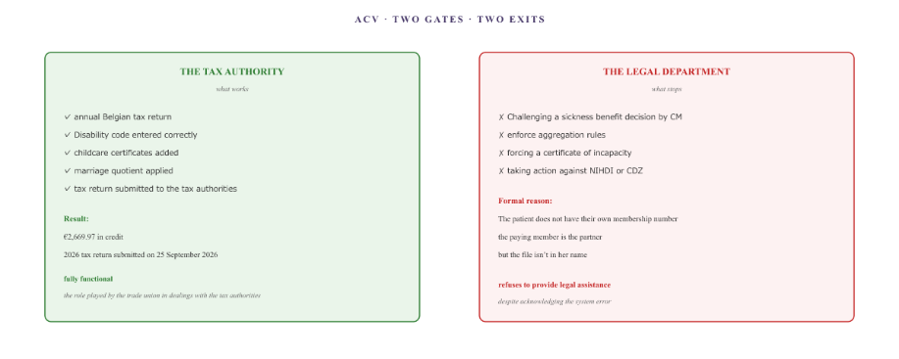
Figure XXI.1 — ACV: two entry points, two outcomes. The tax department is functioning. The legal department stops at the individual membership threshold: only members who have a case file of their own receive assistance.

Part B — UNIA: the watchdog that isn’t allowed to bite
UNIA is the Interfederal Centre for Equal Opportunities. It is Belgium’s independent watchdog against discrimination. When administrative bodies refuse to recognise a citizen on the grounds that they reside in a neighbouring country, the question arises as to whether this constitutes discrimination.
In April 2026, UNIA will be formally notified of the systematic exclusion of cross-border workers. The notification concerns the refusal to recognise medical qualifications solely on the grounds of residence in the Netherlands.
UNIA’s assessment highlights a shortcoming in Belgian anti-discrimination legislation. The watchdog formally declares that it lacks jurisdiction, for two critical reasons.
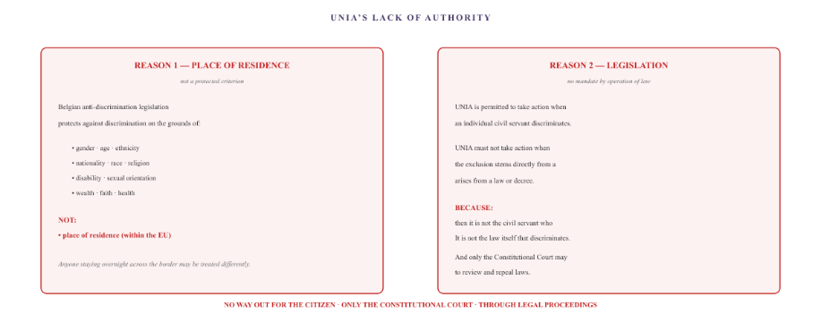
Figure XXI.2 — UNIA’s lack of jurisdiction. UNIA declares that it lacks jurisdiction for two reasons: place of residence is not a protected ground under anti-discrimination legislation, and the exclusion stems from the Act itself.
UNIA is closing the case. In doing so, it unwittingly confirms that the exclusion of cross-border workers under the current system is entirely legal.

Part C — The academic observation layer
The academic world is the final line of defence that could come to the public’s aid. Universities and centres of expertise study systemic failure, publish research on institutional exclusion, and possess the analytical tools to evaluate a case scientifically. What happens when they are presented with a real-life case?

Months of silence
Between May and September 2026, various academics and institutions will be contacted. Maastricht University’s ITEM Centre of Expertise, the Institute for Social Law at KU Leuven, the Montaigne Centre at Utrecht University, the DRIFT Transition Institute at Erasmus University, and Amsterdam UMC. For months, there is no response. Not a single substantive response is received to a dossier that embodies precisely the themes on which these institutions publish.

The opening
When, in the autumn of 2026, the complete dossier exceeds the threshold of 250 pages of irrefutable empirical evidence, the ITEM centre of expertise will begin a substantive review. On 17 September 2026, a professor confirms receipt of the dossier and states that he will read the documents first before commenting on their content.

What follows
In the following week, the case is actively reviewed. An independent researcher specialising in cross-border employment — based at an academic institution and not involved in the case — examines the material and, within a few days, provides a series of legal analyses and alternative courses of action:
- The Wajong procedure and the restrictions set out in Annex X to Regulation 883/2004 (benefits that cannot be exported).
- The Schumacker judgment (C-279/93) and the 90 per cent rule as the basis for tax equivalence.
- The Dimitri Hendrix judgment (C-385/17) on the continued payment of benefits following a move.
- The link between the Vester judgement and Frederic Vester’s systems theory.
- The central role of disciplinary complaints to the Medical Council as a systemic bottleneck.
- The municipality of Hulst’s refusal to accept the European parking card.
In addition, the researcher receives formal written confirmation from the FPS Finance (Non-Residents Tax PG15 Ledeberg) that voluntarily attaching medical certificates to the tax return is a valid way of proving tax disability status. A few days later, he submits an official letter from the European Commission (DG EMPL, 25 September 2026), which shows that the Commission has been investigating three infringement complaints against Belgium and Flanders since 2022 and 2023 without reaching a decision.
What seemed impossible for months has happened in four days. The academic community, which had previously remained silent, has delivered a series of legal breakthroughs in the space of a week. The academic world operates retrospectively, not curatively — and once it gets going, it moves quickly.
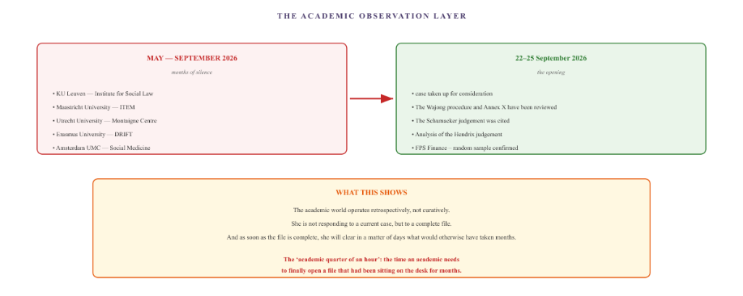
Figure XXI.3 — From silence to disclosure. For months, the academic world failed to respond to the dossier. It was only when it contained 250 pages of irrefutable evidence that the ITEM centre of expertise agreed to conduct a substantive review. And then things moved quickly: within four days, new legal avenues, court rulings and system links were provided.

Part D — What this chapter sets out
The four allies who are supposed to assist the citizen all operate within their own borders.
The trade union works on behalf of its members, but only in relation to the case filed in their name.
UNIA campaigns against discrimination, but only against discrimination that does not stem from the law itself.
The academic world operates on the basis of theory, but only comes into its own once the case has become complete and irrefutable. What had remained dormant for months springs into action within a matter of days. The focus is then no longer on the case itself, but on its scientific validation.
And what remains for the public is that the structural exclusion of cross-border workers has not only been legalised, but has also become socially normalised. Those who build up a case and persevere will eventually be heard. But only those who persevere.
For anyone in the same situation:
- Trade union: check whose name the membership files are in. If the file is not in your name, the trade union may refuse to intervene.
- UNIA: if the exclusion is enshrined in law, UNIA cannot intervene. The only option is to take the matter to the Constitutional Court through legal proceedings. That is a long and costly process.
- Academy: keep submitting the dossier to centres of expertise. Often, an institution will only show interest once a dossier is complete and irrefutable. It is a matter of perseverance and documentation.
All organisations mentioned in this chapter are legal entities. Natural persons are referred to by their position. The facts are based on Document B. UNIA’s role and mandate are based on Belgian anti-discrimination legislation (Act of 10 May 2007). The judgments cited are C-279/93 (Schumacker), C-134/18 (Vester) and C-385/17 (Hendrix). This chapter does not constitute legal advice.

VII. Conclusion

Conclusion — the complete pyramid
Five layers. Twenty-three chapters. One body at the centre. This is the complete System Audit board, at a glance.

The pyramid
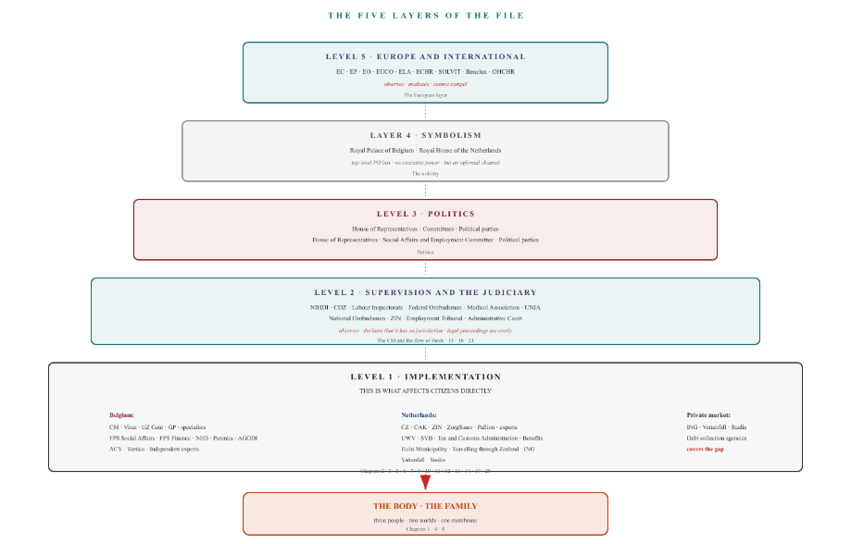
Figure XXIII.1 — The complete pyramid. Five layers. At the top: Europe and the international sphere; then symbolism; then politics; then oversight and the judiciary; and at the base: implementation and the private market. At the very bottom: the individual and the family, for whom everything is ultimately done.

What this case has shown
Five layers, each with its own logic, each with its own mandate, each with its own limitations. What the case has shown is not that one layer is failing, but that the layers are failing together in a way that nobody can fix.
- The implementation applies the rules, but the rules are not designed for people who live in two countries at the same time.
- The supervisory authority recognises the error, but claims it has no jurisdiction or is awaiting a decision from another body.
- The courts may enforce compliance, but access is restricted by costs and the reference year.
- Politicians can change the law, but they only respond to systemic failures — not to individual complaints.
- Symbolism has no power, but it does provide an informal channel through which the political sphere can be reached.
- Europe coordinates, but does not harmonise. Each country retains its own system.
What remains is the body. A body that has been viewed, described and assessed through every layer. And which has never been fully recognised as a single whole. The individual themselves acts as a data hub, a repository of records, a connecting cable between two systems that are incompatible with one another. And when they can no longer fulfil that role, the system grinds to a halt.

The bridge to Document D
Document C has outlined the framework and the mechanisms. Document D draws the conclusions. Three building blocks for reform, based on the realisation that the fault does not lie with the individual civil servant, but in the very architecture of the coordination process itself.
What has become apparent in Document C is the structure of the vacuum. What is set out in Document D is the structure of the solution. Not because a single measure solves everything, but because the architecture can be adapted at three points where it is currently stalling.
This is the conclusion of Document C. All organisations mentioned in this document are legal entities. Natural persons are identified by their role or their symbol (♂, ♀). Document C is the visual counterpart to Document B (data matrix) and Document A (narrative audit). The conclusions and building blocks are set out in Document D (synthesis).

The entire network
Each of the previous chapters illustrated a single mechanism, a single instance or a single pattern. This chapter shows everything at once. The same nodes, the same channels, the same colours — but now in a single image, in no particular order, just as the family experiences it.

What the family sees
Readers who have got this far will have become familiar with each component individually. Each organisation had its own chapter. Each mechanism had its own diagram. Each colour had its own meaning. But the family facing this situation does not have that sense of order. The family sees only the whole picture. And that whole picture is a jumble.
This is the whole thing.
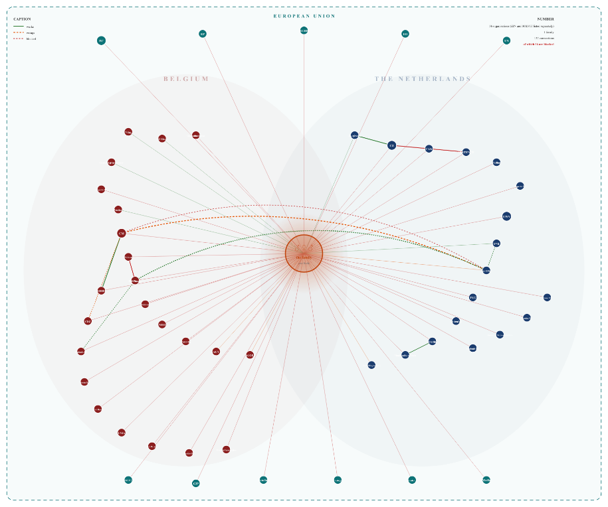
Figure XXIV.1 — The complete network. What the family sees when it tries to navigate. Two worlds, each with its own set of organisations. One family in the middle. And 127 connections, most of which are blocked. In the previous chapters, each component could be followed separately. Here is the whole picture — without order, without hierarchy, without tranquillity.

What this diagram does
All the previous chapters were well-organised. Each had a title, a framework and a clearly defined subject. Anyone reading those chapters gets the impression that the system is comprehensible, that each part has its own function, and that the chaos is merely an illusion.
This diagram dispels that impression. There is no structure here. There is no title for each node. There is only the whole: 54 organisations, one family, 127 connections, 96 of which are blocked. And in the centre, a body that must hold its own.
Readers who have worked their way through the previous 23 chapters knew where to look. They were able to follow the connections, recognise the channels and interpret the colours. But the family facing this situation does not have that structure. They do not realise that Vitaz operates in the healthcare sector and CM in the financial sector. They do not realise that CZ administers a treaty policy and CAK manages the register. All they see is this: there are people who are supposed to process my file, and they are not doing so.
That is what this diagram illustrates. Not the failure of a single body. Not the failure of a single mechanism. But the failure of the whole system — a network so complex that it is impossible for an ordinary person to find their way through it, and so rigid that it is impossible for an ordinary person to change anything within it.

What isn’t in it
The 127 connections shown in this diagram are the most important ones. In reality, there are more. Every letter sent to an organisation, every time a civil servant looks at a system, every telephone call made — these are all connections that do not appear in this diagram.
And the 96 blocked connections shown here are only the blocked connections between the family and the organisations. In reality, there are also blocked connections between the organisations themselves. Between CM and UWV. Between CZ and CAK. Between FOD SZ and FPS Finance. Every blocked connection between organisations is an extra layer that the family has to navigate.
What this diagram shows is not the entire network. It is a representation of the entire network. If all the connections were drawn in, the diagram would become illegible. And that is precisely the point.
All organisations in this chapter are legal entities. Natural persons are referred to by their title or symbol. The organisations are based on Document B. The connections are based on the actual correspondence in Document B, summarised where relevant. The figures (54 organisations, 127 links) are indicative; the actual number is higher. This chapter does not constitute legal advice.

