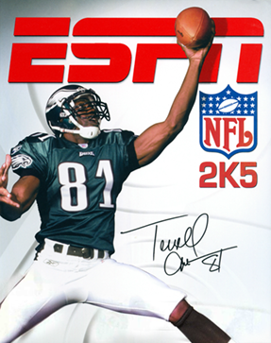

**v1.3.5 Fixes**

- Fixed field overlay shadow

- Fixed Chargers endzone + goal post

- Added CMs coach textures

- Added CMs updated gloves + cleats equipment (Bills, Colts, etc.)

- Added FoHs updated Vikings stadium textures

- Added FoHs updated Steelers stadium textures

- Added FoHs updated Colts stadium textures

- Added snow overlay to Dolphins goal post

- Added orange pants + fixed helmet stripes for Browns

**Applying v1.3.5 Patch**

Download the v1.3 pkg version you want from the github.com project site. The v1.3 fix pkg only includes the texture updates and does not include the emulator.

***NOTE: If this is the first time you are installing the NFL2K5 Resurrected Mod, you will want to download the full pkg and install.***

**INSTALLATION**

1. Extract the v1.3.5 fix pkg you downloaded, and open the folder
2. Move all folders *(textures, txtconfig)* into your main *(.\NFL2K5Res_1.6)* emulator directory and say YES to REPLACE all files

1. The roster folder includes CujoMatty's "Low" Ros + Fran that can be loaded using mymc

1. Launch PCSX2 and enjoy NFL2K5 Resurrected

If you find additional issues, please report them in our [Discord](https://user-images.githubusercontent.com/69597675/124640725-d1e88980-de5b-11eb-926d-ec5f55b19a62.png) [Discord](https://discord.gg/sBVXzYb)

Additional Uniforms

See below to know which teams have additional uniforms.

|  |  |
| --- | --- |
|  | - Current  - 93-94  - 64-93 |
|  | - Current |
|  | - Current  - 02 Alt |
|  | - Current  - 69-73 |
|  | - Current  - 85-96 |
|  | - Current |
|  | - Current |
|  | - Current  - 93-94 |
|  | - Current  - 85-87  - 83-84 |
|  | - Current |
|  | - Current |
|  | - Current  - 94 Alt |
|  | - Current |
|  | - Current |

|  |  |
| --- | --- |
|  | - Current  - 66-67 |
|  | - Current  - 81-99 |
|  | - Current |
|  | - Current  - 90-93 |
|  | - Current |
|  | - Current |
|  | - Current  - 96  - 03 Alt |
|  | - Current |
|  | - Current |
|  | - Current  - 98-99 |
|  | - Current |
|  | - Current |
|  | - Current |
|  | - Current  - 83-02 |
|  | - Current |
|  | - Current |
|  | - Current  - 74-75 |
|  | - Current  - 93-94 |

# Credits

The NFL2K5 Resurrected Mod is a collaborative effort by the NFL2K5 Mod Community.

Many thanks to everyone!

* LostsouL
* Xflamexofxhopex
* Xevan
* BAD_AL
* Orleans02
* Rick
* Heavvy
* MahomesMagic15

If you find additional issues, please report them in our [Discord](https://user-images.githubusercontent.com/69597675/124640725-d1e88980-de5b-11eb-926d-ec5f55b19a62.png) [Discord](https://discord.gg/sBVXzYb)