Macdonald Mide-Madariola
He/Him

Verify in 2 minutes

Business Development | Growth Strategy | Client Solutions
London, England, United Kingdom
·
Contact info

Wrexham University

500+ connections

Open to
Add section
Enhance profile

Open to work · Recruiters only
London | On-site · Hybrid · Remote
Show details

Share that you’re hiring and attract qualified candidates.
Get started

Showcase your services as a section on your profile so your business can be easily discovered.
Add services

Tell non-profits you are interested in getting involved with your time and skills
Get started

Suggested for you
Private to you
Add projects that showcase your skills
Show recruiters how you put your skills to use by adding projects to your profile.
Add a project
Analytics
Private to you

77 profile views
Discover who’s viewed your profile.

120 post impressions
Check out who’s engaging with your posts.
Past 7 days

22 search appearances
See how often you appear in search results.

Show all
About
Eager and skilled artificial intelligence graduate with a background in sales aiming to expand business knowledge.
With the goal-leading strategies that drive profitability and analytical solutions to achieve business intelligence.
Top skills
Communication • Analytical Skills • Direct Sales • Customer Acquisition • Entrepreneurship Education
Activity

612 followers

Create a post
Posts
Comments
Images
- 

Macdonald Mide-Madariola
• You

Business Development | Growth Strategy | Client Solutions
1w •

I recently completed my internship with Blackmont Consulting and would like to share a few reflections from the experience.
Throughout the internship, I contributed to the research and delivery of the final project, and collaborated with the team through regular online meetings and feedback sessions.
One of my biggest lessons was that strong consulting work is not about including as much information as possible. It is about identifying what is relevant, supporting it with credible evidence and communicating it as part of a clear and consistent story.
The experience strengthened my skills in:
• External research and source verification
• Presentation development and visual communication
• Critical thinking and problem-solving
• Remote teamwork and project coordination
• Responding constructively to feedback
• Time management and personal accountability
Thank you to Ratul Sharma, our Project Manager, for coordinating the project and guiding the team throughout. I would also like to thank Juan Yanes, Founder & CEO of Blackmont Consulting, for providing the opportunity to gain practical consulting experience and contribute to a collaborative project.
I am grateful for the experience and look forward to applying these skills to future opportunities in business development and consulting.
#BlackmontConsulting #Consulting #Teamwork #ProfessionalDevelopment #CareerGrowth… more

1/2
32

4

3

612 impressions
View analyticsView analytics

- 
Macdonald Mide-Madariola reposted this

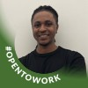

Millprince Mide-Madariola
• 1st

Final year MSc Physiotherapy Student | BSc Sport and Management Graduate | Interested in Neurorehabilitation, Orthopaedics & Exercise Therapy | Evidence-Based Practice
1mo •

Last week Friday, I officially completed my fifth and final clinical placement as part of my MSc Physiotherapy programme.
My last placement at Cleveland Clinic London in Cardio-Respiratory Physiotherapy has been a highly valuable and fulfilling experience, providing the perfect conclusion to my placement journey. Throughout the past two years, I have gained experience across a variety of clinical areas, including Musculoskeletal Physiotherapy, Community Neurological Rehabilitation, Inpatient Orthopaedics, Leadership, and Cardio-Respiratory Physiotherapy.
Reflecting on this journey, some of the most significant areas of development have been strengthening my clinical reasoning, enhancing my communication abilities, building confidence, and improving my capacity to manage increasingly complex patient presentations while providing holistic, patient-focused care. Each placement presented unique challenges and valuable learning opportunities, reinforcing that physiotherapy extends beyond treating a diagnosis—it involves understanding and supporting the person as a whole.
I am sincerely thankful to all the educators, colleagues, and patients who have played a role in my professional growth throughout these placements. Your guidance, support, patience, and encouragement have been invaluable.
With all clinical placements now completed, I am moving into the final phase of my MSc, with my dissertation remaining before graduation. As I start preparing for future physiotherapy roles, I look forward to continuing my professional development, expanding my knowledge, and taking the next step towards becoming a qualified physiotherapist.
Onwards to the final chapter of this journey. 🎉… more


1/4
48

4

4

- 

Macdonald Mide-Madariola
• You

Business Development | Growth Strategy | Client Solutions
2mo •

I’m excited to share that I’ve started my Business Consulting Internship with Blackmont Consulting Edinburgh Branch.
This is an exciting opportunity to develop my skills in business strategy and consulting while gaining hands-on industry experience.
I’m looking forward to working with a talented team and contributing to impactful projects.
Excited for what’s ahead.
#BlackmontConsulting #BusinessConsulting #Internship #Consulting #CareerGrowth … more

Starting a new position

51

32

5

1,832 impressions
View analyticsView analytics

- 
Macdonald Mide-Madariola reposted this



Mariella Mide-Madariola
• 1st

Strategic Account Executive | SaaS | Salesforce Ecosystem | Revenue Growth, Customer Success & Partnerships | UK, EMEA & North America
4mo •

Ireland, Sunshine, Salesforce… and a perfectly poured Guinness? Not a bad way to kick things off 🇮🇪☀️
AC started strong hosting dinner with the Salesforce Partner Cloud team! Incredible food, even better company, and plenty of travel stories shared around the table.
Yesterday, I had the privilege of presenting Advanced Communities Partner Cloud expertise alongside Stas Dunayev at the Tower. Brilliant energy in the room and a great opportunity to share best practices and what AC been working on.
Shoutout to Adrienne, Martin, Loic for delivering brilliant sessions, and to the team and all the ecosystem veterans who generously shared insights, advice, and a few hard-earned lessons. I’m constantly reminded how special this community is.
Huge thanks to Michael McGrath for putting together such a fantastic kickoff session but more importantly for the official Guinness masterclass… safe to say most of us have been doing it wrong🍻
Also Tom Furtney, while you were missed, your restaurant booking legacy lives on… and expectations are now VERY high (we’re thinking cooking classes next? 😄)
And yes… it was sunny in Ireland. I’ll take that as a win.
Grateful to be part of such an inspiring ecosystem! I’m already looking forward to what comes next.
Adrienne McCrory Greg Barsanti Sandro Rugi Nicolas Munoz Loic van Damme Jeremy Bridoux Gerardo Elmini Asmaa Z. Peter Taubitz Søren Staberg Borch Martin Voetmann … more
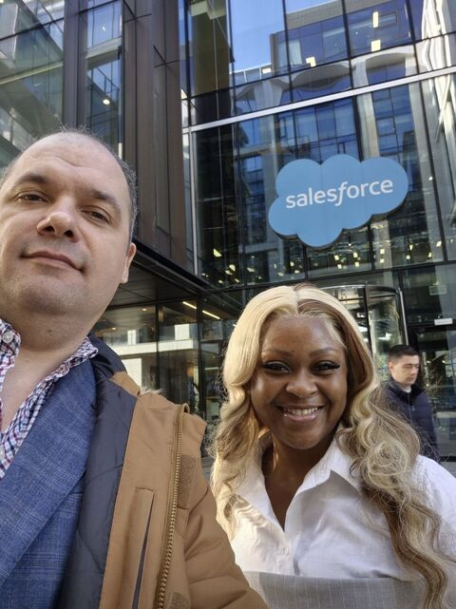
1/5
52

16

5

- 
Macdonald Mide-Madariola reposted this



Stas Dunayev
• 2nd

Leading the best Salesforce Partner and Revenue Cloud team at AdvancedCommunities.com
4mo •

Today we with Mariella Mide-Madariola are in Dublin to talk about Salesforce Partner Cloud - the best and most feature reach Partner Management system on the market transforming channel sales and partner management.
Great team, amazing product and sunny weather in Dublin - what's not to like 😀 ?
… more
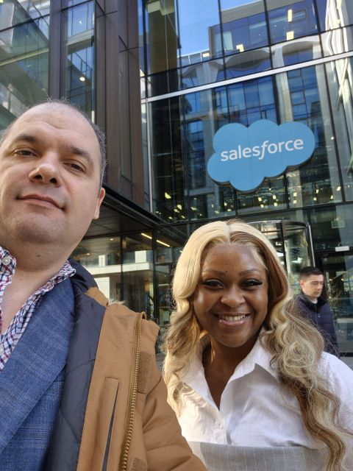
1/4
66

2

4

- 
Macdonald Mide-Madariola reposted this



Jaenes Silvestre
• 1st

First Team Lead Strength & Conditioning Coach• First Year MSc Strength & Conditioning• BSc Sport & Exercise Science
5mo •

Great opportunity for students to gain invaluable experience at Gillingham FC for the 2026/27 season!
Please Share 💙… more

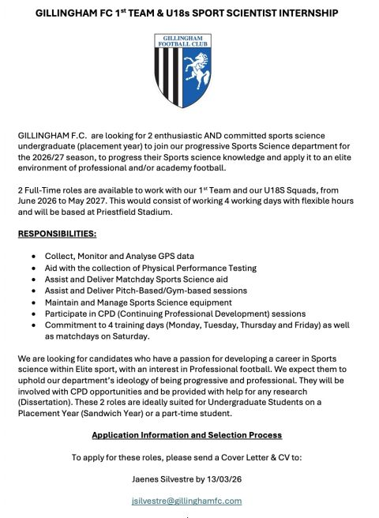
102

1

40

- 

Macdonald Mide-Madariola
• You

Business Development | Growth Strategy | Client Solutions
9mo •

I’m happy to share that I’ve started my MBA at Wrexham University!

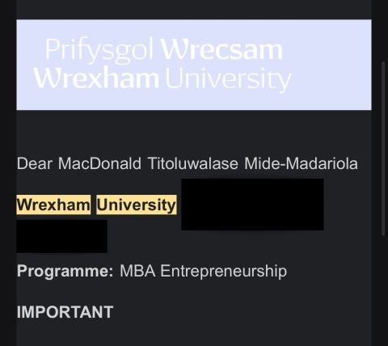
1/2
52

10

1

1,539 impressions
View analyticsView analytics

- 
Macdonald Mide-Madariola reposted this



Naomi Jack
• 1st

BDR@ FlatPay | AI Graduate
11mo •

Hi network,
I hope you’re all doing well. I wanted to share that I’m currently looking for a graduate opportunity in the tech industry. I graduated last year with a degree in Artificial Intelligence and, although I’ve been actively applying, I haven’t yet secured a role.
I’m passionate about tech and eager to bring my skills in AI, software development, and customer-focused work to a dynamic team. I’m especially interested in roles across software engineering, tech consulting, and tech sales, but I’m open to any opportunity where I can learn, grow, and contribute.
If you know of any openings, advice, or someone I should speak to, I’d be incredibly grateful for your support. If you’d be kind enough to repost this to your networks, it would be greatly appreciated.
Thanks so much in advance, and wishing the best to anyone else currently job hunting too!
Naomi… more

111

6

31

- 
Macdonald Mide-Madariola reposted this



David Amoko
• 1st

IT Technician
1yr •

Hi everyone! I’m seeking a new role and would appreciate your support. If you hear of any opportunities or just want to catch up, please send me a message or comment below. I’d love to reconnect. #OpenToWork
About me & what I’m looking for:
💼 I’m looking for IT Consultant, Information Technology Specialist, IT Technician, Information Technology Consultant, and IT Support Technician roles.
🌎 I’m open to roles in London Area, United Kingdom and Northfleet.
⭐ I’ve previously worked at Arts Educational Schools London.… more
10

12

- 
Macdonald Mide-Madariola reposted this



Mariella Mide-Madariola
• 1st

Strategic Account Executive | SaaS | Salesforce Ecosystem | Revenue Growth, Customer Success & Partnerships | UK, EMEA & North America
1yr •

I’m really excited to be part the next session of the Trailhead UK Christian Salesforce User Group on May 14, representing Advanced Communities! 💬✨
If you're a Christian Nonprofit org using Salesforce, this is a brilliant space to connect, swap ideas, and learn how to make the most of the platform to support your mission.
I'll be sharing some insights alongside other passionate professionals like Martin Brown —would love to see you there and hear about your journey too!
📅 Save the date: May 14 at 1 PM BST
📝 Register here: https://lnkd.in/edDxSSz2
Let’s learn, grow, and build together 🙌🏾 #Salesforce #FaithAndTech #SalesforceForGood #TrailblazerCommunity #NonprofitTech
… more


Advanced Communities

1yr •

Calling all Christian and nonprofit organizations using Salesforce!
Our very own Mariella Mide-Madariola will be joining the upcoming online session of the Trailhead UK Christian Salesforce User Group ➡️https://bit.ly/3YfcIin.
We’ll be diving into the latest Salesforce updates, sharing tips, and exploring how to make the most of Salesforce in your ministry or organization.
We’d love for you to join us — mark your calendar for May 14 at 1 PM BST.
Register now 👉 https://lnkd.in/e3sGH_ca and come ready to share your experiences and gain fresh insights from fellow nonprofit professionals!… more

4

1

1

Show all
Experience


Business Consulting Intern
Blackmont Consulting · Internship
May 2026 - Jul 2026 · 3 mos
London Area, United Kingdom · Remote

Conducting market research, trend analysis, and business strategy development.
Supporting client projects through data analysis, financial research, and problem-solving.
Developing insights and recommendations to improve business performance and decision-making.
Contributing to client deliverables, presentations, and strategic solutions in a remote consulting environment.… more
Business Strategy, Business Consulting and +2 skills

Better Pitch
9 mos

Independent Agent
Self-employed
Oct 2025 - Apr 2026 · 7 mos

Sales Associate
Aug 2025 - Oct 2025 · 3 mos
London Area, United Kingdom

Led fundraising campaigns to support charitable organisations.
Trained and mentored new associates to improve communication, outreach, and donor engagement strategies.
Customer Acquisition

Data Entry Specialist
Sensory Everywhere Educational Services · Full-time
Apr 2025 - Jul 2025 · 4 mos
Dartford, England, United Kingdom · On-site

Accurately inputted and managed computer systems and databases containing sensitive information (paper documents/ student reports/ tutor feedback/ etc).
Data Analysis

Teacher Assistant
C P Wrotham Road School · Full-time
Oct 2024 - Apr 2025 · 7 mos
Kent, England, United Kingdom · On-site

Assisted in delivering lessons and provided one-on-one support.
Further duties included using excel spreadsheets to organise student data and formulas.… more

Education


Wrexham University
MBA, Entrepreneurship/Entrepreneurial Studies
Sep 2025 – Jun 2026

Entrepreneurship Education



University of Kent
Bachelor's degree, Artificial Intelligence
Sep 2021 – May 2024

MySQL, Analytical Skills and +4 skills

Show all 4 educations
Connected apps
Add the products you use to stand out and get more profile views.

Gamma

IntelliJ IDEA

HubSpot

Replit
Add connected apps
Skills (17)
Business Strategy

Business Consulting Intern at Blackmont Consulting

Business Consulting

Business Consulting Intern at Blackmont Consulting

