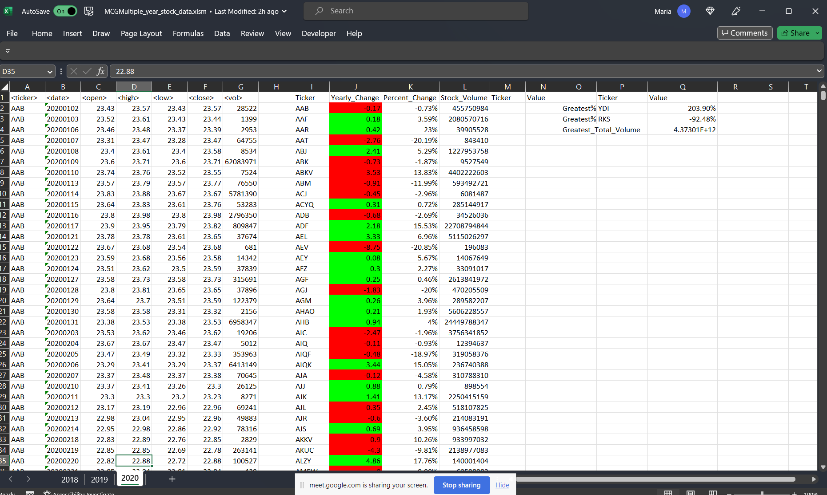

Sub WorksheetLoop()

Const COLOR_GREEN As Integer = 4

Const COLOR_RED As Integer = 3

Const VOL_COL As Integer = 7

Dim HEADERS() As String

HEADERS = Split(",Ticker,Yearly_Change,Percent_Change,Stock_Volume,Ticker,Value", ",")

'WS

Dim WS As Worksheet

Dim wb As Workbook

Dim header_index As Integer

Dim header_column As Integer

Dim Ticker_Name As String

Dim Total_Ticker_Volume As Double

Dim End_Price As Double

Dim Yearly_Price_Change As Double

Dim Yearly_Price_Percent As Double

Dim Max_Ticker_Name As String

Dim Max_Percent As Double

Dim Min_Percent As Double

Dim Max_Volume_Ticker_Name As String

Dim Max_Volume As Double

Dim Summary_Table_Row As Long

Dim Lastrow As Long

Set wb = ActiveWorkbook

'loop through all of the workshhet

For Each WS In Worksheets

WS.Activate

'Column Headers

For header_index = 1 To UBound(HEADERS)

header_column = VOL_COL + 1 + header_index

Cells(1, VOL_COL + 1 + header_index).Value = HEADERS(header_index)

Next header_index

' Set initial variables

Ticker_Name = ""

Beg_Price = 0

End_Price = 0

Yearly_Price_Change = 0

Yearly_Price_Percent = 0

Max_Ticker_Name = ""

Min_Ticker_Name = ""

Max_Percent = 0

Min_Percent = 0

Max_Volume_Ticker_Name = ""

Max_Volume = 0

Total_Ticker_Volume = 0

'Row definition

Summary_Table_Row = 1

Lastrow = WS.Cells(Rows.Count, 1).End(xlUp).Row

For i = 2 To Lastrow

'Ticker Name If

If WS.Cells(i - 1, 1).Value <> WS.Cells(i, 1).Value Then

Summary_Table_Row = Summary_Table_Row + 1

Ticker_Name = WS.Cells(i, 1).Value

Yearly_Price_Change = 0

Total_Ticker_Volume = 0

Yearly_Price_Percent = 0

WS.Range("I" & Summary_Table_Row).Value = Ticker_Name

WS.Range("J" & Summary_Table_Row).Value = Yearly_Price_Change

Beg_Price = WS.Cells(i, 3).Value

End If

'Calculate End Price

End_Price = WS.Cells(i, 6).Value

Yearly_Price_Change = (End_Price - Beg_Price)

If Beg_Price <> 0 Then

Yearly_Price_Change_Percent = (Yearly_Price_Change / Beg_Price) * 100

End If

Total_Ticker_Volume = Total_Ticker_Volume + WS.Cells(i, 7).Value

WS.Range("J" & Summary_Table_Row).Value = Yearly_Price_Change

If (WS.Range("J" & Summary_Table_Row).Value > 0) Then

WS.Range("J" & Summary_Table_Row).Interior.ColorIndex = COLOR_GREEN

ElseIf (Yearly_Price_Change <= 0) Then

WS.Range("J" & Summary_Table_Row).Interior.ColorIndex = COLOR_RED

End If

'Print Yearly Price Change as Percent in summary table, column K

WS.Range("K" & Summary_Table_Row).Value = (CStr(Yearly_Price_Change_Percent) & "%")

'Print Total Stock Volume in Summary Table, column L

WS.Range("L" & Summary_Table_Row).Value = Total_Ticker_Volume

'For Final Calculations

If (Yearly_Price_Change_Percent > Max_Percent) Then

Max_Percent = Yearly_Price_Change_Percent

Max_Ticker_Name = Ticker_Name

ElseIf (Yearly_Price_Change_Percent < Min_Percent) Then

Min_Percent = Yearly_Price_Change_Percent

Min_Ticker_Name = Ticker_Name

End If

If Total_Ticker_Volume > Greatest_Total_Volume Then

Greatest_Total_Volume = Total_Ticker_Volume

End If

Next i

'Print Values in Cells

WS.Range("O2").Value = "Greatest%Increase"

WS.Range("O3").Value = "Greatest%Decrease"

WS.Range("O4").Value = "Greatest_Total_Volume"

WS.Range("P2").Value = Max_Ticker_Name

WS.Range("P3").Value = Min_Ticker_Name

WS.Range("Q2").Value = (CStr(Max_Percent) & "%")

WS.Range("Q3").Value = (CStr(Min_Percent) & "%")

WS.Range("Q4").Value = Greatest_Total_Volume

Next WS

End Sub