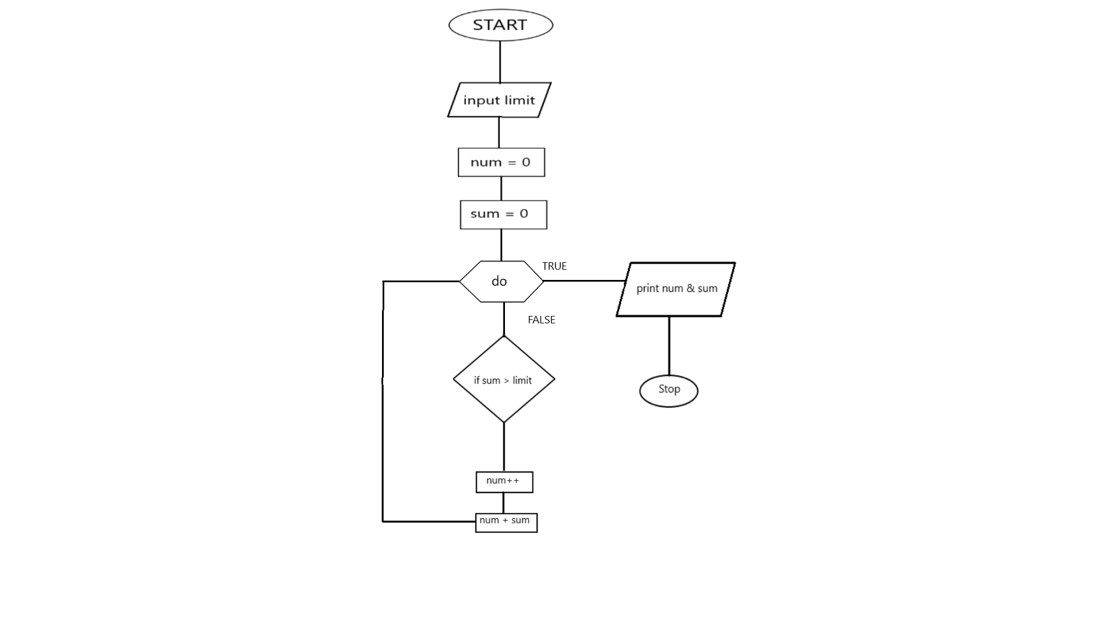

PROMPT Input Limit

SET num to 0

SET sum to 0

REPEAT IF TRUE

IF sum > limit

Increment num by 1

Add num and sum

IF FALSE

DISPLAY num and sum