Sample to Get You Started

Professor Stupendous

## Sample Report Memo

If you don’t know already, you should probably learm knitr. It will make writing analytics reports a lot easier!

## Make it look like a proper memo.

I don’t want to see all your code, so set echo=FALSE when running code.

## Show some results.

The basic merged order and payment data looks like this:

|  |  |  |  |  |  |
| --- | --- | --- | --- | --- | --- |
| PaymentDate | OrderID | PaymentAmt | OrderDate | CustID | OrderAmt |
| 2009-06-12 | 764 | 1,752,362 | 2009-04-25 | 4 | 1,752,362 |
| 2009-07-16 | 765 | 1,748,051 | 2009-05-13 | 4 | 1,748,051 |
| 2009-07-21 | 766 | 957,918 | 2009-06-02 | 4 | 957,918 |
| NA | 36,743 | NA | 2019-02-27 | 497 | 1,863,816 |
| NA | 36,744 | NA | 2019-03-01 | 498 | 257,502 |
| NA | 36,745 | NA | 2019-03-24 | 499 | 473,074 |
| NA | 36,746 | NA | 2019-03-28 | 500 | 565,652 |

This data can be plotted over time:

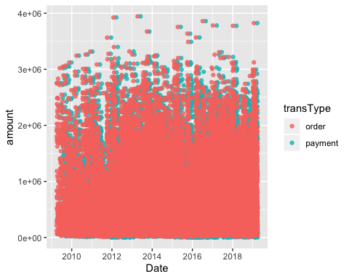

## Output files

The default output for this file is HTML, but you can figure out for yourself how to knit to PDF and Word documents, which should work pretty easily if you have LaTeX and Word installed.

## Conclusion

Being able to put tables and charts in your document instantly when making changes to your document or code is a big time saver.