CISC7204 Data Science and Data Visualization
Semester Project — Team Project Proposal
US Domestic Flight Delay Drivers
Attribution, within-day cascade, airport archetypes and an interactive communication layer
Group: Class K — Team 01
AO KIT I — MC660004
LI YING FANG — MC661599
HO MAN HOU — MC661647
WU PEI YE — MC661846
LI TIAN HAO — MC663312
SAVIDI AVRAM — MC664364
Submission date: 5 November 2026

1. Project Overview and Research Question
This proposal documents an end-to-end, reproducible analysis of delay in U.S. domestic air travel, completed on the full ten-year panel. The region is the United States and the domain category is commercial air transportation. The analysis covers ten annual files from the Bureau of Transportation Statistics (BTS) for 2015–2024 — 63,079,392 rows, of which 61,689,698 are completed flights by 20 reporting carriers — joined to airport reference metadata. The project attributes delay minutes to the five causes published by BTS, measures how delay is inherited within the operating day, groups airports into delay-risk archetypes, ranks the factors that govern delay length and severe-delay risk, and communicates the result through a linked analytical dashboard and a narrative web page written for a non-specialist.
The work extends a pilot completed for Assignment 02 by LI TIAN HAO and LI YING FANG, which used the 2024 file alone. A single year cannot separate a structural pattern from a one-year operational shock, cannot support clustering with stable estimates, and cannot test whether the split between airline-controlled and system-imposed delay holds over time. The ten-year panel removes those limitations. The headline split is 73.3% airline-controlled against 26.7% system-imposed, with a bootstrap 95% interval of 73.0–73.6%, and it is stable across the decade — the per-year internal share ranges from 69.7% (2018) to 77.4% (2022), a swing of 7.7 percentage points.
Flight delay is a public-interest problem because a single average hides very different experiences. A traveller wants to know the chance of losing an afternoon; an airline or a regulator needs to know where delay minutes originate. We therefore treat cause composition, typical delay, severe-delay risk, within-day propagation and factor ranking as separate questions rather than collapsing them into one headline number.
Research questions.
RQ1. How are reported delay minutes distributed across the five BTS causes, and how stable is that composition across 2015–2024?
RQ2. How much of the delay observed in a given hour is inherited from earlier legs in the same day, and at which airports does that cascade concentrate?
RQ3. Do U.S. airports fall into distinct delay-risk archetypes once size and cause mix are considered together, and what operational characteristics separate them?
RQ4. Given route, departure hour and month, how well can delay risk be ranked, and can a linked web tool let a non-specialist act on that ranking?
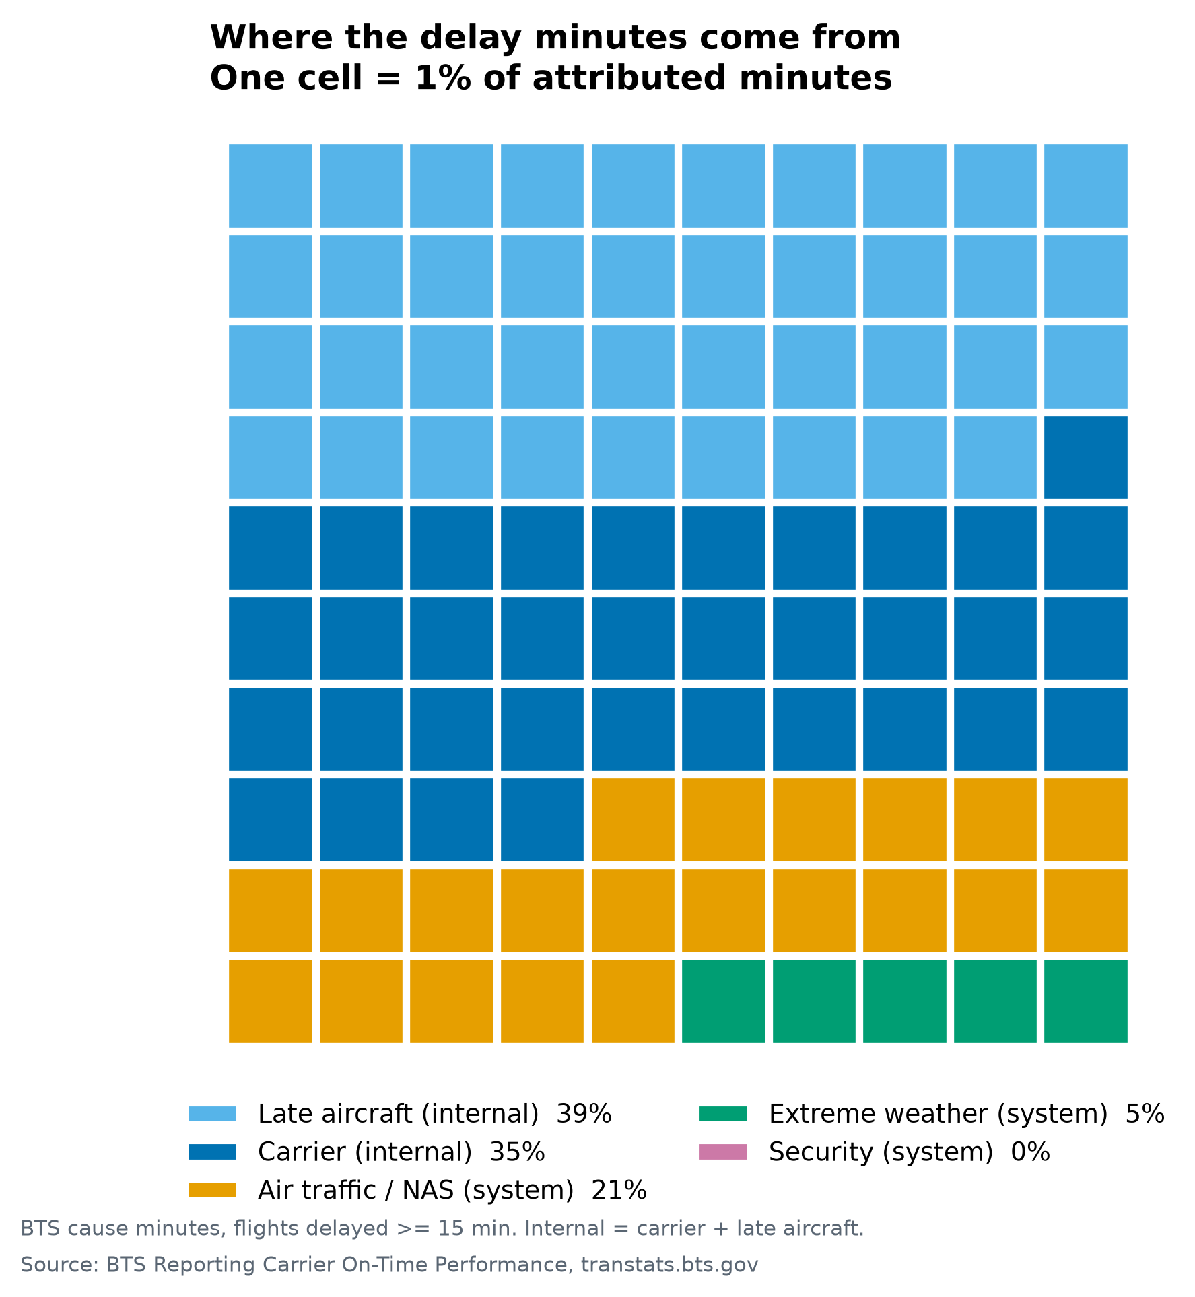
Fig. 1 Attribution of delay minutes on the completed ten-year panel: 73.3% airline-controlled, 26.7% system-imposed (each cell = 1%; the internal causes are 39% late aircraft and 35% carrier, the system causes 21% air-traffic and 5% weather).
Note on the numbers. Every empirical value in this proposal is computed on the completed ten-year panel (2015–2024) and read directly from the pipeline's outputs/ artefacts — the 61.7 million completed flights, the 73.3% split, a Gini index of 0.876, R-squared 0.022 and a held-out AUC of 0.685. A 53-test suite pins the provenance of each number, and no figure here is a fixture result.
2. Project Purpose
Outcomes. The project connects to three course learning outcomes: selecting visual encodings that fit different data structures and questions; moving from exploratory description to an appropriately qualified statistical comparison; and designing an interactive communication product for a non-specialist audience. It also produces a portfolio-ready example of an end-to-end data project, from public-source acquisition to reproducible delivery.
Skills. We practise data engineering at scale (multi-file ingestion, partitioned storage, schema validation), exploratory analysis, panel and robust regression, quantile and logistic modelling, unsupervised clustering, gradient-boosted prediction with model explanation, dashboard and narrative web development, reproducibility testing and concise technical writing. Collaboration adds code review, issue tracking and the division of a six-person workload across analytical stages.
Knowledge. The work develops applied knowledge of the BTS delay-cause taxonomy, the 15-minute reporting threshold, the difference between mean and tail behaviour, incremental explanatory power, the limits of observational models, and the conditions under which clustering is informative rather than an artefact of feature scaling.
3. Project Tasks and Deliverables
Table 1 summarises the six stages of the work, the methods used and the evidence produced. All six stages are complete on the full panel; the remaining work is the communication layer, the usability check and the final submission.
Table 1 Workflow and delivered evidence
Stage | What we did | Evidence delivered
1. Data acquisition and validation | Downloaded ten annual BTS files and airport metadata; validated schema, duplicates, missingness and the 15-minute cause-field threshold; wrote partitioned Parquet. | outputs/metrics/validation.json: 63.1M rows, duplicate rate 0, threshold coverage 99.9999%.
2. Attribution and exploratory analysis | Partitioned attributed minutes across the five causes; compared month, carrier, hour, distance, state and airport; tested composition stability across years. | 73.3% internal share with a bootstrap interval; per-year range 69.7–77.4%; Figures 01–03, 07.
3. Tail and concentration | Compared mean, median, percentiles and severe-delay shares; Lorenz curve; retested the mean-versus-tail hypothesis on the full panel. | Gini 0.876; the worst 1% of flights carries 25% of delay minutes; Figures 04–06, 08.
4. Cascade and airport archetypes | Quantified within-day inherited delay; built an airport feature matrix; k-means with silhouette selection and a Ward cross-check. | k = 5 clusters over 195 airports, silhouette 0.2045 (ARI 0.69, reported unstable); Figures 09–10.
5. Prediction and explanation | Logistic baseline and gradient boosting with a time-based holdout; factor ranking by incremental R-squared. | R-squared 0.022; AUC 0.685 (logistic) / 0.691 (GBM) at a 6.1% base rate; departure hour the top factor; Figures 11–12.
6. Communication layer | Built an eight-panel linked Dash dashboard and a narrative page; a test suite pins number provenance. | Eight-panel dashboard (Fig. 2a–2b); narrative page; 53 passing tests.

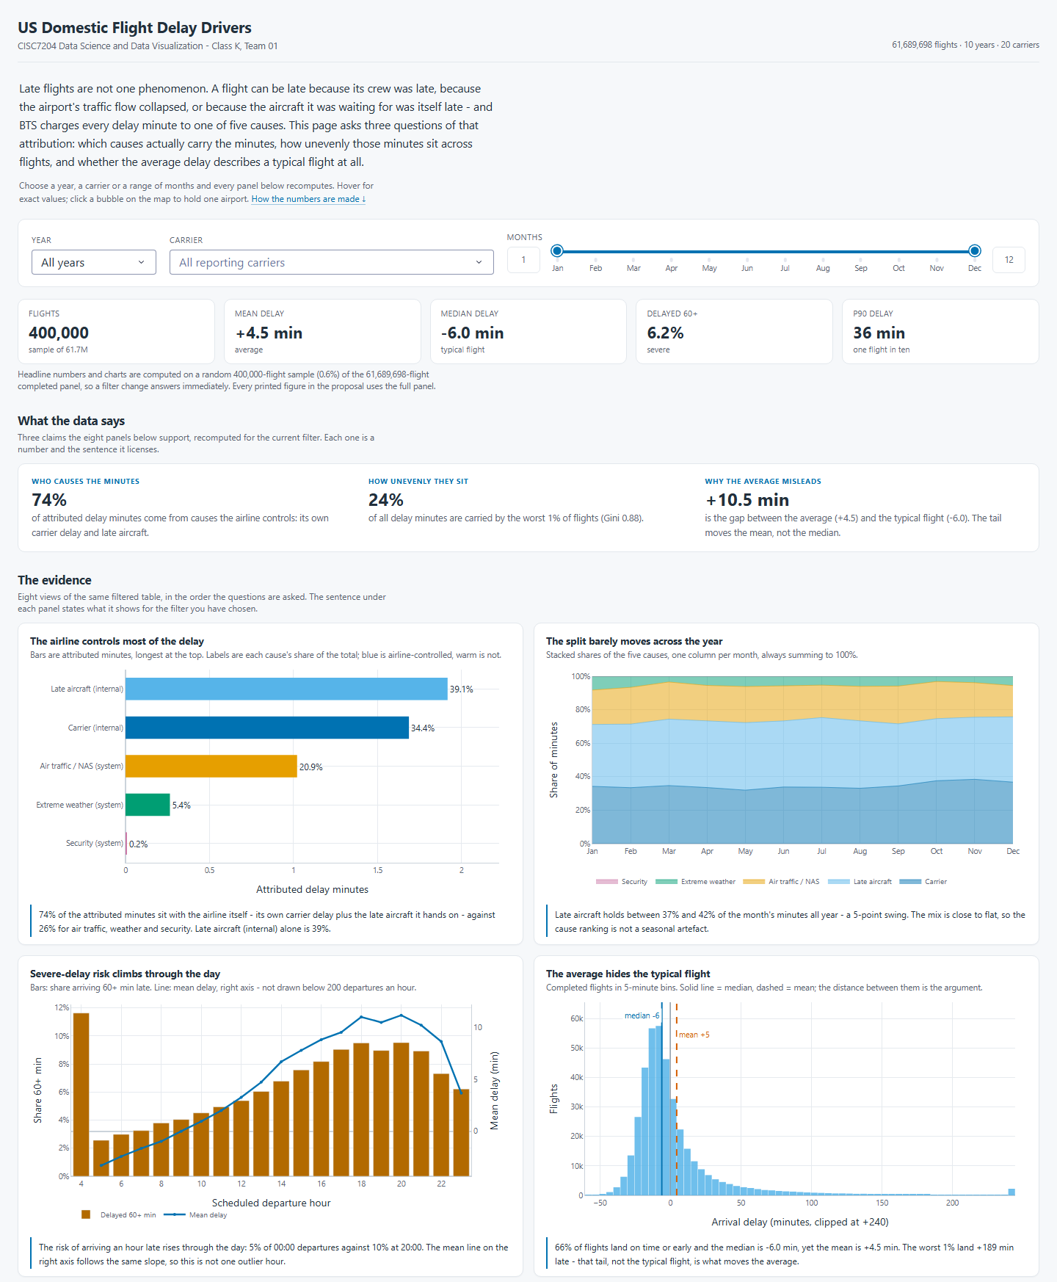
Fig. 2a The dashboard at 1440 px, upper half — header, filters, headline numbers and the first four of eight panels. The header states the panel (61,689,698 completed flights); the headline numbers and every chart below it are drawn from a 400,000-flight random sample (0.6%), which the page states in the line under those numbers, because a filter change has to answer immediately. On that sample the airline share reads 74% where the full panel gives 73.3% (Fig. 1); no conclusion turns on the gap. Year, carrier and month recompute every panel live rather than swapping pre-rendered images.
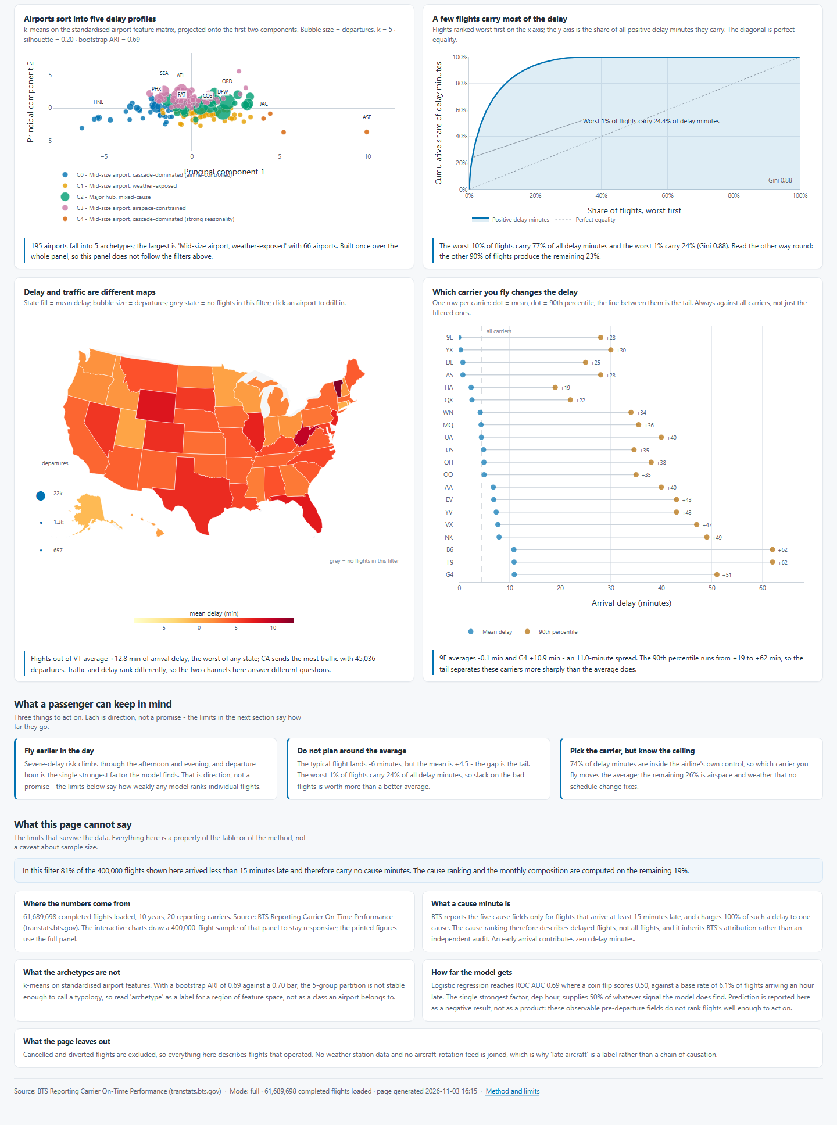
Fig. 2b Lower half of the same view — the remaining four panels, the passenger takeaway band and the method-and-limits section, which states what the page cannot say and why. The view is split across two figures so that no panel is cut mid-way at print width.
4. Data Context, Region and Sources
Region. The United States of America — all 50 states together with the District of Columbia, including Alaska and Hawaii and therefore four time zones. The observation window is 2007–2024 for the descriptive context and 2015–2024 for the analysis panel. U.S. territories (Puerto Rico, Guam, the U.S. Virgin Islands) and all international legs are excluded, so every row describes a scheduled domestic passenger flight that both departs from and arrives at a U.S. airport. Findings are reported at three nested spatial levels: national (all flights), state (origin state) and airport (origin airport).
Domain category. Transportation — commercial aviation, specifically airline operations and air-traffic performance. In data-science terms the problem is operational performance analytics on a scheduled transport network: the unit of observation is one flight leg, the outcome of interest is arrival delay in minutes (and its heavy tail), and the candidate drivers are the operating carrier, the airports at each end, the position of the leg within the aircraft's day, the calendar, and surface weather. Stated in the template's short form: United States and transportation / commercial aviation.
Five public datasets are used, listed in Table 2 as D1–D5 with their publisher, role, coverage and a clickable access link. Every link was re-checked on 2 November 2026 and returned HTTP 200; none requires a login or an API key.
Table 2 The five datasets
ID | Dataset (publisher) | Role in the analysis | Coverage | Access
D1 | Reporting Carrier On-Time Performance (1987–present) — U.S. Bureau of Transportation Statistics | Primary flight-level records: carrier, tail number, origin and destination, scheduled and actual times, delay minutes, and the five BTS cause-minute fields (37 of 110 published fields retained). | 12 monthly files per year, 2015–2024; 63.1M rows. Archive pattern: On_Time_..._{year}_{month}.zip | Download page: https:/​/​www.​transtats.​bts.​gov/​DL_SelectFields.​aspx?gnoyr_VQ=FGJ  Archive directory: https:/​/​transtats.​bts.​gov/​PREZIP/​
D2 | Airline On-Time Performance: Delay Cause — BTS | National monthly aggregates of delay minutes by cause and carrier; an independent cross-check on our per-flight attribution. | Monthly, 2003–present | Query page: https:/​/​www.​transtats.​bts.​gov/​OT_Delay/​OT_DelayCause1.​asp
D3 | Integrated Surface Database (hourly surface observations) — NOAA NCEI | Hourly weather at origin airports (wind, visibility, precipitation, ceiling, temperature) merged on airport and scheduled departure hour; a planned covariate. | 40 busiest origin airports, all ten years, one record per station-hour | Landing page: https:/​/​www.​ncei.​noaa.​gov/​products/​land-based-station/​integrated-surface-database  Direct access: https:/​/​www.​ncei.​noaa.​gov/​data/​global-hourly/​access/​
D4 | airports.csv (airport reference file) — OurAirports | Coordinates, state, municipality, airport type and scheduled-service flag, for the maps and the airport size stratum in clustering. | ≈75,000 airports worldwide, filtered to U.S. large, medium and small airports | Direct download: https:/​/​davidmegginson.​github.​io/​ourairports-data/​airports.​csv
D5 | Air Traffic by the Numbers and Passenger Boarding (Enplanement) data — FAA | Annual U.S. commercial-service airport activity, to validate the hub stratum derived from D4 and report the large / medium / small hub split. | Annual, all U.S. commercial-service airports | By the Numbers: https:/​/​www.​faa.​gov/​air_traffic/​by_the_numbers  Passenger boarding: https:/​/​www.​faa.​gov/​airports/​planning_capacity/​passenger_allcargo_stats/​passenger

Reporting-threshold note. BTS publishes the five cause-minute fields only for flights delayed by at least 15 minutes. The panel verifies this rule directly: of the 11,454,282 flights at or above the threshold, 99.9999% carry a complete cause breakdown, while none below the threshold does. All cause-share statements are scoped to that attribution universe, while counts, means and percentiles use all 61,689,698 completed flights.
Governance. All five sources are public and none needs a login or key. D1 and D2 are U.S. federal government data and are redistributable; D3 is U.S. federal data in the public domain; D4 is a public-domain dedication; D5 is a U.S. federal publication. No personal data is processed and no ethics approval is required. Raw files are excluded from version control and are re-downloadable from the URLs above, with a SHA-256 manifest (`data/checksums.sha256`) recording the exact file behind any reported number.
5. Method Summary
Data acquisition and validation. Twelve monthly files per year are concatenated, types are coerced, and the analysis columns are retained. Each year is checked for row counts, duplicate keys, missingness and threshold coverage before being written to partitioned Parquet so that a single year can be re-read without loading the panel. The full panel passes with 63,079,392 rows, zero duplicate rows and 99.9999% cause coverage above the threshold.
Attribution and stability. Reported delay minutes are grouped into airline-controlled causes (carrier and late aircraft) and system-imposed causes (air traffic, weather and security). The composition is recomputed per year, and a bootstrap interval is attached to the headline split so that a one-year deviation can be separated from sampling noise. The result — 73.3% internal, 95% CI 73.0–73.6% — is stable across the decade.
Tail and concentration. Mean, median and percentiles are reported alongside severe-delay shares; a Lorenz curve and a Gini-style concentration statistic quantify how much of the delay burden sits in the worst flights. The mean (+4.5 minutes) sits far above the median (−6.0 minutes), and the Gini index is 0.876, so the mean-versus-tail hypothesis from the pilot is confirmed on the panel rather than on a single year.
Cascade measurement. Inherited delay is measured with the BTS late-aircraft cause minutes and with a turnaround-buffer calculation on consecutive legs of the same aircraft. The result is expressed as the share of delay attributable to earlier legs, which converts the 38.8% late-aircraft share into a within-day mechanism: 6.0% of flights are in an aircraft rotation with positive delay, and 17.1% of those delay minutes are inherited.
Airport archetypes. Airports are described by a feature matrix covering mean delay, ninetieth-percentile delay, severe-delay share, the five cause shares, seasonal amplitude, departures and hub stratum. Features are standardised; k-means is run over a range of k and selected by silhouette score; Ward linkage provides a dendrogram as a stability cross-check; PCA gives a two-dimensional projection for display. The chosen solution has k = 5 over 195 airports at silhouette 0.2045, and it is reported as unstable (mean ARI 0.69 against a 0.70 threshold) rather than as a fixed taxonomy.
Prediction and explanation. A logistic baseline and a gradient-boosted classifier predict arrival delay of at least 60 minutes, with a time-based split so that later months are never used to train earlier ones. SHAP-style importance ranks the factors, and dependence plots expose the departure-hour curve. The held-out AUC is 0.685 (logistic) and 0.691 (gradient boosting) at a 6.1% base rate; the full model explains R-squared 0.022. Departure hour is the strongest factor, carrying 49.9% of the ranked importance.
Regime controls. A ten-year window holds two operating regimes, so the calendar enters every model as a control rather than as a finding: year fixed effects absorb the long trend, and a COVID-era dummy covers March 2020 to December 2021. The two years stay in the panel because they are the only observations of an extreme operating condition, and every headline statistic is recomputed with them excluded, so the report shows the size of the shift rather than presenting one version of the average.
Visual design and interaction. Charts are selected by the question they answer, following the encoding-effectiveness ordering described in Section 6. The communication layer separates an analytical dashboard from a narrative page: the dashboard supports exploration, while the narrative page guides a non-specialist through four findings in a fixed order.
6. Visual Design Rationale
Because this is a visualisation course, each chart is treated as a decision to be justified rather than a default. We adopt the encoding-effectiveness ordering of Cleveland and McGill (1984) and Mackinlay (1986): position along a common scale is read most accurately, followed by length, angle and slope, while area and colour hue are read least accurately. Each figure is therefore chosen by the question it answers, and where a weaker encoding is unavoidable it is supported by direct labels and a legend that states the scale.
- Part-to-whole: a unit waffle, where area encodes the share of delay minutes and every cell is labelled, so that the 73.3 / 26.7 split reads without a legend.
- Ordered and cyclical: a line cascade for departure hour, because a ranked bar chart would destroy the within-day shape that is the point of the figure.
- Distribution: percentile bands and a violin plot instead of a bar of means, because the mean sits at the seventy-third percentile and misrepresents the typical flight.
- Concentration: a Lorenz curve, read by position, to show that the worst one percent of flights carries 25% of delay minutes.
- Geography: a state tile grid is retained for national comparison because it keeps every state visible at equal weight, and a choropleth is added alongside it for magnitude reading.
- Volume: airport bubbles sized by departures, with an explicit size legend, because area is a weak channel and must be anchored.
One comparison is built deliberately rather than described. A single figure places the same twelve monthly profiles side by side: on the left as a bar of means, on the right with the median, the mean and the p90 retained. The bar chart is not a straw man - it uses a zero baseline, labelled values and an ordered axis, and it still cannot support the sentence a traveller needs, because no bar can show that the median never crosses zero. Publishing both turns the encoding argument into evidence rather than an assertion, and it is the figure we would point to first if asked why the report does not lead with monthly averages.
Table 3 lists the delivered figure set, each tied to the question it answers and the encoding it uses.
Table 3 Delivered figure set
Figure | Question it answers | Encoding
01 cause waffle | Where do delay minutes come from | Area, labelled
02 monthly composition | Is the cause mix stable | Stacked area
03 carrier bars | Which carrier delays most | Ordered bars
04 percentile band | What is the delay spread | Band, position
05 Lorenz curve | How concentrated is delay | Line, position
06 distance bands | Does distance matter | Band and line
07 state tile grid | Where is delay worst | Colour, sequential
08 cascade hour | When is delay inherited | Line
09 silhouette | How many clusters | Line, position
10 cluster scatter | What separates archetypes | Position, colour
11 importance | Which factor ranks highest | Length
12 hour response | How does hour shape risk | Line
13 dashboard | Interactive communication | Linked panels
14 mean bar vs band | Mean vs typical flight | Side-by-side

Colour. One colour scale per cause, held fixed across every figure so that a cause keeps its colour. The palette follows Okabe and Ito (2008) so that the five causes stay distinguishable under the common forms of colour-vision deficiency; sequential scales use viridis, which is monotonic in lightness and therefore survives greyscale printing.
Interaction. The communication layer follows Shneiderman's (1996) task taxonomy: overview first, zoom and filter, then details on demand. The dashboard opens on a national overview, exposes three filters, and reveals flight-level detail only on selection; charts are linked so that a filter applied in one panel updates all others.
Evaluation. Usability is measured rather than asserted. Three tasks are given to a non-specialist — locate the worst month for a named carrier, compare two airports, estimate the risk of a 19:00 departure — and completion time and errors are recorded alongside a short satisfaction questionnaire. The result is reported as a small usability note rather than a claim that the interface is intuitive.
7. Repository and Reproducibility
The project is organised as a runnable repository. Every figure and table in the final report is regenerated from source data by one command, and a 53-test suite pins number provenance.
Team01-FlightDelay-Project/
README.md purpose, setup, run commands, data dictionary link
requirements.txt pinned Python dependencies
Makefile setup / data / pipeline / figures / dashboard / test
docs/ proposal, meeting minutes, video script, forum posts
src/ config, io, cleaning, features, attribution, modelling, viz
dashboard/ app.py, layouts, callbacks, panels/, assets/
figures/ 01-14, one figure per question, regenerated by the stages
outputs/ tables/ and metrics/ consumed by the report
data/ raw/, interim/, processed/ (excluded from Git)
tests/ 53 tests over data, analysis, figure and caption layers
reports/ final report (report.md) and exported submission PDF

Run commands. python -m pip install -r requirements.txt for environment setup; make data to download and validate the panel; make pipeline to run every analysis stage; make dashboard to launch the application locally; make test to run the suite. Every number on screen and in the report comes from the same outputs/ computation, so no reported number depends on stale notebook state.
Version control. One shared GitHub repository with a branch per task, descriptive commit messages and review before merge. Raw and processed data are excluded because they are large and reproducible from documented URLs; a checksum manifest records the exact files used in the reported results.
8. Criteria for Success
Table 4 states the completion standard and the evidence that has been produced for each criterion.
Table 4 Completion checklist and evidence
Success criterion | Evidence produced
Scope and data validity | Counts reconcile across all ten annual files (63.1M rows, 61.7M completed); duplicate rate is zero; the attribution universe and the 15-minute threshold are stated wherever cause shares appear.
Analytical answer | All four research questions are answered; the headline split carries a bootstrap interval and the cluster verdict carries a stability score, with no finding presented as causal without support.
Modelling discipline | Every model reports a baseline, a held-out metric and an explicit statement of what the model ranks rather than predicts (AUC 0.685 / 0.691 at a 6.1% base rate).
Visual encoding justification | Each figure names the question it answers and the encoding it uses (Table 3); the delivered set covers part-to-whole, distribution, concentration, geography and interaction.
Reproducibility | One command regenerates every figure; a 53-test suite passes on a clean checkout; outputs are reproducible from public data.
Communication and integrity | Every chart carries a title, readable labels and a one-line interpretation; the narrative page states the core story and the limits of observational data.
9. Team and Collaboration
Ownership is divided by analytical stage, while interpretation, review and sign-off remain shared. Roles rotate at the mid-point of the project so that no member owns a single stage for the whole duration.
Table 5 Division of work and group roles
Member | Roles | Primary responsibilities
AO KIT I  MC660004 | Team Coordinator  Project Tracker | Meeting agendas and chairing; task board, milestones, dependency map and risk log; progress summaries; drives both submission dates.
LI YING FANG  MC661599 | Project Developer  (lead) | Data pipeline (acquisition, cleaning, validation), notebook and repository structure, reproducibility script and dashboard engineering; leads code review.
HO MAN HOU  MC661647 | Team Scribe | Minutes of every meeting, the decision log and the scope-change log; repository folder conventions and file naming.
WU PEI YE  MC661846 | Team Reporter  Team Liaison | The project proposal as one continuous narrative; the introductory video from script through edit; instructor communication; rehearsal and final submission package.
LI TIAN HAO  MC663312 | Project Analyst  Quality Reviewer | Research question and data sources; data preparation and the analysis (attribution, cascade, clustering, modelling); interpretation and limitations. Separately the quality gate: reproducibility, calculation checks, visual clarity, citations, requirement compliance.
SAVIDI AVRAM  MC664364 | Project Developer | Figures, visualisations and interactive outputs (map, archetypes); ten-year panel scaling and the weather join; stands in for the lead developer.

Ground rules.
- One shared repository, a branch per task, descriptive commits, and review before any merge. Code or figures that cannot be reproduced from the notebooks are never merged.
- One source of truth for numbers: a quoted result must match a notebook output or a file in outputs/. The same rule applies to the proposal, the README and the dashboard.
- A weekly checkpoint on progress, blockers and next actions, with a target response time of 48 hours and decisions recorded in the project log.
- Scope is frozen by consensus. A change affecting the research question, the dashboard or the submission date is discussed before it is implemented.
- Before submission, every member completes an independent read-through of the report and a functional check of the dashboard.
10. Timeline
The analysis stages are complete ahead of the schedule below; the remaining work is the communication layer, the usability check, the project presentation and the final submission. Project presentations are held in class on 11, 18 and 25 November, with each team's slot drawn by lot, so the deck and rehearsal are planned to finish by 11 November, leaving the team ready whichever of the three dates it draws. The plan completes all activity within four weeks, leaving a two-day buffer before the final close, which satisfies the four-week requirement in the brief and stays inside the five-week allowance stated in the course announcements.
Table 6 Four-week schedule and status
Week | Dates | Milestone | Output | Status
0 | 3–5 Nov | Proposal, first meeting minutes and introductory video submitted | Proposal PDF; minutes PDF; 5-minute video; two forum threads | In progress
Present | 11 / 18 / 25 Nov | Project presentation to the class; Team 01 slot drawn by lot; deck and rehearsal complete before the earliest 11 Nov slot | Presentation deck; delivery and Q&A | Scheduled
1 | 6–12 Nov | Environment reproduced by all six members; panel acquired and validated | Notebooks 01–02; validation report; repository set up | Complete
2 | 13–19 Nov | Attribution and tail analysis complete; figure audit closed | Notebooks 03–04; Figures 01–13 | Complete
3 | 20–26 Nov | Clustering and predictive models complete; explanations written | Notebooks 05–06; Figures 14–20; model table | Complete
4 | 27 Nov–3 Dec | Dashboard and narrative page frozen; usability tasks run | Dashboard; narrative site; usability note | Analysis done
Close | 4–5 Dec | Final report and submission package | Report PDF; repository tag; submission | Pending
11. Limitations
- Observational, not causal. BTS cause minutes are a reported partition in which overlapping causes are assigned by the reporting carrier; the split is not an independent causal decomposition.
- Weather enters as a planned covariate, not a delivered one. The hour-matching join is implemented and exercised on the fixture, but the ten-year Integrated Surface Database extraction is not yet part of the pipeline, so until it lands the weather signal is only the carrier-reported weather cause share. If the extraction does not land before the report, the covariate is dropped from the claim rather than reported at partial coverage.
- Clustering is unstable. The chosen k = 5 solution has silhouette 0.2045 but a mean ARI of 0.69 across resampled years, below the 0.70 stability threshold; the archetypes are therefore reported with a stability verdict rather than as fixed airport categories.
- Prediction is ranking, not forecasting. The held-out AUC is 0.685 (logistic) and 0.691 (gradient boosting) at a 6.1% base rate, and the full model explains R-squared 0.022 — enough to rank flights, not to promise a specific arrival time.
- The 2020-2021 pandemic period is retained but controlled: year fixed effects and a COVID-era dummy enter every model, and every headline statistic is recomputed with those two years excluded. The report compares the two versions rather than choosing one silently.
12. References
Bureau of Transportation Statistics. (n.d.-a). Airline on-time performance: Delay cause [Data set]. U.S. Department of Transportation. Retrieved October 21, 2026, from https://www.transtats.bts.gov/ot_delay/ot_delaycause1.asp
Bureau of Transportation Statistics. (n.d.-b). Reporting carrier on-time performance (1987–present) [Data set]. U.S. Department of Transportation. Retrieved October 21, 2026, from https://www.transtats.bts.gov/DatabaseInfo.asp?QO_VQ=EFI
Breiman, L. (2001). Random forests. Machine Learning, 45(1), 5–32. https://doi.org/10.1023/A:1010933404324
Cairo, A. (2016). The truthful art: Data, charts, and maps for communication. New Riders.
Cleveland, W. S., & McGill, R. (1984). Graphical perception: Theory, experimentation, and application to the development of graphical methods. Journal of the American Statistical Association, 79(387), 531–554. https://doi.org/10.1080/01621459.1984.10478080
Lundberg, S. M., & Lee, S.-I. (2017). A unified approach to interpreting model predictions. In Advances in Neural Information Processing Systems (Vol. 30, pp. 4765–4774).
Mackinlay, J. (1986). Automating the design of graphical presentations of relational information. ACM Transactions on Graphics, 5(2), 110–141. https://doi.org/10.1145/22949.22950
Munzner, T. (2014). Visualization analysis and design. CRC Press.
National Centers for Environmental Information. (n.d.). Integrated Surface Database (ISD) [Data set]. National Oceanic and Atmospheric Administration. Retrieved October 21, 2026, from https://www.ncei.noaa.gov/products/land-based-station/integrated-surface-database
Okabe, M., & Ito, K. (2008). Color universal design (CUD): How to make figures and presentations that are friendly to colorblind people. J*Fly. https://jfly.uni-koeln.de/color/
OurAirports. (n.d.). Airports [Data set]. Retrieved October 21, 2026, from https://davidmegginson.github.io/ourairports-data/airports.csv
Rousseeuw, P. J. (1987). Silhouettes: A graphical aid to the interpretation and validation of cluster analysis. Journal of Computational and Applied Mathematics, 20, 53–65. https://doi.org/10.1016/0377-0427(87)90125-7
Shneiderman, B. (1996). The eyes have it: A task by data type taxonomy for information visualizations. In Proceedings of the 1996 IEEE Symposium on Visual Languages (pp. 336–343). https://doi.org/10.1109/VL.1996.545307

