**Student-Surveillance**

**ScholarWatch: AI-Powered Student Surveillance System**

* Plan:- Create 3 models Smartphone detection, Face recognition, Head pose estimation and merge all three into one to monitor students from a cctv feed. It will monitor students and see if a particular student is using mobile phone or if he is peeking left right etc.
* Jupyer notebook will be my work environment with python 3,10 and tensorflow2.15 pytorch for gpu

Setup

1. Created a venv student-surveillance-venv and activated it

student-surveillance-venv\Scripts\activate

1. Installed juptyter notebook and ipykernel
2. Register the venv as new jupyter kernel
3. Create jupyter notebook and test it
4. Limitations

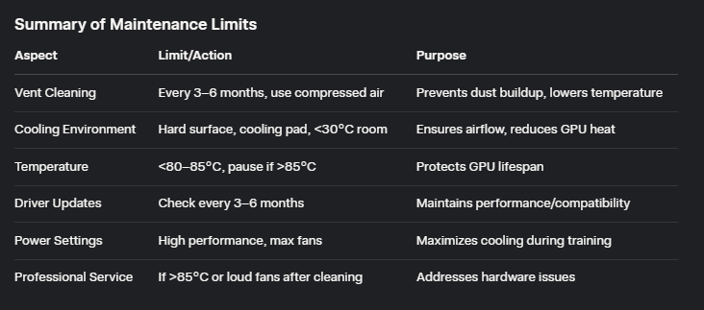

1. Initialize git

**Face Detection & Recognition**

1. Data collection
2. Installing dependencies
3. Detect faces in an image using MTCNN, extracts their embeddings using Inception-ResNet V1, and displays the detected faces
4. Setting up data directory
5. Labelled the data
6. Creating embedings from the data set and saving them in embedings.pt

**IMP Links**

1. [yakhyo/head-pose-estimation: 👤 | Real Time Head Pose Estimation: Accurate head pose estimation using ResNet 18/34/50 and MobileNet V2/V3 models. Evaluate yaw, pitch, and roll with pre-trained weights for quick integration.](https://github.com/yakhyo/head-pose-estimation)

2. [Real-time 6DoF full-range markerless head pose estimation](https://repository.hanyang.ac.kr/bitstream/20.500.11754/187508/1/110298_%EC%9D%B4%EC%84%B1%EC%98%A8.pdf)

3. [Mobile phone detection Dataset > Overview](https://universe.roboflow.com/exam-detection-a9bsf/mobile-phone-detection-mtsje)