Home
Route: /
- Section 1 — Hero
  - H1: JOIN THE / GALACTIC / BATTLE
  - Subtitle: Shadawi is home to eight realms, powerful mages, and a growing collection of extraordinary specimens.
  - Create your mage profile, earn rewards, configure your specimens, and connect with mages around the world. Level up, earn badges, and climb the global owner rankings.
  - Button: ENTER → /universe
  - Stats
    - Stat: MEMBERS — 345
    - Stat: EXISTING SPECIMEN — 998
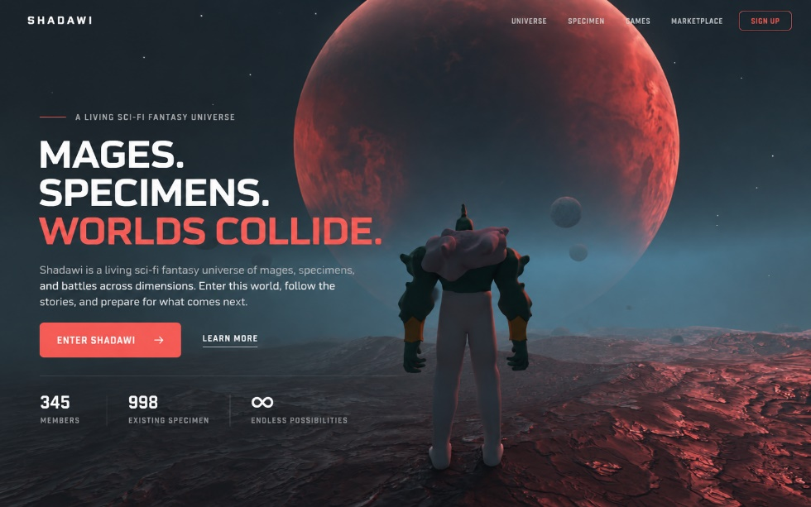

- Section 2 — Every Specimen Carries a Story (right-aligned)
  - H1: EVERY SPECIMEN CARRIES A STORY
  - Subtitle
    - Paragraph: Specimens are the central beings of Shadawi. Some are beasts of war. Some belong to ancient kingdoms. Some are tied to realms, bloodlines, lost battles, and powers older than mage civilization.
    - Paragraph: Each specimen is recorded by SID, class, form, rarity, abilities, and lineage. They are not just monsters to collect. They are living records of the world.
  - Button: VIEW SPECIMENS → /specimen
- Section 3 — THE UNIVERSE (right-aligned)
  - H1: SOME STORMS ARE ALIVE
  - Subtitle
    - Paragraph: Across eight realms, life takes forms unfamiliar to even the most experienced mages. Deep within the Gas Realm lives Cloud Ogre, a powerful specimen carrying Jejar, a sentient cloud that grows and changes with its essence. And when the clouds begin to move against the wind, you may want to reconsider your journey.
    - Button: VIEW SPECIMENS → /specimen
    - Button: Explore the universe → /universe
- Section 4 — Play, Battle, and Build
  - H1: PLAY, BATTLE, AND BUILD YOUR PLACE
  - Subtitle: Take your specimens into battle, build your collection and make your name known among the mages of shadawi.
  - Button: SHADAWI STRIKER → /games
  - Button: SPECIMEN MINTER → /specimen-minter
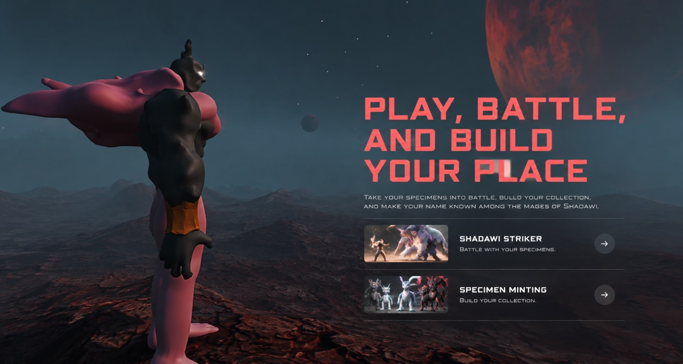

Games
Route: /games
- Browser title: Games — Shadawi
- Hero
  - H1: Games
  - Subtitle: Choose your arena. Every battle is a chance to rise, every quest a legend waiting to be written.
  - Accent label: Browse All Modes
- Cards (no links yet)
  - Card: Shadawi Striker
    - Description: Shadawi Striker is a real-time 3D fighting game where mages build teams of powerful specimens, battle opponents, and earn new creatures through skill-based combat.
  - Remove all other cards

Marketplace
Route: /marketplace
- Browser title: Marketplace — Shadawi
- Hero
  - H1: Marketplace
  - Subtitle: Trade specimens, artifacts, and essence across the realms. Every transaction shapes the balance.
  - Accent label: Browse Listings
- Cards
  - Card: Specimen Minter → /marketplace/specimen-mint
    - Description: Browse, bid, and acquire rare Shadawi from across the universe.
  - Card: Gem Minter → /marketplace/gem-mint
    - Description: Discover and acquire powerful gems to enhance your specimens and mages.
  - Card: Opensea → opensea.io/collection/shadawi
    - Description: The fundamental force that binds and flows through all things. Trade it wisely.

Specimen Minter
Route: /marketplace/specimen-mint
Just follow this image it shows you how to make it responsive and it follows the websites theme:
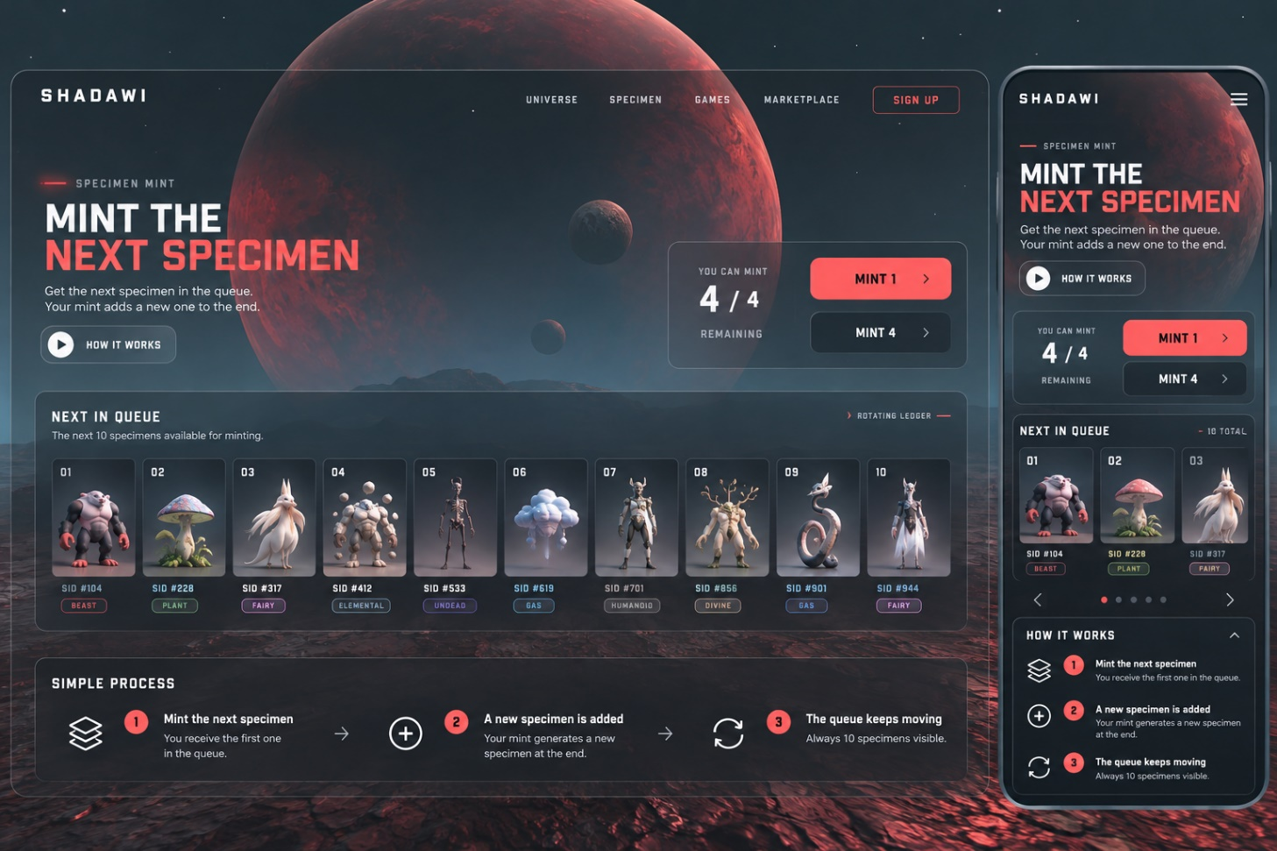

Gem Minter
Route: /marketplace/gem-mint — linked from the Marketplace and Minter menu, but no page exists yet.
Let it lead to a page that already exists but just says coming shortly after mint.

