.

# COVER PAGE

TABLE OF CONTENTS

**1.0 DATABASE SCHEMA** **(STRUCTURE OF DATABASE TABLES / DATA DICTIONARY)**

**1.1 Database Schema**

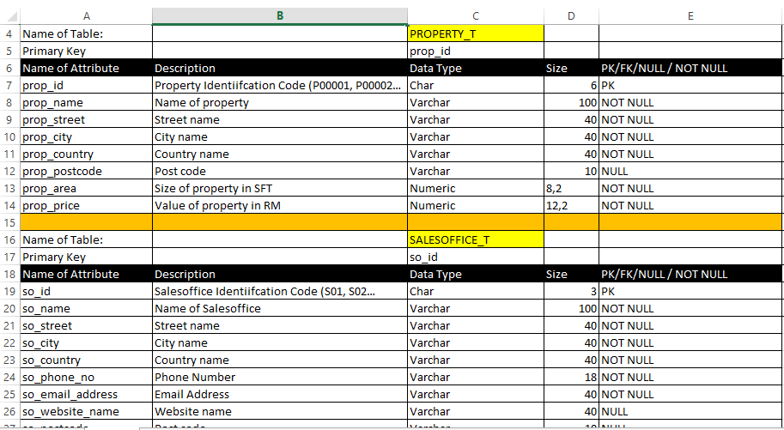

**1.2** Finalized ERD (Entity Relationship Diagram) – Output of the Conceptual database design phase

- Attach here your ERD

**1.3** Finalized EERD (Enhanced Entity Relationship Diagram) – Output of the Logical database design phase

**-** Attach here your EERD

**1.4 Database diagram generated from the MS SQL Server 201X**

Once you set all PKs (Primary Keys) and FKs (Foreign Keys), then how to generate the database

diagram from the MS SQL Server?

Step 1: Go to your MS SQL Server 201x.

Step 2: Select your database

Step 3: Right click on ‘Database Diagrams’

Step 4: Select ‘New Database Diagram’

Step 5: Select all the database tables and click ‘Add’

Step 6: Copy a screenshot and attach it below. That is all.

For en example, the database diagram generated from the MS SQL Server 201x looks as below.

Or watch this video <https://www.youtube.com/watch?v=N6PhiiXJMeU>

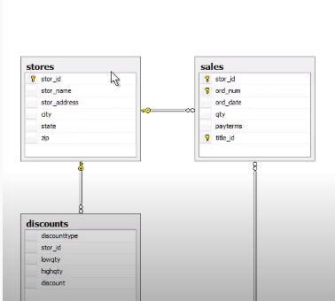

2.0: **SQL-DATA DEFINITION LANGUAGE (DDL)**

2.1 SQL DDL USED

2.1.1 SQL DDL used to create the table (OWNER_T)

-- 2.1 SQL DDL USED

-- 2.1.1 SQL DDL used to create the PROPERTY_T table

-- 2.1 SQL DDL USED

-- 2.1.1 SQL DDL used to create the PROPERTY_T table

CREATE TABLE PROPERTY_T (

prop_id Char(6) NOT NULL,

prop_name Varchar(100) NOT NULL,

prop_street Varchar(40) NULL,

prop_city Varchar(40) NULL,

prop_country Varchar(40) NOT NULL,

prop_postcode Varchar(10) NULL,

prop_area Numeric(8,2) NOT NULL,

prop_uom Char(1) NOT NULL,

prop_price Numeric(12,2) NOT NULL

--2.1.2 SQL DDL Commands to create Pimary Key

ALTER TABLE PROPERTY_T

ADD CONSTRAINT PK_prop_id

PRIMARY KEY (prop_id)

## )) 2. 1. 2 SQL DDL used to create the table (OWNER_PHONE_T)

CREATE TABLE OWNER_PHONE_T

( own_id Char(5) NOT NULL,

own_phonenumber Varchar(25) NOT NULL,

own_score Numeric(5,0) NOT NULL,

PRIMARY KEY (own_id,own_phonenumber),

FOREIGN KEY (own_id) REFERENCES OWNER_T(own_id)

ALTER TABLE PROPERTY_OWNERSHIP_T

ADD CONSTRAINT FK_own_id

FOREIGN KEY (own_id)

REFERENCES OWNER_T (own_id)

ALTER TABLE PROPERTY_OWNERSHIP_T

ADD CONSTRAINT FK_prop_id

FOREIGN KEY (prop_id)

REFERENCES PROPERTY_T (prop_id)

DROP TABLE PROPERTY_T

ALTER TABLE PROPERTY_OWNERSHIP_T

ADD CONSTRAINT PK_prop_id_own_id

PRIMARY KEY (prop_id,own_id)

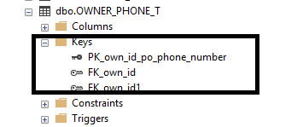

)

2.2 **Sample Data Used**

# 2.2.1 OWNER_T Table

# 

2.2.2 OWNER_PHONE_T Table

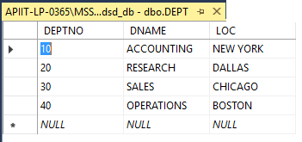

# 3: 0 **SQL DML - DATA MANIPULATION LANGUAGE**

-- SQL DML commands to insert tuples into PROPERTY_T table

INSERT INTO PROPERTY_T(prop_id,

prop_name,

prop_street,

prop_city,

prop_country,

prop_postcode,

prop_area,

prop_uom,

prop_price)

VALUES ('P00001','APU GROUP OF COMAPNIES', '6, JALAN TPM', 'KL','MY','57000',10.00, 'A',900000000.00)

## 

## 3.1- Question 1

* 1. List the book(s) which has the highest rating. Show book id, book name, and the rating.

SELECT * FROM EMP_T

**SQL Server Result**

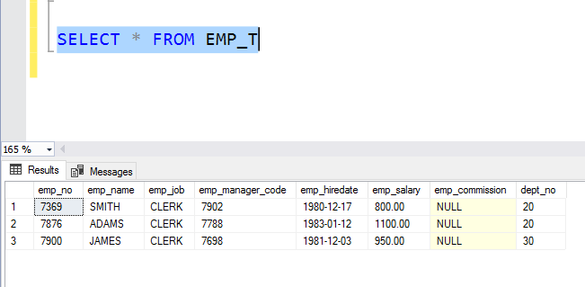

## 3: 2 - Question 2

* 1. Find the total number of feedback per member. Show member id, member name, and total number of feedback per member.

**SQL DML CODE**

SELECT TOP (3) c.course_id AS 'COURSE ID',   
c.course_name AS 'COURSE NAME' ,c.course_cost AS 'COURSE COST',

c.course_catagory AS 'COURSE CATAGORY',   
c.course_duration AS 'COURSE DURATION',

te.tra_event_id AS 'TRAINING EVENT ID' ,te.tra_event_name AS 'EVENT NAME', te.tra_event_date AS 'EVENT DATE',

te.trainee_id AS 'TRAINEE ID'

FROM COURSE_T AS C

INNER JOIN TRAINING_EVENT_T AS te

ON c.course_id = te.course_id;

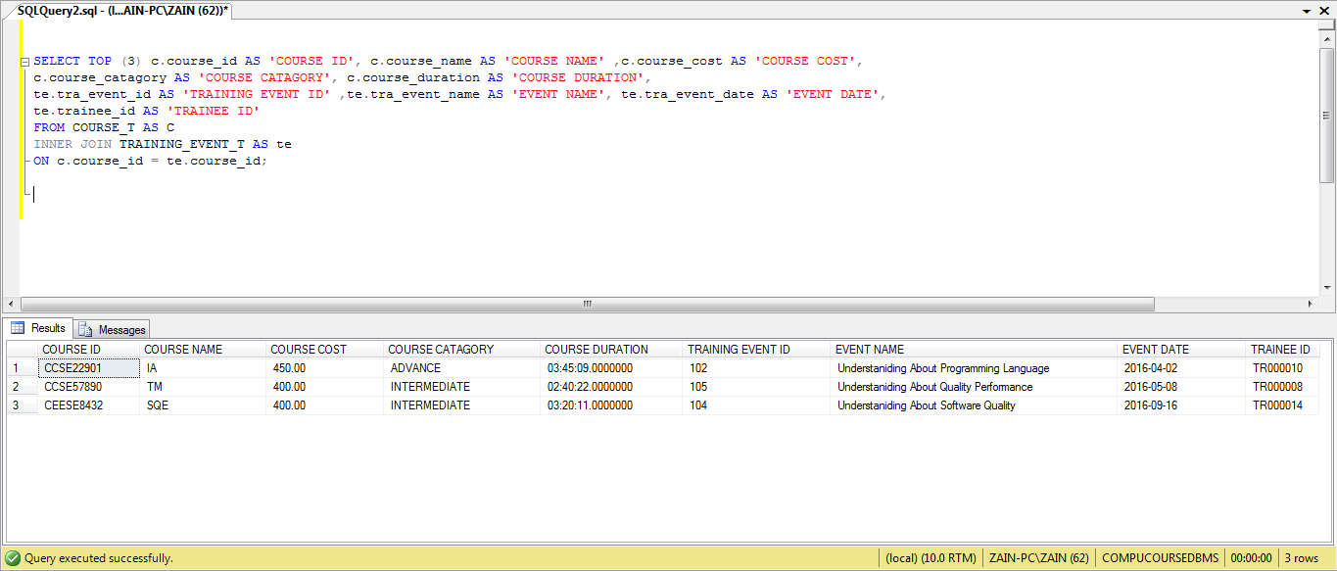**SQL Server Result**

# 4:0 **CONCLUSION**

½ page

# **WORKLOAD MATRIX**

|  |  |  |  |  |  |
| --- | --- | --- | --- | --- | --- |
|  | | | | | |
|
| **TASK ID** | **TASK NAME** | **DURATION  (IN DAYS/HOURS)** | **START DATE** | **END DATE** | **MEMBER(S CONTRIBUTED** |
| 1.0 | **DATABASE SCHEMA (STRUCTURE OF DATABASE TABLES / DATA DICTIONARY)** |  |  |  | Dlhason Padmakumar |
|  | **1.1 Database Schema** | 2 days | Sun,23-May-2020 | Sun,31-May-2020 | Mr.LEE,TP00000,e-signature  Miss.Chow Yee Mei,TP0000, e-signature |
|  | **1.2** Finalized ERD (Entity Relationship Diagram) – Output of Conceptual database design phase |  |  |  |  |
|  | **1.3** Finalized EERD (Enhanced Entity Relationship Diagram) – Output of Logical database design phase |  |  |  |  |
| 2.0 | **SQL-DATA DEFINITION LANGUAGE (DDL)** |  |  |  |  |
|  | 2.1 SQL DDL USED |  |  |  |  |
|  | 2.1.1 SQL DDL used to create the table (OWNER_T) |  |  |  |  |
|  | 2. 1. 2 SQL DDL used to create the table (OWNER_PHONE_T) |  |  |  |  |
|  | 2.2 **Sample Data Used** |  |  |  |  |
|  | 1. List the book(s) which has the highest rating. Show book id, book name, and the rating. |  |  |  |  |

# REFERENCES

Miss.Chow Yee Mei

Mr.