1. Prepare a fbx file (e.g. 1.fbx)

準備一個fbx文件（例如1.fbx）

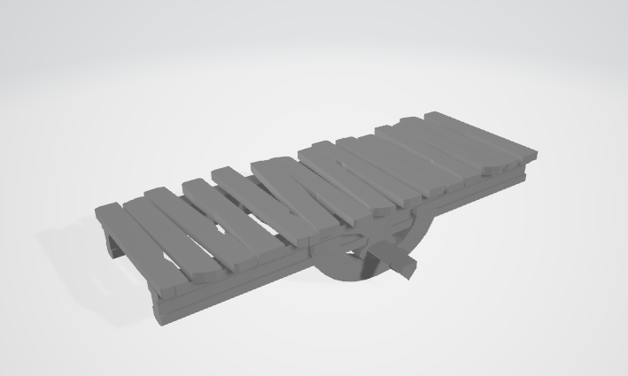

1. Make sure that there is no “Open Edge” in the model. The explosion algorithm requires model to be closed (i.e. no open edge)

In the below diagram, the model is not closed and hence there is open edge.

確保模型中沒有“Open Edge”。爆炸算法要求模型是閉合的（即沒有” Open Edge”開邊）

在下圖中，因為有開邊, 模型不是閉合的

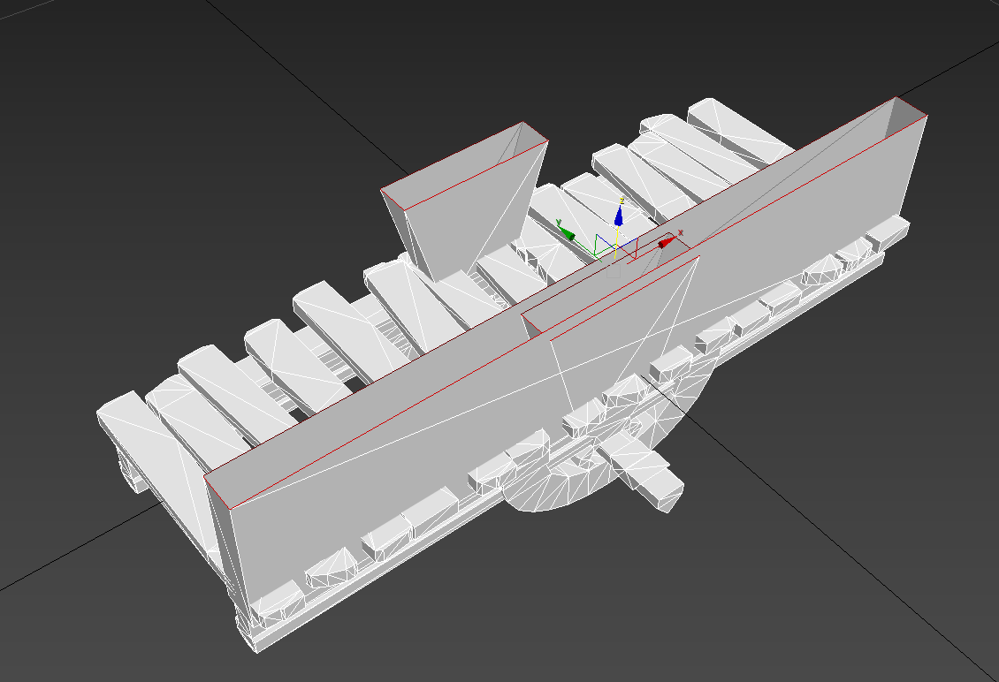

1. For 3dsmax user, you can use edge tool and “Select Open Edges” to help fix the model closed

對於 3dsmax 用戶，您可以使用邊緣工具和“選擇開放邊緣”來幫助修復閉合的模型

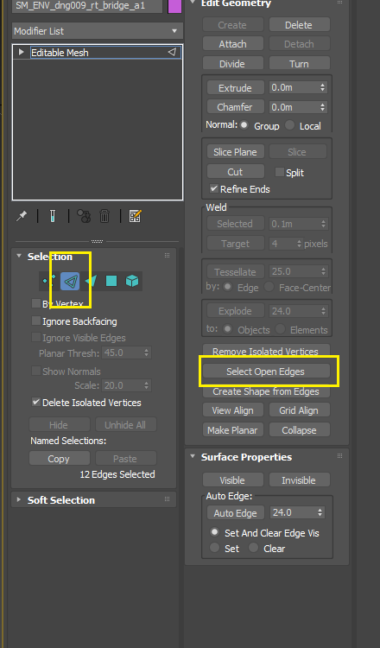

1. To make the Mesh closed, try manually create polygon.

要使網格閉合，請嘗試手動創建多邊形。

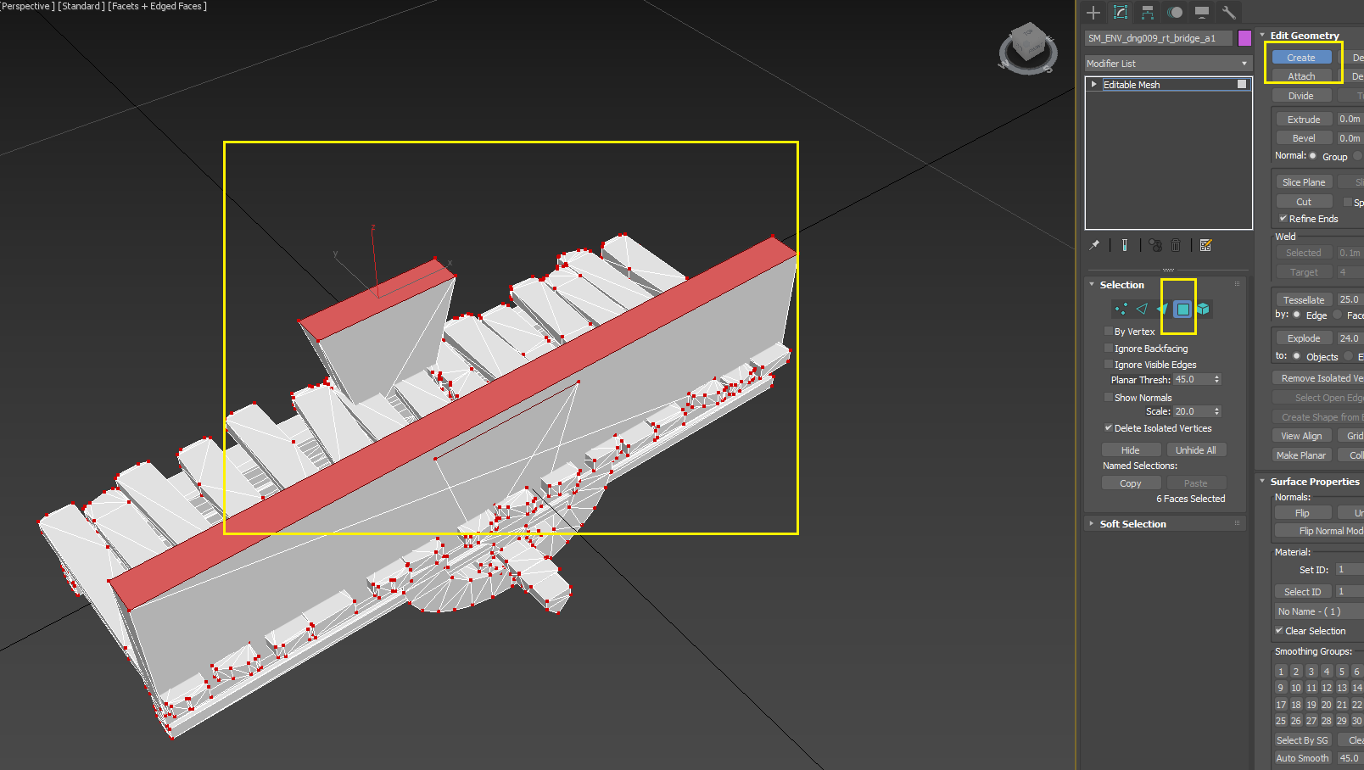

1. Use the command line tool FBXPreprocessor to preprocess the fbx before importing to Unity, for 1.fbx we can do the following

在導入Unity之前使用命令行工具FBXPreprocessor對fbx進行預處理，對於1.fbx我們可以進行如下操作

FBXPreprocessor.exe 1.fbx -o 1out.fbx -engine unity -cts 1

也可以參考demo.bat, 一次性的批處理

1. Import the model, and assignment material

導入模型、賦值材質

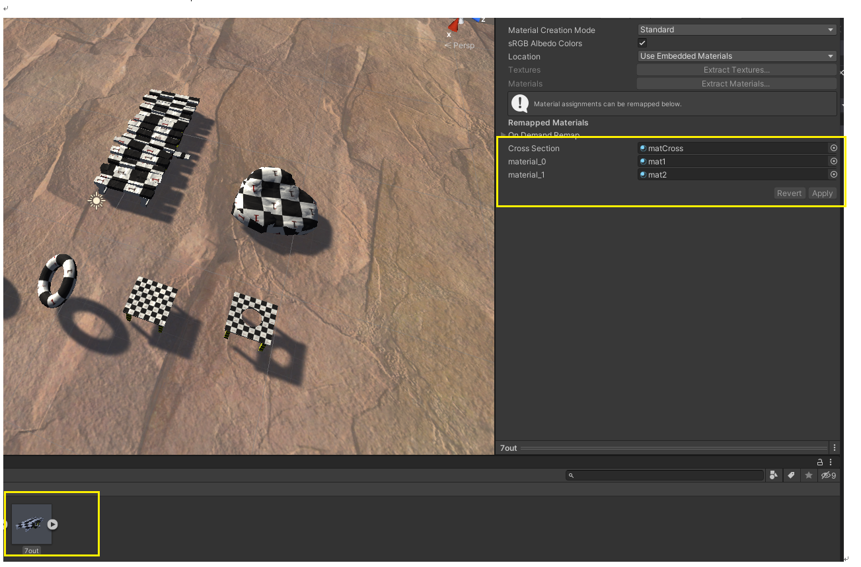

1. Assign MonoBehaviour Destructable1.cs to the root model.

將 MonoBehaviour Destructable1.cs 給根模型。

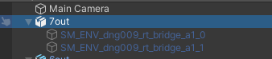

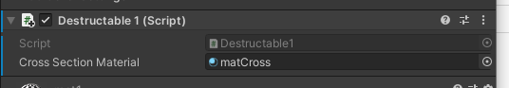

1. Take Reference to Assets\Method1\Scripts\Destructable1Controller.cs to see how it call Destructable1.Destruct

參考 Assets\Method1\Scripts\Destructable1Controller.cs 看看它是如何調用 Destructable1.Destruct

