MACH1 SPATIAL SDK

Open Use License Version 3.0

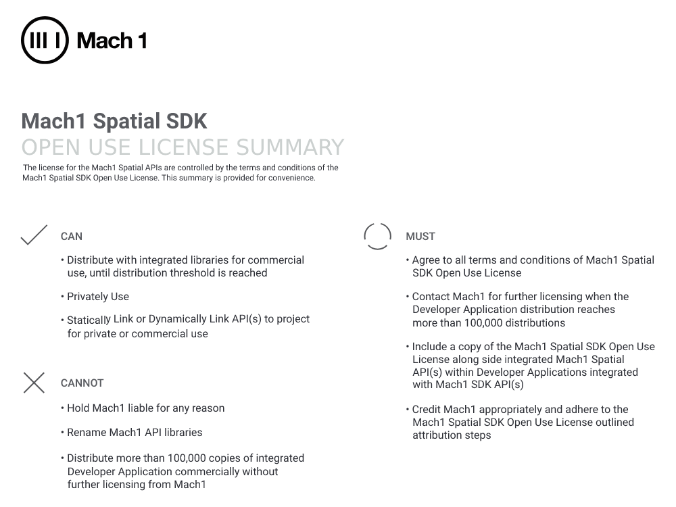

**MACH1 SPATIAL SDK Open Use License**

This License Agreement ("Agreement") is entered between MACH 1 CORP., a Delaware Corporation with offices located at 11 Vestry Street #1A, New York, NY 10013 ("MACH1"), and you becomes effective once you download, install, or use the MACH1 SPATIAL SDK.

1. **SPATIAL SDK**. This Agreement governs all versions of the MACH1 SPATIAL SDK released by MACH1 under this Agreement, including the Mach1 Spatial API libraries (“API Libraries”), together referred to as the “SDK.” The SDK is provided free of charge under this Agreement to assist you with developing applications that include the API Libraries. In this Agreement, “you” means the individual or entity exercising the licenses granted in this Agreement.

2. **LICENSE**. MACH1 hereby grants you a non-exclusive, non-transferable license to: (i) use, modify and distribute copies of the SDK for the purpose of developing and distributing your Applications, and (ii) sublicense the use of the API Libraries to end users solely for use within your Applications, in each case and subject to the limitations of Section 3 (LIMITATIONS).

3. **LIMITATIONS**. You must not use or sublicense the SDK for Applications exceeding the Use Limit. The “Use Limit” is 100,000 users, where a “user” includes a human user, a software bot, or a hardware device. Users are measured across any Application developed or distributed by or for you or your affiliates. You must use the SDK only in accordance with all applicable law. You must not remove any proprietary notices in the SDK. You must use the SDK in accordance with any trademark policy published by MACH1. If the SDK contains any technical measures to track your use of the SDK or Applications containing the Binary Libraries, you must not disable, remove or modify those measures.

4. **LICENSE NOTICE**. You must include a copy of this Agreement with any copy of the SDK you distribute. When you sublicense the right to use the API Libraries, you must do so under license terms that disclaim all warranties and liability on the part of MACH1, and you must cause the user to enter into a binding agreement to abide by such terms. The license terms currently used by MACH1 for distribution to end users, located at (https://www.mach1.tech/license-eula)[EULA Link] is sufficient to meet the requirements of this Section.

5. **OWNERSHIP**. MACH1 hereby reserves all intellectual property rights not expressly granted herein. This Agreement grants you no rights in the trademarks or service marks of MACH1.

6. **AUDIT AND REPORTING**. You must advise MACH1 at the following email address if you exceed or expect to exceed the Use Limitation: whatsup@mach1.tech. Use of the SDK beyond the Use Limit is subject to a separate agreement at terms and fees to be designated by MACH1. Upon MACH1’s request, you must provide MACH1 with access to your books and records to confirm that you have stayed within the Use Limit.

7. **TERM AND TERMINATION**. You may terminate this Agreement at any time. If you violate any provision of this Agreement, your license ends immediately. If you engage in, or assist any part to engage in, any proceeding alleging that the use or exploitation of the SDK constitutes patent infringement, or challenging the validity of any patent claim of MACH1 relating to the SDK, then your license granted hereunder will terminate immediately. Any termination of this Agreement also terminates the licenses granted hereunder.

8. **WARRANTY DISCLAIMER**. THE SDK IS PROVIDED "AS IS" WITHOUT WARRANTY OF ANY KIND. EXCEPT TO THE EXTENT REQUIRED BY APPLICABLE LAW, MACH1 DISCLAIMS ALL WARRANTIES AND CONDITIONS, EXPRESS, IMPLIED OR STATUTORY, REGARDING THE SDK, INCLUDING WITHOUT LIMITATION ANY AND ALL IMPLIED WARRANTIES OF MERCHANTABILITY, FITNESS FOR A PARTICULAR PURPOSE, AND NON-INFRINGEMENT. If this disclaimer is unenforceable under applicable law, your license is null and void. MACH1 reserves the right to discontinue, modify, or cease support of the SDK.

9. **LIABILITY LIMITATION**. MACH1 WILL NOT BE LIABLE TO YOU FOR ANY INDIRECT DAMAGES, INCLUDING WITHOUT LIMITATION LOST PROFITS, OR SPECIAL, INDIRECT, INCIDENTAL OR CONSEQUENTIAL DAMAGES, EVEN IF MACH1 HAS BEEN ADVISED OF THE POSSIBILITY OF SUCH DAMAGES.

10. **GENERAL PROVISIONS**. This Agreement will be governed by New York law, excluding conflict of law provisions. If you are located or domiciled in the USA, disputes arising out of or relating to this Agreement or the SDK are subject to the exclusive jurisdiction of state and federal courts located in New York City, New York. If you are not located or domiciled in the USA, disputes arising out of or relating to this Agreement or the SDK are subject to binding arbitration to be conducted in New York City, New York under the rules of JAMS. The application of the United Nations Convention of Contracts for the International Sale of Goods will not apply. In the event of any court action relating to enforcement of this Agreement, including injunctive relief, the non-prevailing party shall reimburse the prevailing party for all reasonable attorneys' fees and costs, including expert witness fees, resulting therefrom. If any part of this Agreement is found unenforceable, it will not affect the validity of the balance of the Agreement, which shall remain valid and enforceable according to its terms, and the unenforceable term will be reformed to effectuate the intent of the parties. This is the entire Agreement between MACH1 and you relating to the SDK. This Agreement is not assignable by you, including by operation of law.