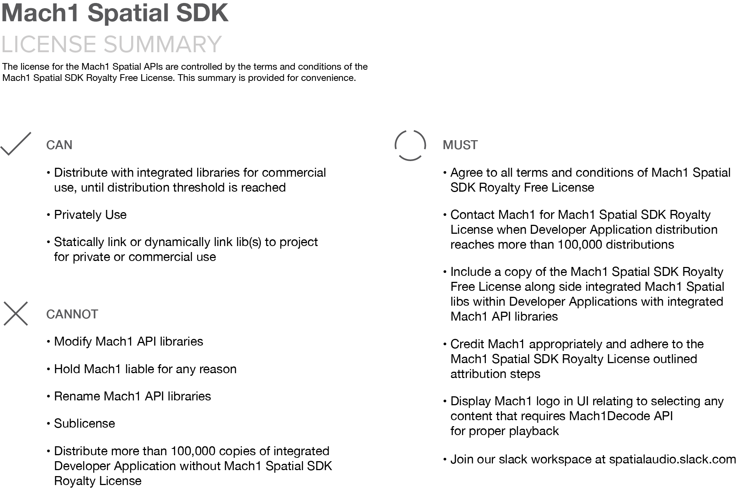

**REMINDER: ASSIGN DEVELOPER APPLICATION HERE**

**MACH1 SPATIAL SDK Royalty License**

This License Agreement ("Agreement") is entered between MACH 1 CORP., a Delaware Corporation with offices located at 11 Vestry Street #1A, New York, NY 10013 (“MACH1”), (hereinafter "MACH1" or "we") and you (“DEVELOPER” or “Licensee” or “you”) and becomes effective once you download, install, or use the MACH1 SPATIAL SDK.

1. **OBJECT OF AGREEMENT:** This Agreement governs MACH1 SPATIAL SDK and all related software and documentation and any update, upgrades or bug fixes which includes Mach1 Spatial API binary libraries (“MACH1 SPATIAL APIs”) (collectively referred to as the "SDK").
2. **GRANT OF LICENSE:** Subject to your full compliance with all of the terms and conditions of this Agreement, we grant you a non-exclusive, revocable, non-sublicensable (except as specifically provided herein), nontransferable license to use the SDK (limited solely to the “ROYALTY FREE USES”) solely to: (i) download, install, and use the SDK for the sole purpose of your development, integration and distribution of up to 100,000 end-user licenses of your application, downloads or otherwise distributed copies including server-side usage which may include but is not limited to embedded/pre-bundled/pre-installed/platform or software application (collectively "Application") to connect with the SDK; (iii) permit sublicensing of the SDK solely to permit the end-users of your Application to connect with the SDK. NOTE THAT ANY USE OF THE SDK WITHIN AN APPLICATION THAT HAS 100,000 OR MORE ACTIVATED LICENSES IS SUBJECT TO SECTION 9 OF THIS AGREEMENT. If you have any questions regarding this license and allowed uses of the contents of the SDK, please reach out to us via email at [licensing@mach1.tech](mailto:licensing@mach1.tech).
3. **LICENSE RESTRICTIONS AND OBLIGATIONS:** Except as expressly and unambiguously authorized under this Agreement, you must not
   1. copy, rent, lease, sell, transfer, assign, sublicense, disassemble, reverse engineer or decompile (except to the limited extent expressly authorized by applicable statutory law), modify, create derivative works from, or alter any part of the Mach1 Spatial binary libraries (“MACH1SPATIAL API’s”);
   2. use any automated means, including, without limitation, agents, robots, scripts or spiders, to access the MACH1 SPATIAL API’s or to interfere or attempt to interfere with the proper working of the MACH1 SPATIAL API’s;
   3. use the SDK for the benefit of a third party, other than end users of your Applications as expressly authorized by this Agreement;
   4. modify and/or rename the MACH1 SPATIAL APIs; or
   5. otherwise engage in activity that interrupts the proper working of the SDK or is otherwise fraudulent or illegal.

Furthermore, you agree

* 1. **to join the Slack workspace** [**spatialaudio.slack.com**](https://join.slack.com/t/spatialaudio/shared_invite/enQtNjk0ODE4NjQ4NjExLWQ5YWUyNWQ4NWEwMDEwZmJiNmI5MzBhYjM3OTE3NTYxYzdjZDE2YTlhZDI4OGY0ZjdkNmM1NzgxNjI5OGU4ZWE) **and to keep your contact information up to date**;
  2. to include MACH1’s attributions as further described in Section 7 (“ATTRIBUTION REQUIREMENTS AND TRADEMARK RIGHTS”);
  3. to distribute your Application with reference or inclusion of the MACH1 GENERAL EULA which is available for download at [www.mach1.tech/license-eula](http://www.mach1.tech/license-eula);
  4. to contact MACH1 via email at [licensing@mach1.tech](mailto:licensing@mach1.tech) once you distribute or intend to Distribute (as defined in Section 9) more than 100,000 single licenses of your Application to obtain a paid license – which you agree is required for such a scenario – to the SDK (as further described in Section 9 below);
  5. to include a copy of this Agreement alongside integrated MACH1 spatial libraries within Applications that integrates the SDK libraries; and
  6. to contact MACH1 via email at [licensing@mach1.tech](mailto:licensing@mach1.tech) if your Application includes software that integrates, applies, or utilizes in an open source environment to obtain a paid license – which you agree is required for such a scenario – to the SDK.

We reserve the right to discontinue, modify, cease support of, and alter the pricing structure of the SDK.

1. **LICENSE TO MACH1:** Any feedback, suggestions or contributions provided to MACH1 by DEVELOPER relating to the SDK, shall be owned by MACH1 and DEVELOPER hereby assigns to MACH1 all such feedback, contributions, written code and suggestions.
2. **REPRESENTATIONS AND WARRANTIES:** You represent and warrant that you: (i) are fully authorized to enter into this agreement; (ii) shall use the SDK in compliance with all applicable local, state, national and foreign laws, treaties and regulations, including those related to data privacy, international communications, export laws and the transmission of technical or personal data laws; (iii) shall not (and shall not permit any third party, including a permitted sublicensee to), directly or indirectly, take any action or upload, download, post, submit or otherwise distribute or facilitate distribution of Content or any material on or through the SDK, that: (a) infringes any patent, trademark, trade secret, copyright, right of publicity/privacy or other right of any third party or induces infringement thereof; (b) breaches any third party contract or obligation; (c) is unlawful, threatening, abusive, harassing, defamatory, deceptive, fraudulent, invasive of another's privacy, tortious, obscene, offensive, or profane.
3. **OWNERSHIP AND PROPRIETARY RIGHTS:** As between MACH1 and DEVELOPER (and any permitted sublicensees), the SDK and all intellectual property rights in and to the SDK, are and shall at all times remain the sole and exclusive property of MACH1 and are protected by applicable intellectual property laws and treaties. You shall not obscure, remove or otherwise alter our copyright or trademark notices or other proprietary rights' notices affixed to or within the SDK or elsewhere.
4. **ATTRIBUTION REQUIREMENTS AND TRADEMARK RIGHTS:** You must reasonably display attribution on all embodiments and uses of the SDK, including, but not limited to your web site and/or Application in a manner consistent with the following guidelines:
   1. Documentation/Website/Marketing of Application must include mention of Mach1 in the following ways:

- Display a copy of the Mach1 logo

**AND/OR** - Display “Spatial Audio Powered by Mach1™”

**AND** - Backlink to www.mach1.tech

**AND** - Display “Copyright 2017 – xxxx, Mach1, CORP. All rights reserved.” (*where xxxx is replaced with current year).*

* 1. Application must have mention of Mach1 when using the Mach1Decode API any content at least one of the following ways:

- Display a copy of the Mach1 logo

**AND/OR** - Display “Spatial Audio Powered by Mach1™”

* 1. Application must have mention of Mach1 when using the Mach1Encode API with the following ways:

- Display on an opening or “splash screen,” a copy of the Mach1 Logo

**AND** - Display “Spatial Audio Powered by Mach1™”

* 1. Application must have mention of Mach1 when using the Mach1Transcode API with the following:

- “Spatial Audio Software provided under license from Mach1™“

1. **SUPPORT AND UPGRADES:** This Agreement does not entitle you to any support for the SDK, unless you enter into a separate agreement with us in writing signed by both parties. Any such support provided by us shall be subject to the terms and disclaimers of this Agreement.
2. **CUSTOMIZED FEATURES AND FEES / USE BEYOND ROYALTY FREE USES:** 
   1. We may opt to make available certain customized features of the SDK in exchange for the payment of certain fees, in which case, DEVELOPER and MACH1 may enter into another agreement, which shall supersede this Agreement, as agreed to by the parties.
   2. **Licenses beyond 100,000 Distributions**: You agree to contact MACH1 at [licensing@mach1.tech](mailto:licensing@mach1.tech) to obtain a paid license in one of the scenarios described under Section 3 (ix) and (xi). If you fail to do so and continue to distribute an Application utilizing MACH1 SPATIAL APIs beyond the royalty free uses described under this Agreement, you shall immediately contact MACH1 and pay to MACH1 a royalty per each Distribution (as defined below) in an amount as solely determined by MACH1. A Distribution refers to either an embedded, pre-bundled, pre-installed platform application or software application that is downloaded, delivered, or served to a user or device by any means of distribution including directly from you or through any platform, including cloud based platforms. For the purpose of determining the number of installs or distributions of any Application, the aggregate number of installs across target operating systems, devices or platforms shall be used. For example; if “AudioX App” has 50,000 app installs on iOS and 100,000 app installs on Android, then AudioX App shall have 150,000 app installs for purposes of this Agreement. For avoidance of doubt, any subscription or rental shall be considered a Distribution. No rights are granted beyond the ROYALTY FREE USES, and any Distribution of the DEVELOPER APPLICATION incorporating the MACH1 SPATIAL SDK beyond the ROYALTY FREE USES shall be royalty bearing and require separate licensing from MACH1.
   3. **Open source**: You agree to contact MACH1 via email at [licensing@mach1.tech](mailto:licensing@mach1.tech) if your Application includes software that integrates, applies, or utilizes in an open source environment to obtain a paid license of the SDK – which you agree and understand is required for such a scenario.
   4. **Audit Rights**: Should you fail to obtain a royalty-bearing, paid extended use license after distribution the SDK as part of an Application beyond the ROYALTY FREE USES or should MACH1 have a reasonable basis to believe that the end user Distribution exceeds or exceeded the 100,000 licenses, MACH1 shall have the right, upon reasonable notice, to audit/inspect any premises, computer(s), and networks on or in which the SDK is installed or used to monitor compliance with the terms of this Agreement, including but not limited to confirming the number of Distributions of the Application. If an audit reveals any unauthorized use, in addition to all other remedies available to Mach1, you shall be responsible to Mach1 for all reasonable expenses related to the audit.
3. **PRIVACY POLICY:** You shall have a privacy policy posted on your website in accordance with all applicable data and privacy laws and include relevant sections from our Privacy Policy, which can be found at www. mach1.tech/privacy-policy. You represent and warrant that you will comply with all applicable privacy laws.
4. **TRADE SECRETS AND CONFIDENTIAL INFORMATION:** You acknowledges that the SDK contains valuable trade secrets of MACH1 and, should you access any such trade secrets in violation of this Agreement, you agree to maintain the confidentiality of the trade secrets of the SDK using at least the same degree of care that you use with your own confidential information.
5. **INTELLECTUAL PROPERTY:** (a) This Agreement does not transfer or assign to You, any intellectual property right including any patent, design, industrial design, trademark, service mark, copyright or rights in any confidential information or trade secrets, in or related to the SDK or any part thereof. The SDK and all copies thereof remain the property of MACH1 and are only licensed under this Agreement. You acknowledges that there are no implied licenses granted under this Agreement, and all rights, save for those license rights expressly granted to Licensee hereunder, shall remain with MACH1. Licensee agrees that nothing in this Agreement shall adversely affect any rights and recourse to remedies, including without limitation, injunctive relief that MACH1 may have under any applicable laws relating to the protection of MACH1’S intellectual property or other rights.  
   (b) Any feedback or suggestions provided to MACH1 by Licensee relating to the MACH1 SPATIAL SDK, shall be owned by MACH1 and Licensee hereby assigns to MACH1 all such feedback, written code and suggestions.
6. **WARRANTY DISCLAIMER:** THE SDK IS PROVIDED "AS IS" WITHOUT WARRANTY OF ANY KIND. EXCEPT TO THE EXTENT REQUIRED BY APPLICABLE LAW, WE DISCLAIM ALL WARRANTIES, WHETHER EXPRESS, IMPLIED OR STATUTORY, REGARDING THE SDK, INCLUDING WITHOUT LIMITATION ANY AND ALL IMPLIED WARRANTIES OF MERCHANTABILITY, ACCURACY, RESULTS OF USE, RELIABILITY, FITNESS FOR A PARTICULAR PURPOSE, TITLE, AVAILABILITY, PERFORMANCE, BANDWIDTH, AND NON-INFRINGEMENT OF THIRD-PARTY RIGHTS. FURTHER, WE DISCLAIM ANY WARRANTY THAT LICENSEE'S USE OF THE SDK WILL BE AVAILABLE, UNINTERRUPTED OR ERROR FREE.
7. **LIABILITY LIMITATION:** REGARDLESS OF WHETHER ANY REMEDY SET FORTH HEREIN FAILS OF ITS ESSENTIAL PURPOSE OR OTHERWISE, AND EXCEPT FOR BODILY INJURY, IN NO EVENT WILL WE OR OUR CONTRACTORS, EMPLOYEES OR AFFILIATES BE LIABLE TO YOU OR TO ANY THIRD PARTY UNDER ANY TORT, CONTRACT, NEGLIGENCE, STRICT LIABILITY OR OTHER LEGAL OR EQUITABLE THEORY FOR ANY LOST PROFITS, LOST OR CORRUPTED DATA, COMPUTER FAILURE OR MALFUNCTION, INFRINGEMENT, INTERRUPTION OF BUSINESS, OR OTHER SPECIAL, INDIRECT, INCIDENTAL OR CONSEQUENTIAL DAMAGES OF ANY KIND ARISING OUT OF THE USE OR INABILITY TO USE THE SDK, EVEN IF WE HAVE BEEN ADVISED OF THE POSSIBILITY OF SUCH LOSS OR DAMAGES AND WHETHER OR NOT SUCH LOSS OR DAMAGES ARE FORESEEABLE. IN NO EVENT SHALL OUR TOTAL LIABILITY TO YOU OR ANY THIRD PARTY EXCEED TEN DOLLARS. ANY CLAIM ARISING OUT OF OR RELATING TO THIS AGREEMENT MUST BE BROUGHT WITHIN ONE (1) YEAR AFTER THE OCCURRENCE OF THE EVENT GIVING RISE TO SUCH CLAIM.
8. **INDEMNITY:** You agree that we shall have no liability whatsoever for you or your end users of the SDK. You shall indemnify, defend and hold us harmless from any and all claims, damages, liabilities, costs, and fees (including reasonable attorneys' fees) arising from you or your end users' use of the SDK or for any breach of this Agreement, including any breach of the representations and warranties you made herein.
9. **TERM AND TERMINATION:** This Agreement shall continue until terminated as set forth in this Section. Either party may terminate this Agreement at any time, for any reason, or for no reason including, but not limited to, if you violate any provision of this Agreement. We reserve the right to cancel, amend, or modify the SDK at anytime. Any termination of this Agreement shall also terminate the license granted hereunder. Upon termination of this Agreement for any reason, you shall immediately destroy and remove from all computers, hard drives, networks, and other storage media all copies of the SDK, and shall so certify to us that such actions have occurred (including all cached ephemeral copies). Sections 5 (“REPRESENTATIONS AND WARRANTIES”), 6 (“OWNERSHIP AND PROPRIETARY RIGHTS”), 11 (TRADE SECRETS), 12 (“WARRANTY DISCLAIMER”), 13 (“LIABILITY LIMITATION”), 13 (“INDEMNITY”), 18 (“GENERAL PROVISIONS”) shall survive termination of this Agreement.
10. **EXPORT CONTROLS:** You shall comply with all applicable export laws and restrictions and regulations and you shall not export, or allow the export or re-export of the SDK in violation of any such restrictions, laws, or regulations.
11. **GOVERNING LAW:** This Agreement shall be governed by New York law, excluding conflict of law provisions. The parties agree to and submit to the exclusive jurisdiction of courts located in New York City, New York. The application of the United Nations Convention of Contracts for the International Sale of Goods is expressly excluded.
12. **PREVAILING PARTY:** Notwithstanding Section 13 (“LIABILITY LIMITATION”), in the event of any court action relating to enforcement of this Agreement, including injunctive relief, the non-prevailing party shall reimburse the prevailing party for all reasonable attorneys’ fees and costs, including expert witness fees, resulting therefrom.
13. **GENERAL PROVISIONS:** If any part of this Agreement is found void or unenforceable, it will not affect the validity of the balance of the Agreement, which shall remain valid and enforceable according to its terms. This Agreement may only be modified by written agreement between the Parties. Updates to the SDK may be licensed to you by MACH1 with additional or different terms. MACH1 further reserves rights, in its discretion, not to license updates. This is the entire Agreement between MACH1 and you relating to the SDK and it supersedes any prior representations, discussions, undertakings, communications, or advertising relating to the SDK. This Agreement is not assignable by you.