Arson Heat Map
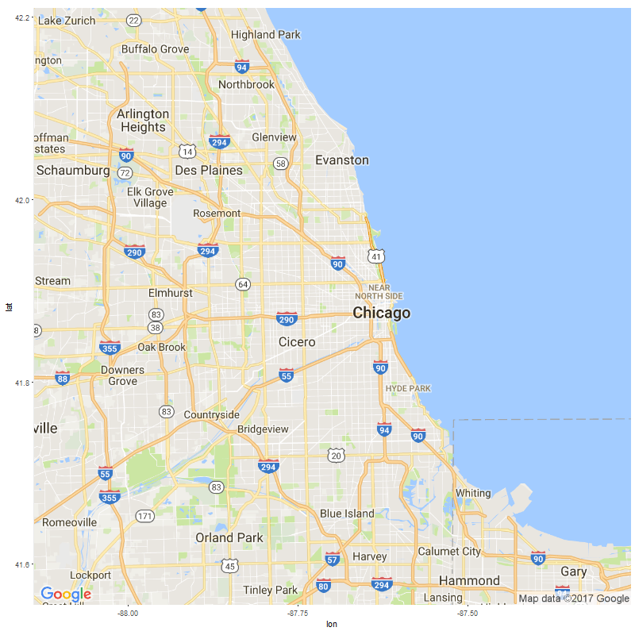

Assault Heat Map

Battery Heat Map

Burglary Heat Map

Criminal Damage Heat Map

Criminal Sexual Assault Heat Map

Criminal Trespass Heat Map

Deceptive Practice Heat Map

Gambling Heat Map

Homicide Heat Map

Interference with a Public Officer Heat Map

Intimidation Heat Map

Kidnapping Heat Map

Liquor Law Violation Heat Map

Motor Vehicle Theft Heat Map

Narcotics Heat Map

Non-Criminal Offense Heat Map

Obscenity Heat Map

Offense Involving Children Heat Map

Other Offense Heat Map

Prostitution Heat Map

Public Peace Violation Heat Map

Public Indecency Heat Map

Robbery Heat Map

Sexual Offense Heat Map

Stalking Heat Map

Theft Heat Map
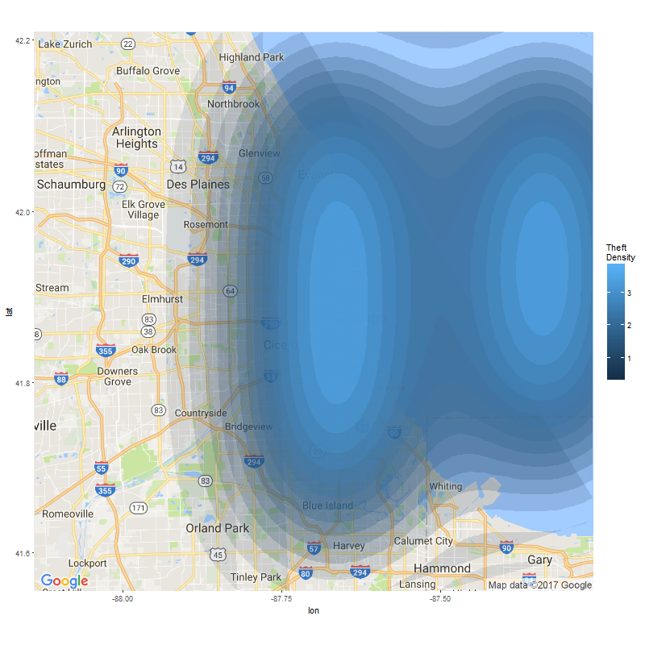

Weapons Violation Heat Map

