Swagger2API AI Agent
Autonomous Playwright TypeScript API Automation in Seconds
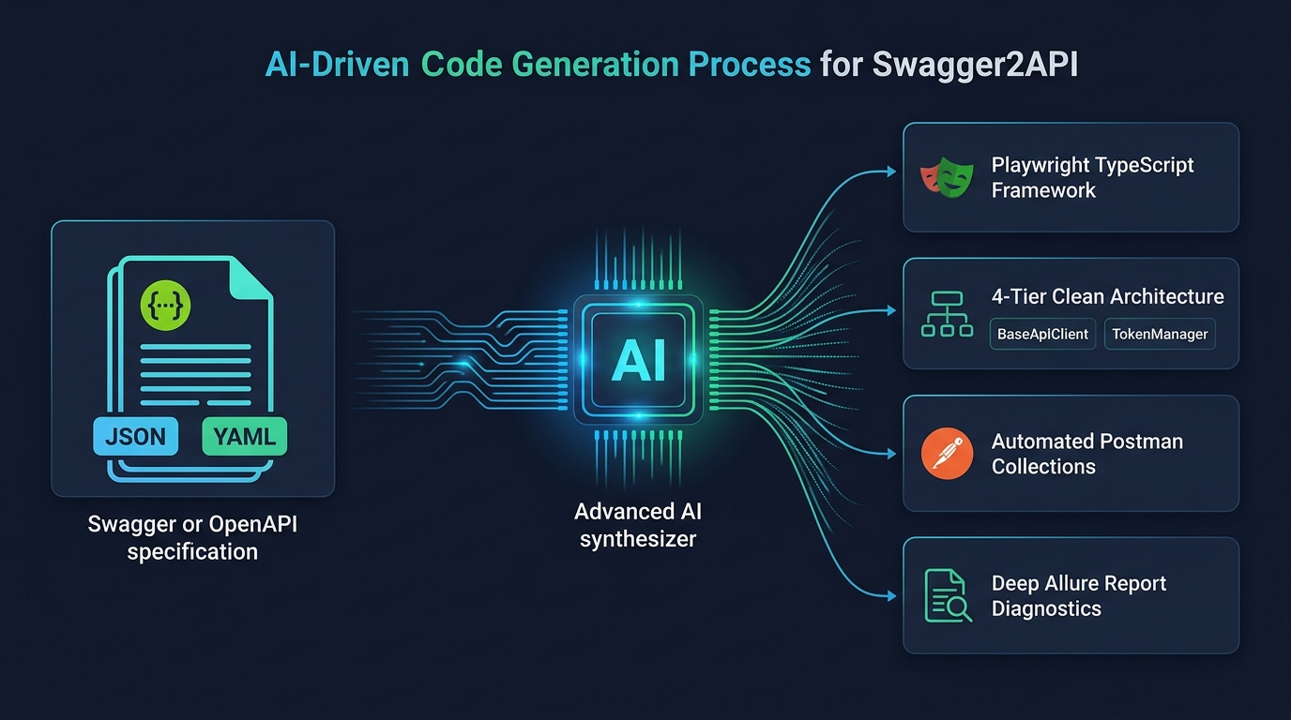
Figure 1: End-to-End AI-Driven Architecture — From Raw Swagger/OpenAPI to Production Playwright Suite

1. Problem – What Are We Solving?
In fast sprints, developers release new APIs constantly. But writing automation tests manually is painful and slow. Teams face three everyday hurdles:
- Takes Days to Set Up: Setting up HTTP helpers, configs, auth tokens, and test folders takes 3 to 5 valuable days per microservice.
- Shallow "Happy Path Only" Tests: Under deadline pressure, engineers usually test only status 200 OK, leaving error boundaries (400, 404) and security flaws completely untested.
- Brittle, Hardcoded Scripts: API URLs are hardcoded directly into test steps. Whenever backend fields change, tests break instantly and require hours of refactoring.
- Repeated Login Overhead: Tests log in again and again on every step, making runs sluggish and triggering server rate-limiting errors.

2. Solution – What Did We Build?
We built Swagger2API AI Agent—a 1-click tool where you paste any Swagger link or upload an API file, and it instantly builds an enterprise-ready Playwright TypeScript framework in under 2 seconds.
- Smart Auto-Discovery: Paste a Swagger UI web link or a raw JSON/YAML file. The tool automatically detects endpoints, parameters, and models from Spring Boot, ASP.NET, FastAPI, NestJS, and Express.
- Clean 4-Tier Architecture: Organizes code neatly into BaseApiClient (handles HTTP calls), TokenManager (caches login tokens in memory), Domain Services, and Playwright Fixtures for zero code duplication.
- 4-in-1 Test Strategy Selector: Choose the exact test combinations you need: 1. Sequential E2E Journey (creates data, passes ID downstream, cleans up), 2. Positive CRUD, 3. Negative Boundaries (400/404/422), and 4. Security Fuzzing (IDOR, SQLi, JWT).
- Deep Allure Forensics: Built-in interactive reporting showing the exact request payload sent, response latency (ms), HTTP status, and step assertions.
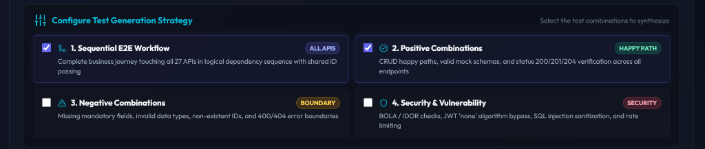
Figure 2: Real-time Strategy Configuration — Dynamically Adapts to Any Uploaded Swagger Document

3. Benefits – What Value & Impact Does It Deliver?
What You Care About | Old Manual Way | With Swagger2API AI Agent
Setup Time | 3 to 5 days per service | Under 2 seconds (< 99% faster)
Test Quality | Happy paths only; errors skipped | 100% full coverage (E2E + Error + Security)
Framework Quality | Ad-hoc scripts; hard to maintain | Strict enterprise 4-tier Page/Service pattern
CI/CD & Postman | Manually written from scratch | Instant GitHub Actions workflow + Postman v2.1

4. Any Additional Info – How Teams Use It
- Universal Backend Compatibility: Tested and verified across Spring Boot, ASP.NET Core, FastAPI, NestJS, and Express. It handles any valid Swagger 2.0 or OpenAPI 3.x spec.
- Ready to Run Locally: Anyone can clone the folder, run npm install && npm start, and open http://localhost:3000 with zero configuration.
- Autonomous ID Chaining: The Sequential E2E test creates an entity (e.g. User), catches the generated ID, checks it, updates it, and deletes it at the end automatically.
- Run Tests with Standard Commands: Run npm test to run all suites, or npx playwright show-report to view the HTML report.
★ Built for Agile Squads | Zero Boilerplate, 100% Quality Velocity ★

