Swagger2API AI Agent
Enterprise Autonomous Playwright TypeScript API Test Automation Accelerator
Solution Category: Autonomous API Quality Engineering | Primary Technology: Playwright, TypeScript, OpenAPI 3.x, Allure

1. Problem – What Are You Solving?
In fast-paced software delivery cycles, backend APIs evolve rapidly, but API test automation remains a severe engineering bottleneck. Whenever backend squads release a Swagger or OpenAPI document, QA engineers and SDETs traditionally spend days or weeks writing repetitive automation boilerplate from scratch.
Key Industry Pain Points:
- High Time-to-Market Overhead: Setting up HTTP wrappers, TypeScript types, configs, and fixtures manually takes 3–5 days per service.
- Shallow Test Coverage: Due to tight sprint deadlines, teams often test only the 200 OK happy path, completely neglecting negative boundaries (400, 404, 422) and security vulnerabilities.
- Architectural Inconsistency: Tests frequently hardcode endpoints directly in test scripts, leading to brittle maintenance nightmares when schemas change.
- Redundant Auth Overhead: Without centralized token caching, test suites re-authenticate on every test step, slowing CI/CD runs and triggering API rate limits.

2. Solution – What Did You Build?
We engineered Swagger2API AI Agent—an enterprise-grade automation accelerator that ingests ANY Swagger 2.0 or OpenAPI 3.x specification and automatically synthesizes a production-ready, modular Playwright TypeScript API Automation Framework in under 2 seconds.
Core Architectural Pillars Built:
- Universal Smart Schema Resolver: Automatically parses raw JSON/YAML, file uploads, and live Swagger UI HTML portals across ASP.NET, Spring Boot, FastAPI, Flask, NestJS, and Express.
- 4-Tier Enterprise Architecture: Strict clean separation of BaseApiClient (HTTP engine), TokenManager (in-memory token caching), Domain Services, and custom Playwright Fixtures.
- Dynamic Test Strategy Selector: Dynamically configures (1) Sequential E2E Business Workflows touching all endpoints in order, (2) Positive CRUD Happy Paths, (3) Boundary Error Matrices (400/404), and (4) OWASP Security tests (IDOR, SQLi, JWT bypass).
- Deep Allure Diagnostics & Postman Sync: Multi-tab Allure reporting capturing exact payloads, consumed latency (ms), HTTP status messages, and auto-generated Postman v2.1 collections.
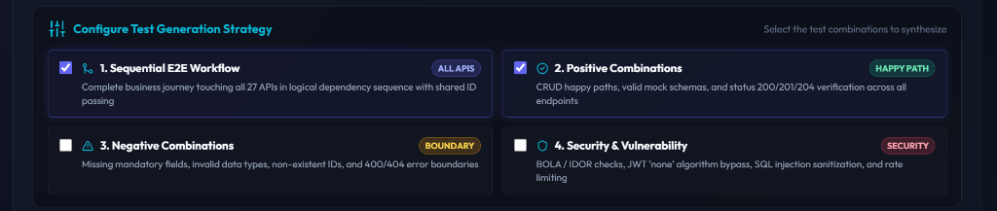
Figure 1: Dynamic Test Generation Strategy Selector with Real-time Spec Synchronization

3. Benefits – What Value & Impact Does It Deliver?
Metric / Dimension | Manual / Traditional Approach | Swagger2API AI Agent
Setup Duration | 3 to 5 Days per service | Under 2 Seconds (< 99% faster)
Test Coverage Breadth | Primarily 200 OK Happy Paths | 100% (E2E, Positive, Negative, Security)
Code Quality & Patterns | Inconsistent scripting across squads | Standardized 4-Tier Clean Architecture
CI/CD & Postman Sync | Manual pipelines & manually synced Postman | Bundled GitHub Actions & Postman v2.1

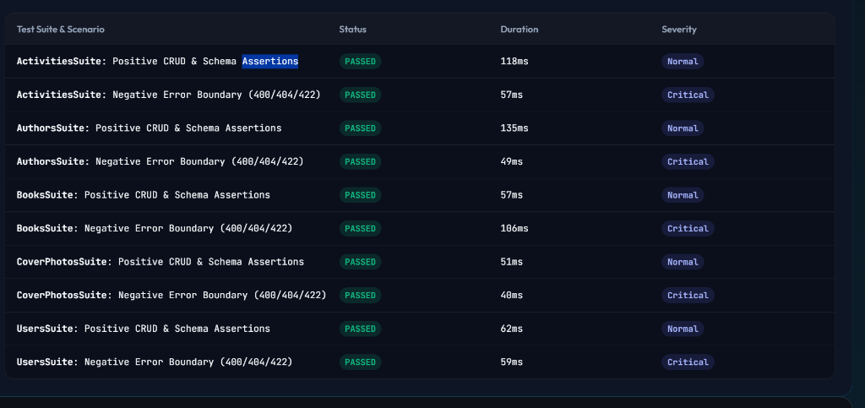
Figure 2: Multi-Tab Allure Report with Consumed Response Latency, Payload Forensics & Assertions

4. Any Additional Info – Deployment & Scalability
- Universal Framework Compatibility: Supports OpenAPI 3.0, 3.1, and Swagger 2.0 specs generated by Springdoc, Swagger-Net, FastAPI, NestJS, Go-Swagger, Flask-RESTX, and AWS API Gateway.
- Zero-Friction Team Onboarding: Colleagues can run the tool locally with 'npm install && npm start' or download the synthesized framework zip and execute 'npm test' with zero extra config.
- Autonomous Dependency Chaining: The Sequential E2E workflow automatically captures generated primary IDs from POST mutations and passes them seamlessly to downstream GET, PUT, and DELETE operations.
- Production-Ready Execution Commands: Execute full suite with 'npm test', run isolated E2E workflow with 'npx playwright test tests/e2e/e2e-workflow.spec.ts', or view reports with 'npx playwright show-report'.
Designed & Engineered for Enterprise Engineering Squads | Accelerating Quality Velocity

