REGULATION ON SPECIAL MEMBERSHIP
Association of Business Professionals (EMEA)
Adopted pursuant to Section 2.5 and Section 2.6 of the Charter
Article 1. Honorary (Senior) Members
1.1. Definition
An Honorary (Senior) Member is an individual recognized by the Association for exceptional and sustained contributions to the field of business, including but not limited to: founding or scaling transformative enterprises, shaping industry standards, advancing international business cooperation, or mentoring the next generation of business leaders. Honorary (Senior) Member status is a distinction of honor and does not carry the obligations of regular membership, unless the individual voluntarily assumes them.
1.2. Eligibility Criteria
A candidate for Honorary (Senior) Member status must satisfy at least three (3) of the following criteria:
- (a) has held a senior executive, board, or advisory position in one or more organizations of international significance for a cumulative period of not less than ten (10) years;
- (b) has made a measurable and recognized contribution to the development of a business sector, market, or professional community at the regional (EMEA) or global level, evidenced by industry reports, independent assessments, peer recognition, or comparable sources;
- (c) has been the recipient of internationally recognized professional honors, awards, fellowships, or distinctions in the field of business, entrepreneurship, innovation, or economic development;
- (d) has authored, co-authored, or substantially contributed to publications, research, frameworks, or standards that have demonstrably influenced business practices, governance models, or industry thought leadership;
- (e) has served as a mentor, educator, or advocate for emerging business leaders, contributing to the professional development of others in a sustained and verifiable manner;
- (f) has represented the business community in international forums, governmental advisory bodies, intergovernmental organizations, or multi-stakeholder platforms in a capacity that advanced the interests of the business profession.
1.3. Nomination and Admission Procedure
Candidates for Honorary (Senior) Member status may be nominated by: (i) any two (2) current Members of the Association; (ii) the President of the Association; or (iii) the Admissions Committee acting on its own initiative. Nominations must be submitted in writing and accompanied by a statement of justification addressing the eligibility criteria set out in Article 1.2. The Admissions Committee shall review the nomination and make a written recommendation to the governing body of the Association. The final decision to confer Honorary (Senior) Member status shall be adopted by the governing body by a simple majority of votes.
1.4. Rights and Privileges
Honorary (Senior) Members shall be entitled to: use the designation 'Honorary Member' or 'Senior Member' of the Association; participate in Association events, conferences, and professional activities; receive communications and publications issued by the Association; and be listed in the official register of Honorary Members maintained by the Association. Honorary (Senior) Members are exempt from membership fees unless they elect to contribute voluntarily.
1.5. Revocation
Honorary (Senior) Member status may be revoked by the governing body of the Association in the event of conduct that is materially inconsistent with the values, principles, or reputation of the Association, following a review by the Admissions Committee.
Article 2. Admissions Committee
2.1. Composition
The Admissions Committee shall consist of not fewer than three (3) and not more than seven (7) members appointed by the governing body of the Association for a term of two (2) years, renewable once. The Committee shall be chaired by a Chairperson elected from among its members. At least one member of the Committee shall hold Honorary (Senior) Member status, where such members exist. Committee members must be in good standing with the Association and must not have a conflict of interest in respect of any application or nomination under review.
2.2. Functions and Powers
The Admissions Committee shall:
- (a) receive and process applications and nominations for membership;
- (b) verify that candidates satisfy the applicable eligibility criteria;
- (c) conduct due diligence on submitted documentation;
- (d) issue written recommendations to the governing body with respect to the admission, deferral, or rejection of each candidate;
- (e) maintain a confidential register of all applications reviewed;
- (f) conduct periodic reviews of membership criteria and recommend updates to the governing body;
- (g) initiate or conduct reviews in cases of potential revocation of membership or Honorary (Senior) Member status.
2.3. Procedure of Meetings
The Admissions Committee shall meet as required and not less than four (4) times per year, whether in person or by electronic means. Meetings shall be convened by the Chairperson or, in their absence, by any two (2) Committee members. A quorum shall consist of a majority of the Committee members then in office. Decisions shall be adopted by a simple majority of members present and voting; in the event of a tie, the Chairperson shall have a casting vote.
2.4. Minutes of Meetings
Minutes shall be drawn up for each meeting of the Admissions Committee. The minutes shall record:
- the date, time, and location (or virtual platform) of the meeting;
- the names of members present and absent;
- the agenda items discussed;
- a summary of the deliberations;
- the decisions adopted, including the outcome of each application or nomination reviewed (approved, deferred, or rejected) with brief reasons;
- any dissenting opinions where a member so requests.
Minutes shall be signed by the Chairperson and the designated Secretary of the meeting, approved at the following meeting, and kept in the official records of the Association for a minimum of five (5) years. Copies of minutes shall be made available to the governing body upon request. Personal data contained in the minutes shall be processed in accordance with applicable data protection laws.
2.5. Confidentiality
All deliberations of the Admissions Committee and the content of individual applications and nominations shall be treated as strictly confidential. Committee members shall not disclose information relating to specific candidates outside the Committee, except as required by the governing body of the Association or by applicable law.

Certification
This Regulation is adopted in accordance with the Charter of the Association and shall enter into force upon approval by the governing body.
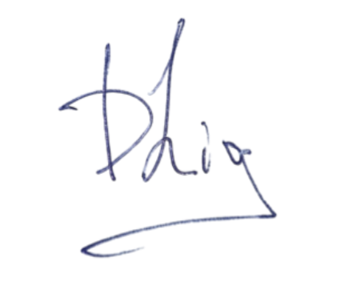
Date: November 17, 2025
Domenico Liguori
President
Association of Business Professionals (EMEA)
info@emeaabp.org

