REPORT: LINEAR REGRESSION

- Prince Singh Tomar (2019101021)
- Utkarsh Upadhyay (2019101010)

Task 1
Given a Linear Regression equation as:
LinearRegression().fit(x,y) is a function of the Class sklearn.linear_model.LinearRegression. It calculates the optimal values of the weights b and x_{i} (∀i ϵ [1,n] ) using the existing values of input (vector x which is a 2D array with n columns and each row represents one input) and output (y) from the train set.
These values are selected to minimize sum of squares between observed targets in the dataset and targets predicted by the linear approximation. It returns self, which is the an instance of the class Linear Regression.

Bias² – Variance Graph
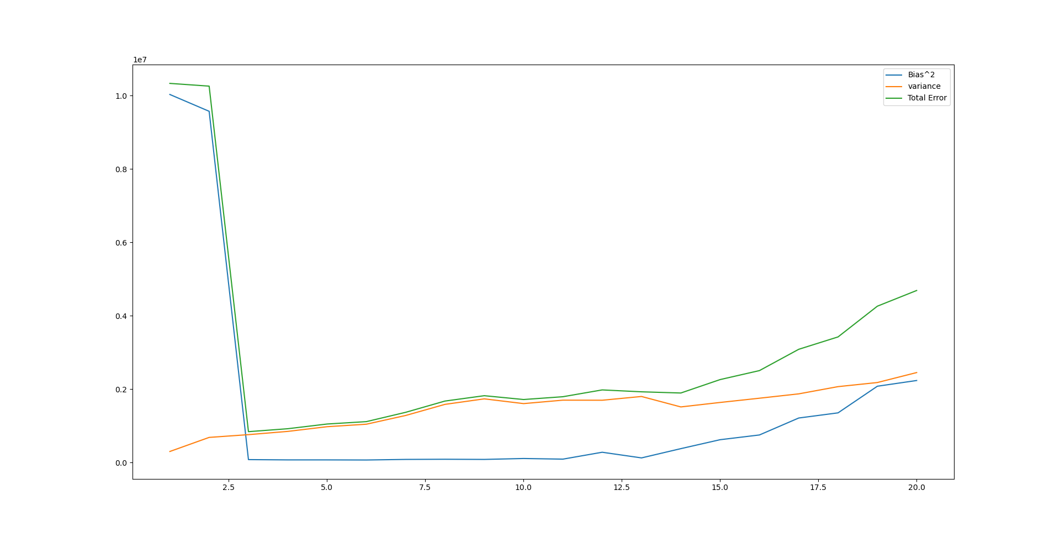

Bias Varinace Table
Polynomial Function Degree | Bias | Varinace
1 | 820.1274029682196 | 23731.01464687495
2 | 811.5730310058455 | 70214.29003169124
3 | 67.20494330902764 | 57949.96115114641
4 | 77.24739410735778 | 70522.4381610456
5 | 76.98315532066735 | 81445.51638642991
6 | 75.46431283880787 | 90865.21613854464
7 | 81.89558694700833 | 100371.24692962335
8 | 83.87197593851022 | 132803.85460543976
9 | 83.224022338467 | 150769.81287848824
10 | 88.26058120838228 | 166940.40797911023
11 | 86.28055147245456 | 172618.76657839367
12 | 116.12440103896374 | 194131.77628783946
13 | 90.44937505320748 | 191979.63440157074
14 | 126.8661984242414 | 196947.464337216
15 | 161.12265463089085 | 200457.87006939476
16 | 166.63644820555805 | 202688.30748305662
17 | 232.54036599126349 | 210622.46210396715
18 | 233.89677351607446 | 209321.40413978443
19 | 304.1232994472372 | 222953.56650112747
20 | 302.1961271492279 | 221821.72018012352

Bias: Initially as the degree of hypothesis increases, the bias (difference between predicted value and correct value) decreases. This is because if the degree of the polynomial is too low, the hypothesis fails to capture important regularities in the training set resulting in a large difference between actual values and predicted values (this is called underfitting)
--- (for higher degrees).
Variance: In general, variance increases with increase in degree of the polynomial function (hypothesis). This is because as the degree of the polynomial increases, the hypothesis becomes more flexible and more sensitive to minor variations in the training set. At higher degrees, the co-efficients of the hypothesis vary significantly in response to the fluctuations in the training set (noise), which results in an increase in variance (this is known as overfitting).

Irreducible Error
Polynomial Function Degree | Irreducible Error
1 | -1.4915713109076023 e-09
2 | 3.2159732654690742 e-09
3 | 1.0186340659856796 e-10
4 | -4.3655745685100555 e-11
5 | 1.4551915228366852 e-11
6 | -7.275957614183426 e-11
7 | 1.6007106751203537 e-10
8 | 5.820766091346741 e-11
9 | 1.7462298274040222 e-10
10 | 1.4551915228366852 e-10
11 | 2.9103830456733704 e-11
12 | -8.731149137020111 e-11
13 | -3.2014213502407074 e-10
14 | -1.1641532182693481 e-10
15 | -6.693881005048752 e-10
16 | 8.731149137020111 e-11
17 | 3.2014213502407074 e-10
18 | 3.2014213502407074 e-10
19 | 3.2014213502407074 e-10
20 | -8.440110832452774 e-10

Irreducible error: The irreducible error og the hypothesis remains more or less the same because, as the name suggests, it is irrelevant of the underlying model and has to do with the inherent noise in the problem. This noise can represent noise coming from data quality (e.g., inaccuracies in collection or reporting of data), from only approximate knowledge of the true function describing the real-life problem, from non-deterministic behavior of the underlying phenomenon and, in general, any type of noise that cannot be easily defined.

