Take Home Final Examination

Assigned: May 5, 2020 Due: Class time May 12, 2020
Instructions:
- Download this file to your cs341/final_exam folder. Fill in your name and answers to Question 1 and Question 3 in this file. Leave your typescript, *.s, *.c and *.lnx files in the same folder.
- The work on this examination is to be your own and you are expected to adhere to the UMass-Boston honor system.
- I give partial credit. Show all work.

- (20 points) Short Questions:

- (4 points) In mp4’s timer interrupt program, we used an assembly language ISR (irq0inthand) that called a C language ISR (irq0inthandc). Why didn’t we code the entire ISR in C?
(Provide specific reasons!)
We didn’t code the entire ISR in C because you
- cant push/pop scratch registers in C
- cant make C compiler generate iret instead
of ret
- Assembly can easily be translated to CPU
and can contain operations that can be
optimized
- C can cause overhead in the compiler

b. (4 points) What is the advantage of interrupt processing over polled I/O? Why?

In Interrupt I/O, the CPU doesn’t need to wait
For the I/O operation to complete and can focus
On other tasks while it is processing, then
Interrupts when the I/O operation is complete
Which makes it faster than polled I/O which
Waits for the I/O operation to complete
Before moving onto other tasks

-I relieves the processor from checking many
Times over to see if the I/O operation was
Completed.

-Faster and more efficient
- (4 points) What is the major difference between
J-K and R-S flip flops?

When both inputs are High, J-K will switch states
To one that is opposite to its current state,
R-S if both inputs are 1 or High turns into
An invalid state
R-S have a set and reset pin
J-K has an additional J and K input that allows
It to toggle its state from either 0 to 1 or 1 to 0

- (4 points) What is the difference between combinational and sequential logic?

Combinational logic output is based off present
Inputs only
-Combinational is generally faster then
Sequential logic
-Based off logic gates

Sequential Logic output is dependent on present
And previous inputs
- Based off logic gates and memory elements
- Slower speed then combinational
- Logic similar to flip-flop

- (4 points) What is the disadvantage of using in-line assembly code?
- The program will need more memory space
- More complex to write
- Code is more difficult to understand
- Small change in detail can corrupt the
Existing assembly code
- More registers will increase compile time

2. (50 points) Watch Dog Timer Programming

A watch dog timer is used to recover from program malfunctions. During normal operation, a program regularly resets the watch dog timer to prevent it from expiring. During faulty operations (e.g. a program gets stuck in an infinite loop), the timer cannot be reset. So, when the timer expires, it gets out of the faulty situation by rebooting (restarting) the system.

- (10 points) Copy the folder /courses/cs341/s20/cheungr/final_exam/ to your c341 course directory and build the watchdog.lnx executable using the makefile provided:

make watchdog.lnx

Run the program in the tutor VM that calls the build_a_product(). The program after building a few products is stuck in an infinite loop. You have to type a few ctrl-C’s to get out of the loop. Capture the run in a typescript file named script_part_2a.

- (30 points) Add in timer functions to initialize the watchdog timer. Set the counter to generate an interrupt every 55msec (this is much longer than the run time for function build_a_product).

To get out of the infinite loop situation in part a, the program call a reboot function when the watch dog timer expires. This restarts the application. Write the assembly language program reboot.s to do this.

cat your programs (watchdog.c, timepack_sapc.c and reboot.s) and capture the run of your program in tutor VM in a typescript file named script_part_2b.

- (10 points) For normal operations, you do not want to reboot your program every 55msec. To ensure this, the program resets the watch dog timer (“kick the dog”) to the original timer count when it finishes build_a_product.

Write the kick_watchdog() function to reset the timer so that it has to wait for another 55msec before generating another interrupt.

int main(void){
….
….
kick_watchdog();
….
}

void kick_watchdog(void)
{

…

}

cat your programs (watchdog.c, timepack_sapc.c and reboot.s) and capture the run of your program in tutor VM in a typescript file named script_part_2c

3. (30 points) Hardware Logic Design:

The truth table for a 4-input combinational logic is shown as follows:

A B C D Output
0 0 0 0 1
0 0 0 1 1
0 0 1 0 0
0 0 1 1 0
0 1 0 0 1
0 1 0 1 1
0 1 1 0 0
0 1 1 1 1
1 0 0 0 0
1 0 0 1 0
1 0 1 0 X
1 0 1 1 X
1 1 0 0 X
1 1 0 1 X
1 1 1 0 X
1 1 1 1 1

Note: X is don’t care

a. (10 points) Write the Sum of Products
logic equation from the truth table:

output = A#B#C#D# + A#B#C#D + A#BC#D#
+ A#BC#D + A#BCD + ABCD

b. (10 points) Develop a simplified logic equation.

Here is a blank four input Karnaugh map. Fill in
all cells with 0, 1, or X. Circle the optimal patterns
to derive a simplified sum of products logic
equation (no further factoring required).

C#D# C#D CD CD#
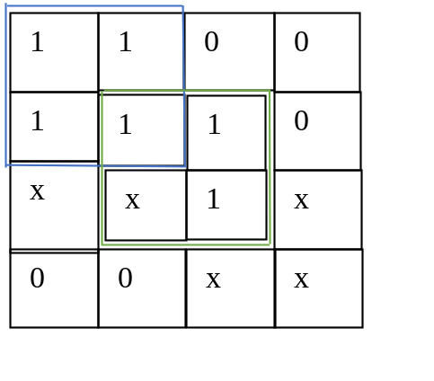
A#B#
A#B#
AB
AB#
Optimized logic equation for:

output = A#C# + BD

c. (10 points) Draw the logic diagram using
standard logic symbols.

A

A#C# + BD
C

B
D

