机器学习计划准备

1. **准备环境**
2. Pycharm：略
3. Jupyter：通过anaconda图形化界面安装，使用<https://www.zhihu.com/question/46309360/answer/254638807>
4. Jupytext：插件，使jupyter能保存为py文件（直接pip）
5. Anaconda：<https://www.jianshu.com/p/62f155eb6ac5>
6. **Python库**
7. numpy：<http://www.numpy.org.cn/about/>

<https://www.runoob.com/numpy/numpy-tutorial.html>

1. scipy：<https://www.qikegu.com/docs/3474>

<https://docs.scipy.org/doc/scipy/reference/tutorial/index.html>

1. matplotlib：

<https://www.kesci.com/home/column/5b87a78131902f000f668549?from=zhihu>

1. pandas：<https://www.pypandas.cn/>

<https://www.w3cschool.cn/hyspo/>

1. sklearn：<https://blog.csdn.net/u014248127/article/details/78885180>

<http://sklearn.apachecn.org/#/>

<https://scikit-learn.org/stable/>

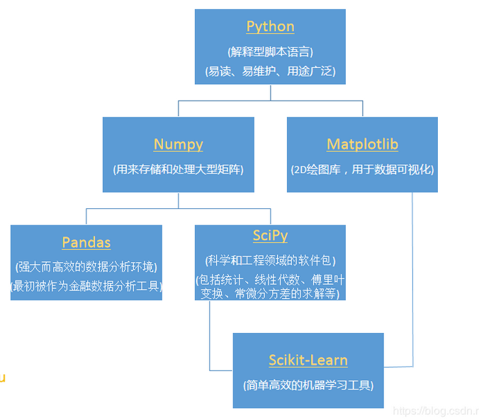

1. **学习路线**
2. **数学：**

概率：

<http://open.163.com/newview/movie/courseintro?newurl=%2Fspecial%2FKhan%2Fprobability.html>

统计：

<http://open.163.com/newview/movie/courseintro?newurl=%2Fspecial%2FKhan%2Fkhstatistics.html>

线代：

<http://open.163.com/newview/movie/courseintro?newurl=%2Fspecial%2FKhan%2Flinearalgebra.html>

1. **吴恩达机器学习**：

<https://study.163.com/course/courseLearn.htm?courseId=1004570029#/learn/video?lessonId=1049052745&courseId=1004570029>

1. **吴恩达CS229：**

<https://www.bilibili.com/video/av28468522/>

1. **机器学习实战：**

<https://space.bilibili.com/97678687/channel/detail?cid=22486>

1. **李宏毅机器学习：**

<https://www.bilibili.com/video/BV1rW411W7Lj?from=search&seid=17516063818933047674>

1. **林轩田机器学习基石：**

<https://www.bilibili.com/video/av12463015/>

1. **机器学习技法（林轩田）：**

<https://www.bilibili.com/video/av12469267/>

8. **深度学习**

【中英字幕】吴恩达深度学习课程第一课 — 神经网络与深度学习：<https://www.bilibili.com/video/av66314465?from=search&seid=5068404032236110778>

【中英字幕】吴恩达深度学习课程第二课 — 改善深层神经网络：超参数调试、正则化以及优化：<https://www.bilibili.com/video/av66524657?from=search&seid=5068404032236110778>

【中英字幕】吴恩达深度学习课程第三课 — 结构化机器学习项目：<https://www.bilibili.com/video/av66644404?from=search&seid=5068404032236110778>

【中英字幕】吴恩达深度学习课程第四课 — 卷积神经网络：<https://www.bilibili.com/video/av66646276?from=search&seid=5068404032236110778>

【中英字幕】吴恩达深度学习课程第五课 — 序列模型：<https://www.bilibili.com/video/av66647398?from=search&seid=5068404032236110778>

1. 书籍资料
2. Learning From Data（配套林轩田）
3. 机器学习周志华
4. 机器学习实战
5. 统计学习方法李航
6. 数学之美
7. Python机器学习(原书第2版)
8. 数理统计（未定）
9. 机器学习算法python实现

<https://github.com/lawlite19/MachineLearning_Python>

1. 吴恩达机器学习笔记

<https://github.com/fengdu78/Coursera-ML-AndrewNg-Notes>