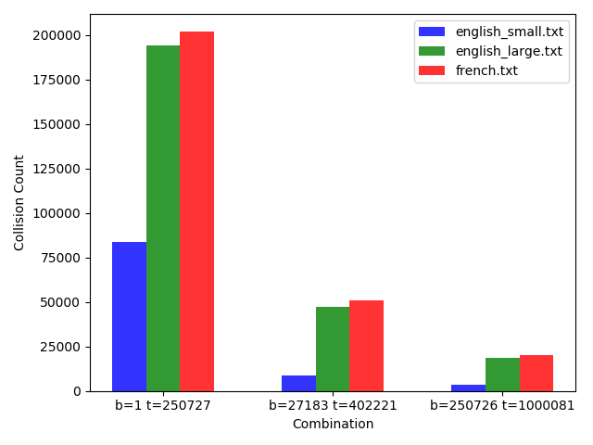

From this graph it seems that as the size of the table is increasing the Collision Count is decreasing. Here when we have used three combination but have plotted only two because for table size: 250727 and hash_base is 1 at that time we are getting Timeout Error. So, it means size of the table and the size of the hash_base is really affecting in collision count. So collision count is decreasing as we increase the length of hash table.

