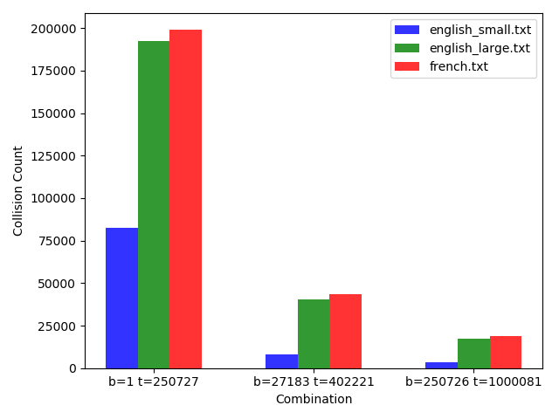

From this graph it seems that as the size of the table is increasing the Collision Count is decreasing. But this chaining method seems better when it comes to very less base size and table size. For base size = 1, linear probing is giving timeout error while this is not giving. Other wise collision count is pretty same for others values. Here, Collision Count is higher then linear probing but max_probe is just 1. Collision count is higher because the length of the table will remain same. Time taken for lower table length is higher but comparatively less than linear and quadratic probing.

