Business Requirement Document: Medico Pvt. Ltd.

Medico Private Limited

Business Requirements Document (BRD)

*Medico Private limited*

*February 2022*

**1 Introduction**

1.1Project Summary

1.1.1Objectives

* Enhancing client’s business of selling medical devices by transforming the data into meaningful reporting
* Making dashboards for client’s internal teams to understand the business better
* Various department members will be able to see the progress & track their performance from these dashboards from time to time and make changes in their processes accordingly
* To help the business owner take decisions based on data backed analysis to deliver

1.1.2Background

A central data repository is necessary for simplifying the data analytical process for the client. Clients should be able to search through all the data and retrieve it as and when required. Data analytical solution that will be provided to the client will help in making the right decisions for the business and understand how to grow the business by improving it in different areas.

1.1.3Business Drivers

* Client is looking for having all the data in one place
* Various internal teams within the client organization are going to be the end users of the dashboards
* Client is responsible for managing all the data from various sources and dumping them at one place for further processing

1.2 Project Scope

The scope of the project is to collect all business processes and customer data from related applications, websites, and servers. The data collected is then transferred to other tools for analytics, marketing, and data warehousing purposes. Fivetran will help in data integration into snowflake and automates in-warehouse transformations and programmatically manages ready-to-query schemas.

1.2.1Scope Functionality

* Freshest possible data
* Improves the accuracy of data-driven
* Synchronizing data from S3 bucket to snowflake

1.3 User Roles

| **Role** | **Description** |
| --- | --- |
| **User/Owner** | * Setup S3 connector * Replicate data into your warehouse * Make connection between source and destination * Check the sync for each connector |

**2 Business Process Overview**

* Setup connection between S3 and Snowflake.
* Data is being ingested into destination i.e Snowflake.
* For each table, create a new connector to load data into it.
* Data gets synchronized at your given time.
* Get freshest data for query.

2.1 Architecture

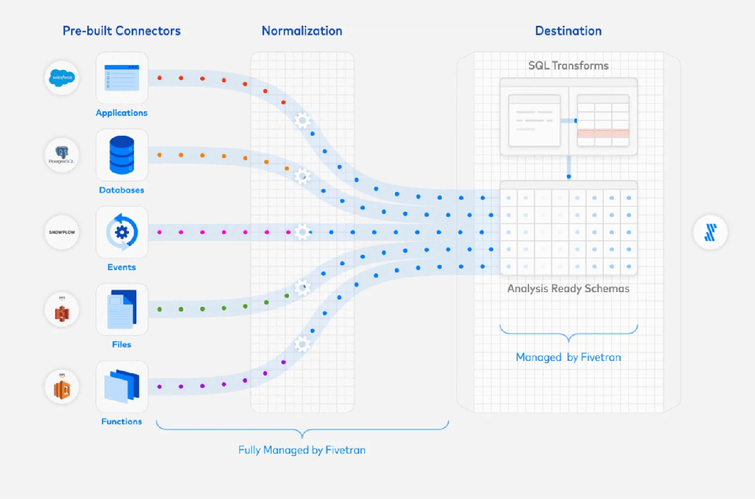

**Fig: Fivetran Architecture**

**3 Business Requirements**

3.1 Functional Requirements

| **Req#** | **Priority** | **Description** |  | **Rationale** | **Impacted Stakeholders** |
| --- | --- | --- | --- | --- | --- |
| FR-001 | 1 | Create connection between S3 bucket and Snowflake |  |  |  |
| FR-002 | 2 | Create separate connection for each table |  |  |  |
| FR-003 | 3 | Set the sync time for your data |  |  |  |
| FR-004 | 4 | Test the connection of snowflake |  |  |  |

3.2 Non-Functional Requirements

| ID | Description |
| --- | --- |
| NFR-001 | Scalability: There is no limitation on the Data size limit |
| NFR-002 | Speed: Data is connected with the given sync up time |