**R Testing for Word cloud**

* This is the Screenshot of the script to make connection between R and Snowflake ReviewTest column of Feedback table of Feedback schema of development database is connected with R-studio

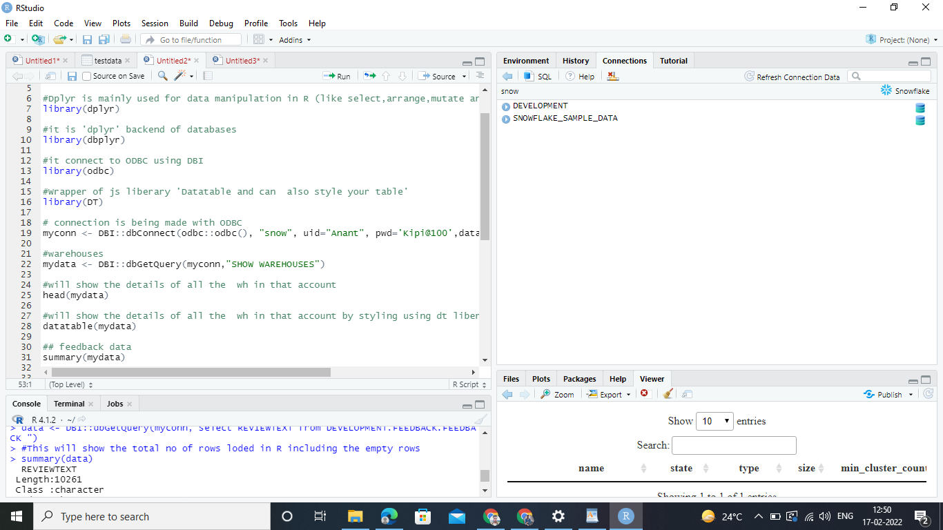

* Now ,This is the screenshot of the testing that weather the number of rows in that particular schema in snowflake is same as the number of rows in R-Studio

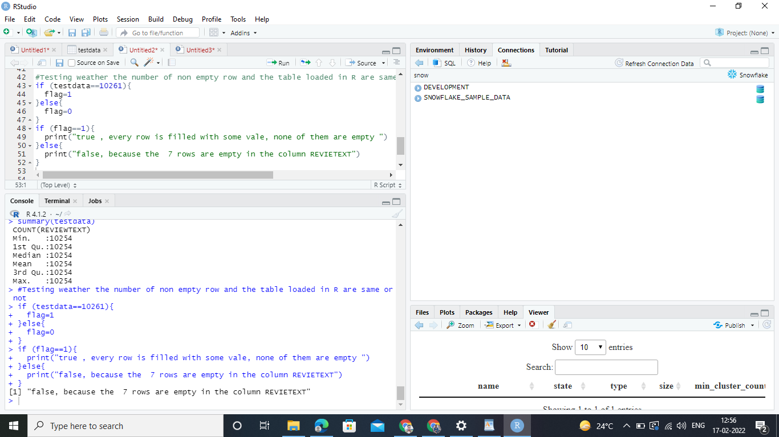

* Since the number there are 7 empty rows so the testing phase will return false

**R Testing for Time series analysis**

* This is the Screenshot of the script to make connection between R and Snowflake Day table of public schema of development database is connected with R-studio

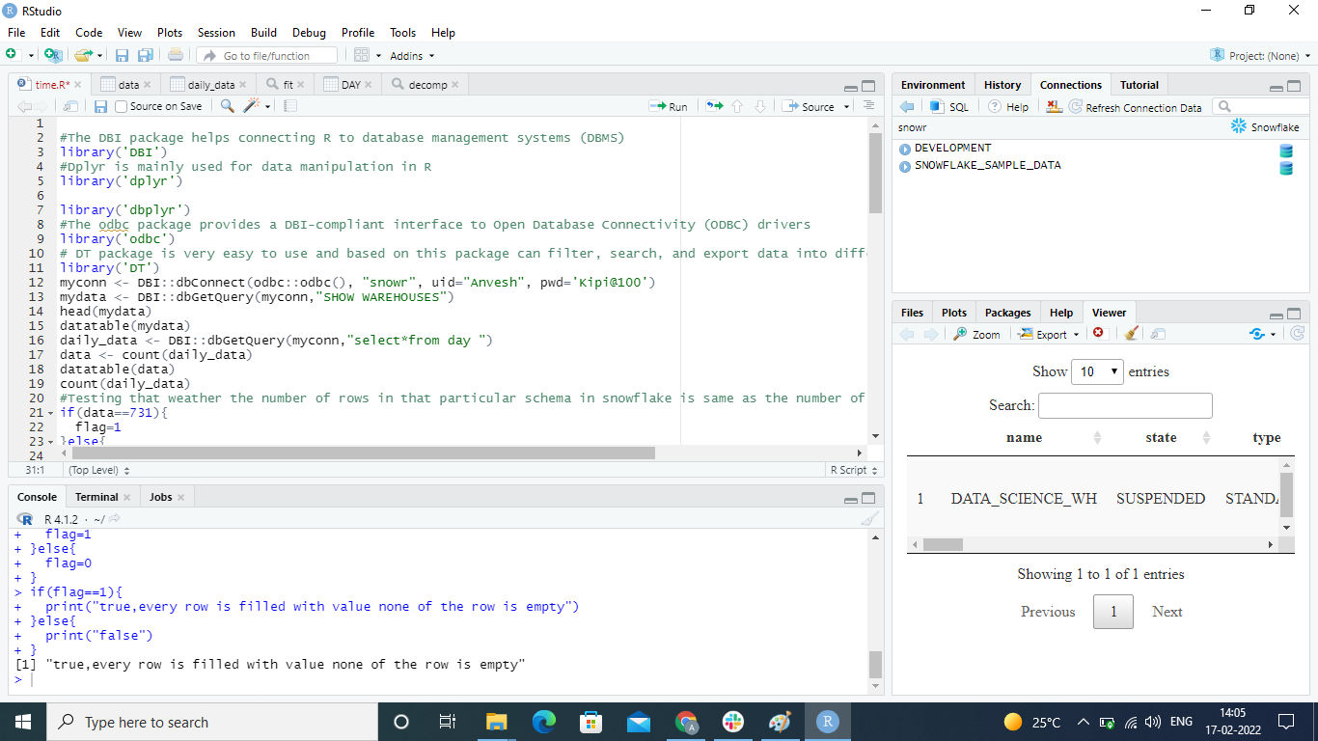

* Now ,This is the screenshot of the testing that weather the number of rows in that particular schema in snowflake is same as the number of rows in R-Studio

