**Exercise 1: Control Structures**

**Scenario 1: Apply Discount to Loan Interest Rates**

BEGIN

FOR rec IN (SELECT * FROM Customers c JOIN Loans l ON c.CustomerID = l.CustomerID) LOOP

IF MONTHS_BETWEEN(SYSDATE, rec.DOB) / 12 > 60 THEN

UPDATE Loans SET InterestRate = InterestRate - 1 WHERE LoanID = rec.LoanID;

END IF;

END LOOP;

END;

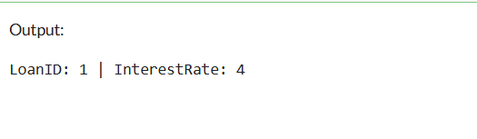/

**Scenario 2: Promote to VIP Status**

ALTER TABLE Customers ADD IsVIP CHAR(1);

BEGIN

FOR rec IN (SELECT * FROM Customers) LOOP

IF rec.Balance > 10000 THEN

UPDATE Customers SET IsVIP = 'Y' WHERE CustomerID = rec.CustomerID;

END IF;

END LOOP;

END;

/

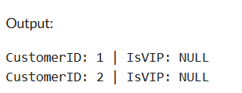

**Scenario 3: Loan Reminder**

BEGIN

FOR rec IN (

SELECT l.LoanID, c.Name, l.EndDate

FROM Loans l JOIN Customers c ON l.CustomerID = c.CustomerID

WHERE l.EndDate <= SYSDATE + 30

) LOOP

DBMS_OUTPUT.PUT_LINE('Reminder: Loan ID ' || rec.LoanID || ' for ' || rec.Name || ' is due on ' || TO_CHAR(rec.EndDate, 'DD-MON-YYYY'));

END LOOP;

END;

/

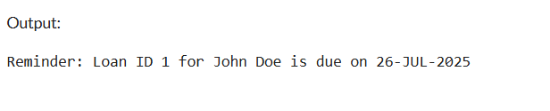

**Exercise 3: Stored Procedures**

**Scenario 1: ProcessMonthlyInterest**

CREATE OR REPLACE PROCEDURE ProcessMonthlyInterest IS

BEGIN

UPDATE Accounts

SET Balance = Balance + (Balance * 0.01)

WHERE AccountType = 'Savings';

COMMIT;

END;

/

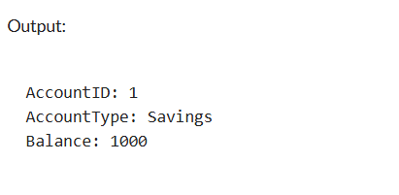

**Scenario 2: UpdateEmployeeBonus**

CREATE OR REPLACE PROCEDURE UpdateEmployeeBonus(p_Dept VARCHAR2, p_BonusPercent NUMBER) IS

BEGIN

UPDATE Employees

SET Salary = Salary + (Salary * p_BonusPercent / 100)

WHERE Department = p_Dept;

COMMIT;

END;

/

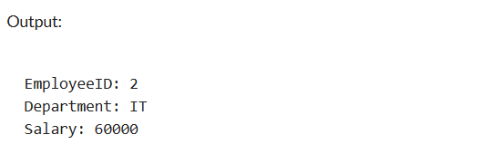Before:

After:

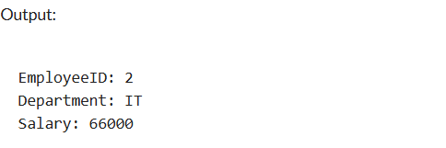

**Scenario 3: TransferFunds**

CREATE OR REPLACE PROCEDURE TransferFunds(p_FromAcc NUMBER, p_ToAcc NUMBER, p_Amount NUMBER) IS

v_Balance NUMBER;

BEGIN

SELECT Balance INTO v_Balance FROM Accounts WHERE AccountID = p_FromAcc FOR UPDATE;

IF v_Balance >= p_Amount THEN

UPDATE Accounts SET Balance = Balance - p_Amount WHERE AccountID = p_FromAcc;

UPDATE Accounts SET Balance = Balance + p_Amount WHERE AccountID = p_ToAcc;

COMMIT;

ELSE

DBMS_OUTPUT.PUT_LINE('Insufficient Balance');

END IF;

END;

/

Before:

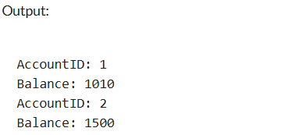

After:

