UNTITLED

Game Design Document – Version 1.3
Project type: Single-player PC game
Genre: Psychological survival horror
Core inspiration: Resident Evil 1 structure + Silent Hill atmosphere + modern PSX/PS1-inspired presentation
Team: Dominykas Juodelis, Justas Petruninas, Adomas Rasalas, Mantas Rimkevičius

1. High Concept
A psychological survival-horror game set in a quarantined city devastated by a mysterious disaster. The player controls a reporter who enters the exclusion zone to gather information from a local news building, only to discover that the catastrophe is connected to a secret laboratory, corrupted superheroes, and fragments of a past he does not fully remember.
The intended experience is tense, eerie, and exploratory rather than action-heavy. The player should feel isolated, uncertain, and increasingly suspicious that the city remembers him before he remembers it.

Core pillars
- Vulnerable exploration: fixed cameras, tank controls, limited resources.
- Investigation through horror: documents, recordings, and environmental details slowly reveal the truth.
- Superheroes as horror: powerful super-abled figures are not normal combat enemies; they reshape spaces, perception, and player behaviour.

2. Core Gameplay

Core loop
- Enter a new area.
- Search for supplies, clues, and puzzle items.
- Solve an environmental puzzle or restore a system.
- Survive enemies while choosing whether to fight or evade.
- Unlock a new route, shortcut, or district.
- Push deeper toward the laboratory.

Player actions
- Fixed-camera exploration
- Tank movement and quick-turn
- Aim-and-fire handgun combat
- Flashlight and lighter management
- Item collection, examination, and puzzle use
- Manual saving at specific limited save points

Survival-horror rules
- Ammunition and healing are scarce.
- Many enemies can be staggered without being fully dead.
- Power and light help the player.

3. World and Structure
The game takes place in a compact quarantined city divided into small, memorable districts connected by alleys, rooftops, service routes, interiors, and shortcuts.

Planned progression
- Checkpoint / Perimeter – last safe human space before entering the city.
- News District – first real playable district; newsroom becomes the first contained survival-horror location.
- Residential / Commercial District – tighter streets, apartments, stores, and stronger environmental puzzles.
- Hero Headquarters – a surreal or deceptive location connected to a surviving hero.
- Laboratory Perimeter – severe corruption and stronger enemy mutations.
- The Laboratory – origin of the event and final narrative reveal.

World progression rule
The closer the player gets to the laboratory, the more severe the physical corruption, mutations, and reality distortion become.

4. Story Direction

Premise
A week after a catastrophic event sealed off a city, a reporter is allowed through a controlled checkpoint corridor to retrieve information from a local news building. What begins as a dangerous assignment turns into a personal investigation when the city begins suggesting that the protagonist has a forgotten connection to the disaster.

Protagonist
The protagonist works as a reporter. At the start, he knowingly enters the exclusion zone for professional reasons, not emotional ones. The personal hook appears later: he begins recognizing things he should not recognize, and the city seems to recognize him in return.

What the player knows at the beginning
- A catastrophic event happened one week ago.
- The city is under military quarantine.
- Some superheroes entered the city during the crisis and changed in disturbing ways.
- The player’s task is to reach the news building and recover information.

What is hidden early on
- The exact cause of the disaster.
- The nature of the corruption.
- The real origin of the superheroes.
- The protagonist’s former connection to the laboratory.

Main mystery structure
- Surface mystery: What happened in the city?
- Mid-game mystery: What is happening to the superheroes?
- Personal mystery: Why does the protagonist know things he should not know?
- Endgame mystery: What role did he once play in the laboratory?

Narrative tone
The game should reveal information gradually, with answers creating larger questions. The opening should feel grounded before becoming uncanny and deeply personal.

5. Opening Sequence (Chapter 1 Direction)

5.1 Checkpoint opening
The game begins at a military checkpoint outside the city. The player can walk around, absorb the atmosphere, and talk to: - soldiers, - refugees or civilians, - journalists who were denied access, - and one exhausted but lucid superhero who hints that his comrades have changed and no longer recognize him.

5.2 Why the player is allowed in
The protagonist has managed to acquire a limited press clearance to follow a “supposedly” safe corridor into the outer district and reach the local news building.

5.3 Crossing into the zone
Crossing the gate should feel like leaving the human world behind. The checkpoint is noisy and crowded; the city beyond it is empty, quiet, and wrong.

5.4 First playable horror section
The player explores a damaged outer street and sees signs of chaos: - abandoned vehicles, - blood on the road, - broken propaganda, - distant inhuman screams, - and evidence that the disaster was not a normal explosion.

5.5 First mutant encounter
The first mutant should be introduced as a tanky enemy. The player can either kill or run into the news building for safety, establishing early that not every threat can be comfortably killed.

5.6 First personal hint
Inside the news building, the protagonist can experience the first small hint of a forgotten connection: he recognizes a code, a room, a sound, or a procedure for no clear reason.

6. Enemies and Encounters

Regular enemies
- Basic mutant: close-range pressure enemy, still partly human.
- Fast mutant: difficult to evade in narrow routes.
- Area-control mutant: limits safe movement or blocks paths.
- Heavy mutant: slow, durable, expensive to kill.

Super-abled encounters
Named super-abled characters are not standard combat enemies. They should function more like survival-horror set pieces.
Possible player responses: - escape, - delay, - outsmart, - trap, - or survive long enough to progress.
Their abilities should create horror mechanically, not just narratively. A superhuman should change how a level is navigated or understood.

7. Puzzle Direction
Puzzles should come from the location itself rather than feeling arbitrary.

Desired puzzle types
- Environmental logic: power routing, shutters, alarms, doors, maintenance systems.
- Investigation puzzles: documents, recordings, timestamps, and contradictions in reports.
- District-specific puzzles: store equipment, service corridors, emergency infrastructure, archive systems.
- Superhuman survival puzzles: using the environment to survive an encounter rather than simply shooting a boss.

Example first-district puzzle
A small power grid outside can only activate one system at a time. The player uses it across nearby locations such as a laundromat, pharmacy, and apartment route, eventually creating a new way forward.

8. Art Direction

Visual target
- PSX / PS1-inspired survival-horror look
- fixed cinematic camera framing
- low-poly environments and characters
- low-resolution or simplified textures
- strong lighting and fog
- readable silhouettes and landmarks
- grounded urban decay with gradually increasing surreal corruption

Visual principle
The game should feel retro without becoming unreadable. The target is closer to a modern reinterpretation of PS1 survival horror than a perfectly authentic hardware recreation.

Audio direction
- Sparse music
- Strong environmental ambience
- Distinct enemy sounds
- Distant screams and unstable public-address or emergency audio
- Silence used deliberately

9. Mood Board / Reference Games
These references fit the current target best. The links below point to official Steam screenshots or official Steam store pages.

Closest references
Heartworm
What to study: fixed-camera framing, dreamlike memory-horror tone, melancholic atmosphere.
Official page: https://store.steampowered.com/app/1257030/Heartworm/
Official screenshot: https://shared.fastly.steamstatic.com/community_assets/images/apps/1257030/246b1e191cddbcf8459641a2b1c75e2f29db3381.jpg

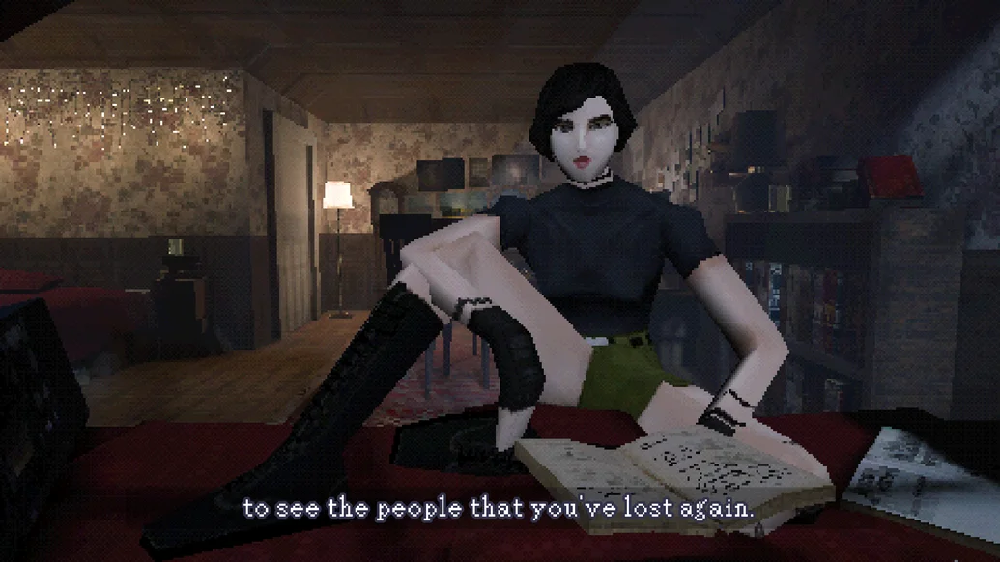
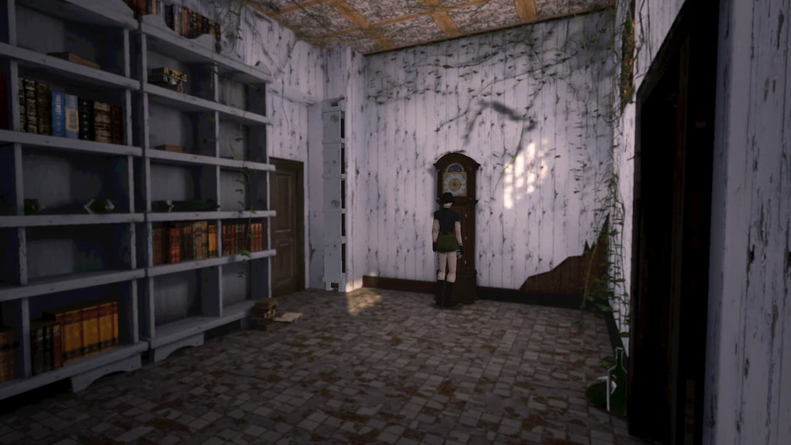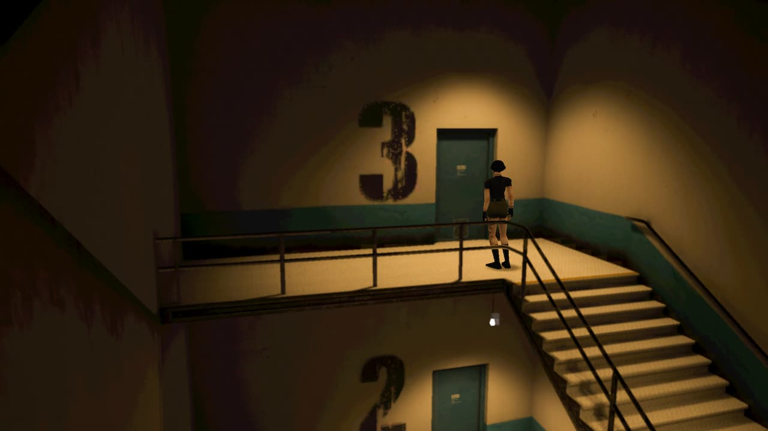
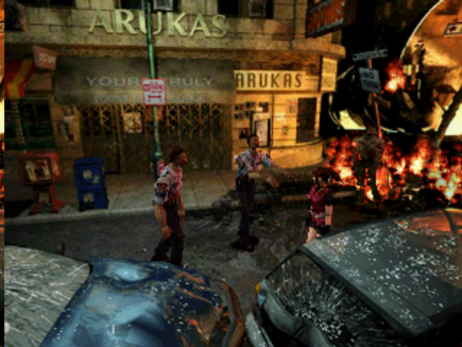

10. Prototype Scope

Small prototype / vertical slice target
- One checkpoint intro
- One short outer-city route
- One accessible news building
- Several fixed-camera shots
- Tank movement and quick-turn
- One weapon
- One mutant archetype
- One simple power-routing puzzle
- One save point
- Basic inventory and map

Prototype success criteria
- The opening immediately establishes tone and isolation.
- The player understands navigation and camera cuts.
- The first mutant encounter is tense and memorable.
- The news building feels like a proper survival-horror location.
- The first personal mystery hook lands without over-explaining the plot.

11. Current Open Decisions
- Final title
- Final city/country identity
- Final hero roster and naming
- Exact laboratory history and protagonist job before memory loss
- Final ending structure
- Exact scope of weapons, upgrades, and boss encounters

