
NATIONAL INSTITUTE OF TRANSPORT
FACULTY OF INFORMATION TECHNOLOGY AND EDUCATION
DEPARTMEMT OF COMPUTING AND COMMUNICATION TECHNOLOGY

PROJECT PROPOSAL

Project Proposal Title: Referral Management System (RMS)
Project Type: Software Development
Student Name: Abdulkarim Macho Rwenda
Registration Number: NIT/BIT/2023/2223
Program: Bachelor Degree in Infromation Technology
Level: 8
Supervisor Name: Mr. Said Chang’a

TABLE OF CONTENTS

PROJECT BACKGROUND 1
PROBLEM STATEMENT 1
OBJECTIVES 2
Main Objective 2
Specific Objectives 2
LITERATURE REVIEW 3
SIGNIFICANCE OF THE PROJECT 5
SCOPE OF THE PROJECT 5
DESIGN PHASE 6
Use Case Diagram 6
System Flowchart 7
REFERENCES 8

PROJECT BACKGROUND
Patient referral management is a critical component of healthcare delivery in Tanzania's public health system. Tanzania operates a five-tier health system consisting of Dispensaries, Health Centres, District Hospitals, Regional Hospitals, and National or Referral Hospitals. Patients who require specialised care beyond the capacity of their current facility are referred upward through this tiered structure, with each level expected to transfer the patient along with relevant clinical information to the receiving facility.

Despite the importance of an effective referral system, the process in Tanzania is still largely dependent on manual, paper-based referral letters and physical record books. As the volume of patient referrals increases each year, the limitations of such a paper-based approach become increasingly clear. Records are frequently lost, inter-facility communication is poor, and there is no mechanism to provide feedback from the receiving facility back to the referring clinician.

The Ministry of Health (MoH) is responsible for planning and resource allocation across all healthcare facilities. However, in the absence of a centralised digital referral system, the MoH lacks real-time data on referral volumes, patterns, and facility-level performance. This absence of data hinders evidence-based planning and results in inefficient distribution of healthcare resources.

Digital health information systems have demonstrated significant success in other low- and middle-income countries in improving the efficiency and accountability of healthcare delivery. A web-based Referral Management System that automates the creation, tracking, and reporting of patient referrals would represent a significant step forward for Tanzania's public health system.

PROBLEM STATEMENT
Healthcare facilities in Tanzania rely on manual, paper-based referral processes that result in significant operational inefficiencies and adverse patient outcomes. Handwritten referral letters are frequently lost during patient transfer, leaving no digital audit trail. Receiving facilities are often unprepared for incoming patients because there is no advance digital notification of a referral, causing delays in treatment and poor patient preparation.

Referring clinicians have no structured mechanism to receive feedback on the outcomes of referred patients. This absence of bidirectional communication breaks the continuity of care and prevents appropriate follow-up treatment. Additionally, the Ministry of Health lacks access to real-time data on referral volumes and facility performance, severely limiting its ability to perform evidence-based health system planning and resource allocation.

In summary, the current referral system suffers from lost records, poor inter-facility communication, no feedback loop, and no national-level data visibility. These problems collectively compromise patient safety and reduce the overall effectiveness of the public health system.

OBJECTIVES

Main Objective
To design and develop a web-based Referral Management System (RMS) that digitalises and streamlines the patient referral process across all five tiers of Tanzania's public healthcare system, enabling efficient referral creation, real-time status tracking, bidirectional feedback, and centralised reporting for improved healthcare service delivery and national-level decision-making.

Specific Objectives
- To develop a secure multi-role user authentication system with role-based access control (RBAC) for Clinicians/Doctors, Hospital Administrators, and Ministry of Health Officials.
- To implement a digital referral creation and management module that allows clinicians to submit patient referrals electronically, replacing paper-based referral letters.
- To design a real-time referral status tracking feature allowing all stakeholders to monitor referral progress: Pending, Accepted, In Progress, and Completed.
- To build a bidirectional feedback module enabling receiving facilities to send clinical outcomes and counter-referrals back to the originating clinician to support continuity of care.
- To integrate an automated notification system using email and SMS alerts that informs relevant users at every stage of the referral process.
- To develop a Ministry of Health reporting and analytics dashboard providing real-time visibility into referral volumes, facility performance, and national referral trends.

LITERATURE REVIEW
A review of the existing literature reveals that patient referral management has been a subject of growing research interest, particularly in low- and middle-income countries where health systems face unique operational challenges. This section reviews the most relevant studies and identifies the gaps that the proposed system aims to address.

Kimaro and Nhampossa (2005) conducted an extensive analysis of health information systems in Tanzania, identifying paper-based record management and poor inter-facility communication as major obstacles to effective healthcare delivery. They called for integrated digital platforms to support data sharing across facilities and improve the quality of health system management (Kimaro & Nhampossa, 2005).

Odendaal et al. (2015) conducted a systematic review of electronic referral systems in low- and middle-income countries and found strong evidence that digital referral platforms significantly reduced processing delays and improved the accuracy of clinical information transmitted between facilities. Their review noted that most systems lacked a bidirectional feedback mechanism, limiting their effectiveness in supporting care continuity (Odendaal et al., 2015).

Shiferaw and Mulogo (2008) assessed referral systems in rural Uganda and found that the absence of structured communication between referring and receiving facilities was one of the most critical barriers to care coordination. Over 70% of clinicians reported never receiving feedback about referred patients, identified as a key contributor to poor follow-up care and treatment discontinuity (Shiferaw & Mulogo, 2008).

The World Health Organization (2010) published a framework for strengthening health referral systems in developing countries, identifying requirements including standardised protocols, digital tracking tools, outcome data collection, and reporting mechanisms for health authorities. The WHO recommended lightweight, browser-based platforms that can operate in low-bandwidth environments and support multiple user roles (WHO, 2010).

Braa et al. (2012) described the DHIS2 platform, used in Tanzania and over 70 other countries. While DHIS2 is highly effective for aggregate facility-level reporting, it does not support patient-level referral management or real-time inter-facility communication. The proposed RMS is specifically designed to fill this patient-level gap that DHIS2 and similar systems leave unfilled (Braa et al., 2012).

These studies consistently highlight the absence of bidirectional feedback, lack of real-time patient-level tracking, no automated notifications, and absence of national-level dashboards as key gaps. The proposed Referral Management System directly addresses each gap through a purpose-built PHP and MySQL web platform designed for Tanzania's public health context.

SIGNIFICANCE OF THE PROJECT
For patients, the system ensures faster and more coordinated care. Receiving facilities will be notified in advance of incoming referrals, enabling better preparation and reducing delays in treatment, which is expected to have a measurable positive impact on patient safety and recovery outcomes.

For clinicians, the bidirectional feedback module ensures that referring doctors are kept informed about the outcomes of referred patients, supporting continuity of care and enabling appropriate follow-up treatment. For hospital administrators, the system provides a centralised platform for managing referrals, tracking status updates, and maintaining accurate facility records.

For the Ministry of Health, the reporting dashboard provides real-time visibility into referral volumes, common diagnoses, facility performance, and national health trends to support evidence-based health planning and resource allocation. The system also aligns with Tanzania's national digital health transformation agenda and the objectives of the Health Sector Strategic Plan.

SCOPE OF THE PROJECT

Within Scope
The following features and functionalities are included within the scope of this project:

- Web-based system accessible via standard internet browsers without additional software
- Three user roles with role-based access control: Clinician/Doctor, Hospital Administrator, Ministry of Health Official
- Digital referral creation, submission, and management module replacing paper-based letters
- Real-time referral status tracking: Pending, Accepted, In Progress, Completed
- Bidirectional feedback and counter-referral module between facilities
- Automated email and SMS notification system for all referral events
- Facility and user management module for administrators
- Ministry of Health reporting and analytics dashboard
- Coverage across all five tiers of Tanzania's public health system
- Developed using PHP and MySQL with Bootstrap 5 frontend

Outside Scope
The following areas are explicitly excluded from this project:

- Artificial intelligence or machine learning features of any kind
- Mobile application development for Android or iOS platforms
- Integration with NHIF, insurance systems, or billing platforms
- Electronic Health Records (EHR) or full patient medical history management
- Laboratory, pharmacy, or diagnostic result management
- Telemedicine, video consultation, or clinical decision support
- Hardware procurement, network infrastructure, or server installation

PROJECT DESIGN
This section presents the system design diagrams for the proposed Referral Management System. Two key diagrams are included: a Use Case Diagram showing the interactions between system actors and use cases, and a System Flowchart showing the step-by-step operational flow of the system.

Use Case Diagram
The use case diagram below illustrates the interactions between the four key actors — Clinician/Doctor, Hospital Administrator, Ministry of Health Official, and Patient — and the use cases available to each actor within the system boundary.

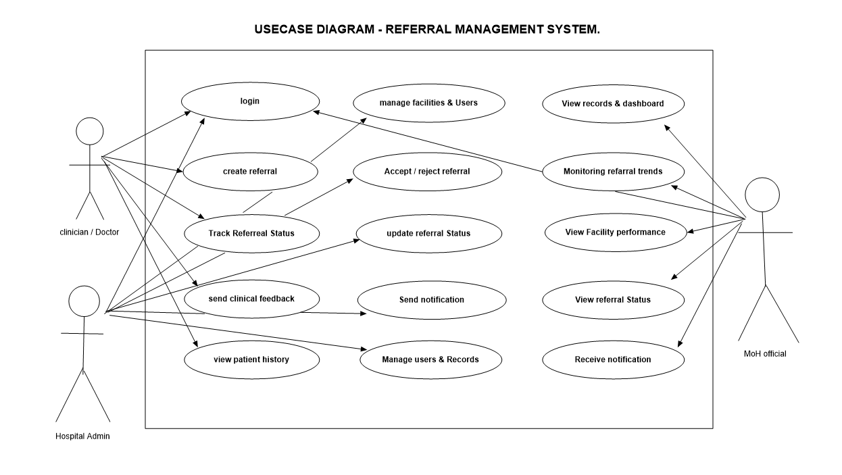
Figure 1: Use Case Diagram of the Referral Management System

System Flowchart
The system flowchart below illustrates the step-by-step operational flow of the Referral Management System from user login through referral creation, review, acceptance or rejection, status tracking, bidirectional feedback, and final data storage. The flowchart covers workflow paths for all three user roles.

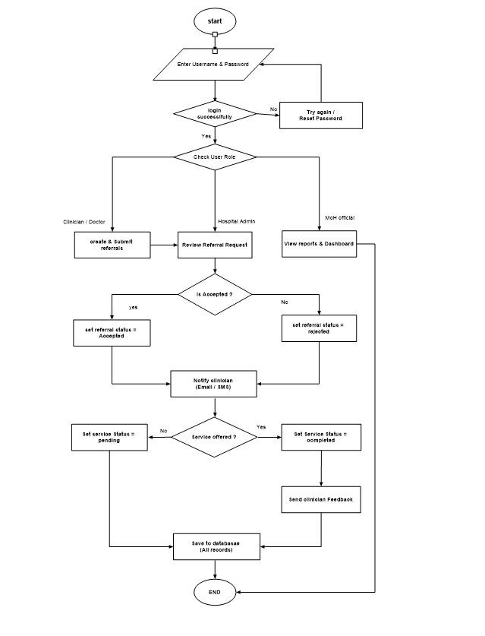

Figure 2: System Flowchart of the Referral Management System

REFERENCES
Braa, J., Hanseth, O., Heywood, A., Mohammed, W., & Shaw, V. (2012). Developing health information systems in developing countries: The flexible standards strategy. MIS Quarterly, 31(2), 381–402. https://doi.org/10.2307/25148796
Kimaro, H. C., & Nhampossa, J. L. (2005). Analyzing the problem of unsustainable health information systems in less-developed economies: Case studies from Tanzania and Mozambique. Information Technology for Development, 11(3), 273–298. https://doi.org/10.1002/itdj.20016
Odendaal, W. A., Ward, K., Uneke, J., Uro-Chukwu, H., Chitama, D., Balakrishna, Y., & Kea, A. Z. (2015). Stakeholder participation in rapid scoping reviews. Systematic Reviews, 4(1), 1–9. https://doi.org/10.1186/s13643-015-0074-z
Shiferaw, F., & Mulogo, E. (2008). Quality of antenatal care services in rural health facilities of the Butajira area, south central Ethiopia. Rural and Remote Health, 8(4), 1–11. https://www.rrh.org.au/journal/article/1013
World Health Organization. (2010). Strengthening health systems to improve health outcomes: WHO's framework for action. World Health Organization. https://www.who.int/healthsystems/strategy/everybodys_business.pdf

