Football Team Management System Documentation
Overview
The Football Team Management System is a desktop application built using JavaFX. It is designed to manage a school football team by organizing player details and match records. This application demonstrates component-oriented programming principles, ensuring modularity, maintainability, and reusability.

Github repository link: https://github.com/Machuge27/Java-Apks.git

Functional Requirements
1. Login System
- Provides a simple authentication mechanism to access the main application.
2. Player Management
- Add Player: Input a player's name and position to add them to the team.
- View Players: Display a list of all players with their respective details:
  - Name
  - Position
  - Goals scored
  - Assists made
3. Match Management
- Add Match: Record a football match by entering:
  - Opponent name
  - Match date
  - Team score
  - Opponent score
- View Matches: Display all recorded matches with their details:
  - Opponent
  - Date
  - Team score
  - Opponent score

Non-Functional Requirements
- Usability: The UI is intuitive and easy to navigate for users.
- Modularity: Components are reusable and independently testable.
- Scalability: The system can be extended to include more features (e.g., advanced stats, editing data).
- Reliability: Accurate storage and retrieval of player and match data.

Design and Implementation
1. Architecture
The application follows a component-based architecture. Each feature is encapsulated in its own module.
2. Core Components
i. MyApp.java
- The main application class responsible for initializing and switching between UI screens.
- Manages navigation between the login page, main menu, player management, and match management.
ii. BEAN Package
Contains the data models:
- PlayerBean.java:
  - Represents a player with attributes like name, position, goals, and assists.
- MatchBean.java:
  - Represents a match with attributes like opponent name, date, and scores.
- TeamManagerBean.java:
  - Manages the list of players and matches using ArrayList.

Usage
1. Running the Application
- Launch the application by running the MyApp class.
- The first screen displayed is the login page.
2. Navigating the UI
Login Page
- Enter credentials and click the "Login" button.
Main Menu
- Options available:
  - Player Management
  - Match Management
Player Management
- Add Player:
  - Enter the player's name and position in the provided fields.
  - Click "Save Player" to add the player to the system.
- View Players:
  - A table displays all the players with their name, position, goals, and assists.
Match Management
- Add Match:
  - Enter opponent name, match date, team score, and opponent score.
  - Click "Save Match" to record the match.
- View Matches:
  - A table displays all recorded matches with details like opponent, date, and scores.

Development Details
1. Data Handling
- Data is managed in memory using the TeamManagerBean class.
- ArrayList is used to store players and matches dynamically.
2. UI Design
- Login Screen:
  - A simple VBox layout with TextField, PasswordField, and a Button.
  - Password and username are not fixed at the moment, use any.
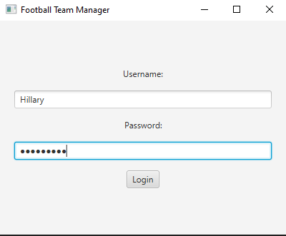
- Main Menu:
  - A VBox layout with navigation buttons.
- Player and Match Screens:
  - Form inputs are created using TextField and Button.
  - Tables (TableView) display data dynamically with columns mapped to model attributes.
3. TableView Configuration
For both players and matches, TableView is used to display data:
- Player Table:
  - Columns: Name, Position, Goals, Assists.
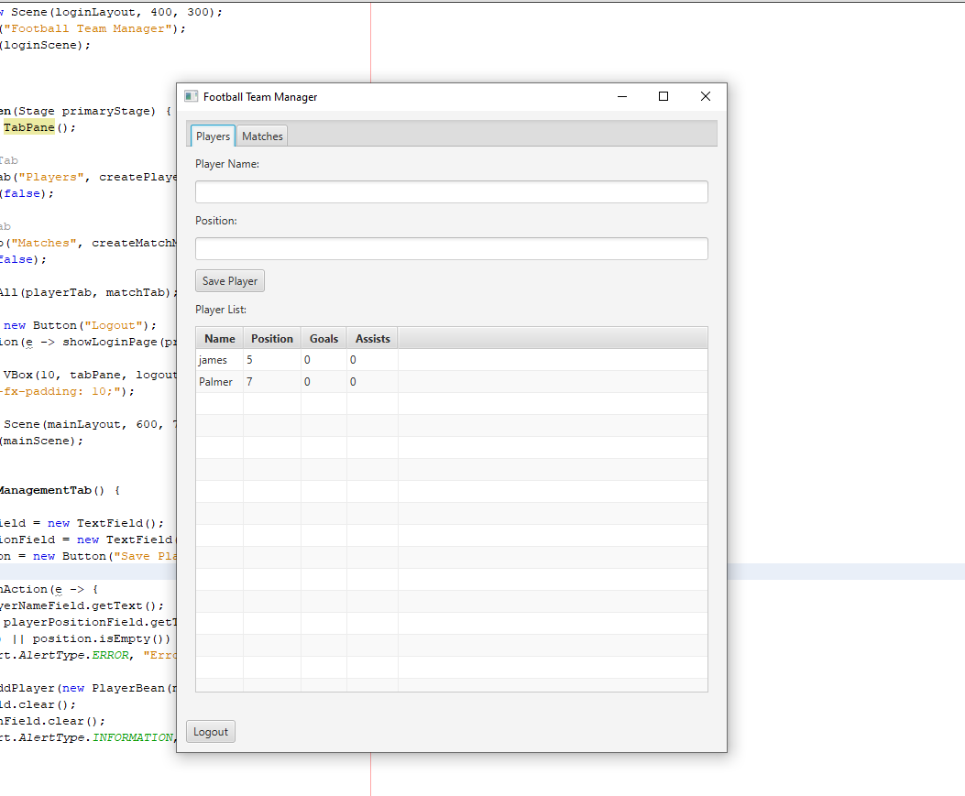
- Match Table:
  - Columns: Opponent, Date, Team Score, Opponent Score.
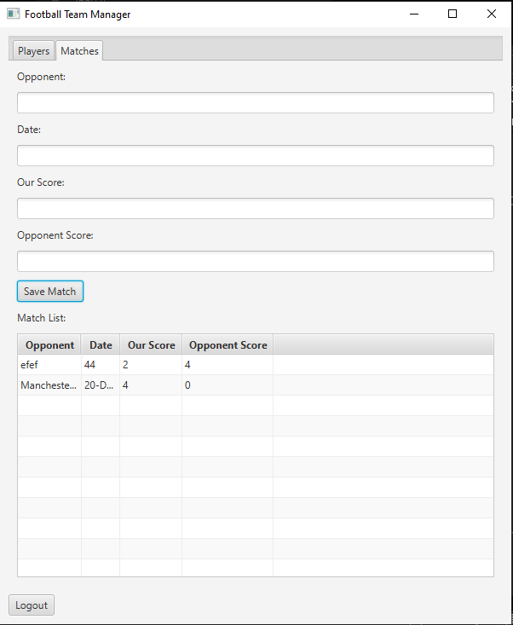

Extensibility
The system is designed with extensibility in mind. Below are some ideas for enhancements:
- Database Integration:
  - Use a database like MySQL or SQLite for persistent data storage.
- Authentication:
  - Replace the mock login system with real user authentication.
- Editing and Deletion:
  - Add options to edit and delete player and match records.
- Team Statistics:
  - Provide detailed statistics for players and matches.
- UI Enhancements:
  - Use CSS for styling to improve the visual appeal.

Testing
1. Unit Testing
- Test the TeamManagerBean class for adding and retrieving players and matches.
- Validate getter methods in PlayerBean and MatchBean.
2. Integration Testing
- Test interactions between the UI and backend logic:
  - Adding players and ensuring they appear in the table.
  - Adding matches and ensuring they appear in the match table.
3. Manual Testing
- Verify all workflows manually:
  - Login -> Add Player -> View Players.
  - Login -> Add Match -> View Matches.

Known Issues
- Data is not persisted after the application closes (no database integration).
- Limited error handling for invalid inputs (e.g., missing fields or incorrect data types).

Conclusion
The Football Team Management System is a foundational tool for managing a football team's players and matches. It showcases component-oriented programming concepts and provides room for further enhancements.

