# http://www.ridgebizdev.com/img/Infare_new_logo_black.pngData Platform Engineer test exercise

## Task 1: ETL/copy of data from S3 to DataBase of your choice I could actually write a Terada Fastload script which would load data to an empty table very efficiently as this is block-wise parallel operation however as the exercises suggest usage of Spark I’ve setup following environment for those tasks:

* ElasticSearch 6.2.2 with Kibana & ElasticSearch-Sql  
  I didn’t used ES before rather Teradata, GreenPlum or pure Hive but it is being evaluated at my current company so I choose it for learning opportunity
* Scala 2.11 with Spark 2.2.1 project built via sbt & and run locally in Intellij. I didn’t used Scala much before (rather Pyspark (Python 2.6.6) with Pycharm & Spark 1.6.2) but I choose it because:
  + Again wanted to use it a learning opportunity
  + There was already some Scala code provided
  + Based on some initial research Scala provides functionality required for the exercises (like easy integration with ES, error handling with Try & Either)

Code for the task is available in GitHub:

<https://github.com/MaciejGajewski/ETL_TestExercise/blob/master/src/main/scala/task1/SimpleDataLoader.scala>

It contains code to read csv data into rdd, wrap it in DataModel case objects, calculating additional week column, measure processing time and save it in a log file. Then it creates 2 types of indexes in EL:

* One with all the data in 1 index
* Second is a group of indexes partitioned by week

Metrics are captured in the log files provided.

Due to limit of my laptop, access key to the files not working and time restrictions I processed only single file and couple of weeks.

Having more time:

* I would try to run it on local Spark cluster via spark-submit or researched some free cloud environments.
* Enhanced code to calculate time metrics automatically

Other files are code for

* some utilities (data model, time metrics & web service call)
* logging config
* build config
* some excel calculation for a observed week based on existing number of days since 01.01.200

Intellij project:

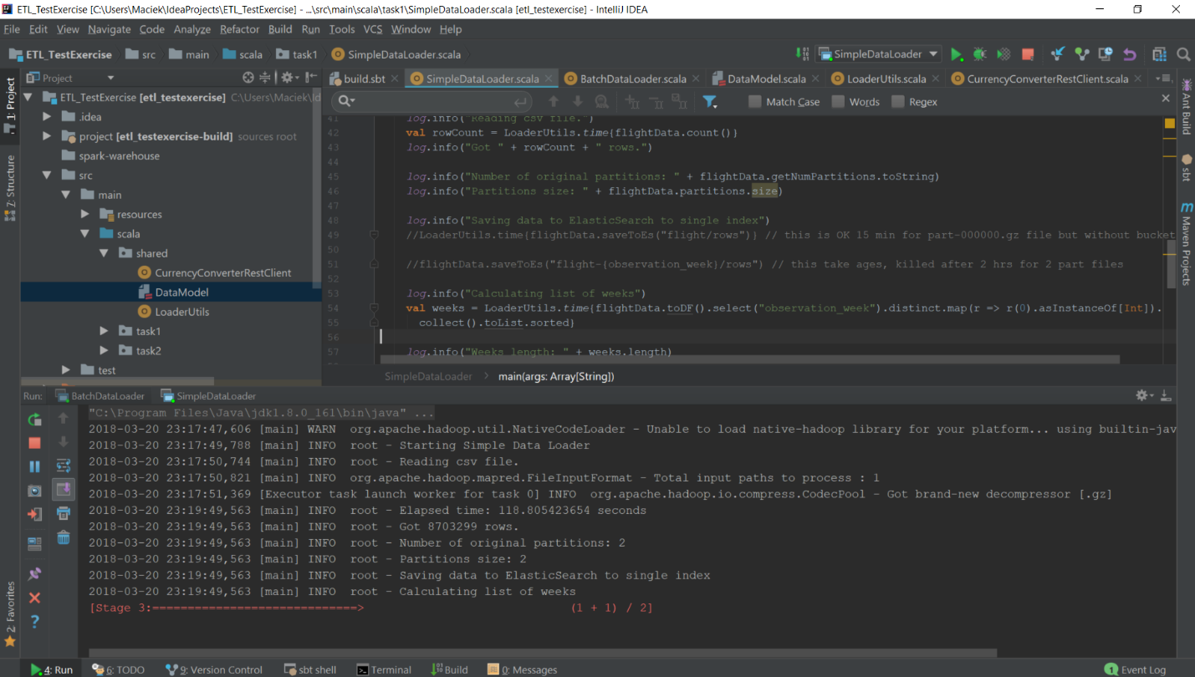

Spark Console:

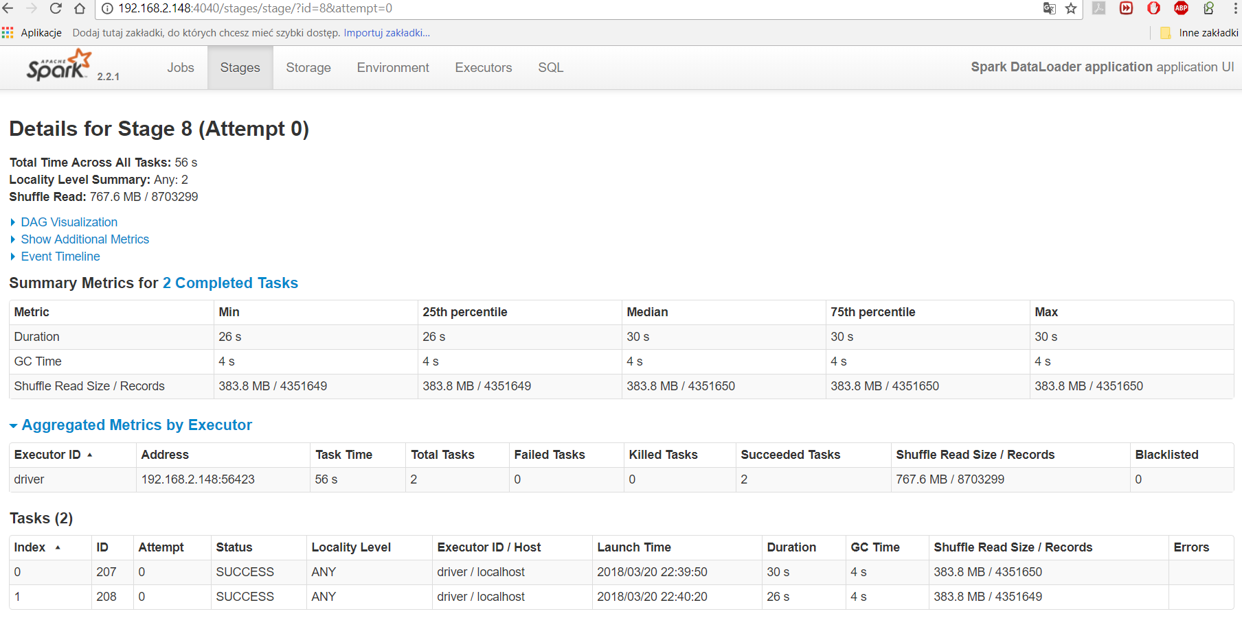

ES & Kibana:

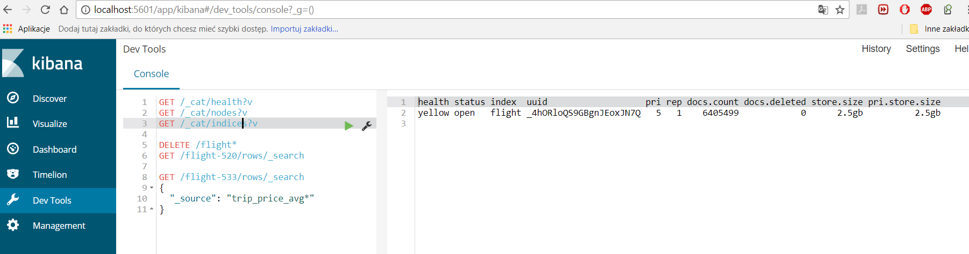

## Task 2: Consuming Rest service during batched ETL process

Code for this task is available in <https://github.com/MaciejGajewski/ETL_TestExercise/blob/master/src/main/scala/task2/BatchDataLoader.scala>

It again reads csv file and wraps in DataModel cases objects. Then it prepares list of weeks but due to resource constraints I ran calculation only for couple of weeks. I don’t have much experience in building web services in Scala so I chose simple apache http client to make API calls to currency service.

Calls to current service REST api are done inside mapPartitions and map methods so they would be executed parallel if ran in multimode/multicore clusters. In order to manage service unavailability calls are wrapped in Try/Either object and successful attempts can be later filtered out and processed separately from failures.

If I had more time I would research proper/most robust way of building web service clients, added retries, waits etc.

## Task 3: (optional) Rest service exercise

Skipped this lacking experience in building web services in Scala or Python (I only once built web service client in Java using Spring).

## Task 4: (optional) Data mining exercise

1. Counts per week  
     
   select observation_week, count(*)

from flight   
group by observation_week   
order by observation_week   
limit 400

1. Duplicates check

SELECT

count(*),

observed_date_min_as_infaredate,

observed_date_max_as_infaredate,

full_weeks_before_departure,

carrier_id,

searched_cabin_class,

booking_site_id,

booking_site_type_id,

is_trip_one_way,

trip_origin_airport_id,

trip_destination_airport_id,

trip_min_stay,

trip_price_min,

trip_price_max,

trip_price_avg,

aggregation_count,

out_flight_departure_date_as_infaredate,

out_flight_departure_time_as_infaretime,

out_flight_time_in_minutes,

out_sector_count,

out_flight_sector_1_flight_code_id,

out_flight_sector_2_flight_code_id,

out_flight_sector_3_flight_code_id,

home_flight_departure_date_as_infaredate,

home_flight_departure_time_as_infaretime,

home_flight_time_in_minutes,

home_sector_count,

home_flight_sector_1_flight_code_id,

home_flight_sector_2_flight_code_id,

home_flight_sector_3_flight_code_id

FROM flight2-823

group by

observed_date_min_as_infaredate,

observed_date_max_as_infaredate,

full_weeks_before_departure,

carrier_id,

searched_cabin_class,

booking_site_id,

booking_site_type_id,

is_trip_one_way,

trip_origin_airport_id,

trip_destination_airport_id,

trip_min_stay,

trip_price_min,

trip_price_max,

trip_price_avg,

aggregation_count,

out_flight_departure_date_as_infaredate,

out_flight_departure_time_as_infaretime,

out_flight_time_in_minutes,

out_sector_count,

out_flight_sector_1_flight_code_id,

out_flight_sector_2_flight_code_id,

out_flight_sector_3_flight_code_id,

home_flight_departure_date_as_infaredate,

home_flight_departure_time_as_infaretime,

home_flight_time_in_minutes,

home_sector_count,

home_flight_sector_1_flight_code_id,

home_flight_sector_2_flight_code_id,

home_flight_sector_3_flight_code_id

having count(*) > 1

This does not execute in my ED due to performance issues

1. Determining PK

select

observed_date_min_as_infaredate,

observed_date_max_as_infaredate,

out_flight_sector_1_flight_code_id,

out_flight_sector_2_flight_code_id,

out_flight_sector_3_flight_code_id,

home_flight_sector_1_flight_code_id,

home_flight_sector_2_flight_code_id,

home_flight_sector_3_flight_code_id,

full_weeks_before_departure,

count(*) as cnt

from flight2-823

group by

out_flight_sector_1_flight_code_id,

out_flight_sector_2_flight_code_id,

out_flight_sector_3_flight_code_id,

home_flight_sector_1_flight_code_id,

home_flight_sector_2_flight_code_id,

home_flight_sector_3_flight_code_id,

observed_date_min_as_infaredate,

observed_date_max_as_infaredate,

full_weeks_before_departure

having count(*) > 1

Primary key looks to the flight route (out and home sectors) for a given week at different observation periods

1. One way flight vs Return flights

select is_trip_one_way, count(*)

from flight2-823

group by is_trip_one_way

Result:

is_trip_one_way COUNT(*)

0 86320

1 2963

1. Top 5 direct one way flight with max number of observations

select

out_flight_sector_1_flight_code_id as out_flight_s_1,

out_flight_sector_2_flight_code_id as out_flight_s_2,

out_flight_departure_date_as_infaredate,

out_flight_departure_time_as_infaretime,

sum(aggregation_count) as sum_aggregation_count

from flight2-823

where

is_trip_one_way = 1

group by

out_flight_sector_1_flight_code_id,

out_flight_sector_2_flight_code_id,

out_flight_departure_date_as_infaredate,

out_flight_departure_time_as_infaretime

-- order by sum_aggregation_count desc

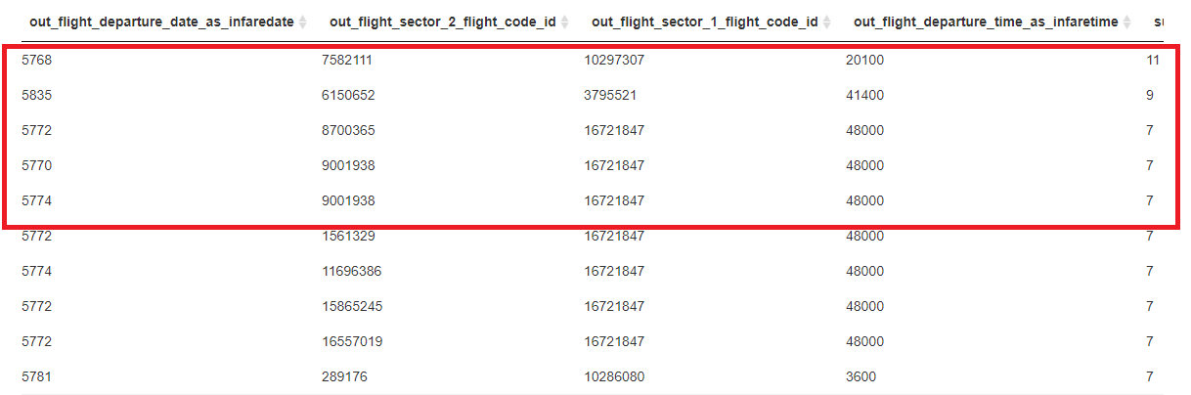

TODO: need to research how to do ordering, ranking and subquery in ES to properly do that.

Or use different DB.  
Also null are not handled properly (agg functions return nulls too). Need to research coalesce equivalent or load data with string “n/a” instead of null

1. Subsample

Using random_score in Kibana. But this will have limit of 10k only.

GET /flight2-823/rows/_search

{

"from" : 0, "size" : 10000,

"query": {

"function_score": {

"query": {

"match_all": {}

},

"functions": [

{

"random_score": {}

}

]

}

}

}

TODO: Investigate how to use SAMPLE SQL function

1. Top 10 flights with largest min/max difference for a single departure  
     
   This would be sth like this:

select * from (

select * from (

select

observed_date_min_as_infaredate,

observed_date_max_as_infaredate,

out_flight_sector_1_flight_code_id,

out_flight_sector_2_flight_code_id,

out_flight_sector_3_flight_code_id,

home_flight_sector_1_flight_code_id,

home_flight_sector_2_flight_code_id,

home_flight_sector_3_flight_code_id,

full_weeks_before_departure,

out_flight_departure_date_as_infaredate,

out_flight_departure_time_as_infaretime,

row_number() over (order by trip_price_max - trip_price_min desc) as price_diff

from flight2-823 TabA

)

where price_diff < 11

) TabB inner join flight2-823

on

/* all the PK columns */

TODO: Would need to better understand the business problem - what is exactly single departure – as my understating is that price for a given flight (which occurs weekly on the same route) was observed multiple times. So are were looking for top10 observations of a flight, top 10 distinct flights, top 10 routes?

1. Compute average price per origin airport

select trip_origin_airport_id, (trip_price_avg * aggregation_count) / sum(aggregation_count)

from flight2-823

group by trip_origin_airport_id

1. 10% cheapest flights

insert into TabD

select * from (

select

out_flight_sector_1_flight_code_id,

out_flight_sector_2_flight_code_id,

out_flight_sector_3_flight_code_id,

home_flight_sector_1_flight_code_id,

home_flight_sector_2_flight_code_id,

home_flight_sector_3_flight_code_id,

out_flight_departure_date_as_infaredate,

out_flight_departure_time_as_infaretime,

trip_price_min,

row_number() over (trip_price_min trip_price_min asc) as trip_price_rank

from (

select

out_flight_sector_1_flight_code_id,

out_flight_sector_2_flight_code_id,

out_flight_sector_3_flight_code_id,

home_flight_sector_1_flight_code_id,

home_flight_sector_2_flight_code_id,

home_flight_sector_3_flight_code_id,

out_flight_departure_date_as_infaredate,

out_flight_departure_time_as_infaretime,

min(trip_price_min) as trip_price_min

from flight2-823

where

out_flight_departure_date_as_infaredate - observed_date_min_as_infaredate >= 14

group by

out_flight_sector_1_flight_code_id,

out_flight_sector_2_flight_code_id,

out_flight_sector_3_flight_code_id,

home_flight_sector_1_flight_code_id,

home_flight_sector_2_flight_code_id,

home_flight_sector_3_flight_code_id,

out_flight_departure_date_as_infaredate,

out_flight_departure_time_as_infaretime

) TabA

) TabB

where trip_price_rank < (select count(*)/10 from flight2-823) TabC

select count(*) from TabD

select trip_origin_airport_id || ‘-‘ || trip_destination_airport_id

from TabD

group by trip_origin_airport_id || ‘-‘ || trip_destination_airport_id

## Task 5: (optional) Visualization exercise

TODO