**Object Programming**

**Project 1. C++**

I’ve managed to fulfill all the tasks required to get 5 point.

Application starts, allowing user to choose if he wants to start a new game, or load the save: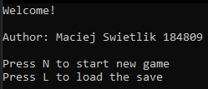

First option requires him to choose dimensions of the grid:  


Then in both cases user can read the “how to play” section: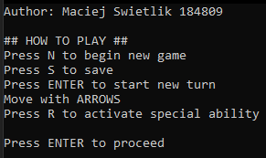

After pressing the ENTER button, the world is generated and drawn, then the game starts:   
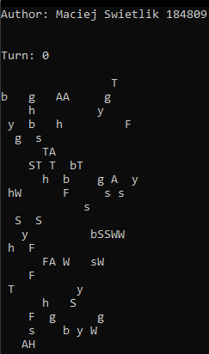

Organisms on the board are named following way (they’re all present in image above):

H = human  
W = wolf  
T = turtle  
F = fox  
A = antelope  
S = sheep  
g = grass  
s = sow thistle  
y = guarana  
h = Sosnowki’s hogweed  
b = belladonna

For new game, world is generated using the void Generator::Generate() method (where place is randomly generated empty square of the board), and for the loaded game, the world is generated using void Generator::LoadGame() method (where LoadOrganism() function is just a simple switch, taking symbol of the organism as a parameter and a few setters that update properties like strength or age).

Number of organisms is calculated with the following formula:

(Where SPECIES is number of species available in the game - 10, and FREE_SPACE is fixed number -currently 40)

Human moves using arrow keys right after world proceeds to next turn (see Human::Move() method).

After pressing ENTER and choosing an action for human (if alive) game proceeds to another round: 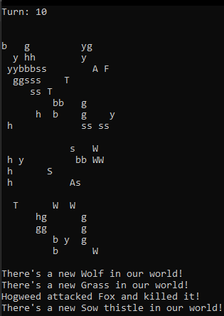  
The turn is made using void World::MakeTurn() method  
(Actions of all organisms are made, additionally using collision when needed)

Plants multiply by randomly choosing free neighboring cells (see void Plant::Sow() method), the game announces it with comment



When animal bumps into organism of the same species new animal appears on the free neighboring cell (see void Animal::Breed() method), the game announces it with comment



Collisions are made between organisms, using Plant::Collision() and Animal::Collision() functions, and are announced with comments:  
  
  
  


Human can decide not to move by pressing the key not associated with any known functionality, the game will announce it with following comment:  


Human can also choose to use his ability (Alzur’s shield) by pressing R:  
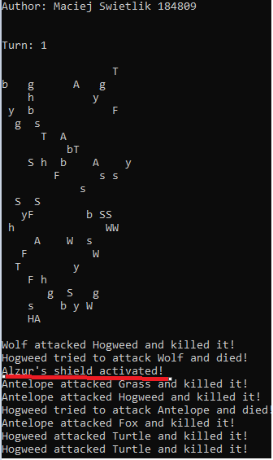

It deactivates after 5 turns  
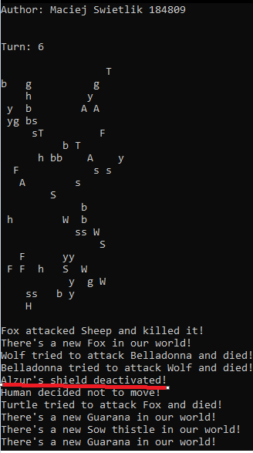

When animal tries to attack human it gets repelled (runs away the same way as Antelope escapes the fight)  


Pressing S makes player able to save the world (see Generator::Save() method) in a .txt file. The program will display following message:  


Guarana in my interpretation adds +3 to animal’s strength every time it’s eaten, not only once.

Belladonna and hogweed both die and kill any animal which walks into them.

Plants sowing rate is 10%.