|  |  |
| --- | --- |
| Maciej Mucha | Multiscale Modelling |
| Part 2 | mgr inż. Mateusz Sitko |

**1.Technology**

Project is continuation of preview grain growth appliaction. Project was creating using Java language and IDE NetBeans. Java has a lot of advantages. In this type of project the most important is decision which langugage is the best for developers. Java give a lot of reason to chosen her. This project is using GitHub repository.

**2. User Interface**

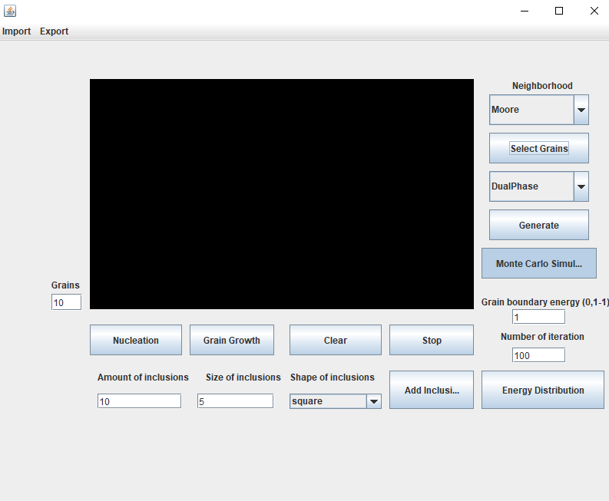

Pic. 1 GUI Application

Graphical user interface include new section. User have a option to change type of simulation like CA or Monte Carlo.

2.1 Simulation output – energy

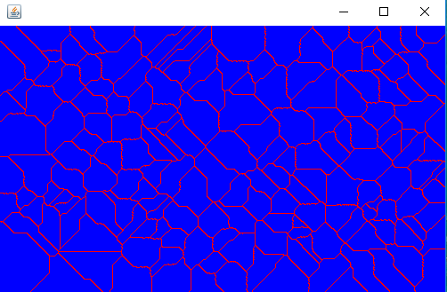

Pic. 2 New windows – energy for base structure

2.2 Basic parameters:

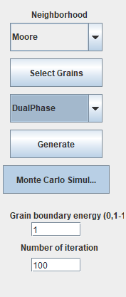

Pic. 3 Base parameters

MC J – physical value for MC simulation

MC iteration – amount of iterations

Monte Carlo Simulation - buton for toggled on MC or CA

**3. Application outputs**

The application give a possibility to generate a complex grain structure, so this part include description of using them.

**3.1 Monte Carlo Grain Growth**

For Monte Carlo have three parameters :

* MC Energy (J)
* Amount of iteration
* Select type of simulation

For small value of iteration we will generate a lot of small grains (rys. 1). Otherwise if we set more iterations we get less grains but bigger one (rys. 2)

 

Pic. 5 MC 100 iterations

Pic. 4 MC 10 iterations

**3.2 Dual phase microstructure**

Application give possibility to generate dual phase microstructure after generate grain structure. First of all you select remaining grains, numer of grains to generate and type of microsturcture. Morover you choose a type of simulation MC or CA. There is possibility to genereate variousy combination of sumilation like CA to MC (pic. 6) or MC to CA (pic. 7)

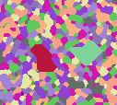 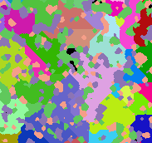

Pic. 7 MC to CA

Pic. 6 CA to MC

3**.3 First step of SRXMC – Energy Distribution**

Application give you opportunity to calculate and show Energy in structure like picture 9. Analyzie this microstructure you see that where is the red color means that we have more energy than blue.

****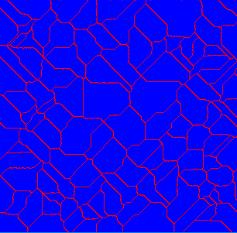

Rys. 9 Heterogenous - Energy for base structure

Rys. 8 Homogenous sHomogenous

**3. Compare real structures**

Monte Carlo simulation give a lat of realistics result compare different methods. The real structure we have on the left.

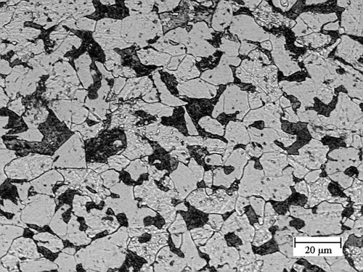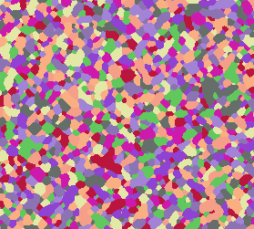

Pic. 10 Carbon microstructure

Pic. 11 MC Microsturcture

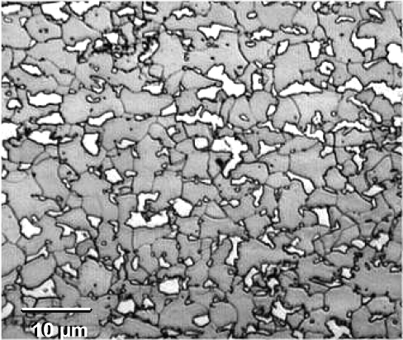 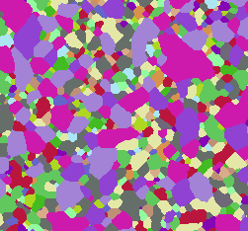

Pic. 12 Dual Phase steel from application

Pic. 12 Dual Phase steel

**4. Sum up**

* Diffrent method of simulation than Cellular Automate
* Monte Carlo method is slower than CA but its possible to imporving some parts of algorithm.
* Monte Carlo method is working completely random. The most important thing is amount of iterations. If we set a lat of iteration we gain a big grain.
* Combination MC and CA methods ensure getting real microsturcture.