|  |  |
| --- | --- |
| **Multiscale modelling** | **Maciej Mucha** |
| **mgr inż. Mateusz Sitko** | **First Report** |

**Java programing language:**

The main advantages of java:

* Firstly applications are compiled to byte code that can run on any Java virtual machine regardless of computer architecture.
* Secondly, many would be surprised to see this one of the top reason for learning Java or considering it as the best programming language, but it is [2].
* Another reason, which made Java popular is that it's an Object Oriented Programming language. Developing OOP application is much easier, and it also helps to keep system modular, flexible and extensible [2].
* Java has powerful developments tools like Eclipse or Netbeans and Intelij.
* Moreover, Java has a solution like ActionListener. It is an interface (not a class) that contains a single method, it gives you the option for creating a simple GUI.

**Idea:**

The main idea of the cellular automata technique is to divide a specific part of the material into one-, two-, or three-dimensional lattices of finite cells, where cells have clearly defined interaction rules between each other. Each cell in this space is called a cellular automaton, while the lattice of the cells is known as cellular automata space [3]

**Program:**

At the beginning we have option in our program to choose the amount of grains which we would like to apply so in the empty field we have enter the number of grains. The next option was to declare a size of array in our case the size of microstructure.

|  |  |
| --- | --- |
|  |  |

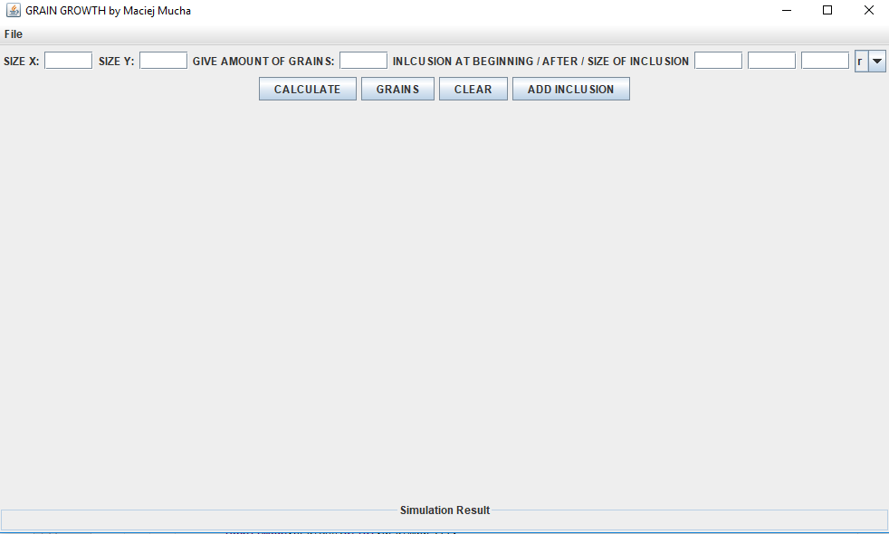

1.1 Appearance of GUI program

The main goal was implementing the inclusions on to way. The first was at the beginnings of simulation (grain growth) [1.5], however the second was after simulation [1.7]. The results of this implementation was included in GUI. You can choose shape and size of inclusions.

**First class/step:**

Results :

 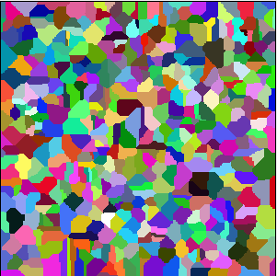

1.2 Microstructure with 100 grains and 100x300 size of array

1.3. Microstructure with 500 grains and 300x300 size of array

To sum up:

Based on the microstructures generated in the program, we can observed that the microstructure was changing with the amount of grains. In addition, the first microstructure [1.2] has larger grains than second microstructures [1.3]. Moreover, we can assumed that grains are regularly distributed.

**Second class/step:**

The next step was to create the possibility of saving and importing text files and images [1.4] For this purpose, I created drop-down menu. The image or file save anywhere on your computer.

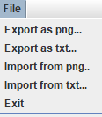 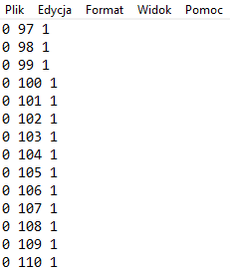

1.4. Menu to import or export png and txt

1.5. Export to txt

**Third class/step:**

Before Grain Growth

 

1.7 Inclusion on the microstructure with circle shape and three size.

1.6 Inclusion on the microstructure with square shape and three size.

After Grain Growth

 

1.9 Inclusion on the microstructure with circle shape and three size.

1.8 Inclusion on the microstructure with square shape and three size.

It is noticeable that using implementation before grain growth, inclusions forms in the middle of seeds [1.6] [1.7] Moreover, using the method after grain growth inclusions appear on the grain boundaries [1.8][1.9]. In our program we have obtained the desired result.

**Comparison of real microstructures with received ones**

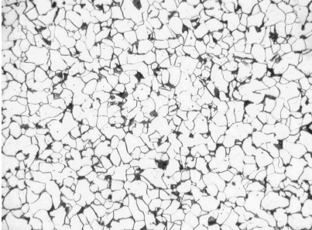 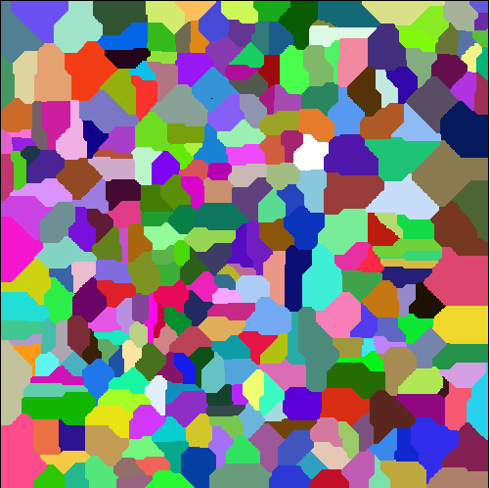

Microstructure of non-alloy steel [1]

1.7 Microstructure with 400 grains.

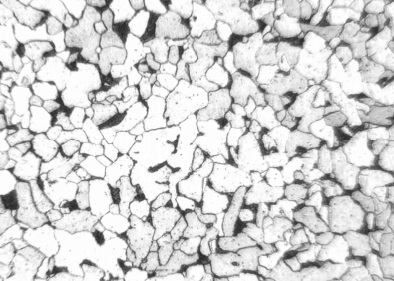 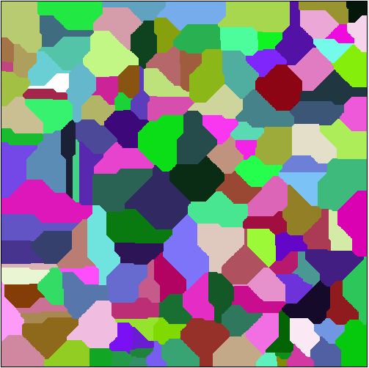

Microstructure of structural steel [1]

1.8 Microstructure with 200 grains.

**To sum up:**

It can be noticed that the program gives a comparable microstructure. First microstructure is more fragmented. In the program more seeds was using. The second has larger size of seeds as a result influence in the properties. One the microstructure the grain boundaries are hardly noticeable. The grain growth wasn’t take place evenly, the larger grains, which have higher thermodynamic durability, absorb smaller ones and grow themselves. Therefore, there are some contrasts in the size of the grain and only at higher temperatures the grain becomes more even. Also the size of the grain affects the properties of the material.

The created program contains conditions such as nucleation and formation of inclusions. It gives us the possibility to generate a microstructure with a certain number of grains. In addition we have opportunity to compare them with actual microstructures.

**Bibliography:**

1. <http://www.wm.pollub.pl/files/66/content/files/3268_Instrukcja,do,cwiczenia,5,struktury,stali,w,stanie,wyzarzon,v02.pdf>
2. <https://javarevisited.blogspot.com/2018/07/10-reasons-to-learn-java-programming.html#ixzz5WryUIj00>
3. <http://home.agh.edu.pl/~msitko/multiscale-modelling/>