## Events

### OnLoad

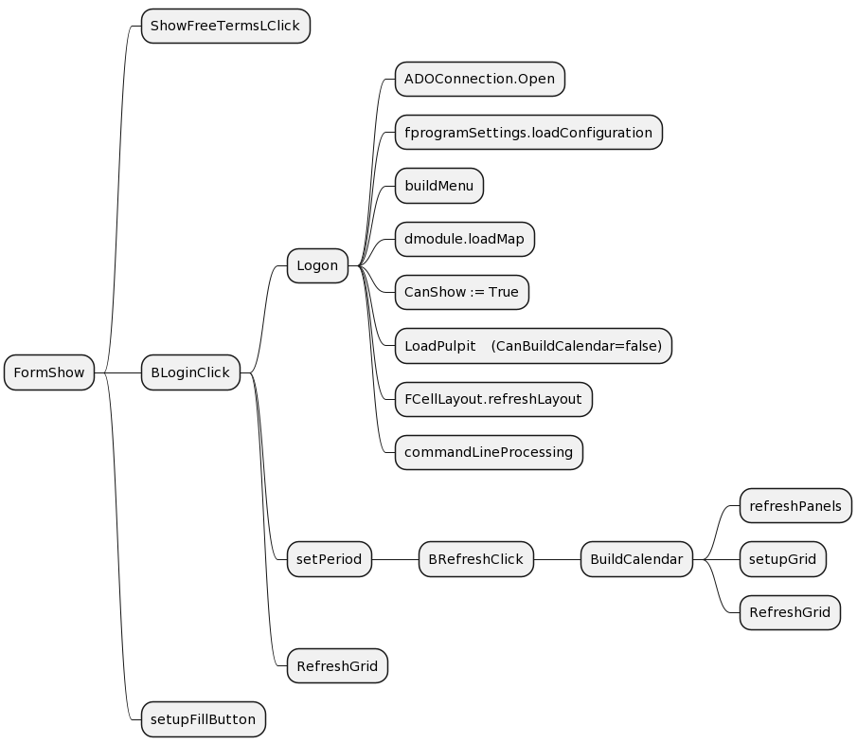

https://www.planttext.com/?text=NP71ReCm38RlF4LkspZq0IPLwc1Y5wgYjI-G4aEjEJ5o4bLx-oKDJDCu-V_ui9rmy45BiEYCrKjLFRLi5ntmIg3k66xg9FEH3QYggbN7OiytlgUwLhde1E02OdtV4evV6JSzp-YsMAiKsUMgLc_lfvQTWp4WkzrfWPLFY_0isfuX17Iptn5haym9voWwoyMxHYHp11TBD9PD97ZOnxJx0xRQvSNKwrvT94A1VJA6I0i6bPxdv3IvLQi9dD6odpHvU2bkrm9HhxyvXft09E1l9PNN8rkhdUdHmI0yWlTfuyT1FOG11DaKiVai7__UH6P_fnPMgtN8e1sGts1g5fSFGRE1jTk6_kNYTqZKn13IVLM7D6FzgJy0