**OBSOLETE SOLUTION: The labels can be updated by standard in Salesforce.**

### Customize flow screen using Lightning components (Next🡪Save)

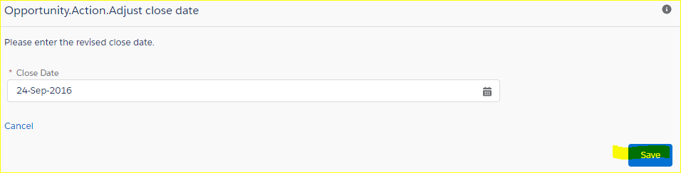

Setup:

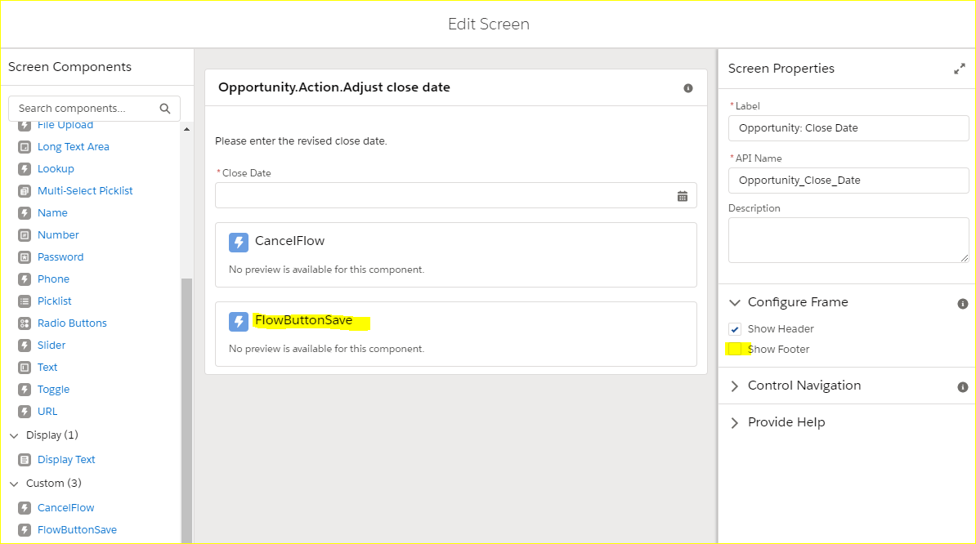

|  |
| --- |
| <aura:component **access**="global" implements="lightning:availableForFlowScreens">    <!*-- Determine which actions are available -->*  <aura:attribute **name**="canNext" **type**="Boolean" />  <aura:handler **name**="init" **value**="{!this}" action="{!c.init}" />    <div aura:id="actionButtonBar" **class**="slds-clearfix slds-p-top_medium">  <div **class**="slds-float_right slds-m-bottom_x-small">  <!*-- If Pause, Next, or Finish are available, display to the right -->*  <aura:if isTrue="{!v.canNext}">  <lightning:button aura:id="NEXT" label="Save"  variant="brand" onclick="{!c.onButtonPressed}" />  </aura:if>  </div>  </div>  </aura:component> |
| ({  init : **function**(cmp, **event**, helper) {  // Figure **out** which buttons **to** **display**  **var** availableActions = cmp.**get**('v.availableActions');  **for** (**var** i = 0; i < availableActions.**length**; i++) {  **if** (availableActions[i] == "NEXT") {  cmp.**set**("v.canNext", **true**);  }}  },    onButtonPressed: **function**(cmp, **event**, helper) {  // Figure **out** which action was called  **var** actionClicked = **event**.getSource().getLocalId();  // Fire that action  **var** navigate = cmp.**get**('v.navigateFlow');  navigate(actionClicked);  }  }) |