Screen flows: Updating records as admin
Maciej Szymczak
Version 2024.04.05

Functional description
OBSOLETE: The functionality has been provided by Salesforce 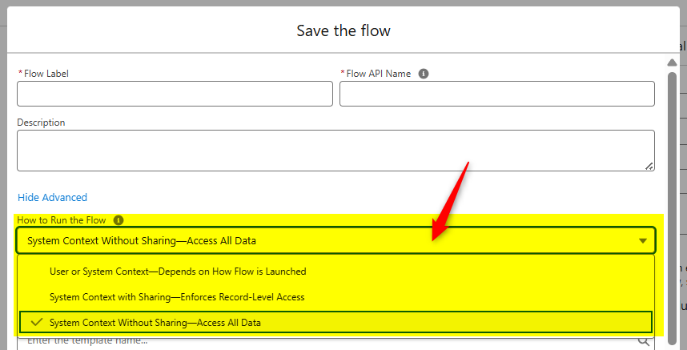

Imagine you would like to build the flow that updates the record type of the record so that record becomes read-only / editable. The snug is the record type typically cannot be updated by the user, of course.
What if you would like to build a screen flow that updates the record type (make the records read-only / updatable)?
Normally the SCREEN FLOW runs with permission of the current user (unlike record triggered flow which runs with system permissions).
Use this apex class inside flow (instead of Update Records component) to bypass the permissions imposed on current user, that block some updates like update the record type of the record from EDITABLE to LOCK.

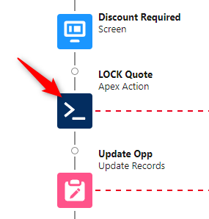
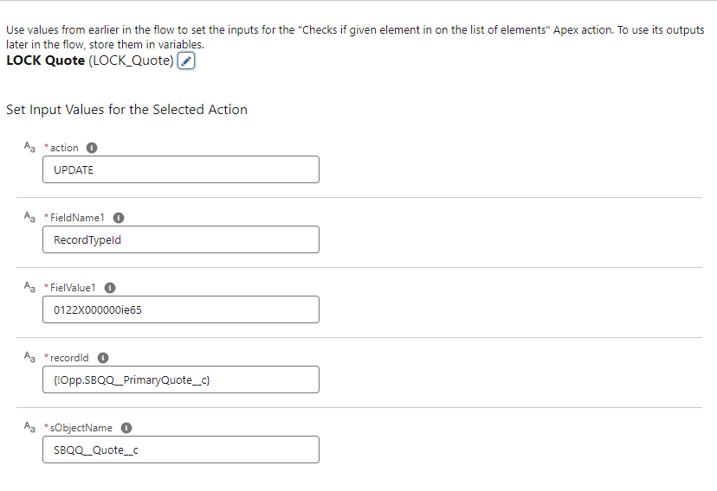

Technical design

How was it made?
Under the hood the update is made by the apex class with the clause “without sharing”, dynamic SOQL.

