Redirection to URL
Maciej Szymczak
Version 2024.04.05
Functional description 1
Technical description 1
How was it made? 2
I need to go back to the same record (no redirection) but somehow the record gets not updated 2

Functional description
By default, when the screen flow is over, it goes back to the record page layout.
What if we would like to go to another location like conga composer or just another record? Or what if we need to refresh the entire screen?
Use this solution. Importantly, CSRF protection is supported by this solution.

Technical description

Follow the instructions below.

Create flow type: Screen flow
At the end of your flow use the redirectToURL component.

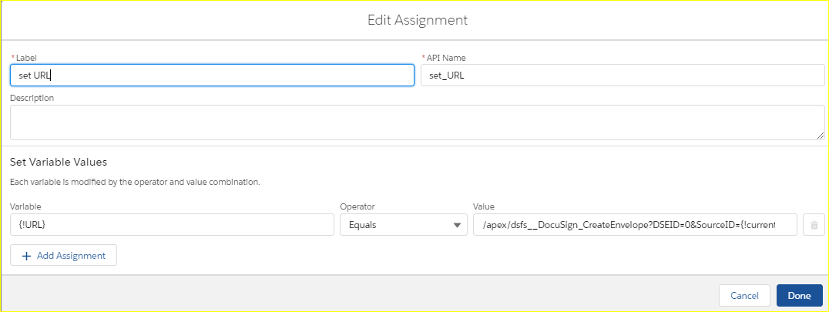

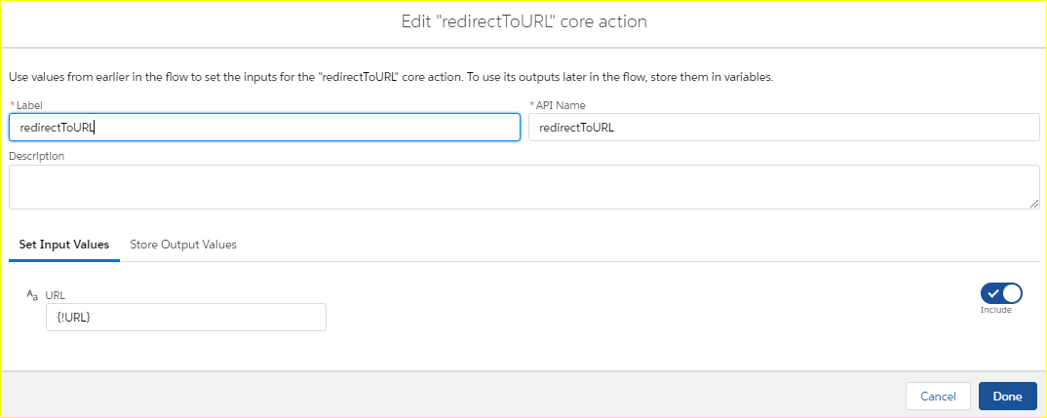

Lex or classic?
The solution works in lex.
In classic call from from URL buton and use RetURL variable.

How was it made?

This lightning component calls the apex class and thus receives URL with CSRF protection. The apex call is asynchronous, so I had to use promise to deal with it.
Notes:
- Can’t you select your component from the list while creating the action? Create the flow of type screen rather than auto launched.
- See also: https://developer.salesforce.com/docs/atlas.en-us.salesforce_vpm_guide.meta/salesforce_vpm_guide/vpm_finish_override.htm
- This component works fine for Lightning but will not work in Classic. In Classic Call flow using URL syntax can use returl.

I need to go back to the same record (no redirection) but somehow the record gets not updated

Navigate to your own visual force page that brings you back to the record. This way the screen is refreshed.
- URL
/flow/Update_SOBJECT?recordId={!Case.Id}&FieldName=Status&Value=No+Action&retURL=/apex/refreshScreen?relatedId={!Case.Id}

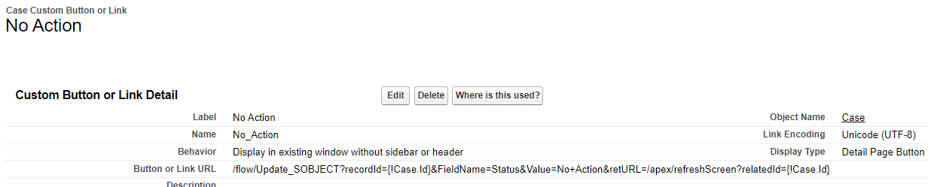

- Visual force page refreshScreen:
</apex:page>

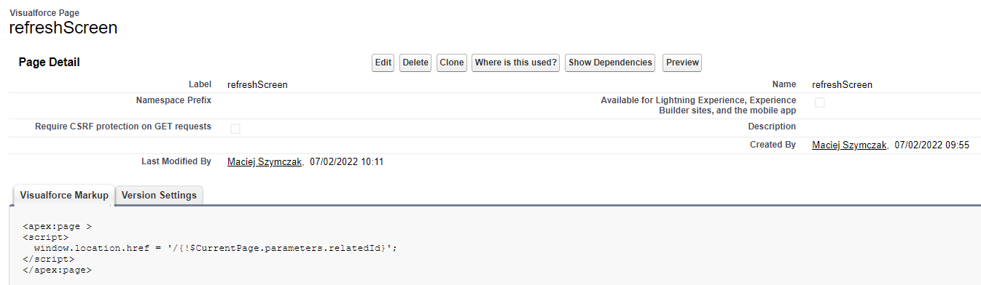
<apex:page >
<script>
window.location.href = '/{!$CurrentPage.parameters.relatedId}';
</script>

