Debugging flow

Maciej Szymczak

Version 2024.04.05

# Functional description

Once the flow fails, especially on record insert, the error notification sent by email shows little details about the record details, for example:

You can find there the recordId (which is quite useless providing the flow fails on insert) but what if you would like to see say country of the lead, company name and the lead name?

To make it more elaborative add the debugFlow as the first step this to your flow:

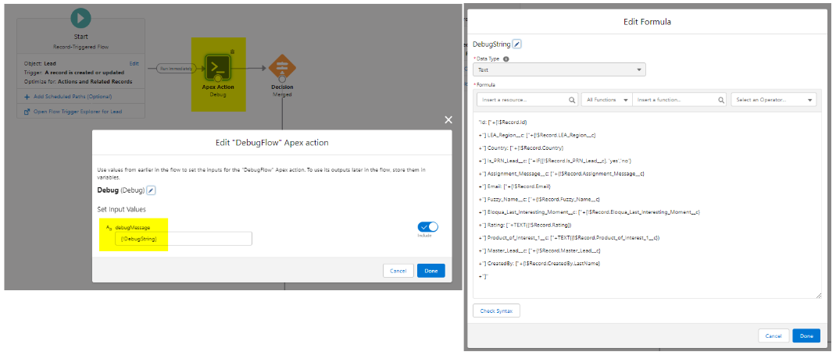

The same can be done in process builder too:

