How to setup developer environment for Synchronizer

1. Install Eclipse
2. Install Google Plugin for Eclipse. Here is nice video showing how to do it.

<https://developers.google.com/eclipse/?hl=pl>

1. Set UTF8 coding

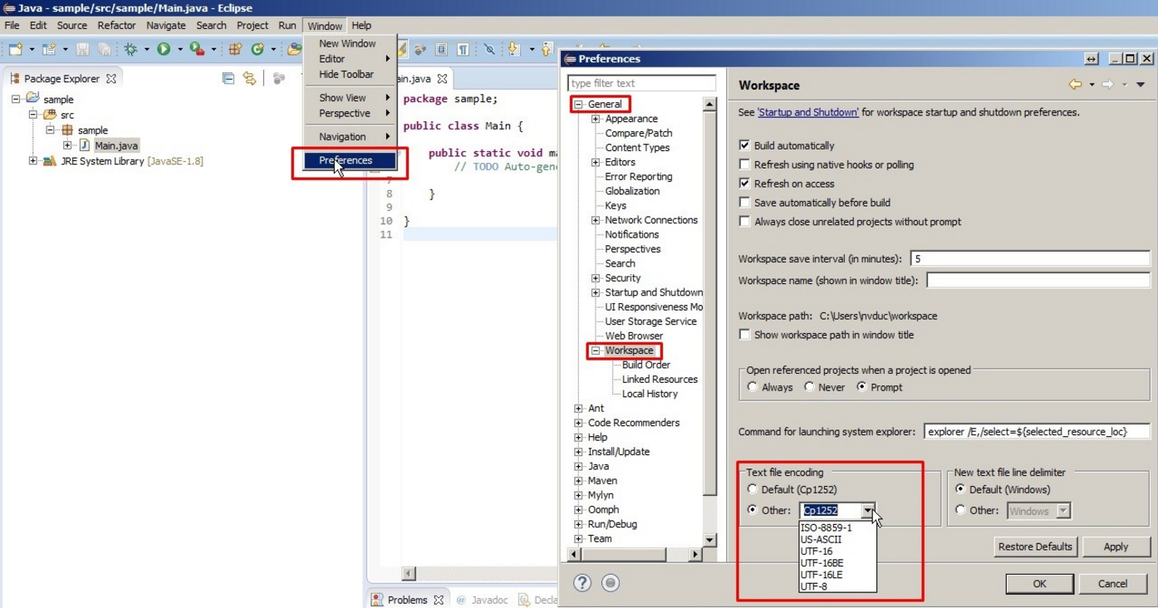

1. Further documentation
2. Google Calendar API with Java examples (search bottom)

<https://developers.google.com/google-apps/calendar/v3/reference/calendarList/insert>

1. Google API Java documentation

<https://developers.google.com/resources/api-libraries/documentation/calendar/v3/java/latest/>

1. You can find here fine java examples

<https://developers.google.com/google-apps/calendar/v3/reference/acl/insert>