**Model’s documentation**

The following documentation relates to the model of ‘grey water storage for heat recovery over water/air-HX (to heat room temperature in basement) in combination with air/water-HP-DHW-boiler’, saved under the name of ‘*Basement_model_vFinal.m’* and ‘*Basement_model_vFinal_without_gw.m’*.

Table of Contents

List of abbreviations 2

Brief model’s description 3

Problems 4

Assumptions 11

Parameters 12

Results 13

## List of abbreviations

Table 1. List of abbreviations

|  |  |  |
| --- | --- | --- |
| Abbreviations | Full form | Units |
| m_gw | Mass of grey water produced in 24 hours | kg |
| m_c_*soruce* | Mass of cold water required by a particular *source* (shower/kitchen etc.) | kg |
| m_h_*soruce* | Mass of hot water required by a particular *source* (shower/kitchen etc.) | kg |
| m_DHW_*soruce* | Mass of DHW required by a particular *source* (shower/kitchen etc.) | kg |
| Thot | Initial temperature of grey water (right after being stored in a tank) | C |
| Tamb0 | Ambient temperature in Duebendorf | C |
| A_*w/g/c* | Area of basement’s *walls/floor/ceiling* (respectively) | m2 |
| V_*r/ceiling* | Volume of the *basement/room-above-basement* | m3 |
| c_air/c_water | Specific heat of air/water (respectively) | J/(kg*K) |
| C_*i* | Thermal capacitance of *i (air inside basement/walls/floor/grey water etc.)* | J/K |
| R_*i* | Thermal resistance of *i (walls, ceiling etc.)* | K/W |
| V_air | Volume of air inside basement | m3 |
| d_*i* | Thickness of ­*i* layer *(walls/ceiling/floor)* | m |
| lambda_*i* | Heat conduction coefficient of ­*i* layer *(walls/ceiling/floor)* | W/(m*K) |
| dens_*i* | Density of ­*i* layer *(walls/ceiling/floor)* | kg/m3 |
| c_*i* | Specific heat of ­*i* layer *(walls/ceiling/floor)* | J/(kg*K) |
| r_tank | Tank’s radius | m |
| H_tank | Tank’s height | m |
| h_air/h_water | Heat convection coefficient of air/water (respectively) | W/(m2*K) |
| k_steel | Thermal conduction of steel | W/(m*K) |
| k_pp | Thermal conduction of polypropylene | W/(m*K) |
| t_fin | Fin’s thickness | m |
| L_fin | Fin’s length | m |
| dis | Distance between fins | m |
| n_fins | Number of fins | - |
| A_tank | Tank’s surface area | m2 |
| A_surf | Surface area of a single fin | m2 |
| A_root | Surface area of a single fin’s root | m2 |
| A_cross | Single fin’s cross section area | m2 |
| P_fin | Single fin’s perimeter | m |
| Rconv_water | Convective resistance of water inside the tank | K/W |
| Rconv_air | Convective resistance of air surrounding the tank | K/W |
| Rcond_tank | Conductive resistance of air surrounding the tank | K/W |
| eff_fin | Fin’s efficiency | - |
| E_fin | Fin’s effectiveness | - |
| emissivity | Tank’s surface emissivity | - |
| Rrad_tank_  without_fins | Thermal radiation resistance of tank excluding fins | K/W |
| Rrad_tank_fins | Thermal radiation resistance of fins | K/W |
| Rcond_fin | Conductive resistance of fins (including conductive resistance of air) | K/W |
| Twhole | Whole simulation’s time period in days (required by Tamb1 and Tamb2) | days |
| Tmean | Mean temperature in the ground at high depth | C |
| Time_simulation | Whole simulation’s time period in seconds | s |
| time_charg | Duration of heat pump operation per day | s |
| V_air_flow | Average air’s volumetric flow through evaporator | m3/s |
| m_air_flow | Average air’s mass flow through evaporator | kg/s |
| dt*i*_k | Condenser/Evaporator small temperature difference | C |
| dt*i*_g | Condenser/Evaporator big temperature difference | C |
| dt*i* | Temperature lift in the condenser/evaporator | C |
| dt*i*_m | Condenser/Evaporator mean temperature difference | C |
| P_h | Heat flux needed to heat DHW from 10 to 60 C in ‘time_charg’ period | W |
| T_c_in | Condenser inlet temperature | C |
| T_DHW | DHW temperature (in DHW storage tank) | C |
| hour | Current time (in hours) | - |
| day | Current time (in days) | - |
| t | Current time (in seconds) | - |
| Tc | Condensation temperature | C |
| Te | Evaporation temperature | C |
| T_lift | Difference between condensation and evaporation temperatures | C |
| Eff_isentropic | Heat pump’s isentropic efficiency | - |
| COP | Coefficient of performance | - |
| P_c | Heat flux in the evaporator | W |
| dTair | Difference between inlet and outlet air temperature in evaporator | C |
| P_hp | Heat pump’s power used in the set of equations (=P_c) | W |
| Tamb1mean | Gravel’s (surrounding walls) mean temperature at various depths | C |
| *Variable*(1) | *Property* of the basement room | - |
| *Variable*(2) | *Property* of walls’ first layer | *-* |
| *Variable*(3) | *Property* of walls’ second layer | *-* |
| *Variable*(4) | *Property* of gravel (surrounding walls) | *-* |
| *Variable*(5) | *Property* of floor’s first layer | *-* |
| *Variable*(6) | *Property* of floor’s second layer | *-* |
| *Variable*(7) | *Property* of gravel (beneath the floor) | *-* |
| *Variable*(8) | *Property* of ceiling’ first layer | *-* |
| *Variable*(9) | *Property* of ceiling’s second layer | *-* |
| *Variable*(10) | *Property* of room above basement | *-* |
| *Variable*(11) | *Property* of grey water | *-* |
| Tamb1 *(Variable(12))* | Gravel’s (surrounding walls) temperature at various depths | C |
| Tamb2 *(Variable(13))* | Gravel’s (beneath the floor) temperature | C |
| Q_hidden | Heat transferred between basement and room above basement | W |
| Q_gw | Heat transferred between grey water and the basement | W |
| P_hidden | Heat flux between basement and room above basement | W |
| P_gw | Heat flux between grey water and the basement | W |
| COP_avg | Average COP | - |
| Troom | Temperature of air in basement | C |
| Tceiling_room_  const | Temperature of air in the room above (constant) | C |

## Brief model’s description

Following daily water usage profile assuming a single family home inhabited by 4 persons, DHW is used three times per day. Right after it is used, grey water is produced and stored in a storage tank located in basement (we assume no losses during water transportation as well as instant transportation process). The grey water storage tank is assumed to be full of grey water (at initial temperature Thot) at the very beginning of the simulation (the capacity of the tanks is equal with one-day grey water production). The storage tank is then continually partially flushed when grey water is produced (a specific amount of newly-produced grey water replaces the same amount of grey water in the tank, what leads to an increase of average grey water temperature). The amount of water inside the tank remains always the same (the tank is always full). Because of temperature difference between basement’s air and the storage tank, storage tank is continuously emitting heat. On the other hand, heat pump is placed in the same room. The heat pump is used to heat domestic hot water and is operating once per 24 hours, following assumed schedule (in the night, from 22:00:00 till 05:59:59). Finally, heat transfer between basement and surrounding soil (3m below surface) is taken into account as well as ‘hidden heat flux’ between basement and the room located above. The objective is to calculate the beneficial influence of grey water heat recovery on basement air’s temperature, what leads to a higher heat pump COP. Picture 1. presents model’s diagram.

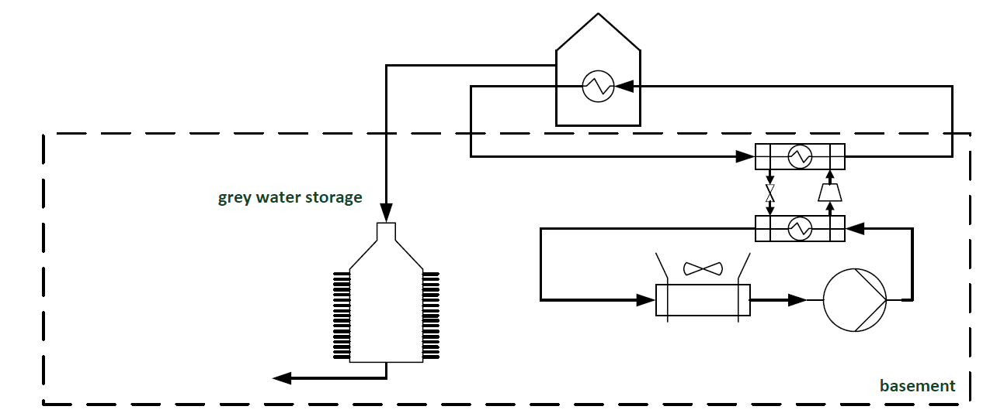

Picture 1. Model's diagram

## Problems

1. Grey water
2. Temperature and mass

The amount of water, used by 4 people during 24 hours, was obtained based on a diagram ‘Wasserverbrauch im Haushalt pro einwohner und Tag‘. Shower, kitchen, washbasin, dishwasher and washing machine are the sinks that require hot water and thus were included in DHW calculations. Hot water temperature required by those sinks was assumed based on ‘Recommenden Code of Practise for Safe Water Temperature' and URL websites: ‘http://products.geappliances.com/appliance/gea-support-search-content?contentId=18924’, https://www.thespruce.com/laundry-and-water-temperature-1900646’. Since the final temperature of water at a particular sink is a mix of hot (60C) and cold (10C) water, mass of required hot water was calculated using eq. (1).

|  |  |
| --- | --- |
|  |  |

Overall mass of hot water is a summation of all hot water sinks’ masses. Its average temperature is a weighted average of their individual temperatures. Naturally, the mass of grey water is the same as the mass of DHW. It was assumed that the temperature of newly-produced grey water amounts to 0.55 of DHW average temperature (what in fact leads to 45% of temperature loss). That value wasn’t based on real data.

1. Production profile

It was assumed, that DHW is used three times per day: 6:00-7:00 (30% of DHW mass), 14:00-15:00 (20% of DHW mass), 19:00-20:00 (50% of DHW mass). Naturally, grey water is produced during the same time periods. However, we assume that the grey water tank is partially flushed and refilled with newly-produced grey water instantly right after production process (at 07:00, 15:00 and 20:00). Eq. (2) presents an example of new grey water temperature calculation (at time 7:00).

|  |  |
| --- | --- |
|  |  |

1. Heat flux

In order to calculate the heat flux between grey water and air in the basement – overall thermal resistance between these two thermal capacitances is necessary. The resistance consists of multiple resistances connected in series and in parallel. Picture 2. illustrates these thermal connections.

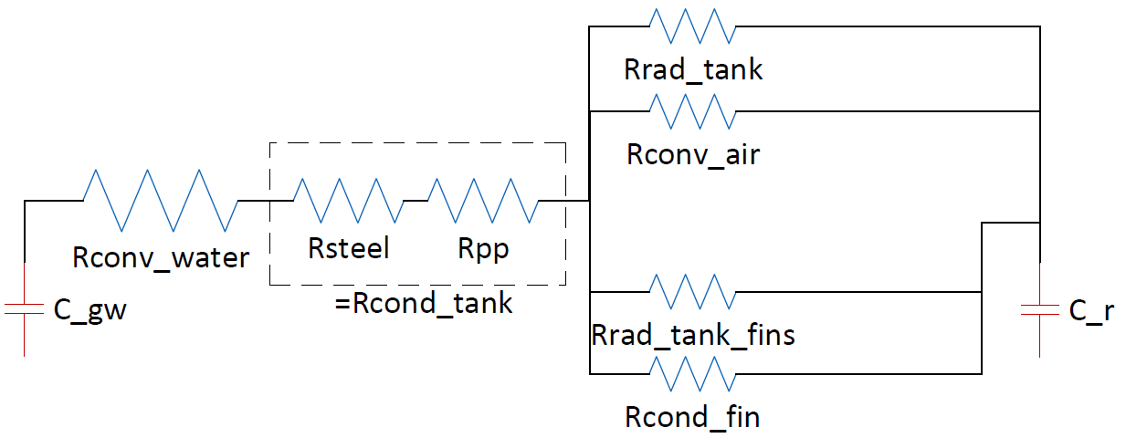

Troom

Tgrey

Picture 2. Thermal connections: grey water – basement air

As indicated in the picture, the tank is equipped in fins (vertical ones). Their conductive resistance has been calculated based on ‘A Heat Transfer Textbook’ by John h. Lienhard IV, chapter 4. ‘Analysis of heat conduction and some steady one-dimensional problems’. Eq. (3) presents the obtained formula:

|  |  |
| --- | --- |
|  |  |

where (mL)2 is a hybrid Biot number:

|  |  |
| --- | --- |
|  |  |

Additionally, fins radiation as well as tank’s radiation has been taken into account. It is important to mention, that h_air and h_water have been calculated based on ‘Fundamentals’ Ashreae Handbook, chapt. 4. ‘Thermal convection’. That required reading data from graphs (ex. air/water kinematic and dynamic viscosity, thermal diffusivity, coefficient of thermal expansion etc.) and calculating non-dimensional numbers (ex. Prandtl, Rayleigh, Nusselt). Since that process requires reading data from graphs and tables for a particular fluid’s temperature, it could not have been automated by being included in the model and thus was conducted manually (assumptions made are listed is ‘Assumptions’ section).

1. Heat pump
2. Power

Power of heat pump’s evaporator depends on its COP and heat flux required to heat up DHW from 10 to 60 C in *time_charg­* time. Since COP depends, among many others, on temperature of air in basement, the power is recalculated in every iteration, using formula presented in eq. (5).

|  |  |
| --- | --- |
|  |  |

1. Operation profile

Heat pump is operating once per 24 hours – between 22:00:00 and 05:59:59. Hot DHW is then stored and used during the day.

1. COP calculation

Heat pump’s COP depends on its evaporation and condensation temperatures (and isentropic efficiency which differs for different temperature lifts). These depend on evaporator inlet temperature (which is the temperature of air in basement), evaporator temperature fall and condenser inlet temperature (temperature of water flowing into condenser). Eqs. (6) – (9) illustrate above-mentioned relations:

|  |  |
| --- | --- |
|  |  |

|  |  |
| --- | --- |
|  |  |

|  |  |
| --- | --- |
|  |  |

|  |  |
| --- | --- |
|  |  |

As indicated in eq. (9), dTair depends on P_c calculated from previous iteration (only in the first iteration it must have been assumed arbitrary – in accordance with data based on heat pump’s manufacture description). Additionally, T_DHW changes in time, starting from 10 C and reaching 60 C at its maximum. Its temperature lift is constant (eq. (10)), since condensator’s power is constant. In was assumed that water in the tank is always perfectly mixed.

|  |  |
| --- | --- |
|  |  |

T_c_in (which represents condenser inlet temperature) is assumed to be always higher than T_DHW by 2 C.

1. Isentropic Efficiency

Since isentropic efficiency depends on heat pump’s temperature lift (difference between condensation and evaporation temperatures), it must have been calculated for every iteration. In order to do that, a polynomial curve was fitted into real data obtained from a graph containing isentropic efficiency as a function of temperature lift (source: publication ‘High efficiency heat pumps for low temperature lift applications’). Next, temperature lift was calculated for every iteration and multiplied by polynomial’s coefficients, thus resulting in precise current efficiency. The graph is presented in the picture 2a.

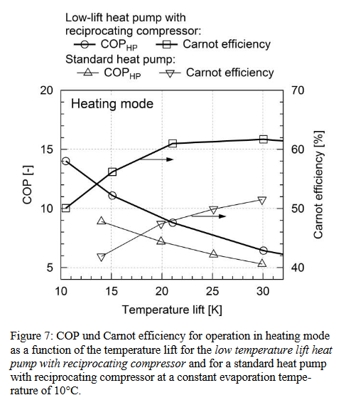

**Picture 3a. COP and Carnot efficiency for operation in heating mode**

**as a function of the temperature lift**

1. Basement-ambient heat exchange
2. Ways of heat exchange

In order to meet real-life conditions, heat exchange between the basement and surrounding ambient was taken into account. Surrounding ambience include: ground surrounding walls, ground beneath the floor and the room above basement. Bulkhead constructions consist of a layer of concrete and a layer of insulation. Additionally, a layer of gravel is added between walls/floor and ground. Picture 3. illustrates the above-mentioned thermal connections in detail.

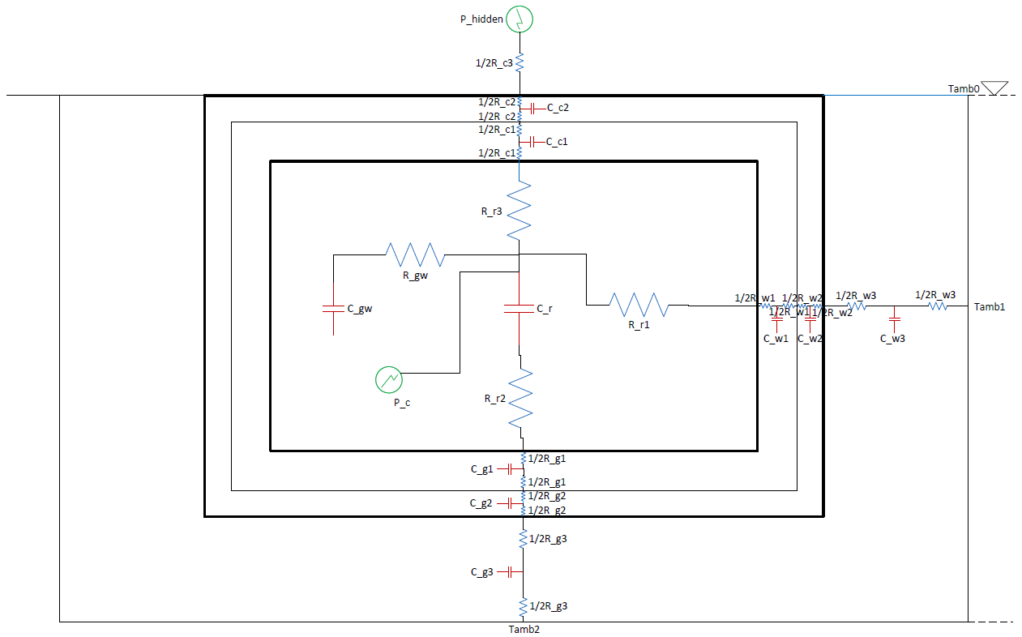

Picture 4. Thermal connections in basement (cross section of basement below ground)

1. Bulkhead constructions

As mentioned before, bulkhead constructions consist of concrete, insulation and an additional layer of gravel (between walls/floor and ground). Their thermal resistances have been separated into two parts each and their thermal capacitance has been placed right in between, in order to simplify the problem while still meeting real-life conditions. Additional layer of gravel dampens the effect of ambient temperature variation.

1. Ambient temperature

Ambient temperature at the surface was imported from design reference year (DRY) data from meteotest (for the city of Duebendorf for 365 days). It was then used to calculate temperatures in the ground at various depths. For ground surrounding walls – the whole height of walls was divided into 10 parts. The calculation of ground temperatures at different depths was conducted in a separate file: ‘*ground_temperature.m’*. First, a damping factor was calculated for each depth, in accordance with eq. 10a.

|  |  |
| --- | --- |
|  | (10a) |

Then, in order to shift the temperature function in time (the deeper it is, the bigger shift it has), a cosine function was applied, which in the end resulted as a final function for temperatures at various depths, presented in eq. 10b.

|  |  |
| --- | --- |
|  | (10b) |

Finally, having obtained temperatures for different depths, it was possible to compare their maximum values with maximum value of temperature at surface and thus to compute the phase shift (in hours). The damped temperatures were then simply shifted by a specific time (given in hours) before being implemented in the main model (the time shift is presented in the picture 4a). In this way, temperatures for the ground situated beneath basement’s floor as well as the ground next to walls, were obtained for the whole year (with daily frequency). The temperature of the ground next to walls was in fact calculated as an average of temperatures calculated for different levels between the surface and basement’s floor. That operation was necessary, since the damping factor and the phase-shift factor (as both are functions of depth) are not linear functions (as indicated in Picture 4b. for damping factor) and hence simple computation of a middle-depth temperature would not be the correct way. Obtained temperature data was then input in the system of differential equations as initial conditions (presented in Picture 4c)

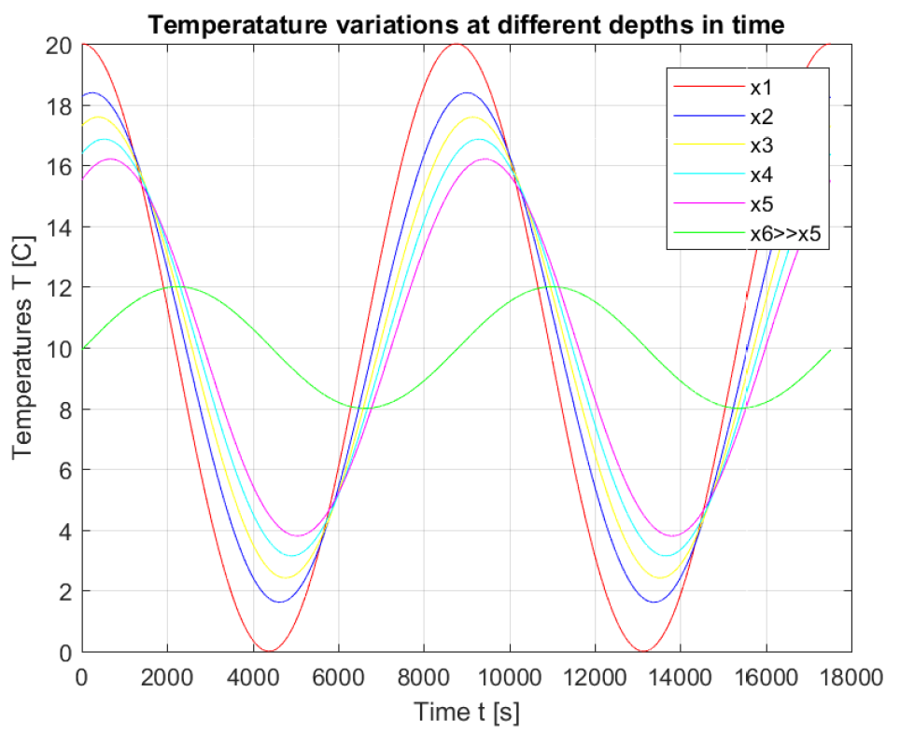

Picture 5a. Time shifted temperature functions

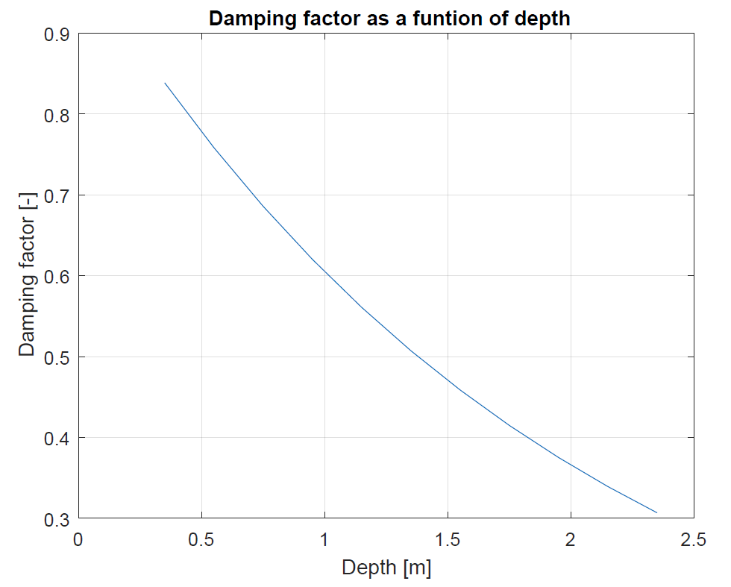

Picture 6b. Damping factor as function of depth

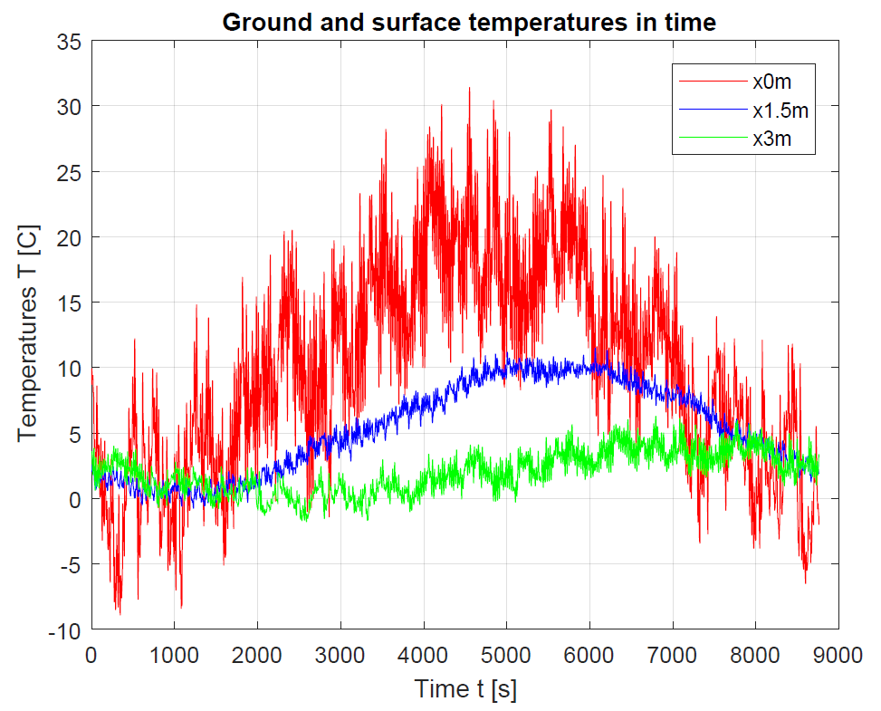

Picture 7c. Obtained temperature data for depths of 0m, 1.5m (average), 3m

1. Hidden heat

As illustrated in the Picture 3. – heat flux between basement and the room above, is also taken into account. Naturally, temperature in the room above is set to be constant, since that part of household is used by people on a daily basis. The lower temperature in the basement, the higher heating system’s power demand (since such as ‘hidden’ heat flux will always be transferred from a warmer room to a cooler basement). Therefore it is reasonable to measure that heat flux, so that it is visible later how much grey water storage reduces heating demand. Eq. (10) was used (in each iteration) to calculate above mentioned ‘hidden’ heat flux:

|  |  |
| --- | --- |
|  |  |

As shown in the equation, summation of small heat packages that are being transferred in each second, divided by the overall simulation time, forms desired heat flux. It is important to mention, that Tceiling_room_const was set constant during the whole simulation (after each iteration it goes back to the same value).

1. Simulation properties
2. Simulation time

Simulation time was set to 365 days (from 1st Jan to 30th Dec). Such time is enough to produce valuable results. Besides, ambience temperature data was only available for the period of 1 year.

1. Initial conditions

At first, initial conditions (initial temperatures 1-13) were set arbitrary and the simulation was running for the set time (365 days). Afterwards, its final temperatures (obtained for 31st of December) were used as initial conditions for the proper simulation.

1. Set of equations

The core element of the model is a set of 13 differential equations. These are solved by Matlab inbuilt ode45 solver. They calculate basement, gravel, ambient and grey water temperatures.

1. Desired outcome

Most desired outcome of the simulation include comparable values for models with and without grey water storage: COP_avg, P_hidden and P_gw. Additionally, Troom(t) and COP(t) are of great importance. The model without grey water heat recovery is the same as the one with heat recovery included, but with the tank’s conduction resistance set to a very high number (in such a way that there is no heat exchange).

## Assumptions

1. Grey water

* Tank’s volume matches the daily volume of grey water
* The tank is partially flushed and refilled instantly at 07:00, 15:00 and 20:00, then the water inside is assumed to be perfectly mixed
* There are no loses in pipes during grey water transportation
* Natural convection was assumed for both water and air sides of the tank
* Both grey water as well as DHW in storage tanks are perfectly mixed during the whole simulation

1. Heat pump

* Heat pump is running for 8 hours once per 24 hours, starting at 22:00
* Heat pump’s air volumetric flow and first value of temperature decrease in the evaporator were assumed based on data for heat pump model ‘Europa 323 DK’ (<http://www.oekotherm.ch/wp-content/uploads/2016/03/MB_Europa-323-DK_de.pdf>), which has similar nominal volume (300 dm3) and has been tested in 8 hours operation time at similar source temperature (15 C), its COP totals 3,1
* Isentropic efficiency factor has been taken into account.
* Heat pump’s power has been adjusted so that it covers DHW heat demand in 8 hours.
* Temperature difference over the condenser is always 10 C

1. Basement-ambience heat exchange

* Room above basement has the same dimensions as the basement itself
* Both, in basement and in the room above, additional thermal mass (additional to air) was assumed: 17kg/m2 of air

1. Simulation

* The solver’s temporal resolution was set to 1 second
* New ambient temperature values are fed into the solver every hour (hourly data available)

## Parameters

This paragraph presents only those parameters, which have neither been calculated nor taken from a reliable external source (note that the source is always mentioned in the Matlab simulation files as a comment, next to a particular parameter).

1. Grey water

Table 2. List of assumptions of parameters regarding grey water storage

|  |  |
| --- | --- |
| **Parameter** | **Assumed value** |
| h_air (calculated using tables) | 1.61 W/m2K |
| h_water (calculated using tables) | 245,96 W/m2K |
| k_steel | 43 W/mK |
| k_pp | 0,1 W/mK |
| d_steel | 0,003 m |
| d_pp | 0,003 m |
| t_fin | 0,002 m |
| L_fin | H_tank |
| r_fin | 0,1 m |
| distance between fins | 0,05 m |
| n_fins | 2*pi*r_tank/(dis+t_fin) |

Table 3 List of assumptions of parameters regarding calculation of convection coefficients (h_air, h_water)

|  |  |  |
| --- | --- | --- |
| **Parameter** | **Water** | **Air** |
| t_surface | 14 C | |
| t_∞ | 11 C | |
| t_f=(t_surface+t_∞)/2 | 12,5 C | |
| Δt_mean=|t_surf-t_∞| | 3 C | |
| k(t_f) (thermal conductivity) W/mK | 0.58349 | 0.02531 |
| γ(t_f) (kinematic viscosity) m2/s | 0.00000123 | 1.4385E-05 |
| μ(t_f) (dynamic viscosity) Ns/ m2 | 0.00123 | 1.7764E-05 |
| Pr(t_f) (Prandtl number) [-] | 8.85362217 | 0.70606812 |
| α(t_f) (fluid thermal diffusivity) m2/s | 1.38926E-07 | 2.0455E-05 |
| β(t_∞) (coefficient of thermal expansion) 1/K | 0.0001384 | 0.002145 |
| Nu (Nusselt number) [-] | 400.4627364 | 60.4716228 |

1. Heat pump

Table 4. List of assumptions of parameters regarding heat pump operation

|  |  |
| --- | --- |
| **Parameter** | **Assumed value** |
| V_air | 510 m3/h |
| dTair(1) | 7 C |
| dtc_k | 3 C |
| dtc | 10 C |
| dte_k | 3 C |
| time_charg | 8h |

1. Basement-ambience heat exchange

Table 5. List of assumptions of parameters regarding basement-ambience heat exchange

|  |  |
| --- | --- |
| **Parameter** | **Assumed value** |
| Basement dimensions | 10m x 10m x 2m |
| Concrete layer’s thickness | 0,2 m |
| Insulation layer’s thickness | 0,15 m |
| Gravel layer’s thickness | 0,5 m |
| Concrete layer’s conductive coefficient | 0,93 W/mK |
| Insulation layer’s conductive coefficient | 0,036 W/mK |
| Gravel layer’s conductive coefficient | 1,4 W/mK |
| Concrete layer’s density | 2300 kg/m3 |
| Insulation layer’s density | 30 kg/m3 |
| Gravel layer’s density | 1920 kg/m3 |
| Concrete layer’s heat capacity | 653 J/kgK |
| Insulation layer’s heat capacity | 1500 J/kgK |
| Gravel layer’s heat capacity | 1850 J/kgK |
| Tmean | 10 C |
| R_r1 | 0.13 K/W |
| R_r2 | 0.17 K/W |
| R_r3 | 0.17 K/W |
| Tceiling_room_const | 21 C |

## Results

Table 6. presents obtained data (COP, P_hidden and P_gw) for both models with and without grey water heat recovery).

Table 6. Output results

|  |  |  |
| --- | --- | --- |
| Parameter | Without grey water heat recovery | With grey water heat recovery |
| COP [-] | 3.13 | 3.35 (+7.03%) |
| P_hidden [kW] | 3.80 | 3.06 (-19.47%) |
| P_gw [kW] | 0 | 2.27 |

The following pictures (5-11) present obtained graphs.

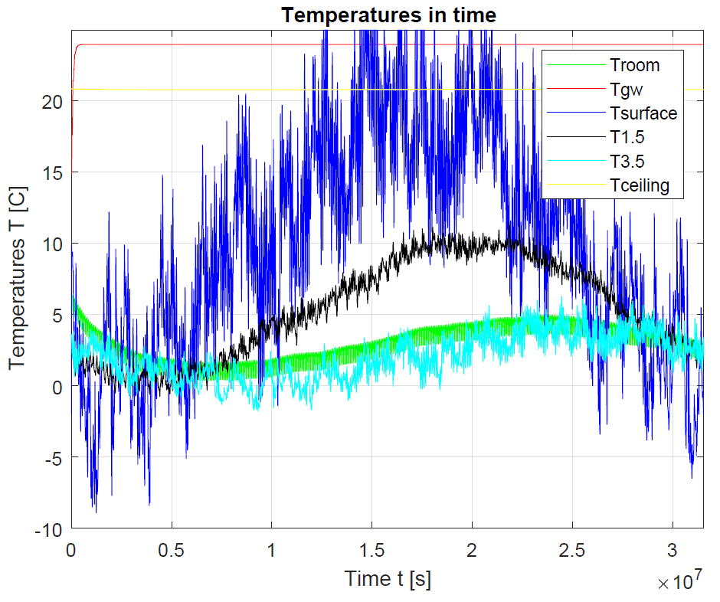

Picture 5. Temperatures in time for model without grey water heat recovery

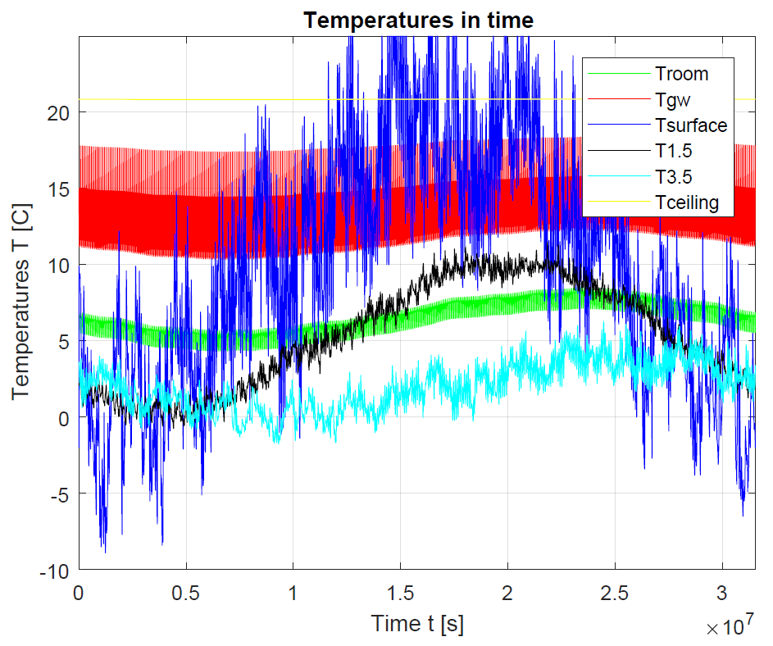

Picture 6. Temperatures in time for model with grey water heat recovery

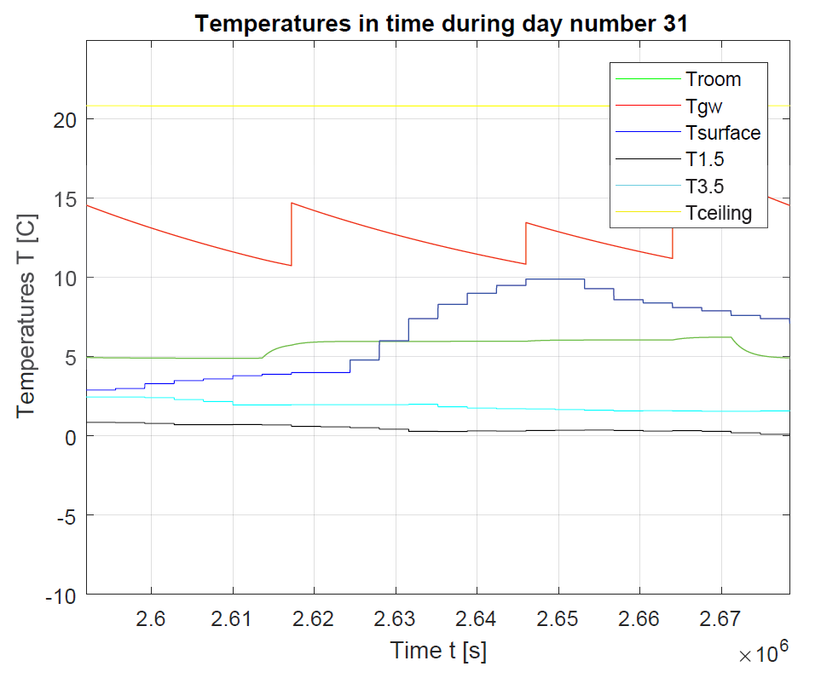

Picture 7. Temperatures in time for model without grey water heat recovery for 24hours

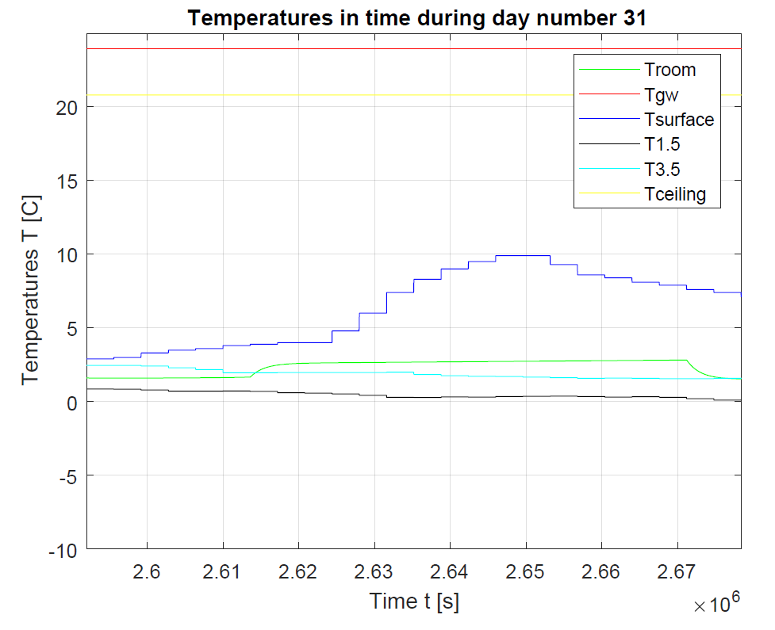

Picture 8. Temperatures in time for model with grey water heat recovery for 24 hours

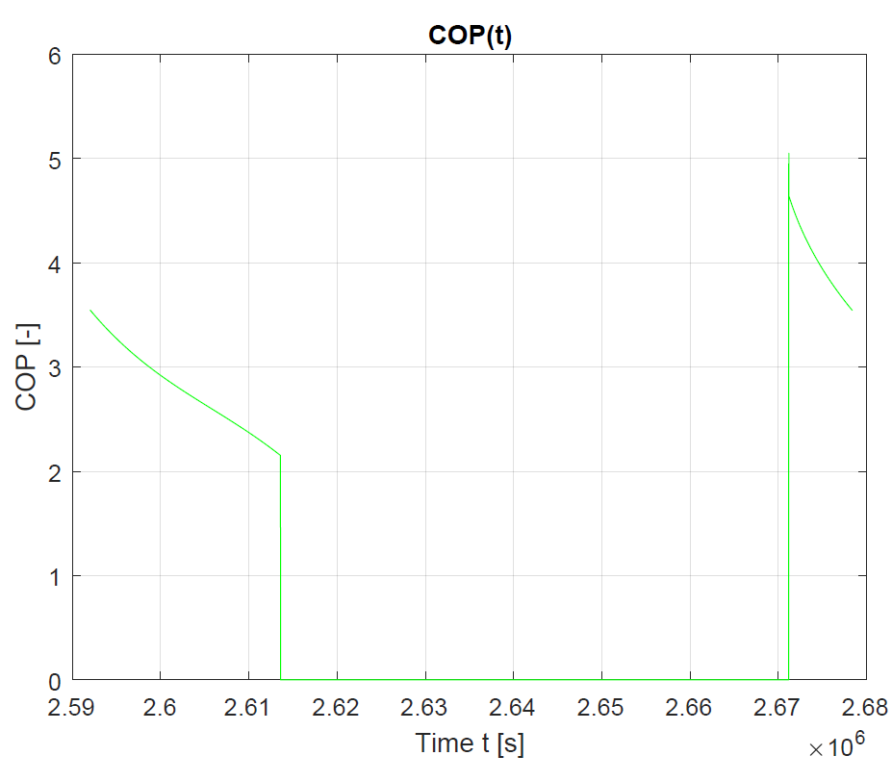

Picture 9. COP in time for model without grey water heat recovery for 24 hours

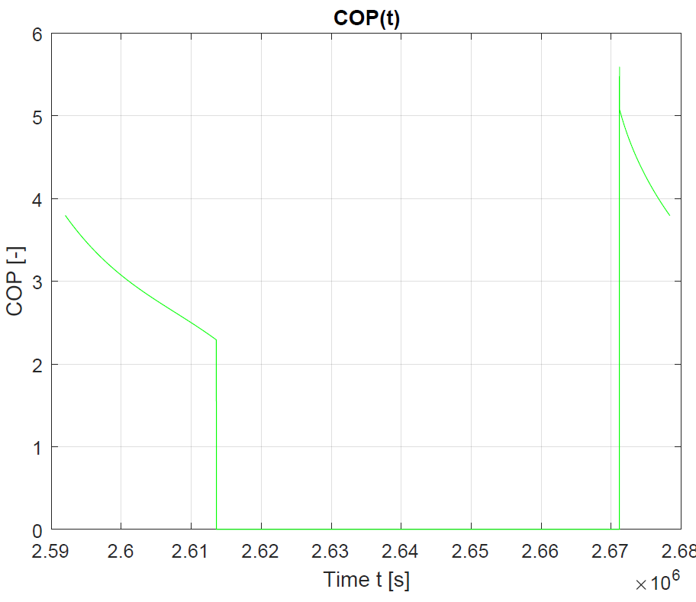

Picture 10. COP in time for model with grey water heat recovery for 24 hours

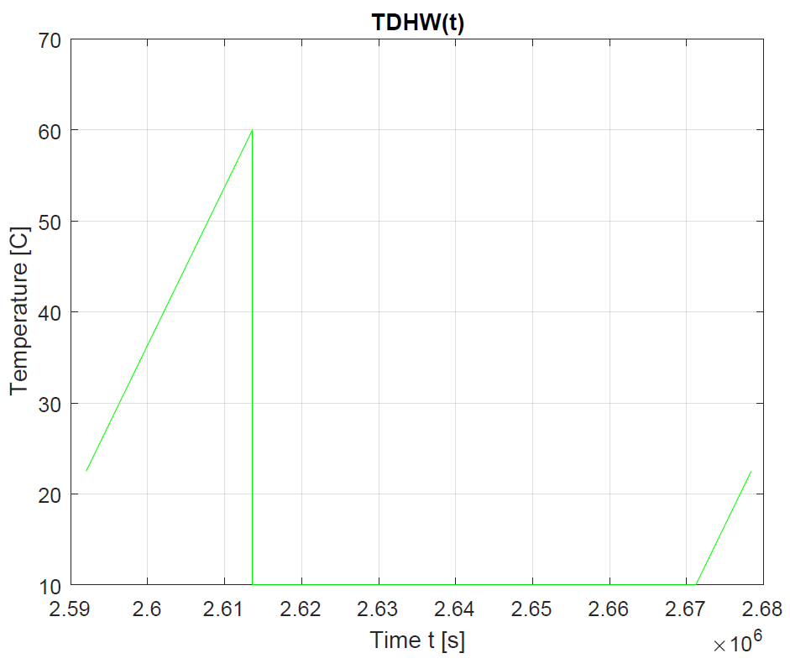

Picture 11. Temperature of DHW in time for 24 hours (for both models)