**REPORT**

Zajęcia: Analog and digital electronic circuits

Teacher: prof. dr hab. Vasyl Martsenyuk

**Lab 01**

Date 28.09.2024

**Topic:** "Spectral Analysis of Deterministic Signals"

**Variant 11**

Szymon Nycz

Informatyka II stopień,

niestacjonarne,

1 semestr,

Gr.1b

1. **Problem statement:**

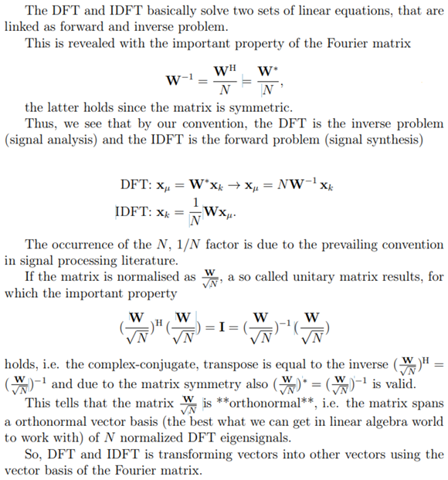

1. **Input data:**

**Variant 11: $x_{μ}={[6, 2, 4, 3, 4, 5, 0, 0, 0, 0]}^{T}$**

1. **Commands used (or GUI):**
2. source code

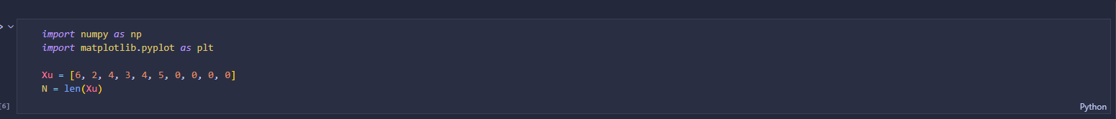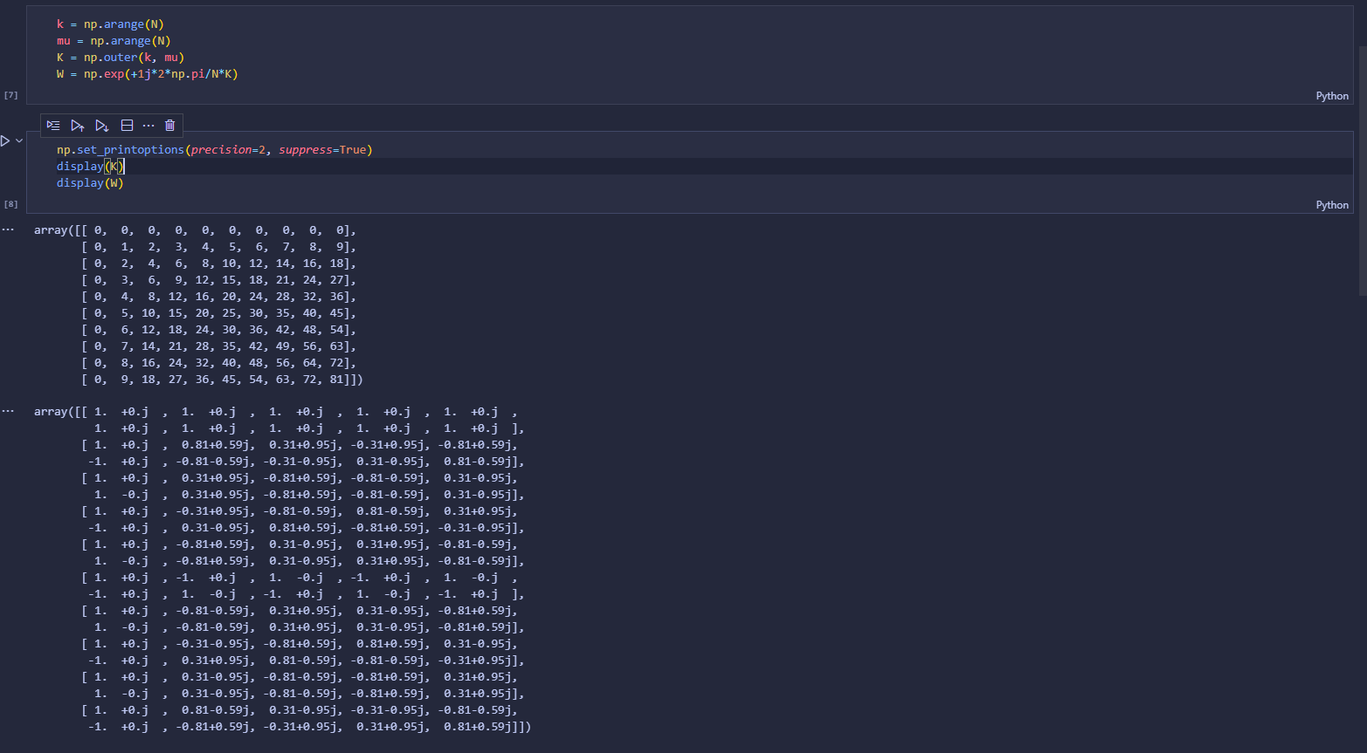

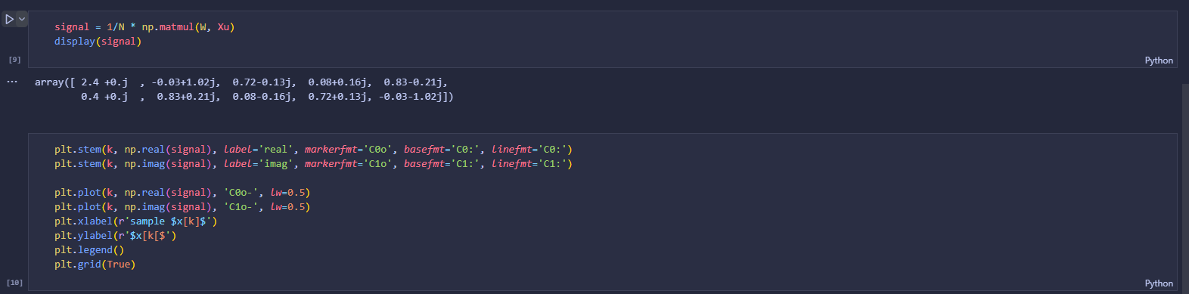

Link to remote repozytorium: https://github.com/Maciek332/Semestr_1_Nycz/tree/master/DSPja/Lab_1

1. **Outcomes:**

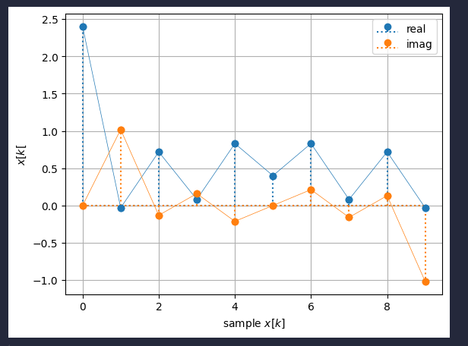

1. **Conclusions:**

For the reasons given, we conclude that thanks to convention used in Python’s ‘numpy.fft.fft()‘, ‘numpy.fft.ifft()‘ and Matlab’s ‘fft()‘, ‘ifft()‘ it’s easy for us to note the sign reversal in the exp()-function and the 1/N normalization in the IDFT. Our task was to synthesize a discrete-time signal by using the IDFT in matrix notation for different values of N and to show the matrices W and K. Plot the signal synthesized. Thanks to all knowledge in materials we were able to make this task with not so much effort as we would have to without them.