Table of Contents

ABSTRACT vi

CHAPTER ONE 1

**INTRODUCTION AND PROBLEM DESCRIPTION** 1

1.1 Background 1

1.2 Problem statement 2

1.3 Project objectives 3

1.4 Significance and Scope 5

CHAPTER TWO 7

**LITERATURE REVIEW** 7

2.1 Topic review 7

2.2 Domain review 9

CHAPTER THREE 12

**REQUIREMENT ELICITATION AND SYSTEM ANALYSIS** 12

3.1 Introduction to requirement elicitation 12

3.2 System functionalities 13

CHAPTER FOUR 17

**SYSTEM DESIGN** 17

4.1 Introduction to system design 17

4.2 System design methodology object, waterfall model 17

4.3 Database design 18

CHAPTER FIVE 21

**SYSTEM IMPLEMENTATION** 21

5.1 Introduction to implementation 21

5.2 Functionalities of implementation 22

5.4 Front end user interface implementation 23

CHAPTER SIX 27

**CONCLUSIONS AND RECOMMENDATION** 27

6.1 Summary of achieved objectives 27

6.2 Conclusion 27

# ABSTRACT

Chukua information system is a web based system that intend to handle the problem of stock management when and how the stocks are ordered, acquired and been bought from the external source. The proposed system is for making it easier for the organization in use to save money and increase the speed of operations.

The system will remove the problem facing different department when ordering goods from the main store, also will help the procurement department to have organized way to purchase goods from the external suppliers. This will promote productivity since things will be done in an efficient way at the high speed. Limiting cheating that might likely to occur due to improper and unorganized way of doing things in a manual way.

The system will provide a proper way which the procurement department will be able to track all suppliers in an ease way. The system will have an organized manner which it will make a detailed list of every supplier’s information which will reflect their identity.

Automating the inventory management process as much as possible, you’ll be able to reduce the likelihood of human error. Once you take the plunge and make the move to inventory management software, you’ll have more time on your hands, giving you more time to focus on what’s really important - growing your business.

It will enable to print purchases requests that are been suggested by the department as due to the reason that they are needed to be bought by the organization.

# CHAPTER ONE

## **INTRODUCTION AND PROBLEM DESCRIPTION**

### Background

### 

Banana Investment Limited is a beverage manufacturing company located in Arusha Tanzania. The current owners of the Company started producing banana wine in 1990 for domestic consumption, and later for sale when demand was noticed, commercial production started. Up to 1993 the activity was made a formal business, and was operated under the business named Arusha Agricultural products enterprises, when employing 6 people. Banana investments ltd was incorporated in 1996.

First to be developed was the opaque wine now called RAHA followed by Meru a clear dry product in 1996 in 2001 a clear sweet product Malkia was developed and in 2011 fiesta dry gin with 40% alcoholic content was introduced with different millimetres (mils) but currently the products produced are Raha, Raha poa and Fiesta dry gin. These Products are filled in 330ml bottles, which are packed in crates or 24 bottles or cartons of 12 bottles, ready for selling.Selling involves delivering the products to specified distributors, who sells them to retailers (Bar Owners), who sell them to customers.

The company has a distribution network covering Arusha, Kilimanjaro, Manyara, singida, Tanga, Dar es salaam, Mwanza, Mbeya and Morogoro Regions. And Operates six deports Dar es Salaam, Tanga, Morogoro, Singida, Rombo and Mwanza. plans are underway to cover most of Tanzania by year 2015

At present the products are sold locally only. Plans are underway to sell them to neighboring countries like Kenya beginning 2014.

Therefore according to the above short history of Banana Investment Limited we can understand that this is a private company owned privately by individuals whereby it also sells its shares and according to the Tanzania Development Policy of 2002 it has categorize this business as a large enterprise were by it state that for the enterprises which has got more than 100 employees and a capital of more than 800 millions

Therefore the type of this business or organization is a corporate business registered under private partnership enterprise whereby it has got limited liabilities as an advantage and it can sell shares so as to maximize its capital.

The organizational structure of Banana Investment Limited in which I performed my project is known as functional structure or traditional structure whereby departments are grouped based on similarity of activities done and resources used. Division of where by this structure follows the organizational rules and regulations, procedures and in this type of organization structure different departments according to their activities according to my observation it is categorized in to various types. The functions performed in the organization such as if the organization comprises of departments such as sales marketing department, accounting and finance department, engineering department, administration department, supplies department and production then employees are employed in respective department.

### Problem statement

Inventory management at banana investment ltd has been a little of disturbance in the process of acquiring something or service from the main store to a certain department for use. The issue lies on the signing of papers manually that prove that the good has been taken and result to too many accumulation of papers which at times may lost or be difficult to find them. Also the process tracking and making the purchases to the external suppliers been difficult for the procurement office to handle.

At banana investment once the goods are not available or finish in the main store for a particular department – let say engineering, the particular head of department must sign a requisition form laying the claim of demand of a particular equipment. The requisition form then taken to the main store department for them to prepare purchase request that may be seen to the procurement and supplies for them to prepare purchase order finding the suitable supplier of goods who can bring the goods at a favorable manner and handle the payment efficiently. After the supplier has been found the goods are purchased and been brought at the main store and the concerned department will confirm its arrival. Goods receive note is prepared by the stores department to acknowledge the arrival of the good. Also, once the goods are available in the main store the process of acquiring it is done in the system through - good issue which is approved by the store manager with the process involves the paperwork for its accomplish.

The keeping of stock records also have been done manually leading to improper management that leads to things like theft and fraud which may bring about huge loss to the company. Misunderstanding also may arise between stores/procurement and other departments due to bad communication between the departments ordering the stock from the main store to their department for personal use been taking an improper way of doing so.

I would like to present a way were a borrower can request and acquire a stock without a delay which is brought by signing of the papers – The paperwork will be summed in and stored to the database and accessible anytime were it will act as a proof of order.

The history of suppliers who have been selling different goods to the organization have also been hard to track down – leading to high amount of time used in the whole process of preparing the purchases from the external sources. Also it was hard to create contract with these suppliers as long as there is a poor organization environments.

The program will provide a proper manner for the automation of different activities which will help increase efficient in an organization and making ease in saving time for completion of several tasks. All the stocks will be recorded in the database by the store’s manager who receive and keep all the stocks of the organization.

### Project objectives

**1.3.1 General objective**

To develop a web-based integrated system with an interactive interface that makes it easier to manage all inventories and stocking activities for each department in the organization. This expands the idea of enterprise resource planning (ERP) systems, allowing the automation of internal business processes, thus providing a platform that supports automation at a global level. It allows procurement professionals across the world to communicate information simply and efficiently, streamlining the global procurement process; reducing time and costs without compromising on standards and quality.

**1.3.2 Other objectives**

There are many benefits to be found from using e-procurement/supplies within an organization, and the following are just some of the key points:

**Reduced Transaction Time**: individual business activities (transactions) can be completed much more quickly; they are not restricted by office hours and may not even need human intervention, thus increasing the capacity to complete transactions on a real-time basis. This means that downstream processes are not constrained by waiting for transactions to be completed.

**Improves the accuracy of inventory orders:** Proper inventory management helps you figure out exactly how much inventory you need to have on-hand. This will help prevent product shortages and allow you to keep just enough inventory without having too much in the warehouse.

**More organized warehouse:** A good inventory management strategy supports an organized warehouse. If your warehouse is not organized, you will have a hard time managing your inventory. Many companies choose to optimize their warehouses by putting the highest selling products together and in easily accessible places in the warehouse. This, in turn, helps speed up the order fulfillment process and keeps customers happy.

**Increases efficiency and productivity:** Inventory management devices, such as barcode scanners and inventory management software, can help drastically improve your efficiency and productivity. These devices will help eliminate manual processes so your employees can focus on other – more important – areas of the business.

**More Cost Efficient**: With the time reductions and increased supplier selection, development of trading communities, more opportunities for purchasing surplus goods and services at below market price, and much more, it isn’t surprising that e-procurement proves to be much more cost efficient than traditional procurement.

**Relationship with the supplier:** Conducting procurements involves obtaining seller responses, selecting sellers, and awarding contracts. Outputs include selected sellers, agreements, resource calendars, change requests, and updates to the project management plan and other project documents.

### Significance and Scope

**1.4.1 Significance**

The system will have a huge impact in automating most of the activities that need to be done through manual way that is prone to lot of errors in doing. This will give more time for workers to deal with other useful stuffs that are more productive and hence increase the output of the aggregate in the organization.

Costs can be reduced by leveraging volume, having structured supplier relationships and by using system improvements to reduce external spend while improving quality and supplier performance. It eliminates paperwork, rework and errors.

Centralized tracking of transactions enables full reporting on requisitions, items purchased, orders processes and payments made. E-procurement advantages extend to ensuring compliance with existing and established contracts.

Standardized approval processes and formal workflows ensure that the correct level of authorization is applied to each transaction and that spend is directed to draw off existing contracts. Compliance to policy is improved as users can quickly locate products and services from preferred suppliers and are unable to create maverick purchases.

**1.4.2 Scope**

Emphasis on the acquisition aspect, this include the acquiring of item from the main store to certain department for use without contradiction between parties involved. Once the certain stock is finished then the concerned department may prepare a requisition form which it outlines the goods which are needed to be bought by the procurement/supplies department for it to be used. The requisition form will be prepared direct by the head of the department concerned and been sent immediately to stores manager for the approval before sent to the procurement and supplies for further purchases process. The orders are prepared simply by the concerned department to the store’s manager once the item is needed, the store’s manager approves it and confirm the good to be taken by the one who claims it.

Store management, this involves how goods can be manage through the system were the orders, requisitions, requests are made and the approval has to be done on time to avoid the delay in any flow of goods commits. The store’s manager here has been given high authority to make sure that goods are in control at any instance- this make him be an important link were contact like mobile are also in touch with other department to get him/her as soon as possible.

# CHAPTER TWO

## **LITERATURE REVIEW**

### 2.1 Topic review

During the period before the Industrial Revolution, when merchants had to write down purchases and keep an eye on how many items were sold that day, and how many of them were left. And since they certainly didn’t have a sales forecasting app, merchants had to forecast future needs themselves, which was not always accurate, and could easily slow down the business and cause troubles.

One of the events that had the most profound impact on people throughout history is certainly the Industrial Revolution, which increased the efficiency and mass production. The businesses grew, and so did their needs for better inventory management.

In the early 1930s, a team at Harvard University designed what would become the first modern check-out system. This system used punch cards, which were inserted into a computer that read them, and eventually passed the information to the storeroom. Although it might seem simple now, this automated process was able to manage inventory as well, which was a huge thing at the time. However, the system was too expensive to use.

**Moving Towards Modern**

A forerunner of the modern bar-coding system was created in the late 1940s and early 1950, and it utilized ultraviolet light-sensitive ink and a reader. In the late 1960s, the Universal Product Code (UPC) was created, which improved inventory management systems. As the computer technology improved, so did the systems, and in the mid and late 1990s, modern inventory management systems began to be used.

One of the amazing technologies used in today’s inventory management is the use of Radio-frequency identification, with microchips that transmit product information that contains everything that’s relevant to a business owner and their employees. Together with a mobile inventory app, managing your inventory in the 21st century has never been easier.

A company's inventory is one of its most valuable assets. In retail, manufacturing, food service and other inventory-intensive sectors, a company's inputs and finished products are the core of its business, and a shortage of inventory when and where it's needed can be extremely detrimental. At the same time, inventory can be thought of as a liability (if not in an accounting sense). A large inventory carries the risk of spoilage, theft, damage, or shifts in demand. Inventory must be insured, and if it is not sold in time it may have to be disposed of at clearance prices – or simply destroyed. For these reasons, inventory management is important for businesses of any size.

Appropriate inventory management strategies vary depending on the industry. An oil depot is able to store large amounts of inventory for extended periods of time, allowing it to wait for demand to pick up. While storing oil is expensive and risky – a fire in the UK in 2005 led to millions of pounds in damage and fines – there is no risk that the inventory will spoil or go out of style. For businesses dealing in perishable goods or products for which demand is extremely time-sensitive – 2017 calendars or fast-fashion items, for example – sitting on inventory is not an option, and misjudging the timing or quantities of orders can be costly.

For companies with complex supply chains and manufacturing processes, balancing the risks of inventory gluts and shortages is especially difficult. To achieve these balances, firms have developed two major methods for inventory management: just-in-time and materials requirement planning.

In a perfect world, a new shipment would arrive at the exact time your previous inventory sells out, eliminating the need for any extra storage space. But without proper stock management, it’s tough to get the timing perfect.

If your new shipment arrives too early, you’ll have to find somewhere to store it, which increases your carrying costs. It’s an added expense, but it’s generally not as damaging as the alternative.

**Organizational Structure**

For inventory management, there are two organizational levels which are required to be created; the plant, and the storage location.

* **Plant -**This is a physical location in the organization where some processes take place. Sometimes these processes involve stored material, sometimes maintenance or sometimes production.

For inventory management, a plant will be created to represent a location that receives stores, and issues materials.

* **Storage Location -**This describes a designated area within a plant. A storage location can be a site where inventory is held. The physical location can be a physical room, a row of shelves, a racking system, a refrigerated cabinet, a trailer or a space in the plant that is identified by painted lines on the shop floor.

The inventory can be materials that are used in the production process, finished goods or maintenance items. The storage location is the lowest inventory level in the inventory management function.

This process involves controlling the receipt of products to prevent the inventory from becoming too high where items are stored at an unnecessary cost, or too low where it can cause a stock-out and production could be halted due to lack of raw materials.

In system, the inventory management functionality revolves around the movement of materials in and out of the storage facility and the physical count of those items at regular intervals.

### 2.2 Domain review

The ordering and managing of the stocks at main store have been a problem that workers in the department were lamenting highly, and made me to perform some finding so as to solve the problem they are facing. Once goods arrive at the store are recorded in a good way but once it comes from the issue of distributing it has been a disturbance among the departments who are once in need with the item in the store at a given period of time immediately. There are different circumstances which has the goods might be ordered – at a high demand and absent in the main store or even at low demand, all need to be recorded in the system without escape.

With this, the model in which the company use is that the identification of the goods that are purchased must been authorized by some hierarchy within the company – passing through different departments who make sure that they are the one who provide a go ahead for the fund to be provided by the company so as purchases can be done.

The main departments who are essential in the go ahead of stock come-in and out are store’s department together with the supplies/procurement, these provide a control on how the stocks should been handled around the organization. The two need to have more preferences on the system so as to manage the rest of the department and how they should consume the stocks available and that needed to be purchased on external source.

**Goods Movements**

There are a number of goods movements in the [system](https://www.thebalancesmb.com/logistics-functions-in-sap-business-software-2221341), and they can be either inbound from suppliers or the production department, outbound to customers, a transfer of stock from another plant within the company, or an internal movement within the same plant.

The bullets below explain the movement of goods in all of the various forms.

* **Goods Receipt -** This process can be either inbound from a supplier or can be from a company's own production process.

A goods receipt can be performed so that the materials are immediately available for use, or they can be placed in a quality inspection hold so that the quality department can perform tests on the items to ensure that they are within specifications before releasing them to stock.

Sometimes the goods can be placed in a blocked stock state where the company does not accept financial liability for the materials as they were not ordered, or incorrect. In that case, the material is not available for use.

* **Goods Issue -** The items in the warehouse can either be used in the production process or sold to a customer. In either scenario, the items are issued to a production order or [sales order](https://www.thebalancesmb.com/sap-sales-and-distribution-2221352) which causes the stock level at the plant to be reduced.

In some instances, material can be issued to scrap if it is deemed unusable by the quality department, past its shelf life, or damaged.

* **Internal Movements -** Material in the plant can be moved from one storage location to another before it is used in production or delivered to a customer.

There is a goods movement so that the material is moved from the main storage area to a staging location close to where the production or delivery area is located. Sometimes the material is moved to another plant if they need the material sooner. In that instance, there is a plant to plant transfer of materials.

One other internal movement is the transfer posting, where a material is logically changed within the system. For example, a material that has been received as material requiring [quality inspection](https://www.thebalancesmb.com/sap-quality-management-2221351) can be changed to material that is available for use, by performing a transfer posting.

Optimizing your supply chain means delivering to your customers what they want when they want it - and executing that by spending as little money as possible.  By using SAP to optimize your inventory management, you can move one step closer to an optimized supply chain.

# CHAPTER THREE

## **REQUIREMENT ELICITATION AND SYSTEM ANALYSIS**

### 3.1 Introduction to requirement elicitation

Requirement elicitation is the practice of collecting the requirement of a system from users, customers and other stakeholders. The practice is also referred to ‘requirement gathering’. Before the requirements are analyzed and modeled, they must be gathered first through elicitation process.

In requirement analysis, the system requirements obtained are organized and classified into two major groups ie Functional and Non-Functional requirements.

System analysis is the problem technique that decomposes a system into its component pieces for studying how well those component parts work and interact to accomplish their purpose and overall purpose of the system. Two main phases are involved in system analysis are feasibility study and requirements specification.

* Feasibility study: Used to check whether the system can be implemented or not.
* Requirement specification: Used to find out what the system will be able to do. Through the technique such as interview, literature review, observation and other methods.

**3.1.1 Feasibility study**

This analyze and evaluate the proposed system to determine if it is technically feasible, feasible within estimated cost and will be profitable. Feasibility studies conducted where large sums of tasks are at stake, sometimes feasibility study called feasibility analysis.

In addition, feasibility study used to determine if the system should get permission to proceed, if the system is processed, the feasibility study will produce a project plan and budget estimates for future stages of development. There are three main areas of feasibility study, which are economical, operational and technical feasibility study.

**Economic feasibility**

During the early phases economic feasibility is been measured to check whether there are possible benefits of solving the problem. As soon the specific requirements and solutions identified, the analyst can weigh the costs and benefits of each alternative.

**Operational feasibility**

This measure of how the solution of problems will work in the organization. It seeks to answer the question ‘how people feel about the system’. What new skills will be required?, do the existing staff members have these skills and can they be trained?

**Technical feasibility**

This is concerned with specifying the equipment and the computer system that will support the proposed user requirements. Here we need to consider the configuration of the system; this is the measure of the practicality of a specific technical solution and the availability of technical resoures and expertise. Technically there is plenty of resources to support the planned system.

**3.1.2 Elicitation of requirement specification.**

The following are brief ways and tools used to collect data from the various stakeholders in order to establish the requirements.

**Interview;** I meet with the stakeholders and ask the necessary questions regarding the current system performance and weakness as well asking what they think the system should be. Various people in the department were interviewed with the stores and the procurement department be the mostly one questioned due to the nature of the system mostly operated by them.

**Observation;** involves using of senses to collect data. It involves the observer making attention and watches what’s going on – this is the most efficient way since it observes what’s going on lively and it provides you with a chance of making decision.

### 3.2 System functionalities

These are the requirements that the system is expected to perform to meet the expectation of the user and the environment that the system will work in. these requirements of the system functionalities includes functions that user wants the system to perform and how the system is going to be and the constraints on respected services to be offered by the system. These requirements are grouped into functional requirements, non-functional requirements and domain requirements.

**3.2.1 Functional requirements**

Refers to the tasks, action or activities that the system must accomplish for user to do. Functional requirements deals with the behavior of the system basing on what kind of tasks performed by a system. Behavior may be expressed as services, tasks or functions the system is required to deliver.

Functional requirements is useful study in development of the system that make easy to distinguish the system competitors’ products and from variants and features that may be additional functionality or differ from basic functionality along some quality attribute such as performance or memory utilization. Functional requirements are;

* The system shall provide all list of items present in the store and its respective departments shall see its items
* The system shall provide a way which other department can order the stock to the main store
* The system shall provide a way which a procurement manager can prepare order of the goods to be bought.
* The system shall provide

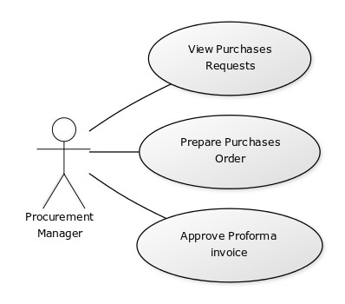

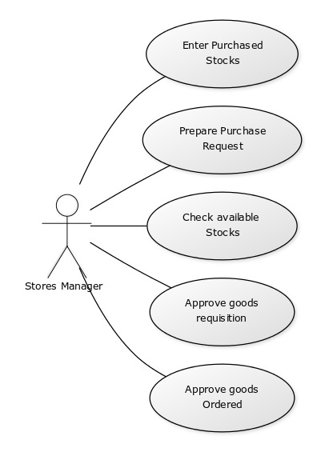

**3.2.2 Non-functional requirements**

These are constraints on the services or functions offered by the system, they include timing constraints on the development process and constraints imposed by standards. Non-functional requirements often apply to the system as a whole, rather than individual system feature or service. Non-functional requirements include;

**Speed;** The system should be very fast in loading

**Usability:** depending on how the user use it

# CHAPTER FOUR

## **SYSTEM DESIGN**

### 4.1 Introduction to system design

The definition of system design is broad as it includes the description of a structure of a system and detailed design of internals of the system components. System design is an act of defining the elements of the system such as the architecture, modules, components, interfaces and databases of the system. It is for the fulfillment of needs and requirements of the system. The system design acts as an intermediate bridge between system analysis and system implementation. It specifies how the system is going to be implemented based on the nature and requirements.

Architectural design; highlights the design of the system architecture that describes the structure, behavior and more views of that system and analysis.

Logical design: pertains to an abstract representation of the data flows, inputs and outputs of the system. This is often conducted through modelling, using an over-abstract or graphical model of the actual system. It involve unified modeling language (UML) diagrams such as class diagram, activity diagram, use case diagram, sequential diagrams, communication diagram and entity relationship diagrams.

Physical design; relates to the actual input and output process of the system. It explains how data entered into a system, how data is verified or authenticated, how data is processed and how data is displayed. Physical design is broken into three parts – User interface design, Data design and Process design.

### 4.2 System design methodology object, waterfall model

The purpose of project development methodology is to provide a standard and guidelines to ensure that information system projects are conducted in well managed and consisted manner that promote the delivery of quality products and results in projects that are completed on time and within budget. Regarding to this project waterfall approach has used in designing and development of the inventory management system.

The waterfall model is a sequential design process, used in software development process, in which progress is seen as flowing steadily downwards through the phases of conception, initiation, analysis, design, construction, testing, production/implementation and maintenance.

**Requirements analysis** encompasses those tasks that go into determining the needs or conditions to meet for a new or altered product or project, taking account of the possibly conflicting [requirements](https://en.wikipedia.org/wiki/Requirement) of the various [stakeholders](https://en.wikipedia.org/wiki/Stakeholder_(corporate)), *analyzing, documenting, validating and managing* software or system requirements.

Requirements analysis is critical to the success or failure of a systems or software project.The requirements should be documented, actionable, measurable, testable, traceable, related to identified business needs or opportunities, and defined to a level of detail sufficient for system design.

**Software design:** usually involves problem solving and planning a [software](https://en.wikipedia.org/wiki/Software) solution. This includes both a low-level component and [algorithm design](https://en.wikipedia.org/wiki/Algorithm_design) and a high-level, [architecture](https://en.wikipedia.org/wiki/Software_architecture) design. Software design is the process of implementing software solutions to one or more sets of problems. One of the main components of software design is the [software requirements analysis](https://en.wikipedia.org/wiki/Software_requirements_analysis) (SRA). SRA is a part of the [software development process](https://en.wikipedia.org/wiki/Software_development_process) that lists [specifications](https://en.wikipedia.org/wiki/Specifications) used in [software engineering](https://en.wikipedia.org/wiki/Software_engineering).

**Implementation:** In this stage, the actual coding of the software takes place. With inputs from the system design, the system is first developed in small programs (units), which then integrated in the next phase. Each unit is developed and tested for its functionality. A proper execution of the previous stages ensures a smooth and easier implementation of this stage.

**Testing:** This phase is integration of all units developed in the implementation phase into a system after testing each unit is taking place. After integration, the entire system is tested for any faults and errors.

**System deployment:** After the functional and non-functional testing, the product installed in the customer environment is ready for use.

**Maintenance:** This involves making modifications to the system or an individual component to alter attributes or improve performance. There are that come up in the user environment, to fix those issues at early stage.

### 4.3 Database design

The process of producing a detailed data model of database. This data model contains all the needed logical/physical design choices and physical storage parameters to generate a design in data definition language.

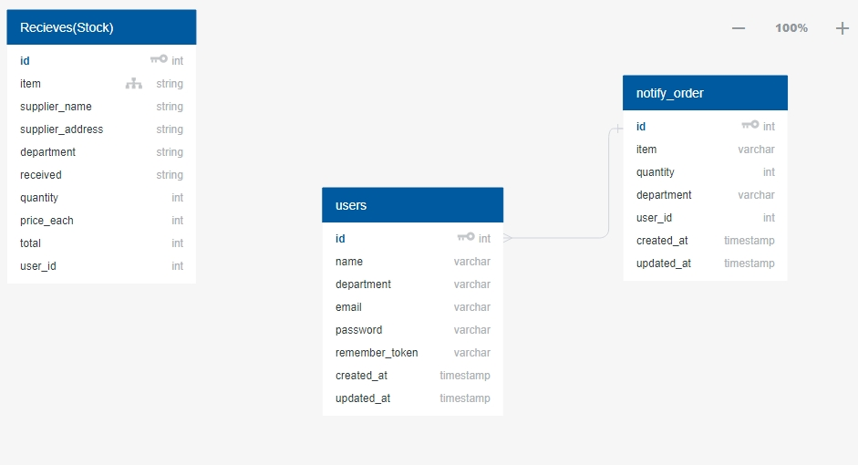

# CHAPTER FIVE

## **SYSTEM IMPLEMENTATION**

### 5.1 Introduction to implementation

System implementation refers to the translation of designs into the actual code. It is a way which system are been implemented by using different programming languages. With inputs from system design, the system is in first developed in small programs (units), which then integrated. Each unit is developed and tested for its functionality (unit testing). In this stage, the actual coding of the software takes place.

The adopted technologies, programming language and platform, used for development and implementation of the system, in accordance to their participation in the implementation of the system as described.

**HTML**

HTML, used as a client side language as server-side scripting executed by a web server. Browser executes client-side scripting. Client end scripts are embedded in a website’s HTML markup code, which is housed on a server in a language that is compatible with or compiled to communicate with a browser. HTML used for describing and defining web pages contents of the system.

**CSS**

CSS is a style sheet language used for describing the presentation of HTML documents (markup language documents). CSS describes how HTML elements should be displayed. Along with Javascript, CSS is a basic technology used by most system to create visually engaging pages, user interfaces for web applications and user interfaces for many mobile applications. CSS designed primarily to enable the separation of document content from document presentation, including aspects such as layouts, color and fonts. This separation can improve contents accessibility, enable HTML pages to share format and reduce complexity and repetition in the structural content.

**PHP**

PHP used as the server-side scripting language. PHP is an open source server side scripting language, which can easily embedded with HTML and CSS in order to create dynamic webpages and responsive system with supportive features from database the development of the system.

**JavaScript**

Java script is a client side language used for making dynamic and interactive web pages. JavaScript is a programing language that run by most modern browsers. It supports both object-oriented and procedural programing. It used to control webpages on the client-side of the browser, sever-side programs and mobile applications.

**MySQL Database Management System**

A relational database management system which is widely used around the globe due to it being open-sourced. Most SQL servers provide reliability but not ease of use unlike MYSQL. When using PHP to develop a system, MYSQL database will be embedded to produce effective system. MYSQL use structured query language (SQL). SQL is the most popular language for managing content in a database. It is recognized for its quick processing, proven reliability, ease and flexibility of use.

**Development tools**

I was running Windows 8 single language operating system for developing of the system. Since windows is mostly used by most users and has good user inteface.

**Visual studio code**

Is the text editor which I used for writing down the code, It includes support for debugging, embedded git control, syntax highlighting, intelligent code completion, snippets and code refactoring. It is also customizable, so users can change the editor's [theme](https://en.wikipedia.org/wiki/Theme_(computing)), [keyboard shortcuts](https://en.wikipedia.org/wiki/Keyboard_shortcut), and preferences. It is [free and open-source](https://en.wikipedia.org/wiki/Free_and_open-source), although the official download is under a [proprietary license](https://en.wikipedia.org/wiki/Proprietary_software).

**Laravel** a free, open-source PHP web framework, created by Taylor Otwell and intended for the development of web applications following the [model–view–controller](https://en.wikipedia.org/wiki/Model%E2%80%93view%E2%80%93controller) (MVC) [architectural pattern](https://en.wikipedia.org/wiki/Architectural_pattern) and based on Symfony.

**AMPPS** is a [solution stack](https://en.wikipedia.org/wiki/Solution_stack) of [Apache](https://en.wikipedia.org/wiki/Apache_HTTP_Server), [MySQL](https://en.wikipedia.org/wiki/MySQL), [MongoDB](https://en.wikipedia.org/wiki/MongoDB), [PHP](https://en.wikipedia.org/wiki/PHP), [Perl](https://en.wikipedia.org/wiki/Perl) and [Python](https://en.wikipedia.org/wiki/Python_(programming_language)) for [Windows NT](https://en.wikipedia.org/wiki/Windows_NT), [Linux](https://en.wikipedia.org/wiki/Linux) and [macOS](https://en.wikipedia.org/wiki/MacOS). It comes with 442 PHP web applications, over 1000 PHP classes and 6 versions of PHP. AMPPS is created by Softaculous Ltd. a company founded in 2009 which makes the Softaculous Auto installer. AMPPS is used to develop on PHP, MySQL applications like [WordPress](https://en.wikipedia.org/wiki/WordPress), [Joomla](https://en.wikipedia.org/wiki/Joomla), and [Drupal](https://en.wikipedia.org/wiki/Drupal).

**Google Chrome** is a [freeware](https://en.wikipedia.org/wiki/Freeware) [web browser](https://en.wikipedia.org/wiki/Web_browser) developed by [Google](https://en.wikipedia.org/wiki/Google). It was first released in September2008,for [Microsoft Windows](https://en.wikipedia.org/wiki/Microsoft_Windows), and was later [ported](https://en.wikipedia.org/wiki/Ported) to [Linux](https://en.wikipedia.org/wiki/Linux), [macOS](https://en.wikipedia.org/wiki/MacOS), [iOS](https://en.wikipedia.org/wiki/IOS) and [Android](https://en.wikipedia.org/wiki/Android_(operating_system)). Google Chrome is also the main component of [Chrome OS](https://en.wikipedia.org/wiki/Chrome_OS), where it serves as a platform for running [web apps](https://en.wikipedia.org/wiki/Web_app).

### 5.2 Functionalities of implementation

Functionalities and services implementation of the system are based on role and impact of user provided by system. Thus, functionalities and services implementation are:

### 5.4 Front end user interface implementation

The interface which the user interact with throughout to perform different actions it is more defined and easy to understand for user to fulfil their needs

The front view of the web interface

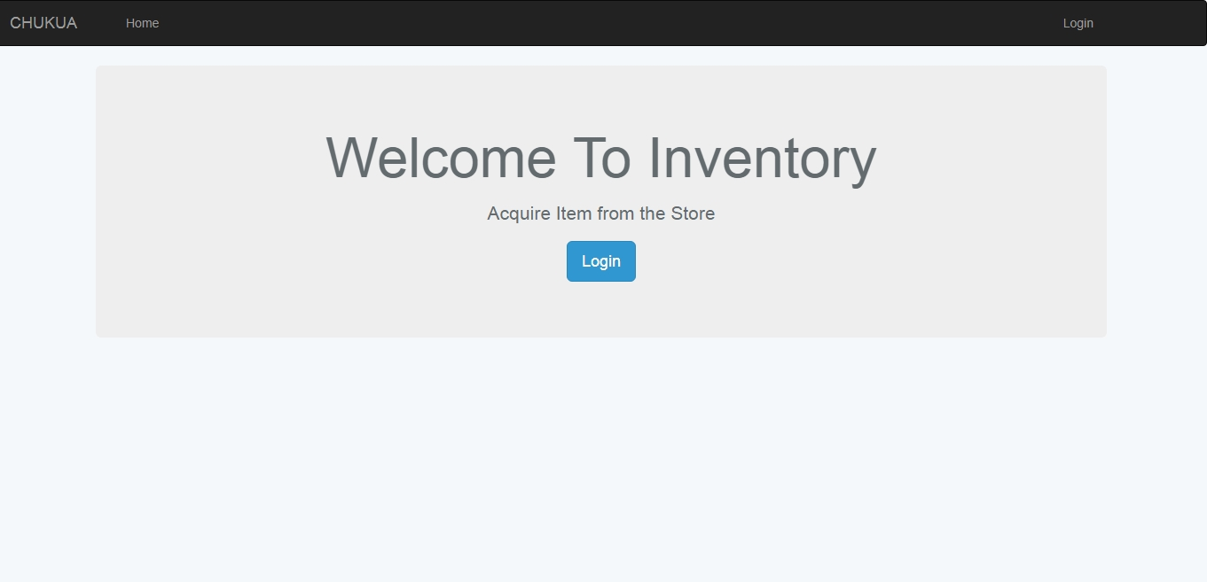

After logged in the user directly move to the dashboard were he/she can see available stocks in the concerned department

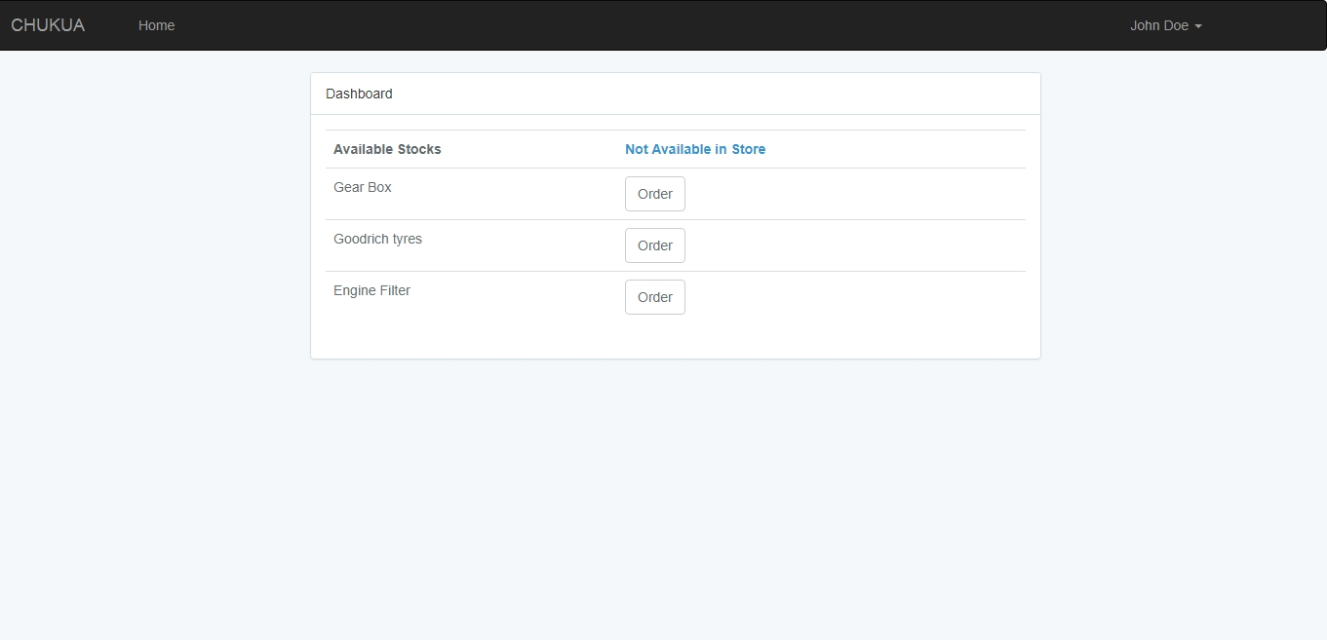

This is how the order can be made and sent to store’s department immediately

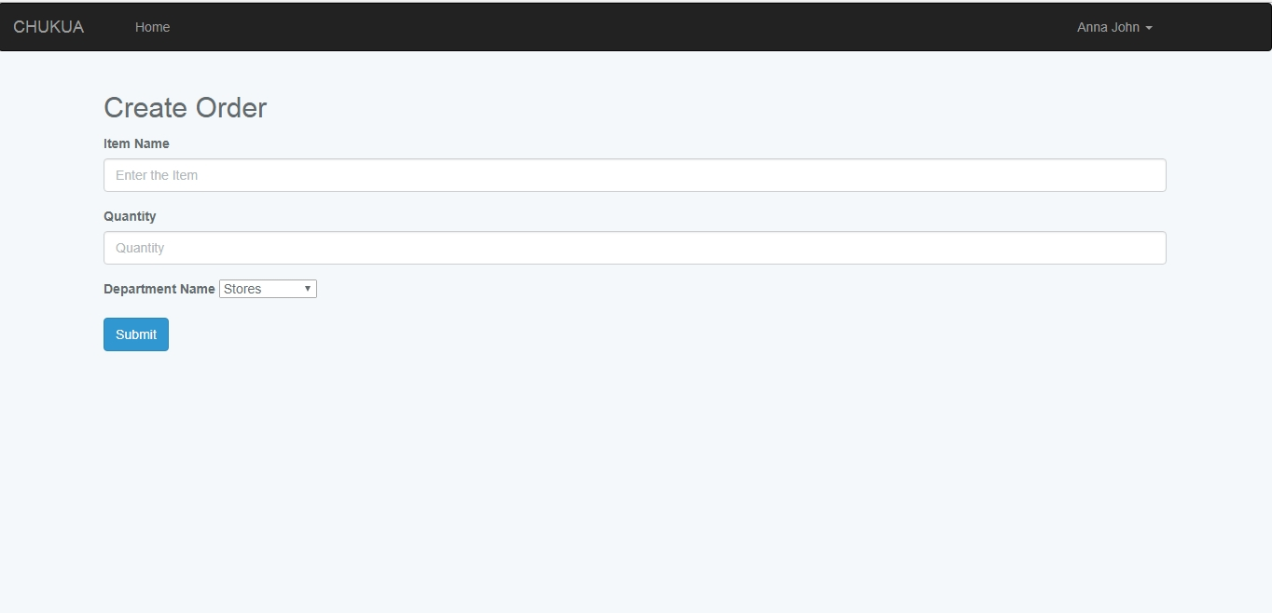

Once the stock is unavailable the user fills the requisition form to send it to the stores department so as to make purchase request.

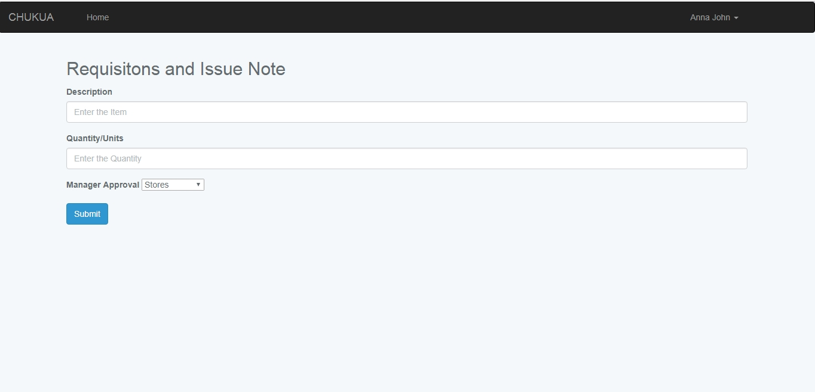

Goods acquired due to their finish in the main store

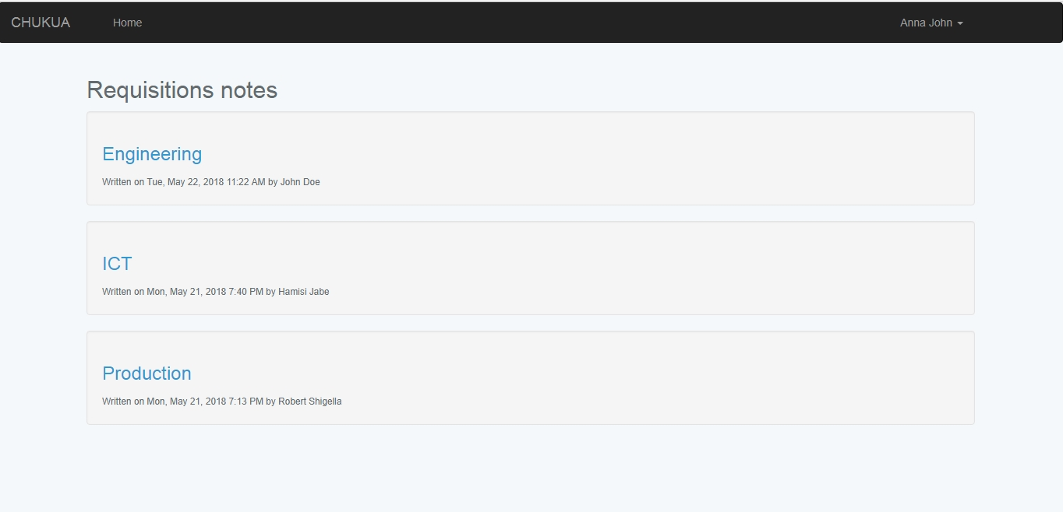

The procurement department the prepare a report to print the Purchases request

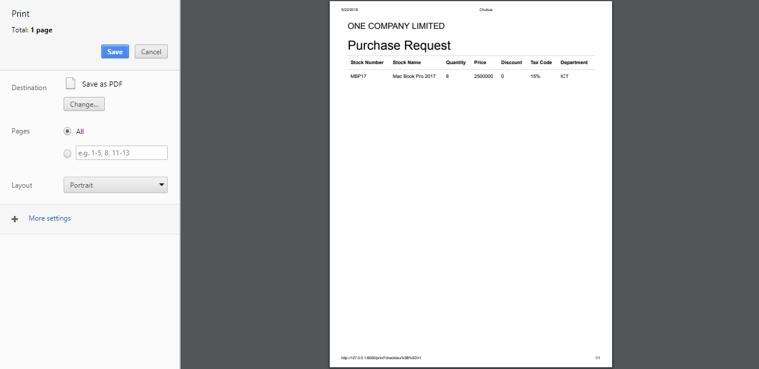

Procurement department uses the purchases request hard copy to find the suitable supplier then after obtaining them they attach the suppliers’ pro forma invoice with it. They prepare Purchases Order with which it’s an official document that goods are been bought.

The Purchases Order prepared by the procurement department revealing the official purchase

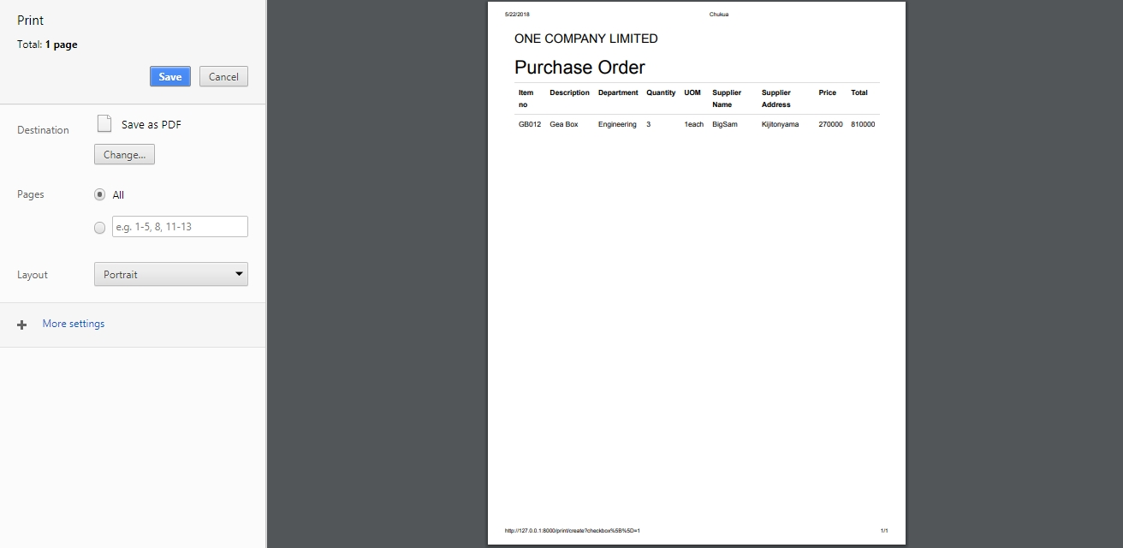

# CHAPTER SIX

## **CONCLUSIONS AND RECOMMENDATION**

### 6.1 Summary of achieved objectives

The study was able to come up with an Inventory system a web based integrated system that make it easier to manage stocks in an organization with all important features necessary been included to help in producing a sufficient outcome of the results.

The objective is to help the internal organization workers in different departments to be able to manage their inventories in an efficient way as well as the controlling department, which is stores and procurement to have a streamlined way to fulfil different task within time and plan other supplementary stuffs for the organization.

### 6.2 Conclusion

### 

# 