LLM Chatbot Design Report
University of the Cumberlands
Instructor: Dr Alan Dennis
Group Members: Mayank Dave, Mustafa Shahid, Upender Reddy Kuntiyellannagari, Aishwaria
Project: Final Group Project (FastAPI + React)
Date: February 19, 2026

Executive Summary
This report documents the design decisions used to build a production-style educational chatbot that accepts English input and returns Spanish output, with optional English output for transparency. The system combines rule-based responses, retrieval-augmented generation (RAG), and Azure OpenAI generation in a layered strategy to maximize reliability, reduce hallucinations, and provide graceful behavior when cloud services are unavailable.

Problem Statement and Goals
The objective was to build a chatbot that is practical for a classroom AI service scenario and demonstrates both traditional NLP and modern LLM integration.
- Provide understandable answers to common user questions.
- Return Spanish output while preserving an optional English response.
- Use local knowledge (corpus) before cloud generation when possible.
- Keep the architecture maintainable using clear MVC separation.
- Expose a simple API for frontend and future integrations.

System Architecture
The solution follows an MVC-inspired backend design with a React frontend.

Architecture Diagram
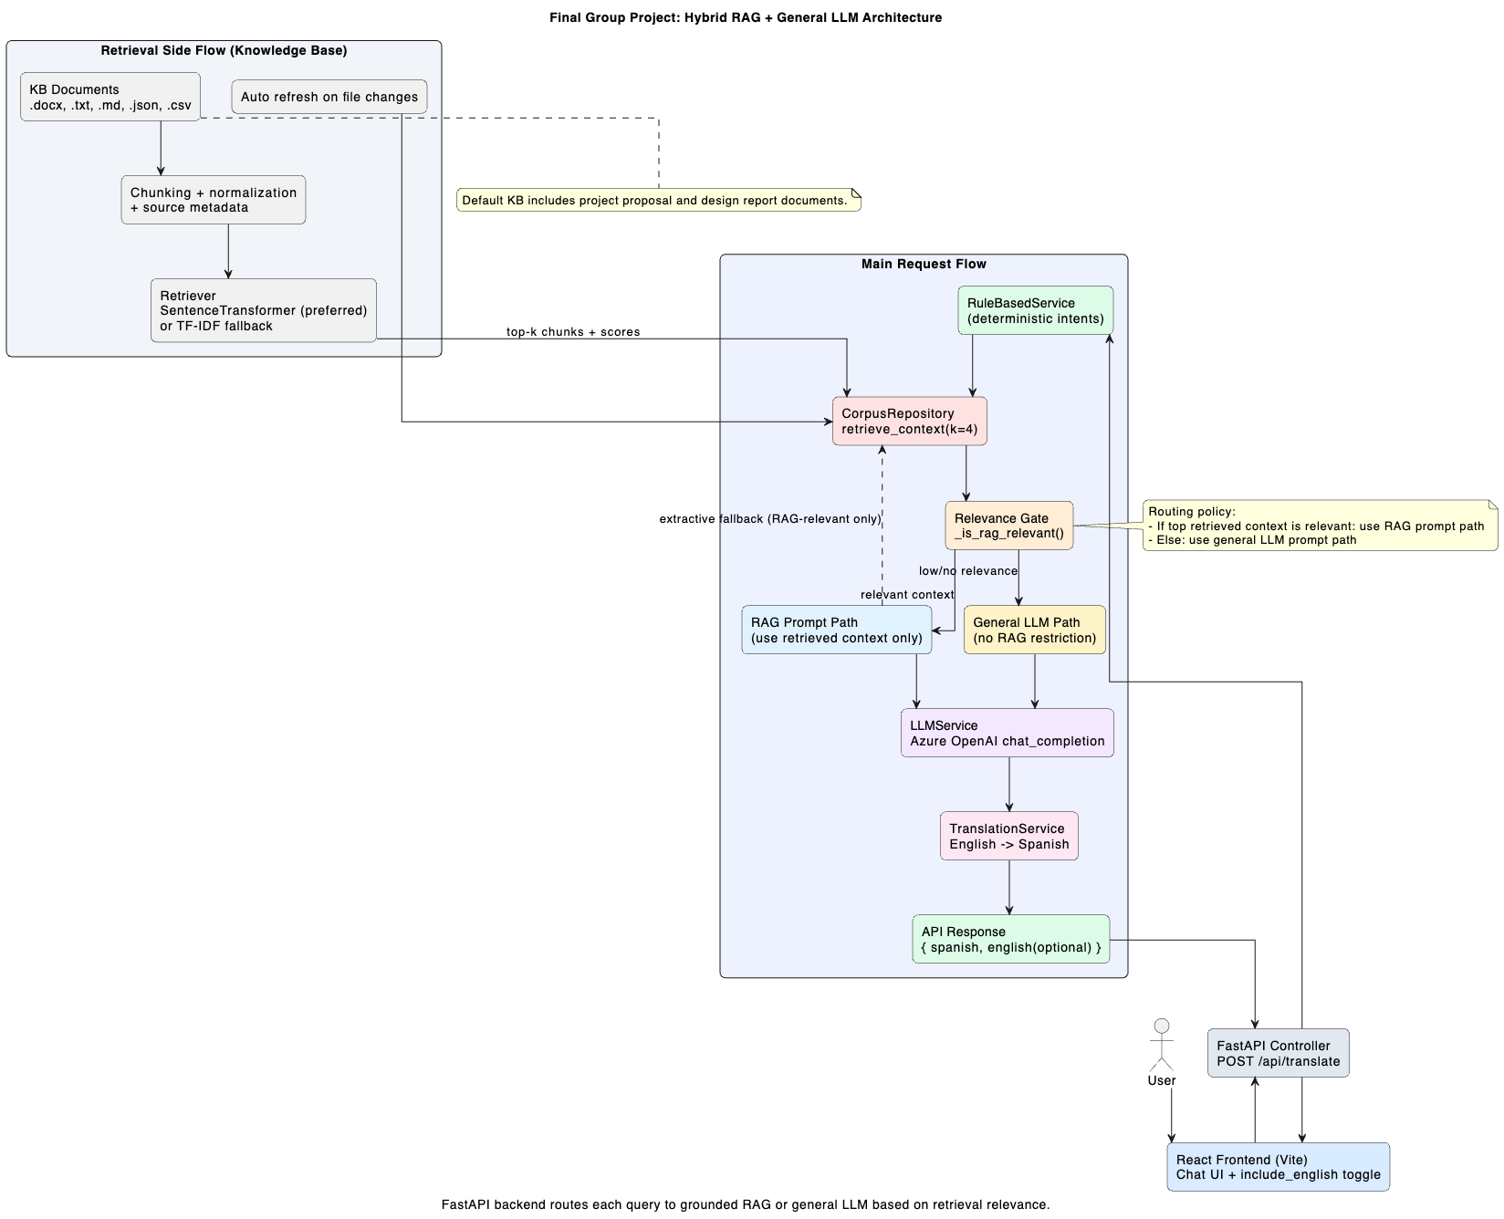

Backend Layers (FastAPI)
- Controllers: HTTP endpoints and request routing (`backend/app/controllers`).
- Services: Business logic for chat orchestration, LLM calls, translation, and rules (`backend/app/services`).
- Repositories: Data access and retrieval logic over corpus files (`backend/app/repositories`).
- Models: Request/response schemas for validation (`backend/app/models`).
- Core config: Environment-based settings and CORS setup (`backend/app/core/config.py`).
Primary endpoint: `POST /api/translate` with payload `{ text, include_english }`.

Frontend Layer (React + Vite)
The frontend was designed as a messaging-style chat interface. Users can send consecutive messages and view assistant replies in a running conversation thread with user and assistant bubbles, loading states, and mobile-friendly layout.

Response Strategy Design (Core Decision)
A multi-stage response strategy was chosen to balance quality, cost, and reliability.
- Stage 1: Rule-based response for deterministic intents and simple FAQs.
- Stage 2: Retrieval from local corpus (`corpus.json`) for known knowledge coverage.
- Stage 3: Azure OpenAI response using RAG context when local methods do not produce an answer.
- Fallback: Return a safe default guidance response if no stage succeeds.
This design minimizes unnecessary LLM calls, reduces latency for common questions, and ensures predictable behavior under partial outages or configuration issues.

Retrieval and Knowledge Design
The repository layer supports semantic and lexical retrieval with graceful degradation.
- Preferred retriever: SentenceTransformer embeddings (`all-MiniLM-L6-v2`) with cosine-style similarity.
- Fallback retriever: TF-IDF vector search when embedding model is unavailable.
- Configurable thresholds (`min_score`, `tfidf_min_score`) to avoid low-confidence matches.
- Top-k context extraction (`k=3`) for RAG prompts.
This dual-path retriever improves portability: richer retrieval when optional dependencies are present and acceptable performance when they are not.

Prompting and LLM Integration
LLM calls are made through a dedicated service using Azure OpenAI chat completions. Prompting is constrained and purpose-specific.
- Chat prompt includes concise system instructions and retrieved QA context.
- Instruction bias: answer from context when relevant; say unknown when context is insufficient.
- Temperature tuned low (0.2 for answers, 0.1 for translation) for consistency.
- Token cap applied to control cost and response length.

Translation Design
Translation is handled as a dedicated service rather than inlining it into the primary answer generation.
- Input is the finalized English answer from prior stages.
- System prompt enforces neutral Latin American Spanish output.
- If Azure is unavailable, the system returns a deterministic translation-unavailable message to preserve API stability.

Configuration and Security Design
Configuration is standardized through `.env` variables, loaded by backend config. This avoids hardcoded credentials and keeps environment-specific values outside source code.
- AZURE_OPENAI_ENDPOINT
- AZURE_OPENAI_API_KEY
- AZURE_OPENAI_DEPLOYMENT
- AZURE_OPENAI_API_VERSION
- RAG_CORPUS_PATH
- CORS_ORIGINS
This approach simplifies deployment and reduces the risk of credential exposure in code history.

API and UI Design Considerations
API design intentionally keeps a narrow surface area for clarity and easier testing.
- Single primary route (`/api/translate`) with validated schema contracts.
- Boolean `include_english` flag for client-controlled verbosity.
- CORS configuration for local frontend integration.
The messaging-style UI improves user experience over one-shot forms by supporting conversational continuity at the interface level, even when backend processing remains request/response per turn.

Reliability and Error Handling
- Network and HTTP exceptions from Azure calls are captured and logged.
- Invalid JSON or malformed model responses are handled safely.
- User-facing fallback messages prevent blank responses.
- Health endpoint (`/health`) supports quick service checks.

Limitations
- Current backend is functionally single-turn per request; long-term memory is not persisted server-side.
- Translation currently depends on Azure availability (no offline translator fallback).
- Retrieval quality depends on corpus coverage and threshold tuning.
- Observability is basic (stdout/stderr); no centralized logging/metrics stack yet.

Future Enhancements
- Add conversation/session memory with bounded token history.
- Persist chat transcripts and analytics for evaluation.
- Introduce guardrails/content filtering before and after model calls.
- Add automated tests for controller, service, and retrieval components.
- Support multilingual input and dynamic target-language selection.

Conclusion
The chatbot was designed as a hybrid system that combines deterministic NLP, retrieval, and LLM generation. The architecture emphasizes maintainability, configurability, and graceful degradation. This design provides a strong baseline for academic demonstration and a practical foundation for future production hardening.

References
OpenAI. (2026). ChatGPT (GPT-5.2 Thinking) [Large language model]. https://chat.openai.com/

