Adaptive User Interfaces, Intelligent User Interfaces, and AI-Based Adaptive Human-Computer Interaction: Design and Implementation Report
Mayank Dave
University of the Cumberlands
MSAI-631
Instructor: Dr. Alan Dennis
February 23, 2026

Abstract
This report documents the end-to-end development of a React-based adaptive user interface (UI) project designed to demonstrate core accessibility principles in practice. The implemented solution includes semantic page structure, keyboard-first interaction patterns, skip navigation, visible focus indicators, alternative text for non-text content, ARIA live regions, and user-selectable adaptation controls for high contrast, large text, and reduced motion. In the final iteration, the interface was reorganized into a top-to-bottom WCAG POUR sequence (Perceivable, Operable, Understandable, Robust), button design was upgraded to improve affordance and visual hierarchy, and high-contrast text token behavior was corrected so text color updates consistently across all sections. The implementation process is presented as a reproducible workflow beginning with requirements definition, followed by project scaffolding, accessible component design, adaptive behavior integration, and final packaging. The paper defines adaptive user interfaces, intelligent user interfaces, and AI-based adaptive human-computer interaction (HCI), then analyzes how these paradigms improve user experience when implemented with transparency and user control. It also examines practical examples of adaptive interfaces from everyday digital products and summarizes the usability and accessibility benefits they offer. The report concludes with ethical considerations, limitations encountered during development, and recommendations for extending the project with AI-enabled personalization while preserving accessibility and trust.

Introduction
User interface quality is no longer measured only by visual appeal or feature density. In modern systems, quality also depends on whether interaction can flex to diverse user abilities, goals, contexts, and preferences. Adaptive user interfaces (AUIs) address this requirement by modifying presentation, behavior, or interaction pathways according to user needs and system observations (Benyon & Murray, 1993; Brusilovsky, 2001). In parallel, intelligent user interfaces (IUIs) integrate artificial intelligence (AI) techniques into interaction design so systems can assist users more effectively, often by prediction, automation, recommendation, or natural interaction support (ACM IUI, 2026).
This report documents the creation of a React Adaptive UI project showcasing accessibility principles through direct interaction. Rather than describing accessibility only in text, the interface demonstrates accessible behavior via functional controls that users can test immediately. The work is grounded in human-centered design guidance (ISO 9241-210, 2019) and web accessibility standards (World Wide Web Consortium [W3C], 2023).

Project Objective and Scope
The project objective was to build a standalone React application that demonstrates accessibility design principles through adaptive interface controls and semantically structured content. The scope included:
- Building a new isolated project directory and React application scaffold.
- Implementing adaptive controls for high contrast, large text, and reduced motion.
- Embedding accessibility-first interaction patterns (skip link, focus visibility, semantic structure, labeled forms, ARIA live feedback).
- Providing responsive behavior for mobile and desktop.
- Documenting the project with run instructions and explanatory content.
The scope intentionally prioritized front-end accessibility and adaptive interaction over backend personalization infrastructure.

Step-by-Step Development Process

Step 1: Project initialization and directory structure
A dedicated directory, react-adaptive-accessibility-ui/, was created to isolate the solution from existing coursework artifacts. Core files were added: package.json, index.html, vite.config.js, .gitignore, README.md, and source folders (src/, public/).
Figure 1
Project Structure of the React Adaptive Accessibility UI
react-adaptive-accessibility-ui/
|- .gitignore
|- Adaptive_UI_APA_Compliant.docx
|- Adaptive_UI_APA_Compliant_FIXED.docx
|- Adaptive_UI_APA_Report.docx
|- Adaptive_UI_APA_Report.md
|- README.md
|- index.html
|- package-lock.json
|- package.json
|- vite.config.js
|- public/
| |- accessibility-illustration.svg
|- src/
| |- App.jsx
| |- main.jsx
| `- styles.css

Step 2: React entry point and application shell
The React entry file (react-adaptive-accessibility-ui/src/main.jsx) mounts the application root and imports global styles. The application shell in react-adaptive-accessibility-ui/src/App.jsx was structured with semantic landmarks (header, main, section) to improve navigation for assistive technologies.

Step 3: Accessibility-first interaction patterns
Core accessibility elements were implemented before visual refinements:
- A keyboard skip link was added in index.html to jump directly to main content.
- High-visibility focus styles were applied in CSS using :focus-visible.
- Form controls were associated with explicit labels and helper text (aria-describedby).
- A live region (aria-live="polite") announces feedback submission status.
- Meaningful image alternative text and figure captioning were added.
These choices align with perceivable and operable design goals from WCAG guidance (W3C, 2023).
Figure 2. Adaptive controls panel in default theme.
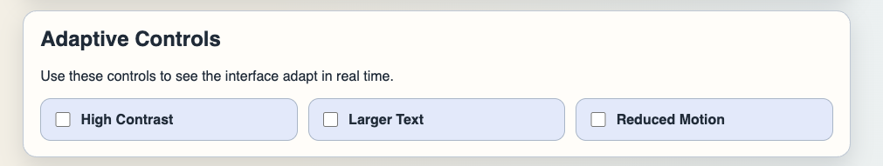

Step 4: Adaptive behavior implementation
The interface includes three user-controlled adaptation modes:
- High contrast mode toggles accessible color tokens for improved visual distinction.
- Large text mode increases reading size and line spacing.
- Reduce motion mode suppresses animation and transition effects.
In code, these preferences are modeled as React state variables in App.jsx and mapped to CSS theme classes (theme-contrast, theme-large-text, theme-reduced-motion) defined in styles.css. During refinement, high-contrast behavior was corrected by moving text color control to theme tokens applied at the application container level and propagated to headings, body text, labels, captions, and input fields.

Figure 3. Accessibility controls and sections in high-contrast theme.
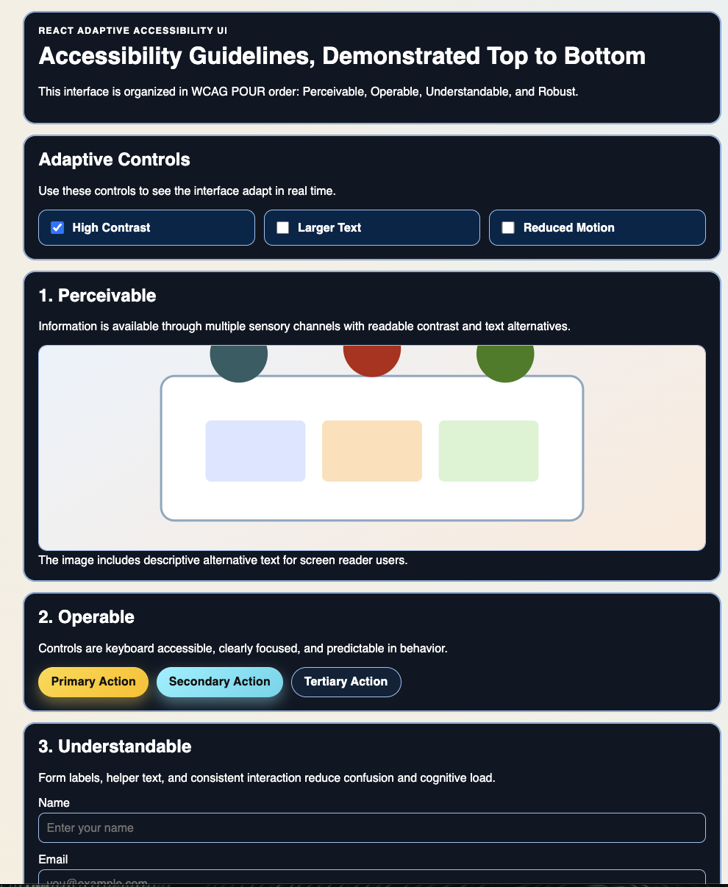

Step 5: Content strategy and principle demonstration
To ensure the interface teaches accessibility explicitly, the content was restructured into four dedicated components organized in WCAG POUR order from top to bottom:
- Perceivable section with media and alternative text.
- Operable section with keyboard-focusable action controls.
- Understandable section with labeled form fields and helper text.
- Robust section with ARIA live status messaging.
This replaced the earlier card arrangement and made instructional flow more systematic.

Step 6: Visual and responsive design
A responsive layout was implemented as a vertical instructional stack to match the ordered guideline sequence across device sizes. Button styling was upgraded from basic controls to visually distinct variants (primary, secondary, and ghost) with stronger affordance, gradient treatment, focus visibility, and interaction feedback. Tokens and theme variables were used for maintainability and consistent contrast behavior.

Figure 4. Top-to-bottom guideline layout in default theme.
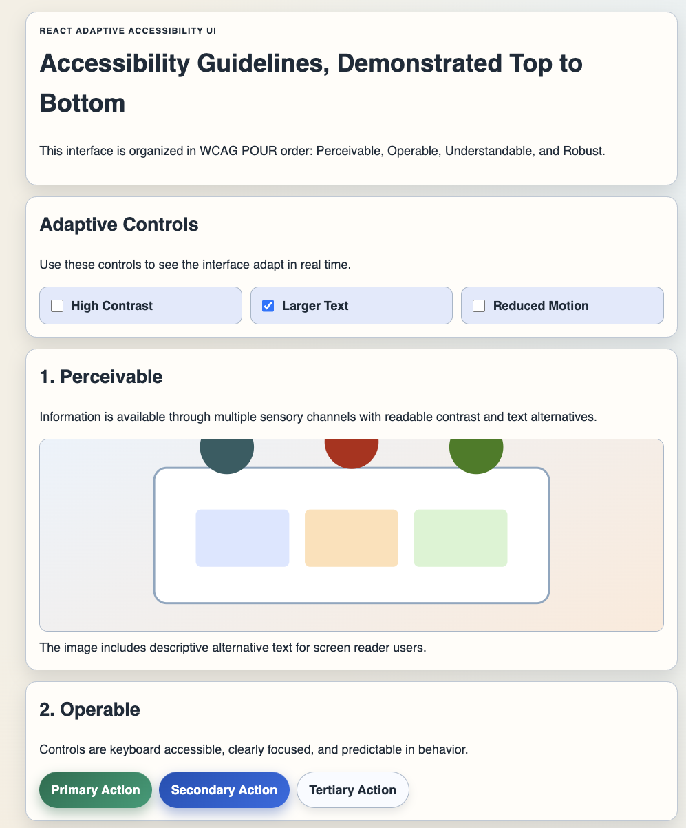

Figure 5. Operable section with styled primary, secondary, and tertiary actions.
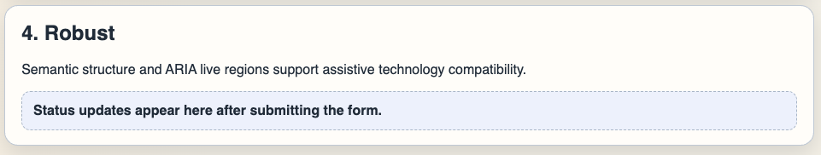
Figure 6. Perceivable section with descriptive image alt-text context.
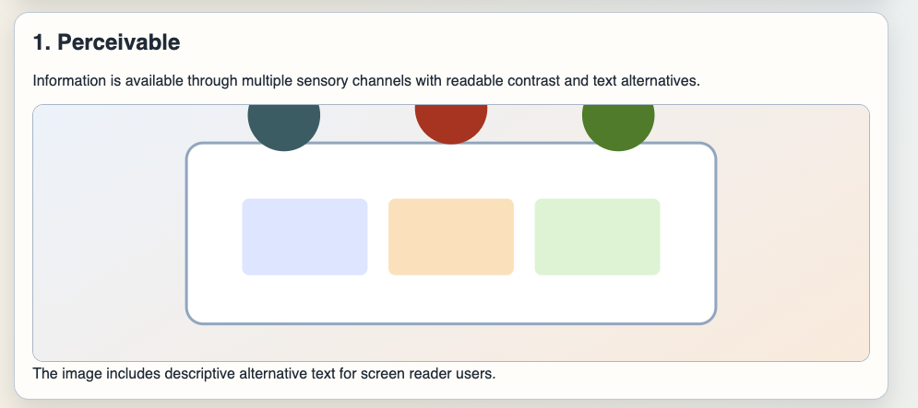

Step 7: Asset and offline reliability decisions
A local SVG illustration (public/accessibility-illustration.svg) replaced an external image URL to avoid network dependency and improve build reliability in constrained environments.

Step 8: Documentation and reproducibility
A project README was added with local run and build instructions. Source files used in this implementation include react-adaptive-accessibility-ui/src/App.jsx and react-adaptive-accessibility-ui/src/styles.css.

Definitions and Conceptual Framework

Adaptive User Interfaces (AUIs)
Adaptive user interfaces are interfaces that modify layout, behavior, information density, or interaction sequence in response to user characteristics, preferences, context, or observed behavior (Benyon & Murray, 1993; Brusilovsky, 2001). AUIs may be system-driven, user-configurable, or hybrid. In this project, adaptation is explicitly user-controlled via accessibility toggles, which supports transparency and avoids hidden behavior changes.

Intelligent User Interfaces (IUIs)
Intelligent user interfaces combine AI techniques with interface design to support users in completing tasks more effectively. The ACM IUI conference frames IUIs as work at the intersection of AI and HCI, emphasizing both computational methods and human-centered outcomes (ACM IUI, 2026). Typical IUI capabilities include prediction, recommendation, natural language processing, multimodal interaction, and context-aware assistance.

Relationship between IUIs and AUIs
AUIs and IUIs overlap but are not identical:
- An AUI can be non-AI (e.g., manual high-contrast toggle).
- An IUI can be non-adaptive (e.g., static chatbot widget with no personalization).
- The most powerful systems combine both: AI informs adaptation, while human-centered controls preserve user agency.

AI-Based Adaptive Human-Computer Interaction
AI-based adaptive HCI can be defined as the design and evaluation of interactive systems that use machine-learning or knowledge-based methods to dynamically personalize interface behavior while preserving usability, accessibility, and user control. This definition synthesizes adaptive interface literature with contemporary human-AI design principles (Amershi et al., 2019; Shneiderman, 2020).

AI Tool Disclosure
The following AI-based tools assisted this assignment:
- OpenAI Codex (GPT-5-based coding assistant): Used to scaffold the React project, implement accessibility/adaptive UI code, and draft this structured report.
- No additional external generators were used for UI screenshots; screenshots were captured from the implemented local web application.
All generated content was reviewed and edited for assignment alignment, technical consistency, and APA-style organization.

Conclusion
This project demonstrates that adaptive interfaces and accessibility principles can be integrated into a concise, practical React solution. The implemented UI operationalizes accessibility through interaction, not only description, by providing user-controlled adaptations and standards-aligned semantic design. The latest revision strengthened the educational and usability value of the interface by ordering guideline sections in WCAG POUR sequence, improving control affordance through stronger button styling, and correcting high-contrast text theming for consistent readability. Conceptually, adaptive UIs and intelligent UIs are complementary: AUIs provide personalization mechanics, while IUIs contribute AI capabilities that can optimize personalization quality. AI-based adaptive HCI becomes most effective when adaptation remains transparent, reversible, and grounded in human-centered design. Future extension of this project can add machine-learned preference modeling, but only with explicit safeguards for trust, accessibility, and user agency.

Source Code

References
ACM IUI. (2026). IUI 2026: The annual ACM conference on intelligent user interfaces. https://iui.acm.org/2026/
Amershi, S., Weld, D., Vorvoreanu, M., Fourney, A., Nushi, B., Collisson, P., Suh, J., Iqbal, S. T., Bennett, P. N., Inkpen, K., Teevan, J., Kikin-Gil, R., & Horvitz, E. (2019). Guidelines for human-AI interaction. Proceedings of the 2019 CHI Conference on Human Factors in Computing Systems. https://doi.org/10.1145/3290605.3300233
Benyon, D., & Murray, D. (1993). User-centered approach to adaptive interfaces. Knowledge-Based Systems, 6(4), 239-248. https://doi.org/10.1016/0950-7051(93)90015-L
Brusilovsky, P. (2001). Adaptive hypermedia. User Modeling and User-Adapted Interaction, 11(1-2), 87-110. https://doi.org/10.1023/A:1011143116306
International Organization for Standardization. (2019). ISO 9241-210:2019 ergonomics of human-system interaction - Part 210: Human-centred design for interactive systems. https://www.iso.org/standard/77520.html
Shneiderman, B. (2020). Human-centered artificial intelligence: Three fresh ideas. AIS Transactions on Human-Computer Interaction, 12(3), 109-124. https://doi.org/10.17705/1thci.00131
World Wide Web Consortium. (2023, October 5). Web Content Accessibility Guidelines (WCAG) 2.2 is a W3C Recommendation. https://www.w3.org/news/2023/web-content-accessibility-guidelines-wcag-2-2-is-a-w3c-recommendation/
OpenAI. (2026). ChatGPT (GPT-5.2 Thinking) [Large language model]. https://chat.openai.com/

