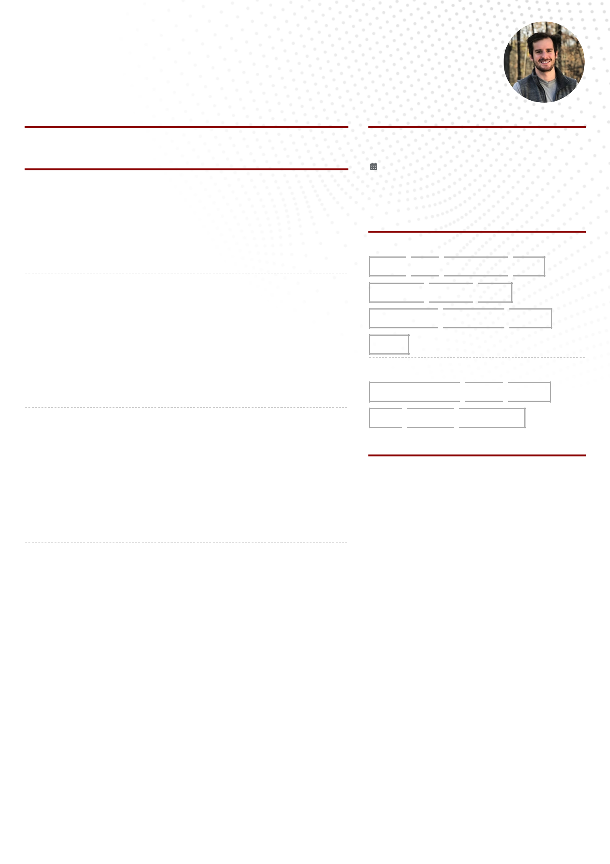**MACK GRISSOM**

**English Teacher / Freelance Web Developer**

**E 404 606-3147** **mack@mackgrissom.io**

**q** [**https://www.linkedin.com/in/mackgrissom**](https://www.linkedin.com/in/mackgrissom) **Atlanta**

**PORTFOLIO**

[https://www.mackgrissom.io](https://www.mackgrissom.io/)

**EXPERIENCE**

Business English Tutor (+3 years of prior teaching experience)

**Preply**

 2023 - Present  Location

<https://preply.com/en/tutor/3446340>

* Highly Rated Tutor teaching English to those in business and computer science
* Tutored 100+ students individually
* Helped 10+ students fnd employment and successfully pass job interviews in English-speaking companies

**EDUCATION**

Full Stack Development Boot Camp

**Le Wagon**

01/2022 - 03/2022  Paris, France

* Graduate from Full Stack Web Development Boot camp
* Built Production Ready Full Stack Products using Ruby on Rails, PostgreSQL

**SKILLS**

Tech Stack

**HTML**  **CSS**  **TailwindCSS**  **SCSS**

Freelance Software Developer

**Self-Employed**

 01/2022 - Present  worldwide

Company Description

* Personally designed and developed full-stack websites in 2022 for businesses in 4 diferent sectors, each client ranging in $0-$10m in revenue
* Handled front-end design on Figma
* Strategically selected tech stack for each client's needs, including content management systems when needed
* Delivered responsive user-friendly front-ends in React/Tailwind.css
* Delivered secured and reliable back-ends primarily in PostgreSQL and Ruby

UX Researcher

**EmployBridge**

 01/2021 - 01/2022  Remote

The Largest Light Industrial Stafng Firm In United States

* Contributed to research and design sprints that led products from zero to one
* Leveraged existing client relationships to build prototypes and MVP's based on customer feedback
* Interviewed clients and built research database including feedback from existing, prospective and former clients in the manufacturing and logistics space
* Studied user interaction with tech products, product ideas, and user interfaces
* Built wireframe mock-ups for user testing in Balsamiq

Implementation Manager, Strategic Partnership Group

**EmployBridge**

 01/2018 - 2021  Atlanta, Ga / Frequent Travel

The Largest Light Industrial Stafng Firm In United States

* Executed over 20+ client specifc project Implementations in 2020 that secured over $50 million in direct revenue
* Recruited, Interviewed and hired onsite teams to continue support of clients and deliver on our contractual service level agreements
* Designed and delivered industry leading workforce solutions for our largest clients in the manufacturing, logistics and light industrial sectors.
* Onboarded large clients & their teams to multiple tech-stacks for timekeeping, job order management, and various VMS's. (Vendor Management Systems)
* Innovated internal processes and developed SOPs as a foundation of our high-end service ofering before going live in the marketplace
* Developed and implemented customized SOP driven on-site service delivery models for process oriented Fortune 500 companies such as Toyota, Home Depot, FedEx, UPS, CVS Health, AT&T, AmeriSource Bergen, etc.
* High-level of accountability and service delivery with very transparent client expected deliverables
* Built and implemented recruiting models for on-site teams to use to hire talent for clients

**JavaScript**  **ReactJS**  **Ruby**

**Ruby on Rails**  **PostgreSQL**  **NodeJS**

**NextJS**

Software

**Visual Studio Code**  **Figma**  **GitHub Miro**  **Airtable**  **Monday.com**

**FIND ME ONLINE**

* **Portfolio**

https://www.mackgrissom.io/

**LinkedIn**

www.linkedin.com/in/username

**GitHub**

https://github.com/MackGrissom

**EXPERIENCE**

Staff Performance Manager

**EmployBridge**

 11/2017 - 01/2018  Atlanta, GA

The Largest Light Industrial Stafng Firm in United States

* Managed onsite operations of contingent workforce for Fortune 500 third-party logistics company
* Actively managed workforce of 200+ employees across 3 facilities with a volatile headcount predicated on client's production requirements
* Quickly recruited out of this role by corporate leadership due to high level of service delivery and for innovating data driven site improvements that directly helped clients and our respective businesses grow YOY