Understanding the need for Generics

The problem with boxing,

Is for example Object is a reference type and when Pushing a double, it is cast to an Object and then again cast back to a double

I .NET memory double values need to be copied to another place this cost performance

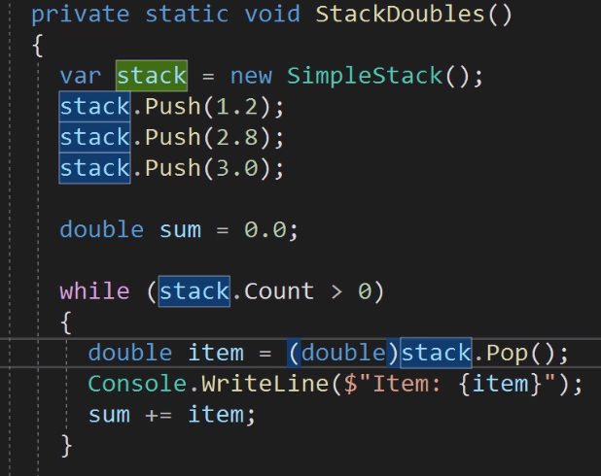

When looking at the generate intermedia Code you can see the performance

Ildasm: Intermediate Language Disassembler

Second problem not type safe anymore

To solve this, we created to different class one form Double Stack and for String Stack

But the problem is now for every time I want to create stack for a deferent type I have to copy past the class So I can’t re use the code

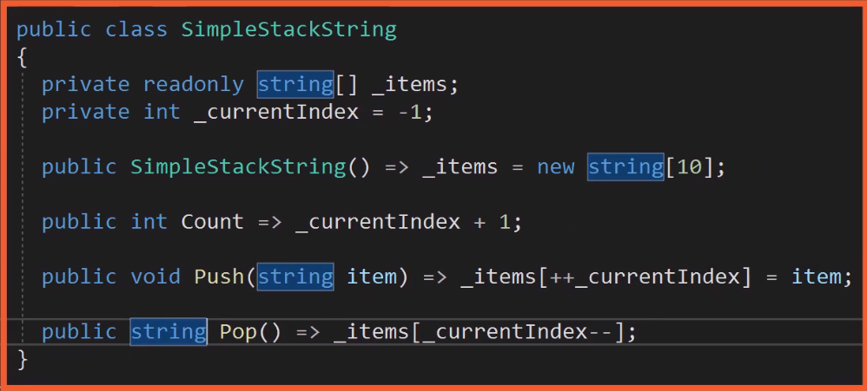

Create a Generic Stack Class

<T> is a type place holder the will be later specified

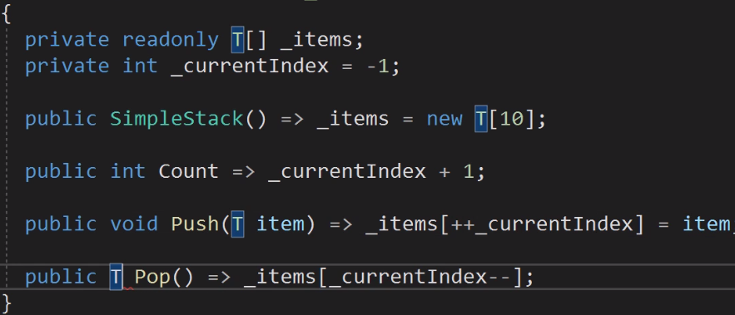

SimpleStack<T> Class is read as SimpleStack of T

Know the advantages of Generics

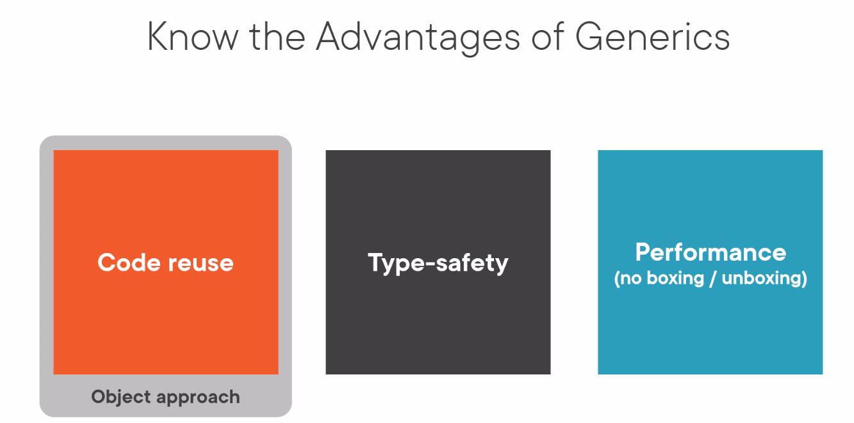

Use the Stack<T> Class of .NET

.NET contains many generic classes ex.

