## Build a Generic Extension Method

This means now that this addBatch method is an extension method for IWriteRepository<T> instances 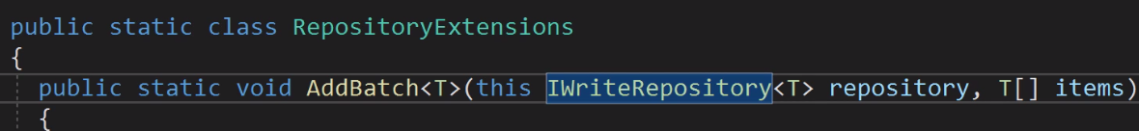

So now we can call it like this because it is now an Extension method of IWriteRepository<T> instances 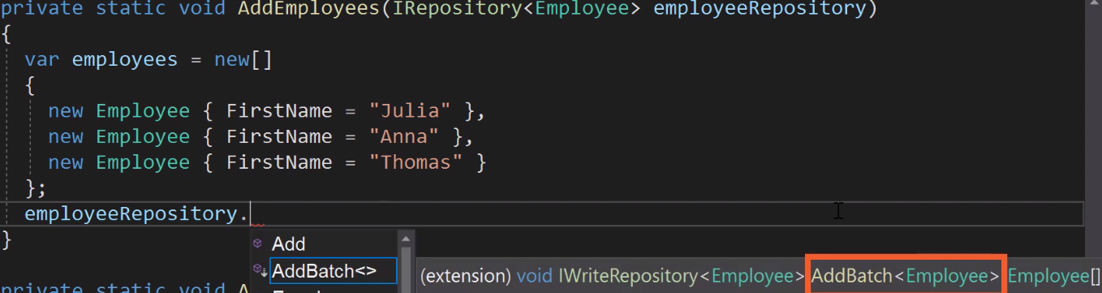

Because the method is generic type of T it can also take a organization since , organization is an IRepository and IRepository extends IWriteRepository we can also use its extension method

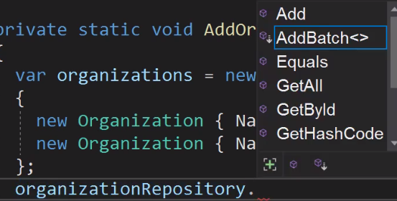

## Write a generic method with return value *

It can be simplify because the compiler know that itemToCopy is of type T

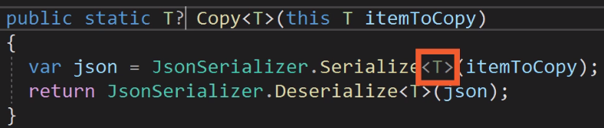

## Add a non-generic delegate

Now let’s say that you want to be able to pass a method to the SqlRepository ctor that is called every time an employee is added, to do this you need a delegate

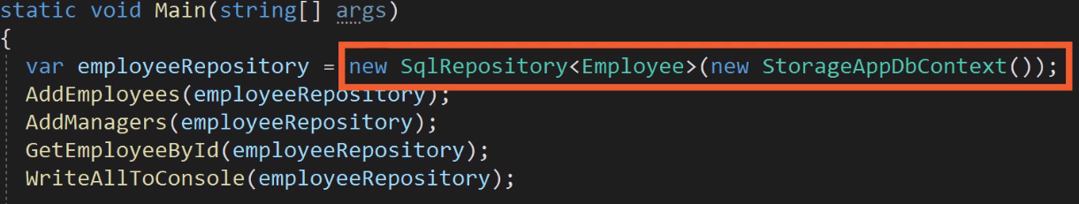

A delegate is like a method pointer. This delegate can point to a method that retuns void and that has an object parameter.

